The Size Of The Blind Sport Is Variable In Humans
Name
Date: __ / __ / __
Abstract
Most of the things we see in the world are nothing but mere illusions of our minds that our brains make up. Surprisingly, each human being has a blind spot that does not allow light and therefore makes things invisible despite being within one’s visual range. This experimentation intended determine whether the blind spot in humans is variable in size. A sample of three participants was used, to take part in a Go Cognitive blind spot test. Results indicate that the blind spots of all the participants varied. The researcher, therefore, concludes that the size of blind spot is variable in humans,
Introduction
This study was conducted to respond to the research question: “Is the size of the blind spot variable in humans?” Research indicate that much of what we see in the world are nothing but the illusions that our brains make up. Many people tend to believe that they can see everything within their visual field, but this is not entirely accurate. Past and present studies indicate that each mammal has a particular region in the eyes’ retina that is insensitive to light. Within this region, the area within one’s visual field is invisible – this part is called the blind spot. However, people rarely notice it because the visual information entering one eye compensates for the other’s blind spot and also the brain considers the field around the blind spot and automatically fills in the information missing to compensate ((Mind Lab, n.d).
Hypothesis: The size of the blind spot in humans is variable.
Method
The primary materials used were a ruler and the Go Cognitive Blind Spot Test. Three participants were selected for the online test. The first step involved locating the blind spot. Participants closed positioned themselves 12 inches from the screen; closed one eye; and focused their fixation on the cross at the middle of the screen while moving it left and right until the white dot disappeared.
Next, the size was mapped. Again, in the same position with the eye closed, the participants were asked to use the up, down, left, and rights keys to increase the width and height respectively until the white dot just reappears, and the decrease until it immediately disappears. The next task was to measure both the height and width of the cross and determine their average – this average measure represents the size of the participant’s blind spot (Go Cognitive Blind Spot Test, n.d).
Data Sheet and Analysis
Screenshots of the position and size of the blind spot of each of the participants

Participant 1
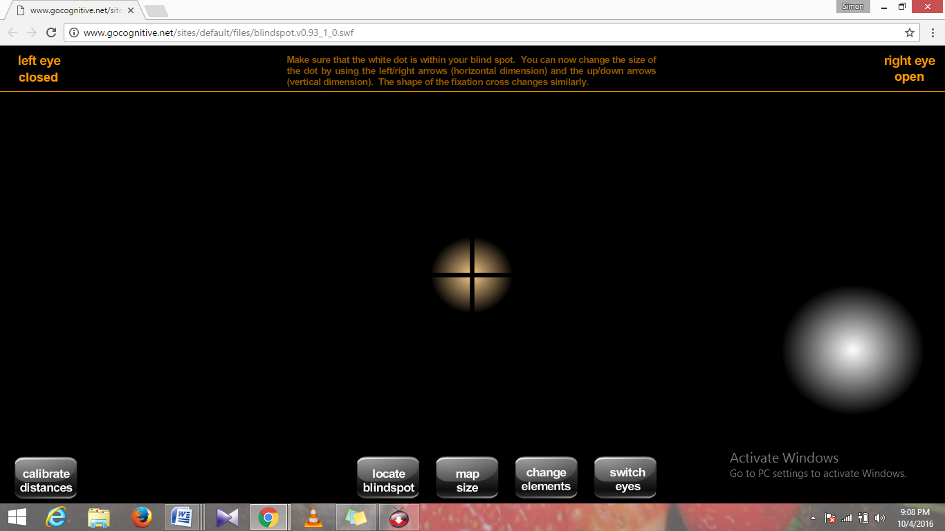
Participant 2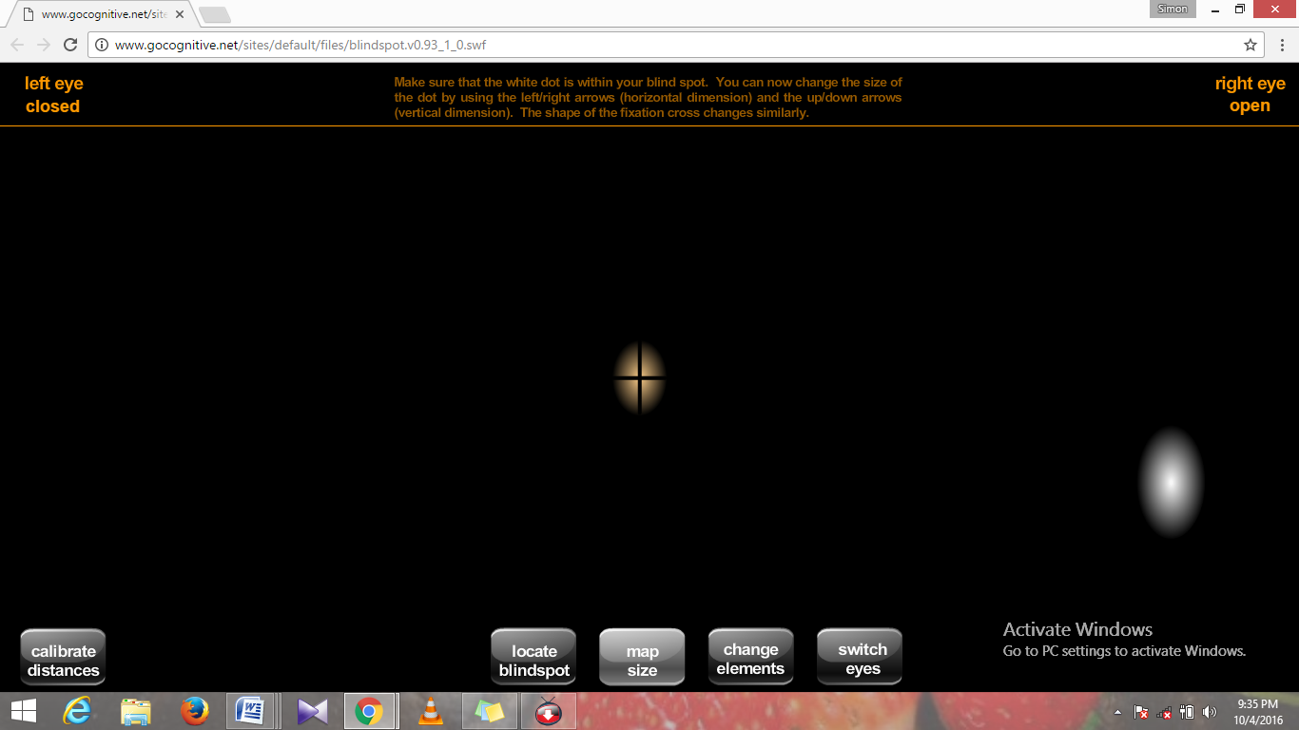

Participant 3
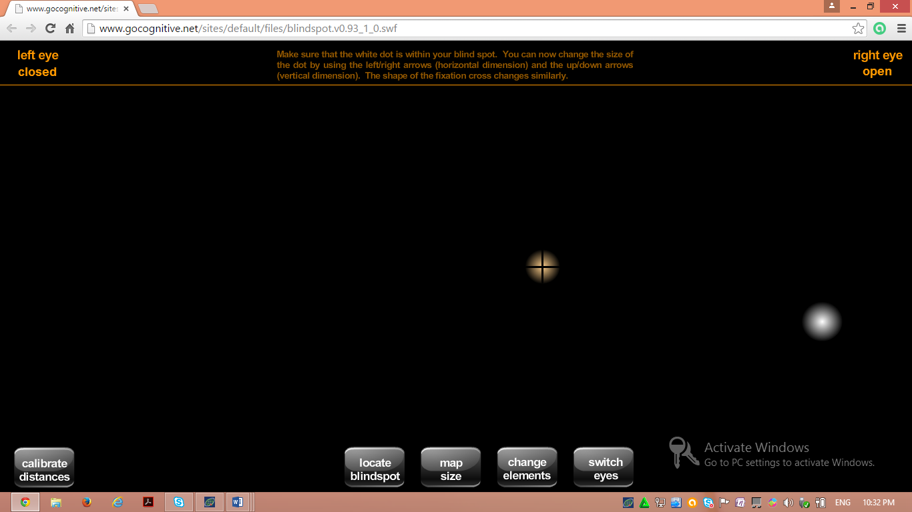

Table: Height and Width of the Cross and Average/ Corresponding Blind Spot Size
Measurement (cm) | Height (cm) | Width (cm) | Average [Size of Blind Spot] (cm)
Participant 1 | 4.0 | 4.3 | 4.15
Participant 2 | 2.5 | 1.5 | 2.0
Participant 3 | 1.3 | 1.3 | 1.3

Results
The size of the participant’s blind spots varied significantly [participant 1, 2 and 3 = 4.15, 2.0, and 1.3 respectively]. This means that each the blind spot of human beings are not the same but rather, differ from one individual to the next. This information supports the hypothesis that the size of the blind spot is variable in humans. Therefore, the hypothesis is correct.
Discussion
Knowing how the mind and brain work is important in determining one's area of the blind spot and its size which varies from one person to the other. Advances in contemporary psychology have made this possible. On this note, contemporary fields of psychology include biological, social, cognitive, behavioral neuroscience, developmental, clinical, as well as personality psychology (Introduction to Psychology: Unit 2 Module 2, n.d). This kind of experiment would be performed in the field of behavioral neuroscience because it focusses on the links between the mind, brain, and behavior, and likewise, this experiment focuses on how the mind and brain work.
The blind spot is a region within the retina that is not sensitive to light thereby making things invisible despite being within one’s visual field (Mind Lab, n.d). The eye has different components each of which plays a specific and vital role in our visual ability.
The eyes structure includes the Cornea which is transparent and at the forefront to allow light get into the eye through the pupil located at the middle of the iris. Once inside, the light meets the lens whose muscles adjust accordingly to focus light onto the retina. Here the image is created but is upside-down, and so its receptor cells to send this data through the optic nerve to the brain's the visual cortex where it is translated, and image presented upright (Introduction to Psychology: Unit 5 Module 10, n.d).
The quantitative variable refers to a quantity that can be measured numerically or in other words, quantitatively; while a categorical variable relates to a quality that can only be measured by assigning a categorical or group label to it rather than a numerical value. In other words, a quantitative variable is measured based on quantity while a categorical variable is measured based on quality. In the current experiment, my variables were quantitative and assigned numerical values.
An independent variable is a variable [quantity or quality] whose change is not determined by the change in another. On the other hand, the dependent variable is any variable whose value depends on that of another. In my experiment the size of blind spot depends on the eyes point of fixation. Therefore, the point of fixation is an independent variable while the blind spot is the dependent variable.
A population refers to the whole group that the researcher wants to learn about while a sample refers to a smaller group drawn from the larger population for ease of study and generalization because it would be impossible to study the entire population. Human beings are unique in their particular way and participants in my experiment are an excellent evidence of this. Despite subjecting them to similar conditions and measurements, each showed varying results - the sizes of the blind spot differed significantly among them. Therefore, the results derived from this sample can be used to generalize to the whole population, and conclude that the size of the blind spot is variable in humans.
References
Go Cognitive Blind Spot Test. Gocognitive.net. Retrieved 5 October 2016, from http://www.gocognitive.net/sites/default/files/blindspot.v0.93_1_0.swf
Introduction to Psychology: Unit 2 Module 2. Oli.cmu.edu. Retrieved 5 October 2016, from http://oli.cmu.edu/courses/free-open/introductory-psychology-course-details/
Introduction to Psychology: Unit 5 Module 10. Oli.cmu.edu. Retrieved 5 October 2016, from http://oli.cmu.edu/courses/free-open/introductory-psychology-course-details/
Mind Lab,. Illusion of an uninterrupted world. Jst.go.jp. Retrieved 5 October 2016, from http://www.jst.go.jp/csc/virtual/find/mindlab/english/index.html?utm_source=twitterfeed&utm_medium=twitter

