Student’s Name
Professor’s Name
Grade Course
Date of Submission
Midterm Artist Paper: Binh Dahn
Binh Danh is a Vietnamese-American artist of national renown. His extensive photographic works investigate the concept of memory, mortality, history, justice, evidence, landscape, and spirituality and have raised him into an artist of national importance. As a result, his work has been included in exhibitions ate museums all over the country. They have also appeared in the collections of The Philadelphia Museum of Art, the Harry Ransom Center, the George Eastman House, San Francisco Museum of Modern Art, the National Gallery of Art, and M.H. de Young Museum just to mention a few. Notably, his reputation goes beyond the national boundaries. He is represented by Lisa Sette Gallery in Phoenix, AZ and Hanes Gallery in San Francisco, and in 2012, Binh Danh was a featured artist at the eighteenth Biennale of Sydney, Australia (Binh Danh: Bio Np). This paper explores the artist in conjunction with his work.
Binh Danh employs a unique technique in his work. Although he confesses of taking some of the photographs on his visit to different places. However, the largest proportion of his work uses previous photos as he explores the main concept of war and its effects in Cambodia and mostly, Viet Nam. On this note, the artist takes a collection of photographs that were published during the war era and photosynthesizes them into modern pieces where the images appear imbedded in the leaves. He makes this possible through the chlorophyll printing process. This is a technique that is unique and almost entirely reserved for Dahn. However, he has incorporated the daguerreotype process in his latest body of work, but for purposes of this exploration, focus will be on the first primary process.
Dahn’s collection and reprocessing of photographs and other remnants of war bring new light to a history that is marked by sharp and painful memories. An excellent example is his “One Week’s Dead” series and the “Immortality, The Remnants of the Vietnam and American War” series (Figure 1 and Figure 2). Dahn got the images from an article that appeared in the 1965 Life Magazine that printed the faces of two hundred and forty-two young American soldiers who perished in the Vietnam War within a week. Nearly forty years down the line Dahn returns these faces back into the public’s attention using photosynthesis. The portraits are incorporated into the cells of grass and leaves which symbolize the jungle that is witness to the scars of war that are still present in the landscape (Figure 1; Figure 2).
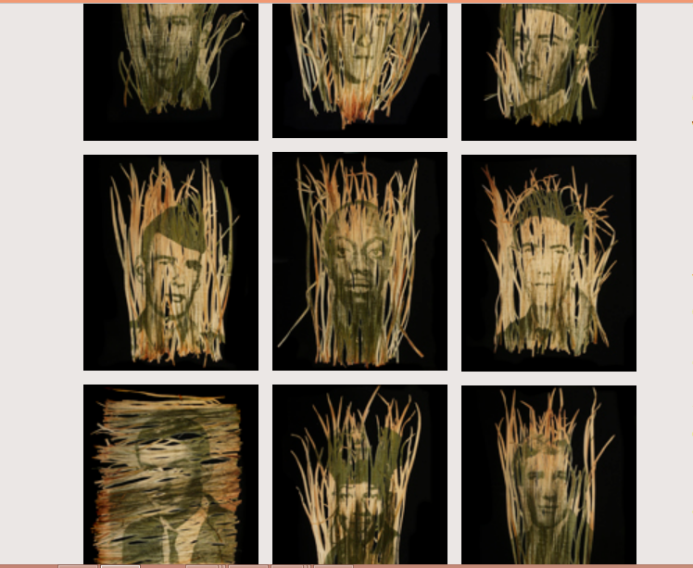 Figure 1
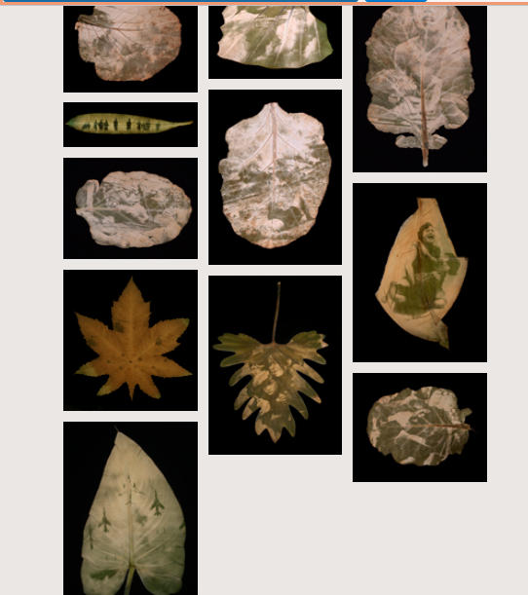 Figure 2

He bases his photosynthesis method in the simple principle of the effects of leaving a water hose on the lawn for too long. The cells in the grass and leaves react to the presence of light by turning dark green and pale when they lack the light. Photosynthesis is used to record the images onto the foliage by using light and chlorophyll which Dahn views as the life source of all the plants and consequently planet earth. The artist then casts the leaves “in resin, like biological samples for scientific studies” (Bin Dahn: Immortality, The Remnants of the Vietnam and American War Np). The faded colors present an inherent gentleness. The detail of the veins and lines permeating each image create a delicate yet painfully beautiful visual effect. The process is informed by the idea of composition and decomposition of matter into different forms, or in other words, elemental transmigration. Dahn tries to show that the remnants of the American and Vietnam War, like matter, cannot be destroyed but live on in the Vietnamese landscape forever (Binh Danh: Ancestral Alters Np).
Dahn’s life and history are directly linked to the images that he presents in his work. It is apparent that the artist uses his work to explore his Vietnamese heritage as well as the collective memory that the contemporary society may have of War. He tries to revisit the past that he may have been too young to remember but nevertheless impacted his life significantly (Guth Np). In works such as “Ancestral Alters” series, he uses the same photosynthesis-chlorophyll process to embed images onto leaves that explore his ancestral ties [family and land] (Figure 3).
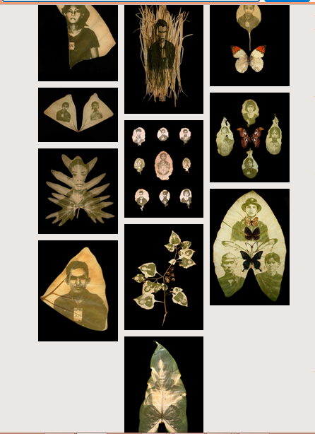 Figure 3
The artists create the images onto the leaves; not by actually printing on them, but by capturing the faces and events of the war within the leaves. By so doing, he encapsulates historical memory into the plant cells biological memory. Binh Danh seems fascinated by the events and history of war. He brings a new life and light into images that may have lost their place entirely if not revisited. In so doing, he does no only tap and elicits the memories of those who existed during the Vietnam America War period, but also the contemporary population who may not be aware of the events as they happened.
I chose this artist because his work fascinates me and moreover he makes me ponder over the significant events such as war and the adverse impact on the victims. I also like the artist as a person because he does not shy away from embracing his heritage and making other people know and appreciate it too. If it is creativity, Danh is an expert, and from him, art students have an important lesson to learn – that nothing is impossible as long as one puts his/her creative side to it, otherwise, who would have thought that art can be presented in the manner that Binh Danh does!

Works Cited
Guth, Laura A. "Binh Danh: One Week's Dead". Binhdanh.com. N.p., 2007. Web. 22 Oct. 2016.
"Binh Danh: Immortality, The Remnants Of The Vietnam And American War". Binhdanh.com. N.p., 2016. Web. 22 Oct. 2016.
"Binh Danh: Ancestral Altars". Binhdanh.com. N.p., 2016. Web. 22 Oct. 2016.
"Binh Danh: Bio". Binhdanh.com. N.p., 2016. Web. 22 Oct. 2016.

Appendix
Some Works By Binh Danh

