The NYTimes reported that in May 2013, Jackson Pollock’s Number 19 was sold for $58 million (including fees) amid aggressive bidding from several potential buyers. The painting had last gone for auction in May 1993 when it was bought by LVMH’s Francois Pinault for $2.4 million.

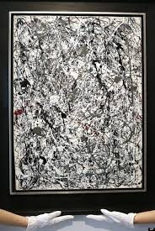

The supply of authentic Pollock paintings has not shifted since 1956 when he died.
Draw the supply curve (be careful) and shift in demand to explain how this price was reached.

