Assignment 1
ResMarket Pty is a Sydney based market research firm. The company has decided to adopt new technologies to enhance their marketing research activities for their clients and to remain competitive in the market. However, there are still scepticisms because of the cost of the technologies. You have been asked to prepare a report to submit to the management focusing on “The impact of technology on marketing research in today’s business environment.”

This report should be persuasive and should identify what the company stands to benefit if they adopt these new technologies into their operations.

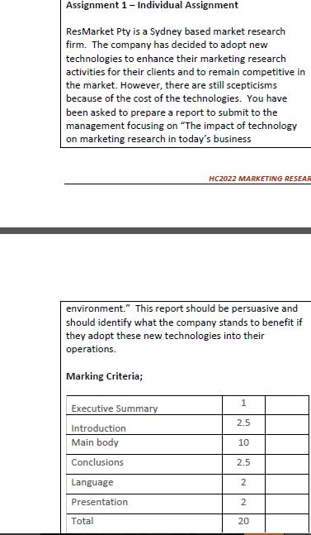

Please see the attached file of this assignment and make it accordingly. the assignment should not be more than 1000 words and references should be Harvard style and references must be online link that can be viewed online. This assignment should be according to the uploaded file there should be Executive summary, introduction, main body and it should be good presented on the given topic.

