Godiva Report
Student’s Name
Institution Affiliation

Godiva Report
PESTLE Analysis
PESTLE Analysis is a system that is utilized to scan the external factors influencing the operations of an organization. PESTLE normally stands for political, economic, socio-cultural, technological, legal and environmental factors (Mühlbacher, Leihs & Dahringer, 2006).
Political Environment
The political variables concentrate on the stability of the political condition and the state of mind of political parties. Godiva Chocolatier has to comply with the regulations set by the government that includes health, safety and workplace and sanitation (Hasan, 2013). Additionally, the company has to label its products according to the regulations. The franchise operations need to follow the registration and disclosure laws. Moreover, the firm has to comply with the laws on taxation in the parent and franchise countries. Taxes affect the management of the company's products. For example, if the parent country increases its Value-added tax, the prices of chocolates will rise. Due to the elasticity of the products market, the sales will reduce and vice versa
Economic Factors
All organizations are influenced by national and global financial conditions. Factors such as the interest rates and fiscal policies affect the prices of Godiva's chocolates. Additionally, the economic conditions determine how consumers, suppliers, and stakeholders of the company behave. During a recession, the consumers of Godiva's products will have a lower purchasing power that will reduce their spending on luxurious items such as the company's chocolates. Economic factors will affect even the competitors of Godiva. Therefore, the firm will need to act accordingly. Also, the sale of chocolates is normally seasonal during holidays such as Christmas, Thanksgiving, and valentines that affect the prices of these products since demand is high.
To penetrate the market, Godiva business will need to be well-informed of the financial conditions across all borders to employ strategies that will secure and advance the business through different economic conditions.
Social Factors
Social environment concentrate on powers inside the general public, for example, family, companions, partners, neighbors and the media (Mühlbacher, Leihs & Dahringer, 2006). Through social forces, companies can meet the attitudes, interest, and opinions. These factors affect who consumers are and the way they behave while purchasing. In the UK people have shifted to organic and less sugary foods leading to a decline in the market share for Godiva. Additionally, changes in population affect the supply and demand for goods and service. For this reason, Godiva focuses on cities and towns where population density is high especially for the youth and teenagers. Godiva also needs to concentrate its stores in places that have high lifestyle customers since they are price insensitive and focus on status and image.
Technology Factors
The advancement of technology has enabled the firm increase its sales. The company uses technological infrastructure such as the internet and social media sites to market its products and services to potential and existing clients. Additionally, customers can shop for the Godiva chocolates online and receive them within hours. Food technologists have given a new impulse to chocolate by adding natural additives to the chocolate recipes. The advancement of technology has enabled the company package the chocolates in attractive boxes that adds beauty and desire to purchase for the customers.

Porter's Five Forces Framework
The tool is used to analyze the attractiveness and profitability of an industry (Magretta, 2012). The competitive environment for Godiva will involve the competitors in the chocolate industry. The company has to consider the following factors
Threat of New Entrants
The threat of new entrants in the chocolate industry is not high even though Godiva operates on a small scale basis. A new entrant can take advantage of producing in large scale. Additionally, the process of making quality chocolate is easy and only requires on specialist, but the business will need large sums of capital to complete a producing line. Furthermore, funding the fixed and variable costs is high, and the distribution of the products is complicated due to considerations of temperature and damage during transportation.
Bargaining Power of Suppliers
The bargaining power of the suppliers of Godiva is high. The raw materials of the company's chocolates come from South America, Africa, and the Middle East. Godiva uses high-quality cocoa beans that are difficult to find. Therefore, once they select a supplier, they have to maintain the relationship. In this case, the supplier can alter the price of the raw materials or sell them to Godiva's competitors.
Purchasing Power of the Consumers
Godiva uses product differentiation and diversity to keep the bargaining power of consumers low. The packaging and variety of flavors make the company the number one choice for the buyers. Additionally, they focus on the creation of surprising, passionate and exciting brands.
The Threat of Substitutes.
The market for Godiva chocolates is full of producers with competitive products. However, the company still has a stable market share since it has been able to position itself away from the competitors by providing luxurious brands. Additionally, their products have designs and tastes that are unique, yet their price range is not too expensive. Godiva considers its substitutes to be high-end chocolate brands such as Leonidas and Guylian. This makes the threat of substitutes to be high
Industry Competitors
There are few industry competitors for Godiva UK. The products of the company are more differentiated compared to those of the competitors, and their pricing is a bit low to cater to a wide range of customers. The company has more than 450 stores and up to 1000 retail shops that take up a sizeable market share. Therefore, the exit barrier for the business is low.
VRIO Analysis
The tool was developed by Barney J.B in 1991 to identify the four attributes of a firm’s resources to maintain competitive advantage (De Kluyver, 2010). According to him the resources of any company should be valuable rare imperfectly imitable and non-substitutable. When considering Godiva UK, the resources of the company are valuable since they enable the company to exploit new opportunities and defend itself against threats such as existing in a saturated market and high competition. Furthermore, Godiva's resources are considered valuable since the product line can be extended and be differentiated. This increases the value of the customers. The products of Godiva have different price ranges that render them marketable in different markets and different market situations
Additionally, the resources are rare especially the raw materials used by the firm. They use high-quality cocoa beans that can only be acquired by few companies. This creates a competitive advantage for the company. It is very costly to imitate Godiva's products at a lower or reasonable price. Acquiring the same raw materials and fixed costs of producing the chocolates would require a competitor to increase the price since the cost of production is high. Also, the resources of Godiva are organized to capture value. The firm has organized management systems, processes, policies and organizational structure that have enabled it to open over 1000 retail shops and stores.
To use the VRIO analysis, the company has to focus on its SWOT. The main strengths of Godiva are strong reputation, good market share, and quality products. However, the firm has several weaknesses such as the decline in sales especially in low-income places and lack of advertising. The firm's opportunities lie within the extension of the product line and the high demand for chocolates. However, Godiva is faced by a saturated market for chocolates that leads to inflation of prices and high competition.
Bowman’s Clock or Porters Generic Strategies
The Bowman’s strategic clock shows the options of strategic positioning for a firm (Kumar, 2004). Therefore, it focuses on how a product should be positioned to make it competitive in the market. The clock is shown in figure 1 below.
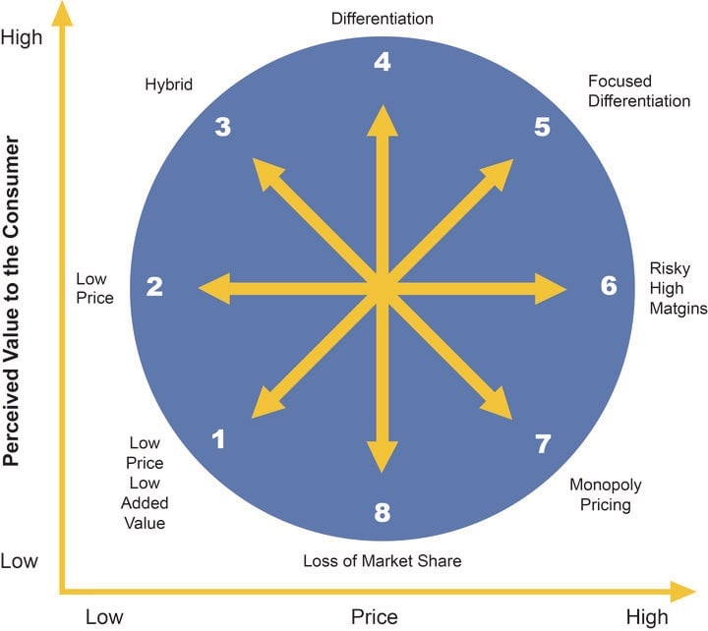

Godiva UK mainly falls under stage four known as differentiation and stage five that has focused differentiation. The company produces products that have unique attributes regarding flavors, tastes, and designs. This brings values to the customers. The differentiated products also have a high-perceived value from that of the competitors making Godiva have a competitive edge. The businesses brand is well-known for high quality and premium prices for the wide array of products. In the elastic price markets, the firm offers focused differentiation whereby the products are perceived to be of high value, therefore, have high prices. Godiva's chocolates are perceived to be wow and luxurious. Therefore, the prices are high especially in markets such as Europe and some parts of the USA. This enables the company acquires high-profit margins.
Strategic Directions for Markets, Products, and Services
Godiva has over the past used strategies for market penetration, product development and market development that have to enable it to remain competitive in the saturated market (Baker, 2012). The company offers special promotions especially during holidays such as mother’s day, valentines, Christmas and thanksgiving. This helps in retaining the existing customers. Additionally, from time to time they offer discounts to clients who purchase in bulk as a strategy to penetrate the market. Moreover, the firm keeps creating a variety of products for their already existing clientele. This involves innovating different flavors that are incorporated into their recipes and improving on the packaging colors, shapes and sizes to add value to the chocolates as seen in figure 2. Through this strategy, the profit margins for Godiva are always high since clients are always looking forward to purchasing a different and exciting flavor of chocolate. Godiva also uses market development strategies when focusing on new markets with the already existing products (Baker, 2012). The company has diversified its market to supermarkets and retail shops, unlike the initial strategy that focused on the company's stores. They have been able to acquire new markets in shopping malls and bakeries.
Figure 2


Methods of Expansion Used by Godiva UK
Godiva uses different methods of expansion across the globe. The firm mainly uses franchises whereby the franchisee pays a fee for the franchise and adheres to the set standards of the company (Hoy & Stanworth, 2014). This helps the company as the franchising company advertises the products and increases brand recognition. Additionally, in some countries, Godiva uses direct investments whereby it owns a company overseas. This enables the business has full control of the operations and quality of the products. These two strategies have enabled the firm to diversify its market and increase its profit margins.
Recommendations
For Godiva to penetrate through new markets, it will need to use segmentation strategies that relate to the income and behavior of people. The firm will need to increase its stores in the new emerging markets such as Singapore, China, and Korea since such countries have upcoming professionals who earn incomes and are willing to spend their money on luxurious goods. Additionally, Godiva has been marketed in retail stores and shops alone. The company will need to use the internet, magazines and social media sites to market the variety of products to different customers. They can also use TV and radio adverts to draw attention to the targeted audience. Moreover, the business can produce quality chocolate at lower prices to target the middle-income earners, especially in the new emerging economies. This will increase the profit margins for the firm,
Conclusion
The comprehensive analysis of Godiva's products shows the marketing analysis and strategies used for the sale of products. The company needs to focus on the macro and microeconomic environment to remain profitable in any market. Additionally, the focus on the strengths, weaknesses, threats, and opportunities have enabled the business to create a wide array of products that are valuable, rare and inimitable. Furthermore, the organization has been organized in its processes and management that has increased its competitive advantage. The firm needs to focus on incorporating the product and promotion strategies to increase their market share. Godiva chocolates are for high-end customers, therefore; their prices are high. Therefore, the company competes with other expensive brands such as Guylian. The focus for Godiva is usually on differentiation to increase the value of their products. However, the company can diversify their market by producing cheaper chocolates to new emerging markets since it will increase growth.

References
Baker, M. (2012). The Marketing book. Abingdon: Routledge.
De Kluyver, C. (2010). Fundamentals of global strategy. [New York, N.Y.] (222 East 46th Street, New York, NY 10017): Business Expert Press.
Hasan, M. (2013). Apple Inc. - An Analysis: PESTEL analysis, Porter’s 5 Forces analysis, SWOT analysis, Comprehensive analysis of financial ratios, and Comprehensive analysis of share performance of Apple Inc.. Munich: GRIN Verlag.
Hoy, F., & Stanworth, J. (2014). Franchising: An International Perspective. Abingdon: Routledge.
Kumar, N. (2004). Marketing as strategy: Understanding the CEO's agenda for driving growth and innovation. Boston: Harvard Business Press.
Magretta, J. (2012). Understanding Michael Porter: The essential guide to competition and strategy. Boston, Mass: Harvard Business Review Press.
Mühlbacher, H., Leihs, H., & Dahringer, L. (2006). International marketing. London: Thomson Learning.

