Name of student
Name of tutor
American History
8 February 2017
North Korea VS South Korea
The rich culture and deep history shared between North, and South Korea have always drawn worldwide interest in the form of criticism and admiration alike. For almost five decades now, the two nations which were once one country have been caught up in a quagmire of bitter rivalries and strained relationships. In fact, to this day the two Asian countries technically remain at war after an armistice that was reached following the end of the Korean War that was sparked by political as well as ideological differences following the end of the Second World War. As such, North and South Korea tend to share quite some similarities and differences almost in equal shares. This essay attempts to shed light on these comparisons by focusing mainly on infrastructure and architecture found in the largest cities of these nations which are Pyongyang for the North and Seoul for South Korea.
Whereas Pyongyang is a city established on socialist political ideologies, Seoul has its foundations rooted in capitalism. As a result, the two cities have stark differences that can be seen in their architectural design. Of these differences, perhaps the most distinct is the facts that whereas Pyongyang is characterized by old buildings and designs that reflect on their communist culture and decades of authoritarian regimes, the city of Seoul is shaped up by modern buildings with numerous skyscrapers and commercial hubs that show the profound western influence on the city. An example of such a construction in the North is the Grand Monument on Mansu Hill which is dominated by soviet style architecture (Ahn, 38). In Seoul, on the other hand, there are quite a number of tall modern buildings such as the Samseong-dong Korea world trade center (Jeong, 273). The two buildings are shown below: 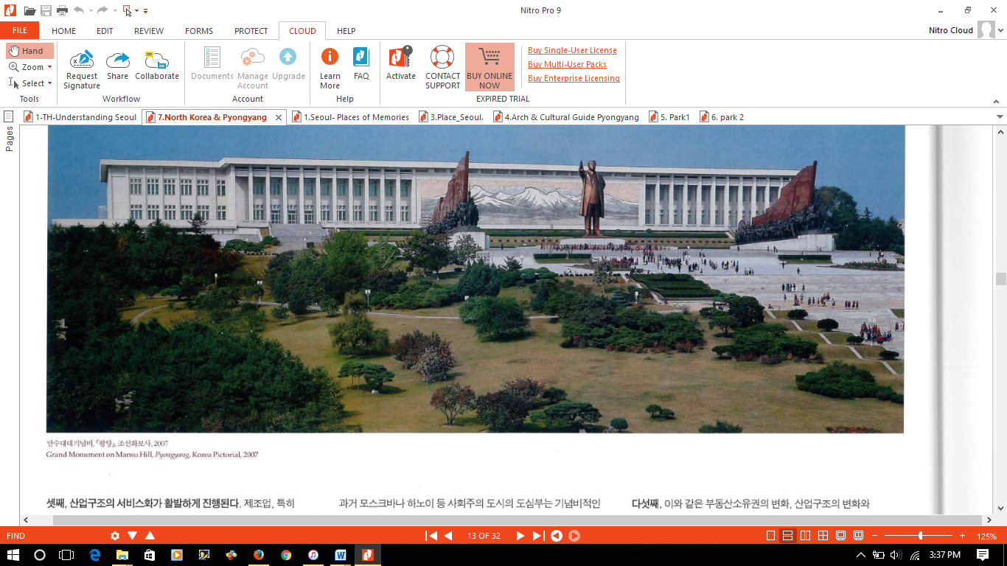
Grand monument on Mansu Hill, Pyongyang, Korea pictorial, 2007
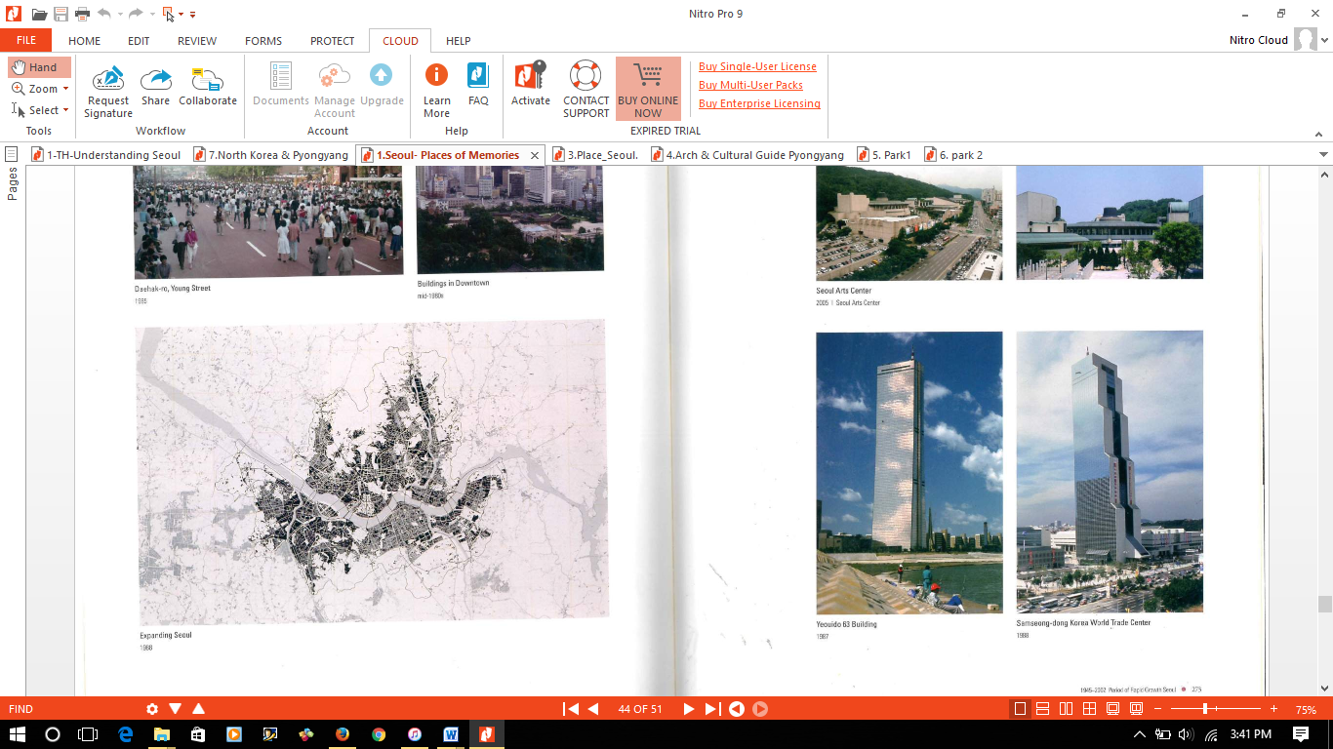
Samseong-dong Korea world trade center, 1988
Another difference is that while the city of Pyongyang has numerous imposing nationalistic monuments that tend to provide an incentive to the residents on their political affiliations, Seoul is mainly lacking in these monuments and instead only has culturally significant buildings or monuments that symbolize the city’s heritage. An example which reflects on this contrast is the party foundation monument in Pyongyang which is a classic socialist symbol (Meuser, 40) and the monument of King Sejong in Seoul in comparison. The photos below show this contrast in detail.
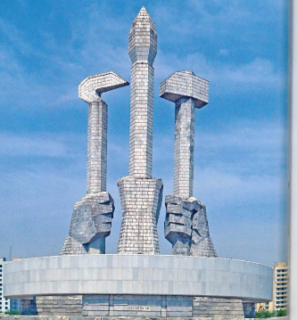
The party monument features the three pillars of society; workers (hammer), peasants (sickle) and intellectuals (calligraphy brush)
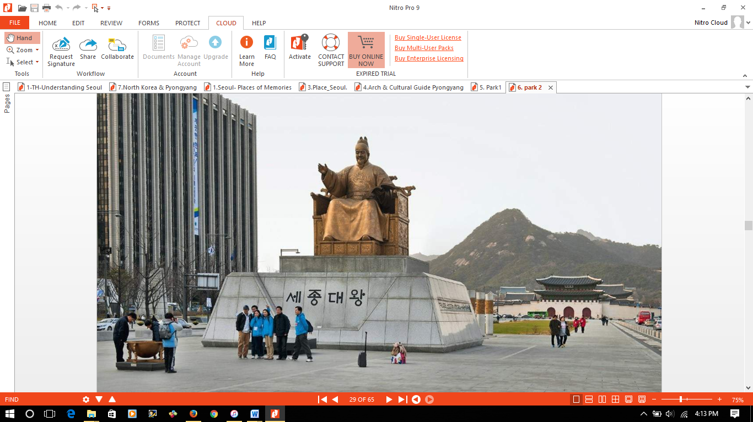
King Sejong the Great of Joseon
The architecture of Seoul is also characterized by religious buildings such as churches which is in direct contrast to Pyongyang where religion is not exactly encouraged and instead the population is urged to look up to political figures such as the founding fathers. This contradiction is clearly depicted by numerous monuments of the first leader of North Korea lining the streets of Pyongyang whereas in Seoul there are a number of churches including the ancient Myeongdong Cathedral built in 1898 which has been modernized.
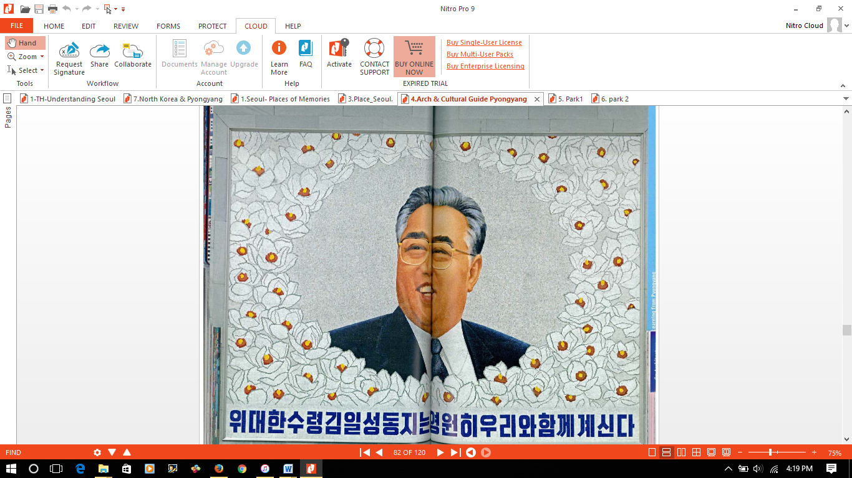
Wall Mosaic in a parking lot with the caption; “Our great leader Kim Il- Sung is with us as our comrade forever.”
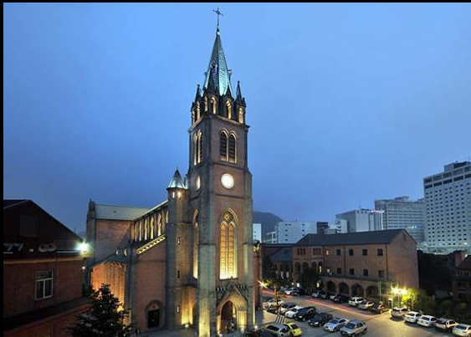
Myeongdong Cathedral, today.
Despite all these differences between these, some similarities that characterize the landscape, as well as the architecture of Seoul and Pyongyang, are also evident. This is mainly due to geographical, historical as well as political factors. An example of a similarity that is as a direct result of the geographic location of the two cities is the fact that there are major rivers that flow through both cities. The city of Pyongyang is graced by the Taedong River (Ahn, 43) whereas in Seoul there is the Hangang River (Kyung-Koo, 32). These rivers have proven to be a source of economic growth for both cities with their developments revolving around the water bodies. In both Seoul and Pyongyang, numerous development projects have been undertaken along the shores of these rivers to change the faces of the cities. For instance in Seoul, there is the Hangang Park (Jeong, 275); whereas in the North there is the Juche Tower (Ahn, 43).
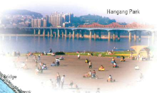
Hangang Park;a recreational facility along River Hangang.
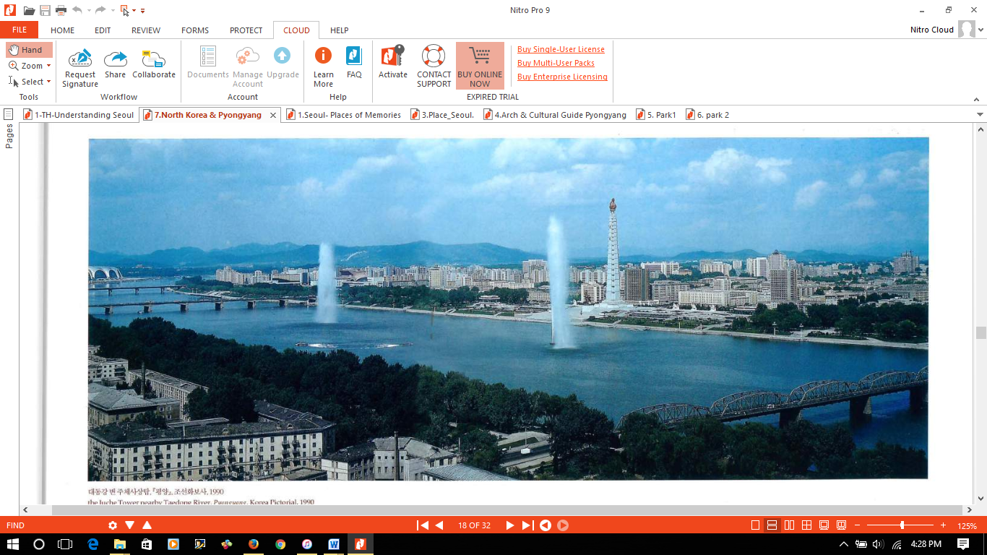
The Juche Tower, near Taedong River, Pyongyang, 1990
Another similarity between Seoul and Pyong is ironically based on architecture. This is seen at two broad levels. On one level there is the the\ resemblance of monumental structures such as historical palaces between the two cities, and on another level, both cities are characterized by distinct modern buildings that stand out defiantly in a bid to show dominance and architectural superiority. The reasons for these similarities are both historically and politically motivated.
According to history, both cities were once part of the same nation and as such had adopted a similar type of architecture. To this effect, although there has been modernization especially in Seoul, there are still palaces such as Gwanghwamun gate in the south and people’s palace of culture in Pyongyang (Ahm, 40) that show an ancient similarity in the culture of the two cities.
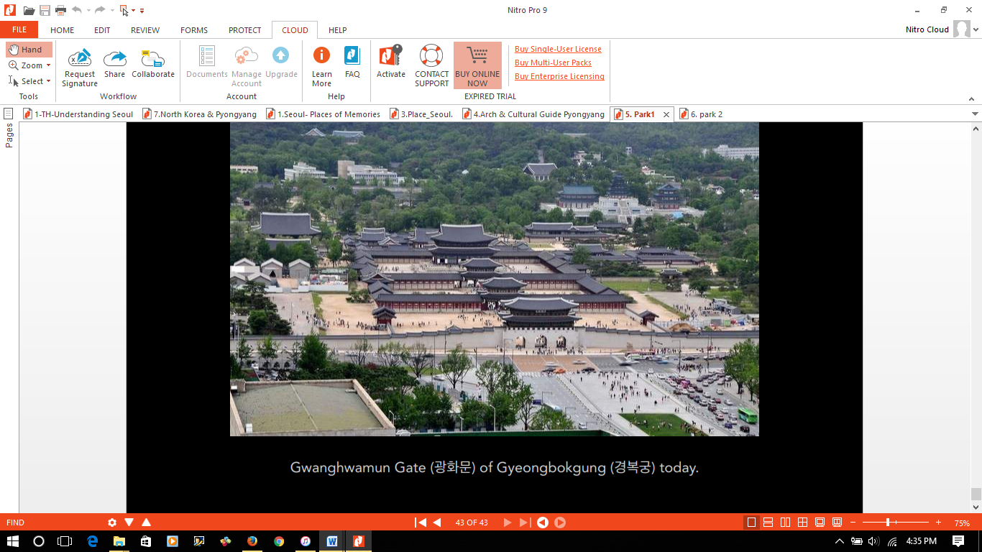
Gwanghwamun gate of Gyeongbokgung today
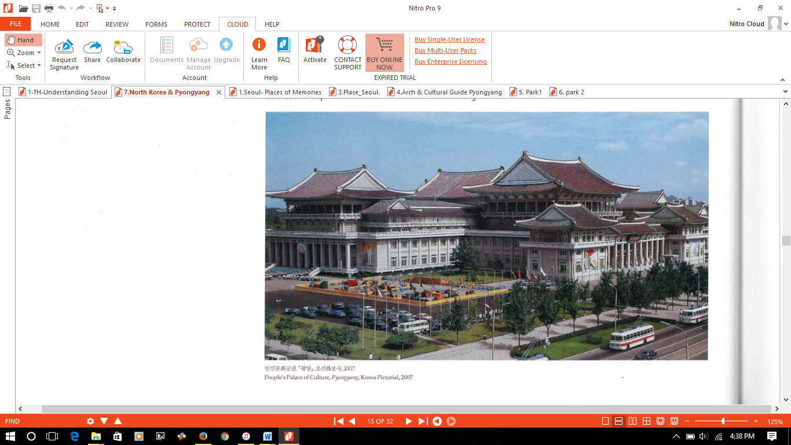
People’s Palace of Culture, Pyongyang, 2007
Both cities are also characterized by isolated dominant buildings that dominate the city skylines in a bid to show superiority. This is mainly because of political reasons and the dark history between the two nations. Since the separation of the two Koreas, there has always been a spirit of competition between the two countries with each trying to prove to the other that they have always been right by history and indeed is well off independently. This rivalry has given birth to unique architecture in both cities designed to make a point. In Pyongyang for instance, there is the arch of triumph to symbolize victory over the south whereas in Seoul the current town hall reeks of architectural elegance and also sends a message to the neighboring north.
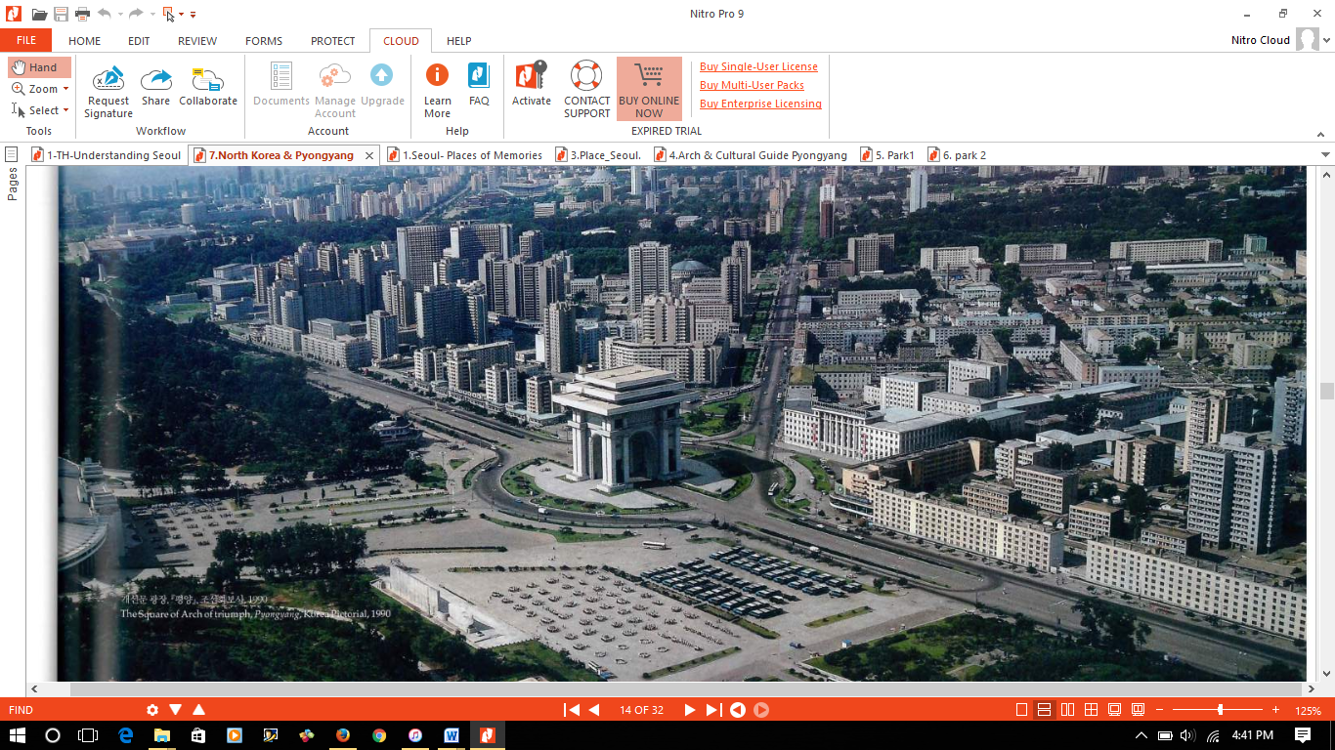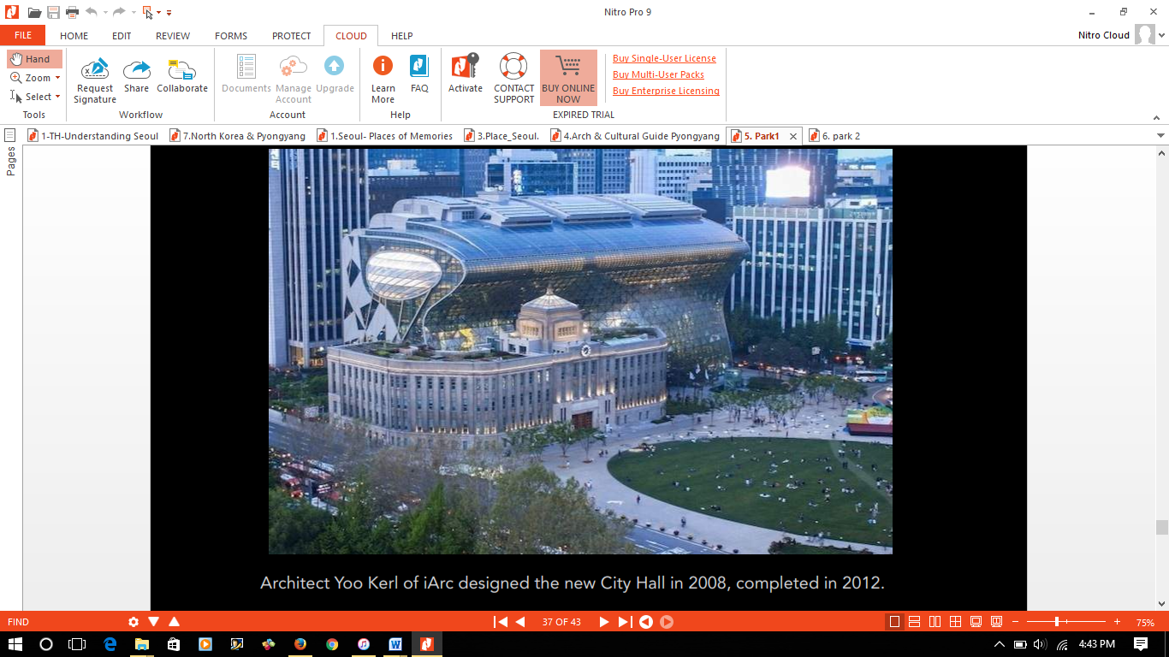
Arch of Triumph, Pyongyang today Seoul city Hall, completed 2012
Based on the above insights and analysis of two of fascinating cities in the eastern hemisphere today, some deductions and conclusions can be made. The differences that are existent in these two cities that were part of the same nation a mere five decades ago clarify the fact that the policies and ideologies adopted by people can significantly affect and influence changes within a short period whether positively or otherwise. The similarities, on the other hand, show that in spite of political orientations and social orientations, identifying with a particular culture and heritage is important lest people forget where they are coming from. All in all, it is clear that both Pyongyang and Seoul are unique cities that have shaped the cultures and perspectives of the Korean people.
Works Cited
Ahn, Changmo. "The Ideal and the Reality Etched into the City and the Architecture of Pyongyang." SPACE 543 (2013): 26-35.
Jeong, Jae-Hoon, and Kyung-Hoon Lee. "The physical environment in museums and its effects on visitors’ satisfaction." Building and Environment 41.7 (2006): 963-969.
Kyung-Koo, Han. "The archaeology of the ethnically homogeneous nation-state and multiculturalism in Korea." Korea Journal 47.4 (2007).
Meuser, Philipp, ed. Architectural and Cultural Guide Pyongyang: Backgrounds and Comments. Dom Publishers, 2012.

