American Airlines
Week 4
Details:
Read "American Airlines," located in Chapter 24 of the textbook, Managerial Economics: A Problem Solving Approach. American Airlines announced a new pricing strategy that they believed would address concerns and benefit the company. Conduct further research on American Airlines' value pricing. Analyze American Airline's structure and decision to implement value pricing and discuss the following (750-1,000 words):
- Discuss the decision behind American Airlines developing and implementing value pricing to gain more market shares.
- Evaluate the impact competitors and additional economic factors had on the results of the value pricing strategy. What factors contributed to the advantages and disadvantages of this new pricing strategy.
- Provide alternative recommendations to the value pricing strategy that would result in a different outcome when implementing the strategy.
Prepare this assignment according to the guidelines found in the APA Style Guide, located in the Student Success Center. An abstract is not required.

American Airlines
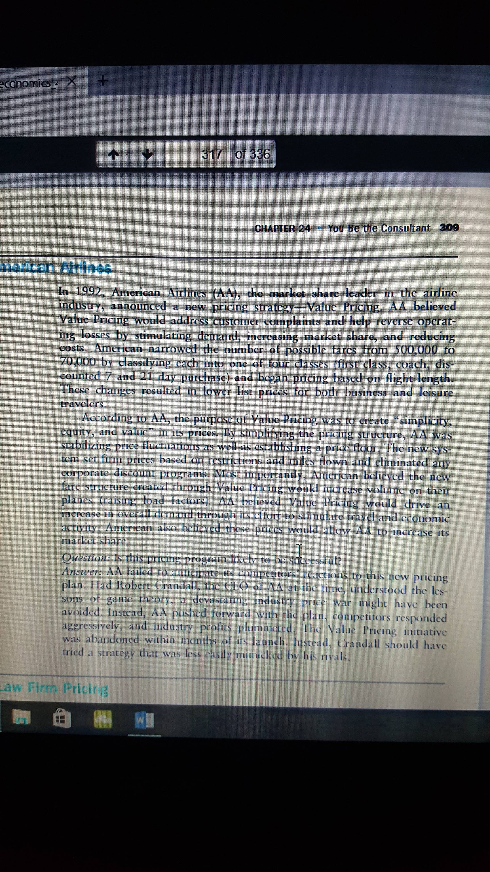
American Airlines

Introduction
In 1992, American Airlines decided to bring a radical change to its pricing strategy. It introduced- value pricing, a plan to simplify its pricing, increase occupancy on its aircrafts, and be more competitive. This was in response to the consumer perception of an extremely complicated and unpredictable pricing mechanism. Prices would often depend on early bookings, and jacking up at the last moment, or during peak season. In other words, the company aimed to leverage pricing as a differentiator. The idea of value pricing was to have only 4, clearly demarked pricing slabs- First Class, Coach, discounted 7 and 21 day purchase) and price the flights basis the lengths. This would eliminate any corporate or other discounts, and make pricing more consistent for the flyers. The expectation was that the users will like a pricing structure which was dependent on lesser factors and assured a certain level of services. As a result, they will choose American Airlines over other players (Maxon, 1993).
Impact of value pricing
However, the outcome was not as planned by the company. In the initial days, it attracted a large number of flyers, pulling away traffic from other players, provided cheaper travel for flyers, but turned out a nightmare for the company. American Airlines not just lost $251 million in the next two quarters but also had ‘predatory pricing’ lawsuits filed against it by the competitors. Even though the company could absorb these losses due to its deep pockets, the pricing had to be withdrawn soon after.
The pricing also impacted the competition in a big way. There were not many airlines with as deep pockets as American Airlines. They had to renegotiate their terms and lower down the interest rates/expectations from their investors/lenders, aircraft lessors, and issue paycuts to the employees. There were also a few companies that had filed for protection of bankruptcy law and decided to extend this tenure. (McDOWELL, 1992)
Apart from this, the competitors responded with further lowered prices, at times even at the cost of losing out on their own margins. The reason for this was that nobody wanted to lose on their market share because once the customers experience the other airline, it is hard to get them back to your carriers. As a result, the collective revenue losses for the industry were about $1.5 billion. It was more of a self-destruction game started by American Airlines which forced other players to follow the suit and propagate the collateral damage.
The impact was not only limited to American Airlines and its competitors. Even the customers were deeply impacted by it. Though they reaped the benefits of this price war, they never felt totally satisfied. The typical belief amongst consumers was that they did not get the best price and could have got a better deal, had they chosen a different player. This brings down the brand loyalty as the customers are always looking for the cheapest prices. On the other hand, the price war forced the players to often compromise on user experience. This started a vicious cycle of low prices-low service quality, lower satisfaction and loyalty. (Rothman, 1992)
Alternative Recommendations
- Instead of initiating a price war, American Airlines should use its deep pockets to build and communicate the value to the consumers. So, instead of differentiating on the basis of lower prices, the company should look for engaging with the target audience and tell them what they can get for a specific price.
- Airlines is a capital intensive business. No airline is suggested to acquire market share at the cost of its profit margins. This is not a long term sustainable practice. Instead, the company should look to optimize its operational costs and use mark-up pricing (with a competitive mark-up on its cost). This will also simplify the cost structure for the company and will help it to ascertain its pricing in a better way.
- Do not completely discard the discounts and festive offers. These are a good way not only to lure the consumers with lower prices but also to sustain the conversation with them. Hence, the company needs to be creative with its discount offers so that it can compete both, on price front as well as consumer engagement.
- Allocate funds for brand communication with clearly measurable business goals. One of the activities here could be to have a consumer survey to understand why they choose or reject an airline. The findings of this survey can be used for further deciding the pricing strategy of the company with a better rationale.

References

Maxon, T. (1993). American Price Wasn't Right For Airlines. Retrieved from mcall.com: http://articles.mcall.com/1993-01-03/business/2909615_1_value-pricing-american-airlines-three-airlines
McDOWELL, E. (1992). Air Fare Plan Fails, American Admits. Retrieved from The New York Times : http://www.nytimes.com/1992/10/17/business/air-fare-plan-fails-american-admits.html
Rothman, A. (1992). The Airline Mess . Retrieved from Bloomberg: http://www.bloomberg.com/news/articles/1992-07-05/the-airline-mess

