Student’s Name
Professor’s Name
Course
Date
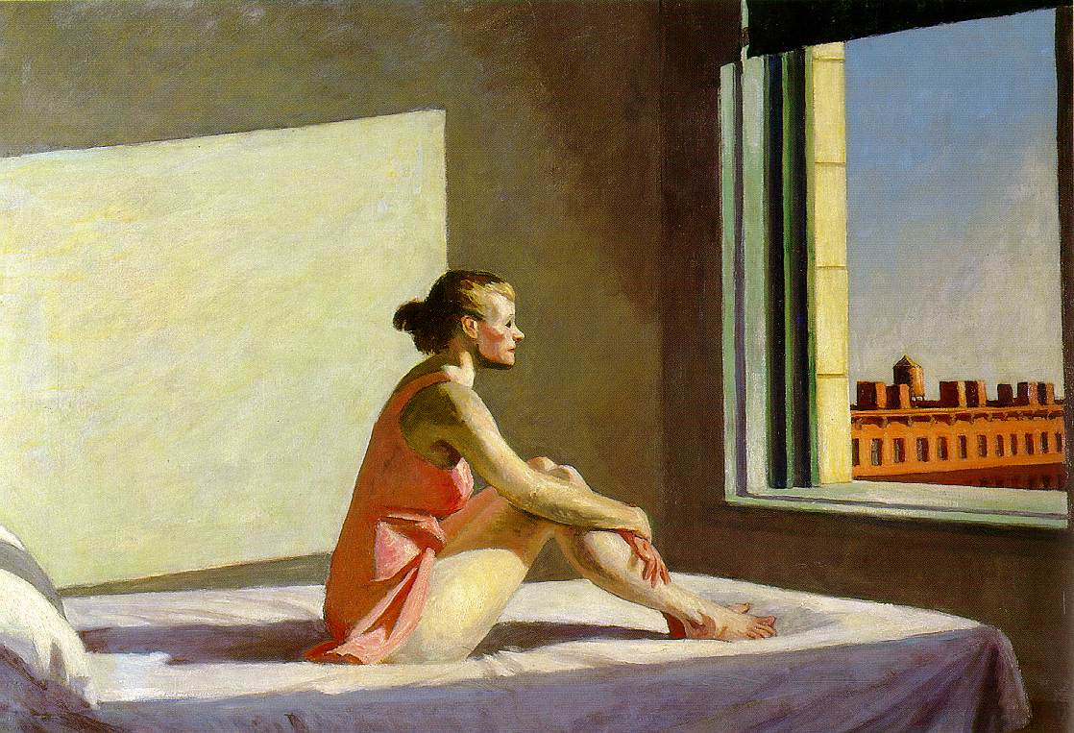
Edward Hopper: Morning Sun (1952)
Most artists develop their biographies based on the creative forms and imagery of their own imaginations. This is sometimes achieved unconsciously or intentionally. For Edward Hopper, his works follow the same ideology of self-representation. The following paper aims at visually analyzing his 1952 painting Moring Sun. Hopper’s 1952 Morning Sun painting tells a tale of self-representation in terms of the inner-self as well as the interior vs. the exterior and his relationships with his wife.
Hopper’s painting portrays a woman sitting upright on a well-made bed as she stares keenly and calmly outside the open window. The morning sunshine fills the room through the window, scraping the woman’s figure and straight to the bare wall behind (Hopper 1). From the visual portrayal of the woman, she is an elderly woman not a young female. This makes it obvious that it is an illustration of Hopper’s wife, Josephine who by the time the work was created was about 68 years old while hopper was in his 70s (Theophanidis 1). The distinct lack of detail on the face of the woman tells of a psychological influence added to her facial expressions of ambiguity. So this is not as much as a visual expression, but a hidden psychological issue illustrating the self or inner-representation of the artist. Hopper’s wife is the model in the painting and her representation seems rather regretful for the artists, but it is something he meant to express or tell the world in an intentional manner. Hopper is known to have had a difficult relationship with his wife (Theophanidis 1). Therefore, the long shadow that is behind or in the back of the figure is a symbolic feature. This represents what has becoming of his life losing his only lover and his only presence can be felt only in her shadow. It illustrates the powerful nature of or power of the woman as his wife to which the painter had submitted since their marriage. This tends to illustrate his well-founded, but challenging relationship with his wife. As an artist, Hopper did not hide his existentialism. He specifically used his wife as the model of the painting to express himself as a free and responsible agent acting out of his free will. The shadows and lack of detail on the female figure or tell a story of self-representation for Hopper. However, the color pink on her short dress reminds depicts Hopper’s love or romanticism with the female figure, meaning it is someone he cherishes in his life.
The light used is also a critical symbolic effect used in the painting. The light assumes the leading role as observed in some of his other works making a kind of exaggeration. It illustrates the mood and environment in the exterior as bright and shining in the interior, where the woman is in a sad or solitude state as though almost reaching out to the audience. The reddish color on the woman’s bare hands and legs is also an illustration of the lighting effects from the morning rays (Hopper 1). The casting of the shadow in a long unending posture also depicts that its early morning and the woman just got of her bed, made it and then sat their upright with a shallow gaze. With her hands crossed on her feet, her gaze talks of a psychological influence or deep thought. Perhaps the woman is lost in another world wondering of the realities of the new America. The exterior may have changed so much especially in the American society from industrialization to the middle class. It seems as though time has caught up with her and she is transfixed with the realities of today and what she knew as America in earlier times. In fact this seems to represent the status of women in the modern America where they faced increased prejudice as well as discrimination. Having come from her slumber, on waking up she must have had a big thought that just couldn’t go away in the morning. Hooper would later die in the 1960s meaning that this was a time in his life he had time to reflect on his past and experiences throughout life. Focusing on his wife seemed an important aspect of telling his story and coming to terms with how he lived. Overall, the painting offers an interesting mixture of emotions, themes, and self-expression. Moreover, it is a sort of a biography, but only on the part of Hopper’s relationship with his wife.
In conclusion, Hopper’s Morning Sun is both intriguing and complex. It offers the self-representation of the artists as either a dedication or expression of his life. Hopper seeks to illustrate himself as a free and responsible agent in his own way or creativities. The use of lighting falls in his style of art and offers a great deal of detail in the painting. Moreover, the shadows and expression of the female figure illustrates the complex relationship between Hopper and his wife. Nonetheless, her gave to the outside is also a feminist symbol and the changing American society.
Works Cited
Hopper, Edward. Morning Sun. Columbus Museum of Art, 1952.
Theophanidis, Philippe. Studies for “Morning Sun” by Edward Hopper, 1952. Aphelis. 11 Sept. 2014. Web. 8 Jul. 2017. < http://aphelis.net/studies-morning-sun-edward-hopper/>

