Advertisement and Media Kit Review
Student’s Name
Institutional Affiliation

Advertisement and Media Kit Review
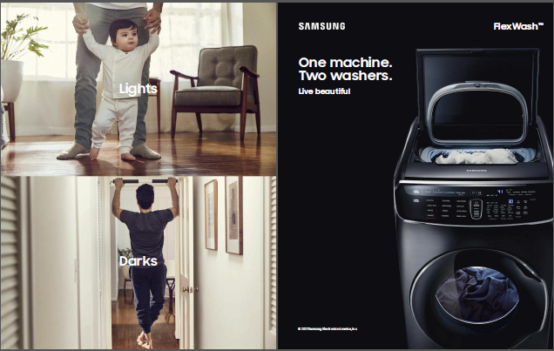
Food Network Magazine print ad.
The following paper aims at conducting an advertisement and media kit review of a print ad from a magazine. The name of the product being advertised is the Flexwash Samsung washing machine featured in the Food Network Magazine in the June 2017 issue.
The advertisement features a young child or toddler and a male who seems to be the child’s dad as well as the Samsung washing machine. This advertisement is targeted towards moms, married couples, and households with children. This is because; it features a child in white clothing and a guy in black clothing. The words used in the advertisement also illustrate the main target audience. The picture of the child has the word “lights” while that of the man has “darks”. Beside the washing machine, it’s written “one machine, two washers”. The basic message or ideology is that the Samsung washing machine comes with two washers, one for light or white clothes and the other one for dark or black clothes. The color choice is also specifically tied to the message since white clothes cannot be mixed with dark clothes. The casting choices also point to the target audience. The use of a toddler and a man signifies a family household. The family set up illustrates that there are more than one member in the family and they require a convenient and efficient washing machine to do the laundry. Additionally, moms are always in need of easy and convenient washing machines to ensure that their children’s clothes are always clean. A family with children may find this product interesting since the washing duration may be reduced as light colored clothes can be washed separately with dark colored clothes all at the same time. Therefore, the machine target women and households with children or married couples.
Based on the media tool kit of the Food Network Magazine, the print media is circulated to about 2 million print readers and over 8 million on digital platforms. The highest number of readers is women accounting for 74.5% with only 25% of men (Food Network Magazine, 2017). This illustrates that the advertisement is aimed for women especially married women or mums. Moreover, adults aged between 18 and 49 have the highest number of readers with about 61.1% (Food Network Magazine, 2017). This is the same age as most married women or mums. Again, based on the Food Network Magazine media kit, most readers have a household income of about $50, 000 and above yearly. This means that about 60% of their readers are people earning over $50, 000 annually. Based on this information, these are customers who are in the middle class as well as have a good educational background. Moreover, whites make the largest population of middle class households, meaning the ad was targeted to white middle class households. Again, over 60% of these readers have attended college and are employed (Food Network Magazine, 2017). This means that the advert is targeted at employed household with the ability to pay a premium price for the unique feature of two washers in one washing machine. Furthermore, the media kit also indicates that the highest percentage of readers are engaged, married, or partnered at about 63%. This also illustrates that most of the readers are couples.
Based on the analysis, I believe that target audience of the ad is the same as the average reader of the magazine. This is because among the entire adult that read the Food Network Magazine, women are read it the most with over 70%. Women are known to handle most of the house chores, which including doing the laundry. Consequently, it makes sense to place the ad in this advert as they might be influenced psychologically to gain interest in the product since it helps them enhance their daily duties at home. Additionally, 61% of the people who read the Food Network magazine are aged between 18 and 49 years and about 63% of them are couples either married or engaged. Nonetheless, only about 43% have children meaning that the advert does not necessarily target moms or couples with children. Likewise, the features on the Samsung washing machine mean it’s a premium rather than ordinary or average products. Therefore, the advert also effectively targets middle class couples or women since 60% of the readers have a household income of about $50,000 annually. It is also highly likely that this kind of income comes from both partner in the marriage or couple. In addition, most of the average readers have a college degree as well as employment.
In conclusion, the advert was effective in reaching its target audience based on the household income medians, education, and employment. This is because the magazine’s readers are in the middle class and can afford to buy the premium washing machine. Overall, the advert was effective in getting the message to the intended or target audience based on the analysis of the average reader of the Food Network Magazine.
References
Food Network Magazine, (2017). Food Network Magazine Media Kit. Retrieved from http://www.foodnetworkmediakit.com/

