Using Situational Strategic Management (SSMA) approach

- Financial Analysis MUST be included.
- using this approach, the following broad sections must be covered:
Situation Orientation
Situation Analysis
Situational Planning
There MUST be sub-sections under each of these headings in accordance with the online notes for the SSMA approach.

Situational Strategic Management Concept
The management process generally can be seen as consisting of:
Analyzing
↓
Planning (including Strategy, Resourcing, and Organizing)
↓
Implementing and Executing
↓
Monitoring and Controlling
↓
Feedback information inputs to the next cycle of Analysing
↓
Et cetera….
For strategic management, the central element of Planning is the formulation of corporate mission, objectives and strategy. Strategic analysis can be seen as starting with tangible company performance indicators and moves to visualizing the underlying directions and positioning. Strategic planning can be seen as starting with visualized desired strategy directions and positioning and then determines the tangible performance targets.
Always in reality, the management process is contingent on that reality and especially the context and the situational here-and-now—and this reality is always dynamic and always changing. The situational strategic management concept makes explicitly recognises contingency by including situation orientation as a first step in the process.
The component items of strategic management are shown in the diagram in Exhibit 1.
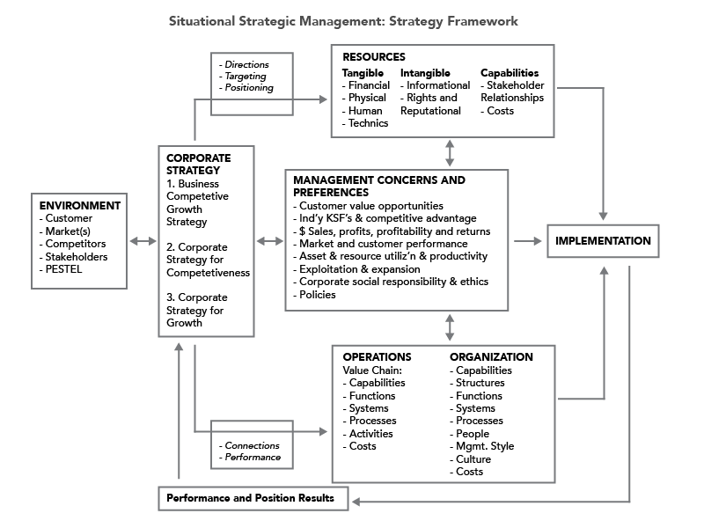
Exhibit 1
A pragmatic view of strategic management may be: To maintain as much cash as possible in the company, to use to generate more profit and more cash. This can be done by working to:
- obtain as much cash as possible, as fast as possible from customers, for as little as possible in product or service costs.
- obtain as much benefit as possible, as fast as possible, for as little cost as possible paid as slowly as possible, from all other stakeholders, depending on their bargaining power.

The Concept of Corporate Strategy
Corporate strategy is the linkage between the company and its environment, including customers and competitors. It is the central component of situational strategic management planning, as shown in Exhibit 1 above. Corporate strategy is the means to achieve managerial concerns, preferences and objectives (MCPOs) for present and future. Corporate strategy is seen here as constituted by:
- Business Competitive Growth Strategy
- Corporate Strategy for Competitiveness
- Corporate Strategy for Growth
Every strategy and its every component strategy is the positioning and performance of the company (resources, organization and operations) versus its competitive environment, to address and achieve managerial concerns, preferences, aims and objectives.
Strategy is seen here as always having two aspects that must be considered together as “both sides of the same coin”:
- for directions, targeting and positioning (for competitive or cooperative maneuver and targeting)
- for connections and performance (for influence over and benefits from targeted customers or stakeholders)
In situation analysis, tangible connections and performance are identified and information and findings obtained. Conclusions regarding the underlying, intangible strategy directions, targeting and positioning are based on the information and findings.
In situational planning, desired directions, targeting and positioning are considered first, and then connections and performance activities and targets for implementation are determined.

Business Competitive Growth Strategy
This is conceived as Strategy for Competitive Markets and Customer Products/Services, and has dimensions of Directions, targeting and positioning, and Connections and performance.
Strategy is relative to the business competitive environment, as the means to achieve managerial concerns, preferences and objectives (ends). Strategy components are:
- SC 1. strategy (customer—product-or-service) connections
- SC 2. external customers, markets, competitors and stakeholders
- SC 3. company resources and capabilities: quantity, nature and deployments
- SC 4. company functions operations: quantity, nature and deployments
- SC 5. company organization and people: quantity, nature and deployment

Corporate Strategy for Competitiveness (CSCs)
Constituent corporate competitiveness strategies are:
- CSC 1. Industry-market technology and product-or-service improvement strategy (based on strategy (customer—product-or-service connections)
- CSC 2. Company stakeholder development strategy
- CSC 3. Company resources and capabilities development strategy
- CSC 4. Company functions operations and processes development strategy
- CSC 5. Company organization and people development strategy
These strategies all have dimensions of Directions, targeting and positioning, and Connections and performance. These constituent strategies relate, respectively, to each of the strategy components SC1–SC5 listed above.

Corporate Strategies for Growth (CSGs)
Constituent corporate strategies for growth include:
- CSC 1. Company industry-market technology and customer innovation strategy
- CSC 2. Company integration growth strategy
- CSC 3. Company geographic and international business strategy
- CSC 4. Company diversification and multi-business strategy
- CSC 5. Company stakeholder growth strategy
These strategies all have dimensions of Directions, targeting and positioning, and Connections and performance. All of these constituent strategies are made up of strategy components SC1–SC5 listed above.

Process Concept

Situation Orientation
This includes strategic gap time frame, and insider perspective.

Situation Analysis
Considering the company in its competitive environment, the process is worked through from the tangible specifics of company business connections and performance to the intangible but more fundamental visualization of past and present strategic position and direction and the underlying strategy.

Analysis of Past and Present
Information and findings on managerial concerns, preferences and objectives (MCPOs) for positioning and performance:
- MCPO 1. Customer value opportunities and performance
- MCPO 2. Industry key success factors, competitive differentiators and advantages
- MCPO 3. Financial performance indicators
- MCPO 4. Customer and market performance indicators
- MCPO 5. Customer segment and market exploitation and expansion
- MCPO 6. Assets, resources and people development, utilization and productivity
- MCPO 7. Stakeholder relationships
Information and findings on corporate strategy, through analysing its constituent strategies:
- Business Competitive Growth Strategy
- Corporate Strategy for Competitiveness
- Corporate Strategy for Growth
For each strategy, information and findings are sought based on strategy components (SC) positioning and performance results:
- SC 1. Strategy (customer—product-or-service) connections
- SC 2. External customers, markets, competitors and stakeholders
- SC 3. Company resources and capabilities: quantity, nature and deployments
- SC 4. Company functions operations: quantity, nature and deployments
- SC 5. Company organization and people: quantity, nature and deployments
Conclusions can be made on present strategy performance and positioning.

Analysis into the Future: Projections and Expectations
Projections for trends, developments and changes can be made for present continuing-into the-future:
- Managerial concerns, preferences and objectives for positioning and performance
- Strategies and strategy components positioning and performance results
Conclusions can be made for expected strategy positioning and performance into the future
These expectations form the baseline for visualising the future strategic gap.

Situational Planning
Considering the projected future competitive environment, the process is worked through from visualized desired future strategic position and direction, and the strategy to achieve them, to the tangible specifics of desired company business connections and performance.
The linkage between strategic analysis and planning is at the conceptual level of corporate strategy for direction and positioning.

Formulating Strategy for the Future
Managerial concerns, preferences and objectives for positioning and performance for the future can be determined. The Strategic Gap at some specified future planning horizon is the difference between these desired concerns, preferences and objectives and the projected baseline MCPO expectations of positioning and performance.
Corporate strategy can be formulated as positioning and performance to be achieved for the future, to close the strategic gap at the specified time horizon. Corporate strategy is constituted by:
- Business Competitive Growth Strategy
- Corporate Strategy for Competitiveness
- Corporate Strategy for Growth
Each of these strategies has components SC1–SC5 as listed above, as the business connection or functional operational areas in which business activities take place, to implement and execute the strategies and deliver results and performance.
Strategy for the future is seen here as including in its components the planning of resourcing and organizing, planning the implementing and executing the strategy in the future, and planning the monitoring, control and feedback information processes and activities for the future.

