Name
Instructor
Course
Date
Sea-Level Rise
Rise of sea level have been noticed to expand tremendously as evidenced by the displacement of people in the coastal regions. Many have lost their life, land and other properties due to the rise in level of seas and oceans. Sea level rise has become major threats to climatic change today, which have taken the attention of many researchers, learners, scientist and also policy makers. Its impact have been felt even by those who are not near the seas and oceans indirectly, this is observed through congestion migrant are causing to people living in other areas ("Advancing the Science of Climate Change"). Therefore, logic dictates that sea level rise have contributed a lot to major environmental problems we are facing today. These Issue attracted attention of the researcher to carry out the study on the issues that are contributing to the rise of sea level and find out the most probable solutions.
Several researches that were carried in the past identified that burning of fossil fuels and other human and natural activities have added enormous amounts of greenhouse gasses to the atmosphere. Considering that the oceans absorb at least 80% of this additional heat, the effects of global warming are most likely to be felt through inundation and submerged coastal cities (FitzGerald, 36). This results to the rise of sea-level causing the displacement of the people in the coastal region. Research by Scripps Institution of Oceanography, NCAR, and Climate Central attempts to crystallize the most significant factors contributing to climate change, global warming and its associated effects such as sea-level rise, noted that emissions of four specific pollutants such as methane, black carbon, hydrofluorocarbons and tropospheric ozone have contribute much to the increase of sea-level rise by 25-50% (Gupta, Aarti, 8.2). The main sources of these pollutants are motor vehicle exhaustion, industrial emissions and chemical solvents. Simply put, they are the major cause of the global warming that has been accounted to the rise of the sea level.
The automobile industry is one of the chief contributors of greenhouse gasses in the atmosphere. In the US alone, cars and trucks account for one-fifth of total emissions, emitting twenty-four pounds of carbon dioxide and other heat-trapping gasses for every gallon of gasoline burnt as explained by (Rignot et al. 45). In the 1960s, Volkswagen faked diesel emissions prompting global outrage. This is one scandal in a long line of automobile scandals that has embroiled large car manufacturers in a plethora of lawsuits. The automotive industry has been plagued by the worst scandals relating to false disclosures of emissions in the face of heightened emissions and safety regulation standards (Meinshausen et al. 125). Automobile manufacturers in the US are in charge of conducting their tests and submitting them to the government. In Europe, car makers use the services of third-party manufacturers. Although regulatory bodies have tightened their grip on car manufacturers, corporate scandals abound. It boils down to the morality of the automotive industry. Most of the Car makers embrace their profits rather than the act of environmental conservation (Gupta 6). They prefer manufacturing of vehicles in the most affordable way without taking into consideration the effect of emissions produced by the industry and their vehicles. Burning of fuel generates emissions which propel the rate of global warming (Meinshausen et al. 125). This means that oceans will absorb more additional heat and the melting of glacial sheets as stated by (Meinshausen et al. 125). By a similar token, energy companies have played a major role in the rise of sea-level. Fuels produces more emissions when they are burnt. Energy producing companies on daily basis attempt to implement new fuel energy that is appealing to their customer than environmental friendly which result to impairment of the climatically condition and global warming as shown in the graph of water pollution in china.
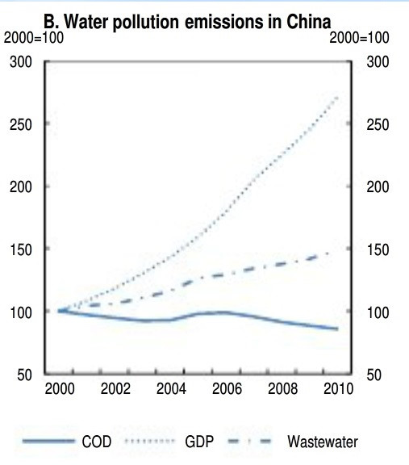
Manufacturing gasoline fueled vehicles and producing fossil fuel energy will always accelerate the rate of global warming and its associated effects (Hegerl et al 98). However, less usage of renewable energy have acted as a weapon that has contributed to much of the climate change. Governments seem to be reluctant to campaign for more usage of renewable sources of energy by not perpetuating an ideological shift from fossil fuel dependence to cleaner renewable sources of energy such as solar and wind energy. Generation of fossil fuel is observed to be relatively cheaper compared to the initial cost of laying out the infrastructure for wind, solar energy and electric energy. This may explain the reason as to why many industries and individuals fail to shift from non-renewable to renewable energy options.
A comprehensive global study conducted in 2007 established that 634 million people (about one-tenth of the world population) inhabit coastal areas and are therefore highly susceptible to the impacts of ocean change (Link, Jeff. This is according to the current situation where by everybody is after self-gain rather than the beauty of the environment they are leaving in. Governments also have partly not been observant of their key responsibilities in cushioning their citizens against storms, tides, and other extreme weather events. The looming problem of sea level rise calls for through evaluation to be put in actions, in order to assess how various aspects might be contributing to the sea-level rise and implement mitigation measures before it is too late (Meinshausen et al. 125). Although there is an international consensus and concerted efforts by governments and economic superpowers on how to stop climate change, it is imperative to have a few measures that can be put in place to mitigate the effects of a sea level rise because stopping Mother Nature is going to be an uphill task as shown in (Watson 14). Various potential adaptive strategies ought to be considered in defending coastlines against the threat of rising sea levels. The best approach the research proposes is the application of techniques that will lead to reduction of global warming.
To curb these issues of rise in sea level, respective authorities are supposed pass and implement policies that aim at; minimizing future loss of the people living in the areas affected by the sea rise, give them protective measures like fresh drinking water resources, provide to them natural resources that are most viable to the coastal region and that have adequate space which can allow rise of sea level without affecting the inhabitant, give back natural techniques that are related to movement of sediment in the coastal waters which can leads to effective adaptation of the activities in the area such as movement of the habitat from one area to another as touched in (McCormick 352–356).
It is very important for governments to begin with a current and the best fitting accounting of shoreline conditions that covers the entire nation. That is a clear indication on how the shorelines are likely to change as a result of rising sea levels as covered in (McCormick 352–356). Such ideas should involve tracing of the inundation, similarly, the current locations of cohesive protection standards that could prevent the movements of the free natural systems in return to rise of the sea level as stated by (McCormick 352–356).
They should also collect adequate information on coastal natural resources that will help them in strategic management at both state and local positions as it was said by (D. Gerace 97). The strategies adopted should look at ecosystem management and get full financial support for the purpose of fitting them well to the targeted areas. This should be taken as the most fundamental guideline of the defense against extreme storms, which is characterized with dunes, barrier islands and tidal wetlands which take the brunt of the waves and storms. All these result in the reduction of effect on the coastal communities and also infrastructure as illustrated (Hulme 245-266). In order to preserve the coastal normal functioning, natural features should be conserved and be protected from destruction as this could allow a room for curbing the rise of sea in the settlement areas.
In addition, solution such as raising and strategic positioning can also be used to deviate the long term threats that are caused by the flooding; this means state agencies have started to include such solutions in their measures of the long term coastal agenda of protecting for its planning and management as stated by (Hulme 245-266). Application of the environmentally beneficial techniques is highly accommodated in order to protect public infrastructures that in other terms cannot be maintained by non-structural methods (Hegerl et al, 98). While these applications are environmental friendly, such applications do not completely eliminate the effect of the layout and it is not possible also for them to take the position of the inhabitant.
Taking an example of the New York, it applied various regulatory frameworks that consider sea level rise in suggestion for their development and infrastructure in the areas that are highly subjected to risk. Some of the regulations that where implemented by the New York government includes, restriction of the structural shoreline preventive methods and the soft shore line in order to minimize the risk, the government also consider and fund the use of non-structural and soft shoreline preventive methods to reduce the risk, more so, it gives larger buffers in between the natural preventive characteristics and the new progress, it also asked for the local and regional planning efforts in order to identify areas that need more attention as explained in (Hegerl et al, 98)). They also welcome additional studies that involved creation of the long term assessment system that will advance their little analysis that they have about the greatest risk of flooding.
Some of the areas that New York government suggested to be looked at are; monitoring and evaluation of the causes of tidal wetland and the changes that appear at the landscape scale, they also suggested the evaluation of the potential shift in the upstream extent and the inundation of the underground drinking water supplies, moreover, they called for an interest to evaluate map projected range shift of the key coastal species and finally but not the least they suggested for better understanding on how sea level end up raising, how erosion come about, cause of the storms, how show line modification end up affecting shoreline changes, how water differs in quality and wetlands and aquatic habitat (McCormick 352–356).
Another approach is the use of solar energy, this is an ultimate method equally feasible though not so much embraced approach in solving the impending effects of rising sea levels. This refers to the usage of solar as the source of energy to prevent much of the global warming resulting to reduced rise of sea level. Solar technology has been partly practiced over the world, and particularly in the New York after Hurricane Sandy in 2012. With rising sea levels, climate change may now be a part of the gentrification story as illustrated (Hugerat et al. 309-315). Implementation of the solar energy usage in New York has brought about potential extreme weather in the area. The increase in usage of this pure electricity will end up supporting more than 10,000 people who live in the coastal region.
To some extent many will ask questions such as; does usage of the solar energy relate to the rise of sea level? The answer is yes. Solar energy being a renewable source of energy will help in protecting deterioration of the environment and lowering of the effect of climate change such as global warming (Hugerat et al. 309-315). Solar panel industries are considered to play a very important role in ensuring we are leaving in a clean environment though in the process of making the panels they contribute to environmental pollution, but the rate of pollution is very insignificance as stated by (Manuel 107). Wider usage of the solar panel would save environment a lot from pollution that is contributed by gasoline and fossil fuels.
Solar power can be used widely, being more economical and of benefit. The countries that are capable of producing power from the solar panels can be used to distribute harvested power to other nations that receive little sunlight as illustrated (Davis 52-53). More so, countries with less sunlight can use other renewable source of power such coal that are a bit environmental friendly like it is done in most of the Europeans countries (Manuel 107). Taking an example of the most of African countries especially those that are around the two main desert; that is Kalahari and Sahara desert can be used in solar power plantation to benefit other countries in the world as illustrated (Crosby 132-133).
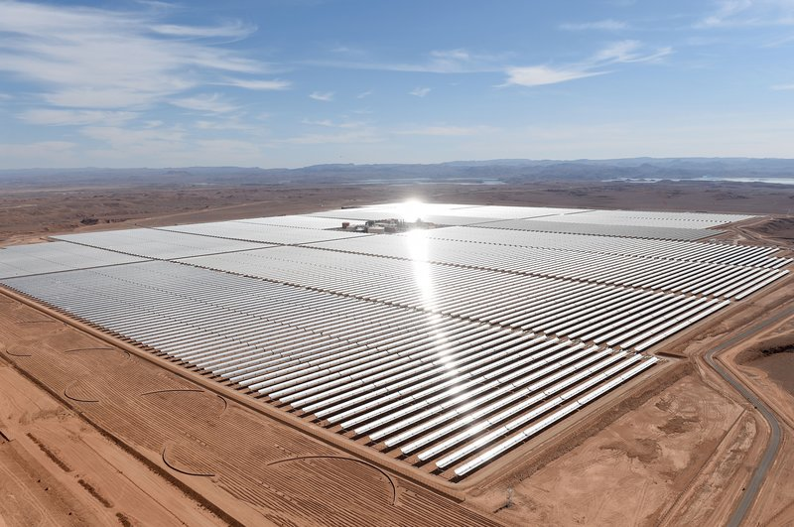
Government must develop a policy that aim at supporting individual that are not capable of installing solar panel in order achieve more of environmental friendly source of power as stated (Gulf 53-56). Taking an example of California, the study carried out there in the year 2012 indicated that the number of rented houses and those who had low income had large percentage of all total California households (“44% low-income, 45% rented”). According to the California research it shows that if rest of California citizen installs solar panels except those who have low incomes and the ones who have rented, it would still attain 60% significance level, which means if the government tend to concentrate in any of the group it would still reduce emission of this pollutant gases to some point, therefore governments should encourage usage of environmental friendly power by giving incentives and subsidies to the citizens as in (Gulf 53-56).
The main problem and hindrance of achieving this is lack of cooperation between various countries, and relaxation of the governments in taking the matter of global warming as a serious matter. It is very possible for each country to relay on clean power from the solar energy as explained (Davis 52-53), if only governments take the matters of global warming and rise of sea level serious, taking into consideration the effect it has to both citizens and the world economic point of view. Millions of people have suffered politically, socially and also economically in the past as a result rise of the sea level.
Most important to note action to cope with the detrimental impacts of sea level rise needs to start now, bearing in mind that the rate of released gases is increasing on daily basis leading to the rise of sea levels. The sea has substantially encroached into the land. Some experts suggest that the Island are likely to be fully submerged by 2100. Currently, the entire island nation is planning to evacuate to Fiji before they are submerged into the Pacific. The case of Kiribati exemplifies the serious implications of sea level rise and is a call for governments to speedily come up with evacuation plans so as to stay one step ahead (Guilford, Gwynn). In the face of increasing intensities of storms and sea level rises, a good plan to flee the city becomes a key part of protecting its inhabitants. The order to evacuate during the New Orleans Hurricane Katrina disaster came late by many accounts partly explaining the death toll of 2000 people. The growing consensus is that while efforts are in place to combat climate change and sea-level rise, coastal cities have no option but to prepare for its inevitable encroachment (Hulme 245-266).
To sum up, the research find out that most of the effect that are caused by the rise of sea level have been contributed by our own negligence. Therefore, agencies and government are advised to encourage use of environmental friendly powers such as solar energy where possible to reduce the rate of pollution. This can be done by offering incentives and subsidizing prices of solar panel to the manufacturing companies and individuals. Governments are also supposed to raise an international campaign that encourages and support motor vehicle industries to come up with motors that can use solar energy as source of power during the sunny period (dual purpose motors) in order to curb massive pollution that is threatening the entire world
Works Cited
"Coastal Armoring | Explore Beaches". Explorebeaches.Msi.Ucsb.Edu, 2017, http://explorebeaches.msi.ucsb.edu/beach-health/coastal-armoring.
Bowermaster, Jon. "If Sea Levels Keep Rising, A Lot Of Us Will Be Swimming To Work".Takepart, 2013, http://www.takepart.com/article/2013/04/22/rising-sea-levels-causes-and-solutions.
Strategies for Managing Sea Level Rise". SPUR, 2009, http://www.spur.org/publications/urbanist-article/2009-11-01/strategies-managing-sea-level-rise.
"Southwest Washington | Coastal Resilience". Coastalresilience.Org, 2017, http://coastalresilience.org/project/southwest-washington.
Lehmann, Evan. "Sea Walls May Be Cheaper Than Rising Waters". Scientific American, 2014, https://www.scientificamerican.com/article/sea-walls-may-be-cheaper-than-rising-waters.
Chang, S. W., Clement, T. P., Simpson, M. J., & Lee, K. K. (2011). Does sea-level rise have an impact on saltwater intrusion? Advances in water resources, 34(10), 1283-1291. http://www.sciencedirect.com/science/article/pii/S0309170811001187.
Link, Jeff. "How Coastal Engineering Aims To Rescue Cities From Sea-Level Rise". Redshift, 2016, https://redshift.autodesk.com/coastal-engineering/.
"Adaptive Strategies - Sea Level Rise | METEO 469: From Meteorology To Mitigation: Understanding Global Warming D7". E-Education.Psu.Edu, 2017, https://www.e-education.psu.edu/meteo469/node/220.
"Beach Nourishment | Explore Beaches". Explorebeaches.Msi.Ucsb.Edu, 2017, http://explorebeaches.msi.ucsb.edu/beach-health/beach-nourishment.
Guilford, Gwynn. "An Entire Island Nation Is Preparing To Evacuate To Fiji Before They Sink Into The Pacific". Quartz, 2017, https://qz.com/228948/an-entire-island-nation-is-preparing-to-evacuate-to-fiji-before-they-sink-into-the-pacific/.
Hulme, Mike. "Reducing the future to climate: a story of climate determinism and reductionism." Osiris 26.1 (2011): 245-266. https://scholar.google.com/scholar?q=The+future+of+evacuations+in+the+climate+change+era&btnG=&hl=en&as_sdt=0%2C5.
Gupta, Aarti. "Transparency under scrutiny: Information disclosure in global environmental governance." Global Environmental Politics 8.2 (2008): 1-7. http://www.mitpressjournals.org/doi/abs/10.1162/glep.2008.8.2.1.
"Advancing The Science Of Climate Change". 2017, https://www.nap.edu/read/12782/chapter/11.
Werner, Adrian D., and Craig T. Simmons. "Impact of sea‐level rise on sea water intrusion in coastal aquifers." Ground Water 47.2 (2009): 197-204. https://scholar.google.com/scholar?q=Werner%2C+Adrian+D.%2C+and+Craig+T.+Simmons.+%22Impact+of+sea%E2%80%90level+rise+on+sea+water+intrusion+in+coastal+aquifers.%22+Ground+Water+47.2+%282009%29%3A+197-204.&btnG=&hl=en&as_sdt=0%2C5.
FitzGerald, Duncan M., et al. "Coastal impacts due to sea-level rise." Annu. Rev. Earth Planet. Sci. 36 (2008): 601-647. https://scholar.google.com/scholar?start=10&q=solutions+for+sea+level+rise&hl=en&as_sdt=0,5.

