Contents
Summary (A1) 1
Business Challenge (A2) 5
Observations (A3) 5
Contributing Factors for Challenges (A4) 7
Monetary Management (A4.1) 8
Leadership Style requires a Structural Change (A4.2) 9
Change Management (A4.3) 10
Solutions to address challenges (A5) 12
Monetary Management (A5.1) 12
Leadership Structural Change (A5.2) 14
Change Management process for new classes (A5.3) 15
Resources required to implement suggestions (A6) 17
Visual Timeline for Recommendations (A7) 20
Long-term Expected Organizational and Financial Impacts (A8) 21
Time Log (A9) 23
Executive Summary (A10) 24
References (A11) 24

Summary (A1)

This report will provide an evaluation of Ranken Technical College, a Non-profit school of higher learning located in Missouri. The outlined expected recommendations and observations contained in the report are based on discussions over several different exchanges with Ranken Technical Colleges Vice President over the course of seven weeks. These informative exchanges included access to, but not limited to financial reports, marketing aids, and board meeting questionnaires and presentations that the vice president provided. The following report identifies continued monetary sustainability as a substantially difficult issues facing the institution, while also highlighting the key issues in the area of leadership that is suspected of being the underwriting factor. The suggested advantages that follow are here to address the central problems and their integral roots. The report will conclude with an analysis of long-term influences that are anticipated as a result of the successful execution of each initiative.

Ranken Technical College is in jeopardy of eating away at its existing endowment by the end of the year in 2047, especially in light of year-after-year lower-than-expected student enrollment numbers. There are two issues that worsen this problem. First, the institutions staff members must shift from the current disciplined workings of a standard style of teaching to a more creative, technology-intensive flipped classroom environment, a substantial educational style change. Second, Ranken Technical College flaunts itself as a hands on technical college of higher education. This creates a substantial, year-over-year expenditures in high-tech classrooms, whiteboards, and new facilities in an attempt to separate itself from other institutions of higher learning, which has driven up costs. The previous outlined concerns have left the institution in a declining fiscal situation, which further exposes substantial inadequacies in fiscal administration aptitude, change management aptitude, and moreover leadership style.
Therefore, to address the challenges facing Ranken Tehcnical College, and secure its fiscal sustainability while guaranteeing it does not face a comparable situation in the forthcoming years, the subsequent initiatives are suggested:
- To ensure the institutions ambitions are in line with the primary objectives of the school, and provide incentives for staff members to continue their pursuit in professional development in the service of students, educational excellence, learning and growth, the creation of faculty evaluations is recommended.
- To provide accurate outlines of the hierarchy, while listing the necessary responsibilities of the hierarchy needed to function a proficient higher educational institution in an extremely federally regulated higher educational industry, the creation of an efficient administrative structure is suggested.
- To have employees acknowledge and take part in the actions essential to shift from a standard style of teaching to a more creative, technology-focus method while including a process of change management before things are changed in the classroom.
- To increase accessible assets while providing a reference line against which monetary achievement can be measured. Precise execution of monetary cuts and arrangements with the agreement of a non-ambiguous financial plan is advised.
Successfully implementing the previously recommended initiatives, the school can expect to see a transition into a more monetary aware philosophy. This will help reduce cost associated with non-efficient operations in excess of 3 million dollars a year. The transition will help financial decisions and make sure they align more with the institutions goals, while providing regular access to a non-ambiguous financial plan when trying to make informed decisions.
David Ranken was born in Boystown, County Londonberry, Ireland in 1835. Over the years, and after working in the linen industry David Ranken came to Saint Louis in 1862 to assume charge of a large estate left by his uncle. David Ranken never married and simply devoted his time to his real estate and financial interest. However, he was not uninterested to civic affairs. In the year 1870 he become the director of the Missouri Pacific Railroad, which was later sold to Jay Gould. David Ranken was also a director in the Louisiana Purchase Exposition and was a member of the St. Louis Business men’s league. After several years of living in Saint Louis and having investigated and thinking about an institution wherein students could be taught the dignity of labor trough the teachings of necessary mechanical labor, in November 1907 he created a foundation deed, which the following extract is taken:
“Whereas, for many years I have been impressed with the fact that too little attention is given to the instruction of boys in the mechanical trades, and that the public schools and other free educational institutions have a tendency to create in the minds of the young, as well as in the community a prejudice against manual labor, and the idea that common work is not respectable, so that a false impression and a false pride often influence boys and young men to avoid the mechanical trades in which they are unfitted and branches of business which are over-crowded and in which they probably would not succeed, I am satisfied that there is need of an institution the object of which shall be education and instruction in the ordinary mechanical trades and in which boys, especially, may be taught the dignity of labor. I have therefore formed an intention of endowing an institution in the city of Saint Louis and the State of Missouri, in which boys and men may be trained to habits of industry and economy, and taught such mechanical trades or handicrafts as may be suited to their several capacities, so that they may be able to support themselves by the labor of their own hands. Since, at my instance, a corporation has been organized to establish and maintain in the city of Saint Louis a school of mechanical trades known as ‘The David Ranken, Jr., School of Mechanical Trades, I propose to now endow the same with a sufficient fund to enable it to carry out my long-cherished purposes and plans, so that I may see in my lifetime its foundation and not leave the plan to be carried out after my death.” This was his Lightbulb moment. Imagine if he could bring technical trade skilled workers to market year after year with skills desired by the regions employers. The school has been very prosperous from its inception, and has increased its enrollment year over year. It has become generally known for the effectiveness of its teaching, and its alumni are satisfying the hope of Mr. Ranken that they might “earn good wages and be fitted for positions of responsibility in the trades.”

Business Challenge (A2)

The establishment’s revenue is not enough to withstand tasks beyond June, 2047. The highly regulated educational industry in which we operate effects delays that hinder profit generation. Again Ranken Technical College is a Not-profit institution of higher learning.

Observations (A3)

As an educational institution, a substantial amount of work has to be spent by the president and the instructors including part time faculty to work toward the recognition of a mutual vision. Consistently working long hours and staying late every other night is typical. Being the innovative persons doing the majority of the work needed to accomplish this vision of a society where we all make it or not, is powered by the resourceful communication all of their hard work produces.
Issue 1: Marketing departments cost. Those in the marketing department are the facilitators for the institution when it comes to the company’s brand, including its graphic design, website development, promotional video, and marketing material creation. This department has highly creative brainstorming and collaborative sessions. The marketing department engages in these activates, and in doing so, it leads them to commit long hours every day. However, even with the use of long hours and dedicated commitment to the vision of the institution, there are no immediate or measurable impacts of the revenue required for the institution to remain viable, in fact, the top-heavy number of staff that are engaged in the undertakings of the marketing team lead to a compromise of the existing financial plan for the institutions improvement efforts. Once the initial marketing team came up with its “media blitz” and the development of the institutions branding was completed, the realities of operating the institution fiscally responsibly started to set in. Ensuring that the institution can produce revenue requires that we garner the approval from state and federal agencies required to run the new classes in said “media blitz” to ensure that a sales channel could be created. While the marketing department gets lost in the creative aspects of the business, it lacks foresight with its ability in seeing the length of time required for this sales channel to be established. While that “media blitz” sits because of pending approval on classes even more resources are continually allocated to the marketing department, thus consuming cash-on-hand at a greater rate than what was initially anticipated. With the closure of many for-profit institution many new regulatory hurdles are in place to protect the tax payers. With all of the state and federal approvals needed to have a class approved have caused things to slow down. Educational classes, typically, are granted approval one at a time. This severely limits the schools available market until each class gets such approval. To date, just three of the six new classes, in the marketing blitz, have been approved; with approvals still pending that have been identified as geographically significant educational needs which make them primary targets for the institution.
Issue 2: Modernization as a differentiating factor in an educational market. The second issue validating the business revenue problems are the institutions very own business model. Ranken Technical College identifies itself as a “Technical School” in its advertising resources; however, education, like most educational investments, is highly sought after students interested in getting the highest level of educational degrees at the least cost. In Rankens’ aspiration to distinguish itself from other institutions, the school invest heavily in technology and branding initiatives that “may” have enticed attention, however by doing so Ranken has also seen a significant increase in cost doing so. The outcome of this investment has made the cost basis of these new classes inflated, in return causing the institution to raise its tuition to near the amounts of most of its competitors, what once was a big attraction to prospective students, has now been used to offset the increased cost structure. Even though the institution believes that the values it adds to the regions workforce will be sufficient to entice a new student, the outreach needed to said target market about said value, another time consuming and expensive “media blitz”, is a prerequisite to students acceptance in the region. This further slows the revenue stream brought in from these new classes.

Contributing Factors for Challenges (A4)

As the leader with the institutions vision in mind Ranken Technical College vice president is in charge of inspiring the staff in the direction of the success of the schools mission, the vice president find their self challenged by the necessity to change the “exciting and inspired” work setting into a more serious approach as a working institution that generates adequate revenue. The terms “exciting and inspired” and “generate adequate revenue” are by no means necessarily equally exclusive. In fact, there exists sufficient proof in business writings that backs the idea that sustaining an optimistic atmosphere assist an institutions ability to be a sustainable business (Garvin & Levesque, 2006). Rankens primary managing task, then, is maintaining the desire that preserves its staff’s ability to work persistently towards the colleges vision; while also safeguarding the adoption of philosophies for good corporate administration and making sure that state and federal regulatory requirements are met in a timely manner. This warrants the aptitude to effect transformation, encourage financial accountability and enable effective procedures. This requires change in the arears of monetary management, leadership styles, and change management. Unfortunately, the institution leadership reveal insufficiencies in these capacities.

Monetary Management (A4.1)

For any, educational business, the act of trying to balance investments use to try and differentiate the institution from other competition while also trying to sustain operations is and will always be a difficult task. Ranken Technical College has always placed a substantial importance on how it is viewed by its branding and technology. This is an effort by the institution to participate effectively in a business where it has to be cognitive of the price it uses for its service in education. The institution must also be aware of the burden on available resources that it incurs based on its use of cutting-edge innovative organizations and the professional technology assets may, in some cases, not add a sufficient amount of value to offset or even justify the higher cost of the tuition. As stated earlier students are primarily interested in “bang for buck” vs paying higher fees for tuition when they can go to more well-known institutions.
With the vice presidents fondness for optimism, early revenue projections for these classes were based on an optimistic outlook rather than previous performances or reality, this also lead to no official accounting process to be implemented. With an initial investment of $4 million in expenses only yielded the institution about $1.5 million after all related fees, as stated by the vice president this seemed more than satisfactory given the institutions initial forecast was around 2 million for the first year. However, 2017 fiscal year revenue, first expected to reach over $4.5 million, has now been adjusted to mirror a more accurate amount of $2.75 million. With the following year’s revenue for these classes in 2018 being adjusted from $7 million to $5 million. The net revenue, after all salaries, bonuses, marketing, facilities, pensions, healthcare, etc. gives us a negative impact of more than -10% for ROI. After paying for all of the previously listed items included the additional staff brought on board, the institutions expected loss, over the course of next two years, is near $1 million.
The investment in classifying ourselves as being different from other institutions, along with the “technical school” mentality including promotional videos for the new facilities, revamping of the website to bring it up to date, the development of social media advertising, cost the company an additional $1.5 million dollars. With expenses during the time the facilities are not in use, and the full time faculty being paid during non-revenue generating periods, the institution sees an expense on average of $8,000 per employee with 14 teacher’s total. This beings the monthly loss revenue over the course of three months to $336000. That total however does not include personal investment amounts which the institution would not share with me. Once classes start back up over summer break, continued expenses, including the cost for staff, website/IT support, bond payments, pension payments, healthcare, and security for campus began to consume more than $2.3 million per month. Being careful to assume that if the cost remain as they are reflected as of today and the above projections hold true for next year, with Ranken earning close to $21 million last year, Ranken will see its revenue chart go into the “red” vs the “black”. If the projections hold Ranken will lose for the 2018 year $6.6 million dollars. It is imperative that Ranken find ways to generate revenue, cut its operational cost or sell more bonds. While the final option is realistic it is only a temporary “Band-Aid” to the wound where the company is bleeding resources. By implementing a fiscally conservative approach and placing more appropriate fiscal management practices in place will ensure the survival of the institution.

Leadership Style requires a Structural Change (A4.2)

By Ranken making certain that the institutions leaders conform to worthy administration practices is a challenge that needs further development. The imaginative vitality at the institution is praiseworthy and is likely an artifact of the vice presidents idealistic, transformative method to an otherwise commonplace educational industry. The vice presidents passion for the school and its overall mission is communicable, however, the staff is given to much free reign on how they can work. This often times leads the staff dismissing the idea of a fiscally competitive approach in the market of educational institutions. Instead of having the staff use a sound approach the vice president allows them to come up with the ideas for branding and technologies to separate the institutions from others. Using this leadership style the vice president is able to inspire his employees by “raising their consciousness about the significance of specific outcomes and new ways those outcomes might be achieved” (Hay, 2006). This method also lends a hand to the perceived risk of stylishness over substance. In turn circumventing the organization and administration qualities needed to see positive growth for the institution. As a result of this, the employees who witness the vice presidents methodology to administration may in turn try to mimic these actions and not care for the needs of the institution on a monetary concern. In some occasions it’s been noted that the staff focus on innovation rather than completing the initial task and the requirements to get the previous classes through the approval process that would attract more students and lead to a positive generation of new revenue sources. This in effect has an impact on the institutions fiscal issues, and in turn this requires a more hierarchical approach to management.

Change Management (A4.3)

Ranken Technical Colleges administration and employees are challenged with a cultural change of moving from the chaotic, get-up-and-go innovative pursuits of a small educational institution to a business that is disciplined on the idea of being a profitable institution functioning in a highly state and federally regulated setting. The institutions attention on constructing an “appearance and impression” that reflects an image of one that is of a bleeding edge technology culture must conform to the idea of working in a repetitive, student and transaction oriented rhythm of an educational institution. The mundane day-to-day actions positioned around brainstorming conferences, web and marketing design updates along with technology spending and facility development must give way to the sales, student outreach, student enrolment, state and federal reporting and clearance of classes critical to the institutions success. . Out of need, the “exhilarating” must coincide with the “mundane.” The vice presidents test is to preserve an equal level of interest experienced in the institutions changes in offerings during the course of its progression, while having the ability to use their capability to influence transformation at the same time preserving a captivating vision. An incapability to persuade employees to change their methods to their accustomed work life and grasp the businesslike requirements of the institutions need to grow could corroborate an outcome that is exceptionally expensive. By remaining to give more attention to the innovative quests as an alternative to attracting new students, running resourceful procedures and complying with burdensome state and federal regulatory requirements would likely magnify the institutions monetary issues. The vice president, in their administrative role, must develop ways to appeal to the staff that they need to set the scale of their creative predispositions to balance that equally to that of following routine guidelines and processes necessary to be successful in the realm of an educational institution. The vice presidents leadership challenge, however, is to not get rid of good parts and bad parts equally. This will ensure continued creativity which also functions as a portion of the institutions survival. Looking over what was previously stated, handling transformation or adjustments to the institutions culture must be controlled cautiously to find the middle ground which is a key institutional asset; while also implementing an established process for introducing and upholding modifications critical to Ranken Technical Colleges existence and needs to turn into an all-encompassing priority.

Solutions to address challenges (A5)

Ranken Technical College primary task of remaining in business past the year 2047 is subject to how successful the institution is at its evolution from the frenzied enthusiastic culture it is now and its ability to turn into a more routine and practical business that is characterize as a well-run, profitable educational institution in heavily state and federally regulated educational industry. The vice president of Ranken has to bear the burden of this transition. The vice presidents ideas and eagerness has attracted buyers of our bonds, however, those talents must also yield results. Ranken Technical College present-day stratagem to make itself “different” from other institutions, constructed fundamentally on its “technical” supremacy and popular branding, must be supplemented by actual implementation and execution.
While there is still a foreseeable amount of time before the institution reaches its insolvency date, the fundamentals of administration during a fiscal change with the vision of the institution, the vice president needs to lead with consideration, making sure work habits become consistent, and make sure that confidence is continuously demonstrated by the vice president; this is important and the vice president must espouse these qualities. (DurBrin, 2013)
Therefore, there are three distinct but interrelated initiatives that are suggested to the institution in order to address the insufficiencies in monetary management, leadership style, and its change management. Engaging in these initiatives collectively with produce rapid cost savings and aid in the preparation of the new vision for the institution.

Monetary Management (A5.1)

Recommended Solution 1: Develop and implement economical and reduction of cost measures. Ranken Technical College administration must improve on the coast associated with starting classes and filling those classes with students, to deliver profits. Ranken Technical College indeed faces a problematic road ahead. The incontestable issue with Ranken is that it devotes far too much of its revenue on technology, accommodations, and workforce essential to upkeep the institution. By subcontracting certain occupations, especially marketing, and slowing its spending on new technology initiatives, Ranken Technical College can reduce its overall obligations to staff; and in-turn alleviate its revenue challenges meaningfully. A mockup of new advertising options for the institution listed at the bottom called advertising, includes a timeline graph for implementation. The institution has also agreed to the change its slogan from “Are you Ranken Material?” to “Ranken. Professional Grade” Prospective students are no longer asking themselves if they are Ranken Material. They can now look at the slogan as Ranken can make me professional grade. The next department that can see changes applied to it are its IT staff. The IT staff, or the “call center” as it’s named, can reduce its budget by over $435,000 by releasing its overnight staff of 6 employees and subcontract that out at a more reasonable rate. A study of the IT service related issues that come up overnight showed 95%, for both student and staff, were related to password issues. By outsourcing or even implementing an automated password resetting system the school can reduce its cost there. With Ranken Technical College showing a level of conscientiousness when approximating the cost for certain departments when the school is in a time period in which there is a prolonged period of time in which generally no revenue is being made and by doing so leaving revenue available for the institution to fund unforeseen event would possible have assisted the institution to by-pass the current revenue issues. “Planning and controlling tools that mirrors the firm’s anticipated sales proceeds, functioning expenditures and cash earnings and disbursements” (Boone & Kurtz, 2013), a appropriately established financial plan. Doing this would have assisted in showing that the expenses that institution is taking on should have been scaled back, as soon as possible, to make sure that adequate monetary assets were accessible for standard procedures. This would have allowed the Institution to be ready for any unavoidable challenge that it had run into.

Leadership Structural Change (A5.2)

The subsequent chief adjustment encompasses the adoption of a structural change that will enhance the effective administration of the institutions procedures. Ranken Technical Colleges prior outreach to students was based on solely word of mouth. This rarely involved the Administration and management of specific teams. Thus the institutions leadership, unquestionable, lacks an understanding of an administrative organizational hierarchy, and most importantly how it is appropriate from the institution to have. Subsequently, the present institutions hierarchy is amorphous, consisting of random collections of people dedicated to autonomous ventures, each with individual metrics and purposes.
The structure upon which Ranken Technical College was built by and assisted in the imaginative quests and technical developments necessary to keep the institution operational. While the institutions undertakings were best accomplished as assignments or projects, the institutions functioning society consist of group undertakings including class improvements, advertising, student services, financial aid, financial and monetary bookkeeping, human resources, IT management and state and federal regulatory reporting. An improvised methodology to the actions and direction undercuts the position of the institutions vision and the efforts put in to accomplish that vision as the workforces of the institution chase their individual schemes. In view of that, an organization that assembles Diversity, enrolment management, administration, and student records into well-designed branches, each of which “is concerned for the institution as a whole” (Daft, 2014) can enhance the alignment of the workforces efforts with the schools long-term vision and mission. Configuring the business in this method “allows for a financial prudence of balance and effective supply use” (Daft, 2014) by building obtainable common interest that aid the whole institution along with unchanging processes that facilitate dependable administration and corporate continuousness in the event of workforce leavings. The well-designed organization will in turn address insufficiencies in Ranken Technical Colleges leadership style, as long as an organizing tool that bring into line the labor efforts that are regularly grassed by the brashness of transformational leaders (Hay, 2006). This will also ensure that the institution is more student centered as show below.
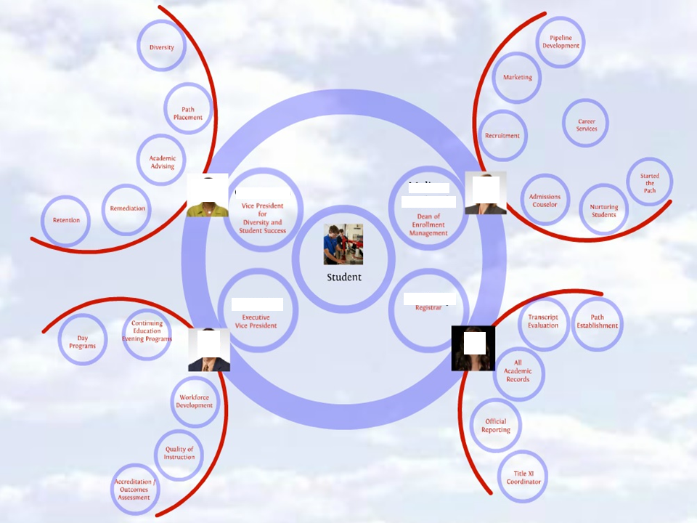

Change Management process for new classes (A5.3)

Often the greatest challenges for a leader will arise during change. Ranken Technical College needs to be able to acclimatize its innovative pedigrees to the humdrum works of an college instructor, even if it means changing course from the staffs encouraged works to repetitive production, from plan to achievement, and especially the initial idea to finishing point ( I.E. new clases). This transformation must be seen coming from the top of the hierarchy and it must also show the urgency in which the institution needs to evolve. For the vice president to accomplish this change, their decisions must be influential, and allocate resources correctly to accelerate this change. (MindEdge, 2015) This task can be made easier through the utilization of the well-designed administrative organization listed above, and the change management cycle shown below.
The vice president needs to be very cautious as to now give reason to raise alarm among the staff which can lead to the potential loss of employees. He needs to ensure that the staff understands that all of the changes coming are to ensure the school stays in business, while also telling them this will be a transition and we are in no present danger of that happening. For the Vice president to sustain the staffs’ commitment to transformation, personnel must be involved with the ability to “debate the idea for transformation and how to implement it,” in turn allowing them to be invested in doing what is needed for the vision of the institution and make them mindful of the rewards they will obtain as an outcome of achieving said vision (MindEdge, 2015). During the course of all change processes, the vice president must observe development and offer support where necessary to keep things on the appropriate trajectory for the school. The vice president needs to “generate a sense of improvement” and preserve the progress of moving forward. Any changes should be broken down into smaller sections and follow the change management process listed below. This will allow the staff and administration to feel “short term wins”. (MindEdge, 2015). As a final point, in the vice presidents administrative role, they must untiringly underpin the necessity for the renewed, methodical methodology as an accepted advancement for the institution that best work for the students, staffs, and the institutions interests (MindEdge, 2015). This change management can be accomplished by following the new change process as listed below for all activities of the institution.
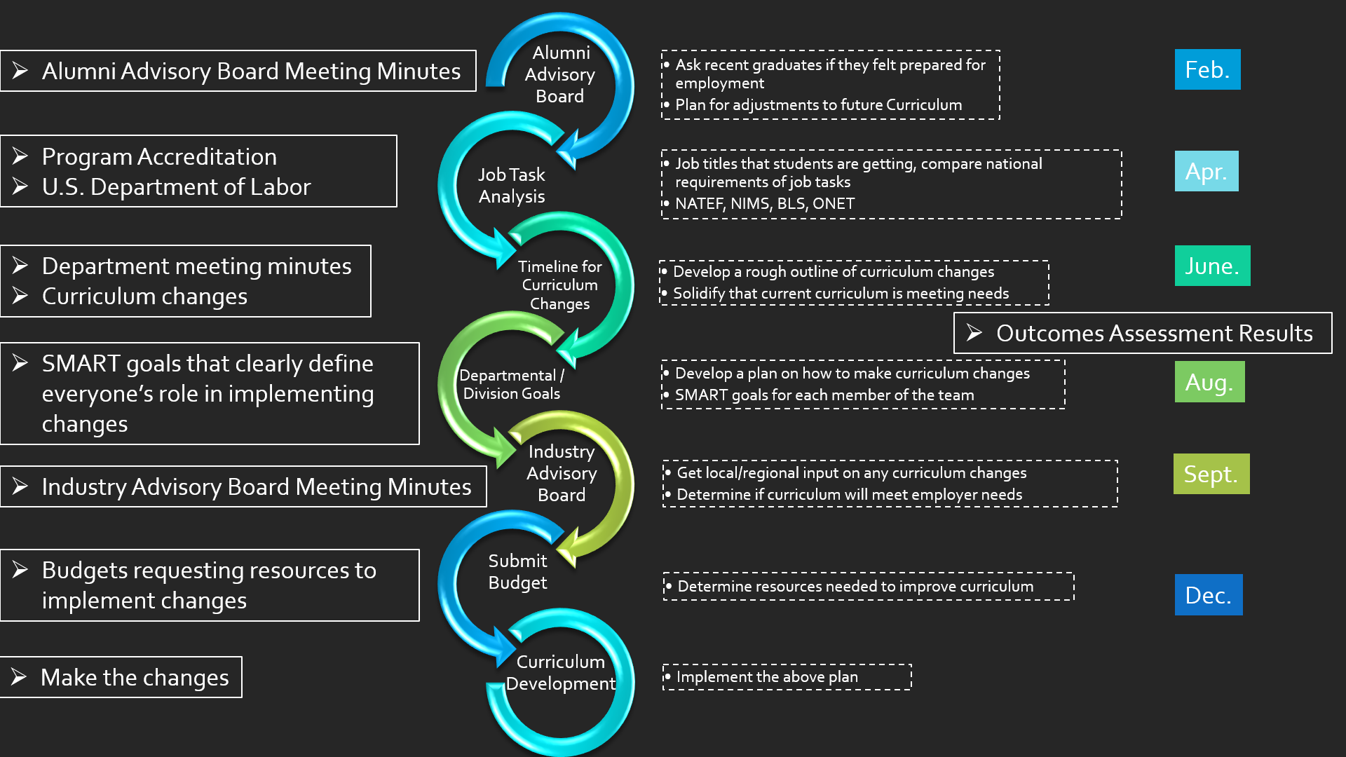

Resources required to implement suggestions (A6)

For the institution to properly implement recommendations outlined in the aforementioned sections, precise resources need to be installed in place, procedures monitored and a financial plan set in place and allocated. As listed in the table below for each recommendation.
Recommendation 1:Monetary Management
People | Leadership Style | Necessary Process to implement | Budget
Executive Vice President  Recommendation 1 | Transformational | Dissolve the inside marketing team and find and outside marketing firm that accepts month by month contracts. | Maximum allowed 200k per fiscal year
Vice President for diversity and student success | N/A | Assist the executive vice president with the development of the vision | N/A
Dean of Enrollment Management | N/A | Work with staff to emphasize the need for change, and entice the support for an “all in” mentality to the recruitment of students and the completion of important task. | N/A
Registrar | N/A | N/A | N/A
Department Heads | N/A | Enforce staff vacations during off peak, non-revenue generating periods for the school. | Positive revenue impact of $2.3 million

Recommendation 2: Leadership Style via Structural Change
People | Leadership Style | Necessary Process to implement | Budget
Executive Vice President  Recommendation 1 | Transformational | Create a sense of improvement, effectively develop and communicate the institutions vision.  Develop, implement and manage a team of department heads that are student centered | N/A
Vice President for diversity and student success | N/A | The above actions of the executive vice president will create this position. Assist in the retention of students, remediation, academic advising, path placement, and diversity. | 100k-125K per year
Dean of Enrollment Management | N/A | The above actions of the executive vice president will create this position. Manage the new outside marketing team, recruitment efforts, career Services, admissions counselors, nurturing students and setting them on their started paths. | 60k – 75k per year
Registrar | N/A | This position is already exist, however, the vice president will enhance the objectives of this position. They will no longer only manage transcripts and academic records, they will also manage Title XI, official reporting, transcript evaluations, path establishment. | 50k-60k per year
Department Heads | N/A | The above actions of the executive vice president will create this position. Manage teams and enforce appropriate vacation and overall departmental budgets. | 5k bonus each year

Recommendation 3: Change management process for new classes
People | Leadership Style | Necessary Process to implement | Budget
Executive Vice President  Recommendation 1 | Transformational | Follow included change management process for all changes in the institution. | N/A
Vice President for diversity and student success | N/A | Follow included change management process for all changes in the institution. | N/A
Dean of Enrollment Management | N/A | Follow included change management process for all changes in the institution. | N/A
Registrar | N/A | Follow included change management process for all changes in the institution. | N/A
Department Heads | N/A | Follow included change management process for all changes in the institution. | N/A

Visual Timeline for Recommendations (A7)

2018
July | August | September | October
Recommendation 1: 1st 31st
Recommendation 2: 1st 31st
Recommendation 3: 1st ongoing year round No end date

Long-term Expected Organizational and Financial Impacts (A8)

By implementing proper monetary management, the school will directly gain a reference point alongside which forthcoming performance can be assessed and provide an upswing in it’s available on hand cash. The application of monetary management will show a solid communication that the school is fluctuating away from the “technical” emphasis to a more student centered, revenue generating operation. Remaining to stick with managing Ranken Technical College without an official cost-effective outlook offers undiscriminating expenses, and negates any value which can be had by comparing performance and allows the removal of marketing departments’ staff members, which frees up $326,250 per year in assets (Howard, 2015). The cash obtained by doing this may be used in the creation of other positions and ultimately build the pathway to Ranken generate revenue. The savings alone on a yearly bases will be $126,000, essentially paying for advertisements every three years at the price it cost the institution ever two years. However excess funds can be used in the creation of the other positions in the college as an offset to increased spending. One thing to make note of is that even though these are new positions being created, they are internal hires. In turn meaning the staff members that move into these roles will have their monetary impact softened by the fact they were already being paid. By developing the position of department heads, this allows the school to have a means of enforcing vacation hours over the summer which is typically a non-revenue generating period for the school. After taking into account the amount of paid vacation the school was responsible for last year, over the three month period of summer, the school could save $2.3 million by forcing vacation during this time. In turn this will reduce the cost of paying employees “overload” for covering someone else’s class.
An explicit “chain of command” is established in a functional hierarchy that categorizes its reporting, accountability and answerability for the numerous occupational purposes needed to run a professional corporation (Daft, 2013). Creating fees, developing classes, the procurement of state and federal approval, and maintaining the institutions campuses and staff necessitates the need for profound knowledge of each area, including well-organized action and rock-solid administration abilities. Inattentiveness to any of the aforementioned recommended structural changes, the school will come across excessive trouble in its effort to point in the right direction to accomplish its vision, leading the school to operating inadequacies that in turn could advance itself to its insolvency date. Implementation of a well-designed hierarchy enables the administration of actions executed by those with very diverse talents, while instituting a more proficient basis for ongoing tasks.
Finally, Ranken Technical College is missing several of the recognized organizations and procedures common among many educational institutions. As the school has evolved over 100+ years is has gone without a more methodical method to the commercial environment that is critical in maintaining fiscal sustainability; specifically given the highly state and federally regulated conditions in which it functions. Putting into practice the recommendations encompassed in this report will offer the rock-solid ground work to improve implementation and knowledgeable administration that will help the institution for the foreseeable future by alleviating the danger of monetary issues. The long-standing effects anticipated to result from each recommendation are defined in the subsections hereafter. Implementing a change management process is the first step in this entire process. This will enable the changeover from a purely imaginative institute use to cooperating with each other on projects to the systematic, and meticulous procedures of a school of higher education. The modification to the procedures will produce the important work practices, goals and enthusiasm required of the institution. Additionally, as a institution that provides degree granting programs, it is imperative that the corporate structures shared among other institutions is followed with each cycle that has descending pressure on staff to collectively work on cost control. Implementing a change management procedure will enable reworking to an imperative requirement for operation in an educational setting.

Time Log (A9)

Visit/Meeting # | Date | Length | Place | Discussion topics | Action Items
1 | 7/1/2017 |  | Email | First call with department chair to set meeting with vice president to ask for participation in the project. | N/A
2 | 7/10/2017 | 1 hour | Office | Discussed with the vice president about participation and reviewed problem statement; including the organizational changes, monetary issues and how they can be solved, also informed that all information can be redacted from the assignment to protect confidentiality, and requested she sign the verification form. | Obtained signed verification form.
3 | 8/1/2017 |  | Email | Reviewed challenges visited during initial seating with the vice president defined in the problem statement. | Set up follow-up meeting
4 | 8/7/2017 | 2 hours | Office | Review finances, and other related material | Setup follow-up meeting
5 | 8/24/2017 | 1 hour | Office | Discussed recommendations and what processes can be used to implement them | Prepare final draft for the institution
6 | 8/25/2017 |  | Email | Scheduled appointment to discuss final presentation | Schedule appointment
7 | 8/28/2017 |  | Email | Discuss final presentation and schedule date to present it. Review final presentation and make any necessary changes on my end. | Schedule appointment
8 | 8/29/2017 |  | Email | Vice president reschedules saying she wants to invite the board of directors to meeting | Reschedules appointment
9 | 9/4/2017 | 20 minutes | Phone conference with members of the board | Gave report and recommendations.

Executive Summary (A10)

As a whole, the implementation of the three outlined recommendations will result in $2.426 million in revenue. Currently there is no impact on finances that can be calculated for the creation of the organizational structures without further research. $126,000 will be available immediately with the other $2.3 million over the course of the year based on vacation time adjustments. While a total of $200, 000 is required yearly for outside marketing firms to implement the part of the recommendations, a considerable amount of the remaining 2.3 million in savings is already allocated to the staffs’ payroll. The 2.3 million in savings over the non-revenue generated months can be held in reserve for pension payments, healthcare, facility upgrades, etc. this will have another impact on funds that were allocated to those initiatives, in turn yielding more available resources for the college. Therefore, the recommendations are anticipated to help Ranken regain its pecuniary stability and deliver the structure necessary to withstand business related task while preserving the imaginative, “technical” environment that has inspired to be since 1907. The only personal issue I had while creating this report is that it lead to the termination of the employees on the marketing team.

References (A11)

Bass, B. M. (1990). From transactional to transformational leadership: Learning to share the vision. Organizational Dynamics, 18(3), 19-31.
Boone, L. E., & Kurtz, D. L. (2013). Contemporary business (15th ed.). Hoboken, NJ: John Wiley & Sons.
Daft, R. L. (2014). Management (11th ed.). Mason, OH: South-Western/Cengage.
Domo. Wikipedia. Retrieved from https://en.wikipedia.org/wiki/Domo
DuBrin, A. J. (2013). Leadership: Research findings, practice, and skills (7th ed.). Mason, OH: South-Western/Cengage.
Garvin, D. A. & Levesque, L. C. (2006,Oct). Meeting the challenge of corporate entrepreneurship. Harvard Business Review, 84(10).
Hay, I. (2006). Transformational leadership: Characteristics and criticisms. E-journal of Organizational Learning and Leadership, 5(2). Retrieved from https://www.leadingtoday.org/weleadinlearning/transformationalleadership.htm
Kaplan, R. S. & Norton, D. P. (Fall, 1996). Linking the balanced scorecard to strategy.
MindEdge. (2017). Change management and innovation. Retrieved from https://wgu.mindedgeonline.com

