An Evolution in Media’s Portrayal of Women
It is imperative that we as individuals engage in honest self-reflection about our perceptions of groups of people. Through reflection and follow-up adjustments to our thinking, we can rid our society of unfair stereotyping, racism, and prejudice. Our perceptions of men, women, African Americans, poor people, etc. fundamentally affects the quality of our lives. Our perceptions say a lot about what we value and reveal themselves in the ways we behave and communicate in our daily life (for example: - how tip our server, help others, complete transactions with cashiers..etc.) and become leaders. With thoughtful introspection, we can present a more open stance to the world and embrace all it has to offer. Without doing this, we live in a limited and divisive world with closed doors, four walls, pervasive blaming, and fewer options.
To begin, it is helpful to understand where our perceptions come from. Most influential is the media we watch, read, and listen. It has estimated that most Americans spend an average of five hours a day or 18% of our day watching television. Media has a strong influence on our society all along and particularly progress of the woman. However, as women progress the portrayal of a women by media has also changed..
After World War II the sole focus in US was the family. To encash this sentiment and acquire the attention of their viewers, the media, films, and television portrayed woman as a conventional and traditional homemaker. In the book Through Women’s Eyes, “Television were often depicted as bringing families together… Television advertisers themselves often tackled this theme” (DuBois and Dumenil, 631). This further emphasizing the importance of family.As a result, women are confined to a domesticity image, for most thought this is "correct way" to live. Furthermore, this motivated them to marry early age and lead family life which resulted highest marraige rate during this period. To further seal their domestic status, they would attend college on the sole mission of receiving their M.R.S degree. Women strived to achieve the "supermom" status. A "supermom" is someone who can cook, clean, attend to all the family needs instantly, take the kids to school, birth many children, become backbone for family and never complain. This image was portrayed by popular tv shows, such as I Love Lucy, The Donna Reed Show, and Leave It To Beaver, The Goldbergs. According to the book, Through Women’s Eyes, “Woman’s primary roles as housewives become a predominant theme for network executives and sponsors in the early years of television. They were eager to attract women viewers because of their responsibilities as family purchasing agents” (DuBois and Dumenil, 631). Proving that eventhough the invention of the television was just released to the public, television excutives wanted to attract the women audience. As TV was just invented, the inspiration had to come from real family lifestyle.

bell hooks essay “Seeing and Making Culture: Representing the Poor” hooks starts by distinguishing between being poor and feeling poor. Similiarily, when women first introduced into the workplace in a very male-dominated society, they were constantly put down. She relates her own experiences growing up and shuns the label “working class.” Likewise, women in the feminism era, were trying to make a living but not paid the same amount as men. Even though they were considered “working class”, in actually they did not see themselves that way. She said she and her siblings “felt poor” because even though her parents worked, they were barely able to pay bills and buy groceries. How were women suppose to become independent individuals, if they were barely making the minimum to pay bills, cloths and groceries? Like the poor, the men degraded and humiliated the women. She also pointed out that many middle-class blacks have no money because they help support family members who have fallen into poverty.

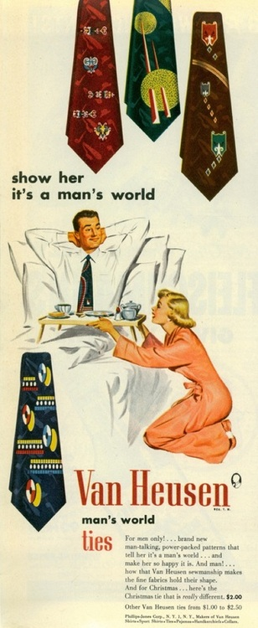

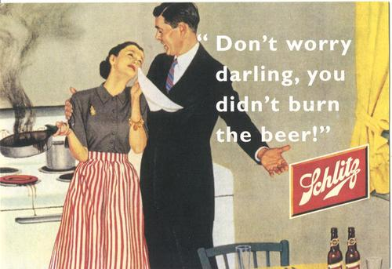

Three decades later, the feminism began to progress rapidly. It opened doors for women to evolve and metamorphosis into career-driven, ambitious independent human beings. Women were sharing the male job positions. According to the The Atlantic “Women seem to be crowding into sectors of the work force traditionally occupied by men” (Guilder, 1). At the time the women were paid less, so it cheaper to hire women than men. For this reason, the men would become imidated and worried of losing their jobs. To save the humiliation, they would degrade the women and treat them like the poor. A though illustration of this is presented in bell hooks essay, where she says “They were almost always portrayed the as shiftless, mindless, lazy, dishonest, and unworthy,” (484). To overcome this kind discouragement encouraged the women to prove their worth. They had help. The advertisements industry, media, and television shows acknowledged this and further nurtured them. See example below:

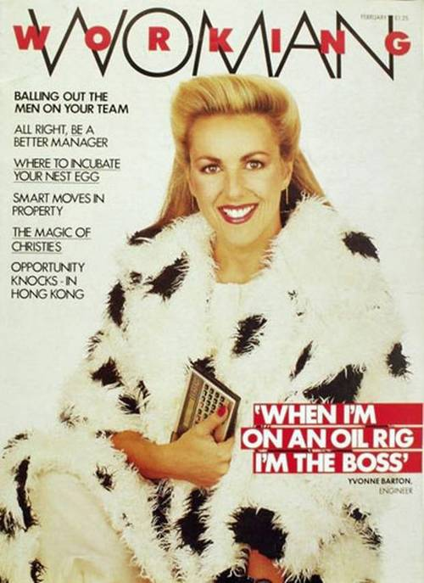
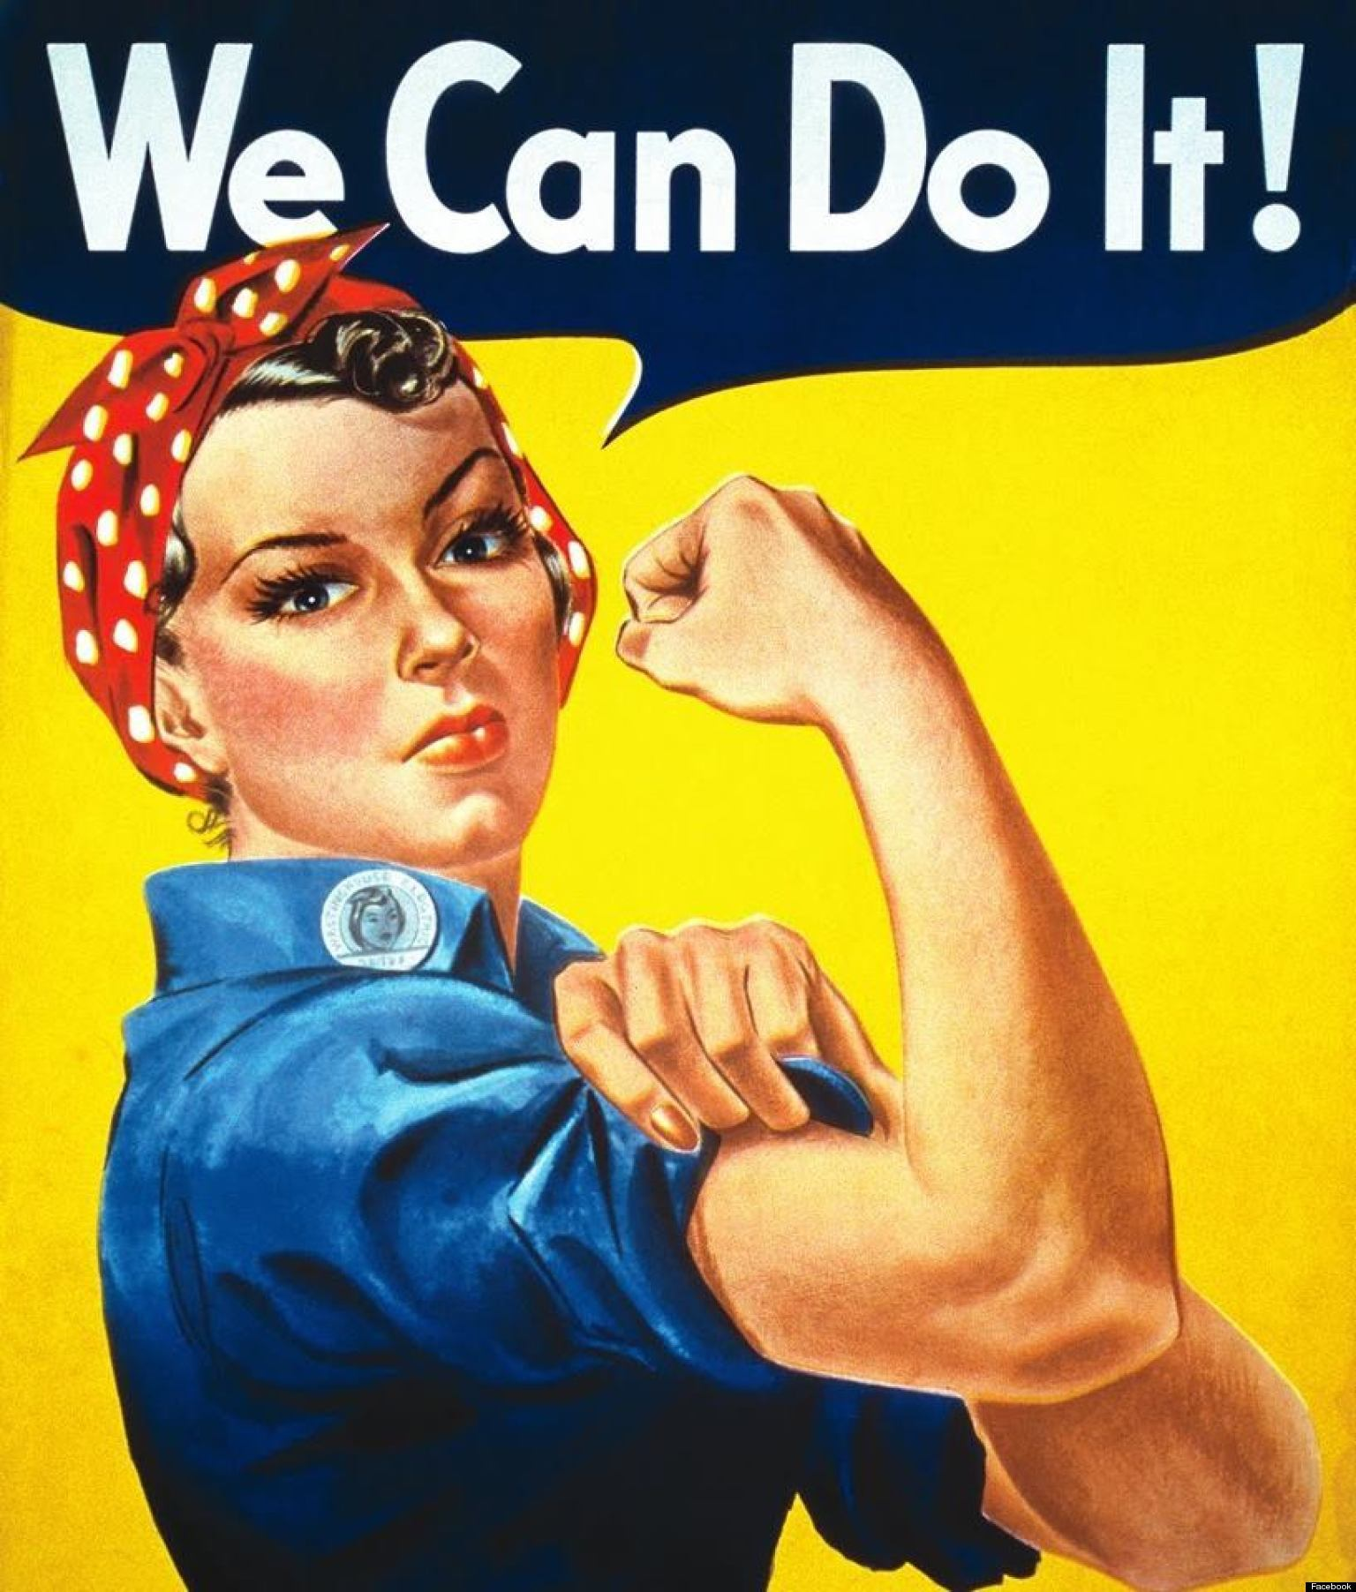

Popular tv shows such as Friends give proof. For example, the very first scene of the show shows Rachel Green ditching the rich marriage for a life to be independent and hold down her own job. Her friends, Phoebe and Monica have also traded in for being married early and raising a family to holding down a job and getting army later in life. Further, Sabrina the teenage witch, is a tv show about two witch aunts Hilda and Zelda raising and teaching their witch niece Sabrina to control her magic powers. In the show, the three main characters do not marry until very late in life and are seen going to school for an education. Other popular talk shows, like the Coby Show depicted marriage switching gender roles or acting as each other's equal, rather than the traditional male versus female. For this would have been considered a taboo, before the 1980's and 1990's. The Cosby show rose the feminism and women became more popular in the labor force. Lastly, in the show, Mrs. Huxtable argues marriage is as give and take 50/50. Once again, the change in advertisements paralleled the progressive era.

In the twentieth centuries and twenty-first century, there was much talk about “The New Woman.” This label referred to women’s emergence as free from their dependence on men to become independent, political, bicycle-riding, career-minded persons.

In 2000’s, women are even more independent, strong and career-driven people. Here women are have a higher status and portrayed as intelligent and influential. During this decade, women in the media has been protraying the women more authentic as they becoming more confident in their skin. For instance, shows such as Grey’s Anatomy, Scandal, The Catch, Blackish. These are all roles where the women take the leading role. In these types of leading roles, women are portraying the “The New Women”. Someone is strong, independent, leader, and fearless. The women have evolved with the support of the men. Meantime, the men have evolved, to become the “New Man” potrayed by in “Post-Princess Models of Gender: The New Man in Disney/Pixar” by Ken Gillam and Shannon R. Wooden. In their article, the new man is potrayed as the “Armed with a new masculine identity, one that expresses feeling and acknowledges community as a site of power…,” (478).

In order to preserve this positive image, women should be careful and mindful of their actions, as they can deterate their individual power. these stereotypical portrayals of women over the years have created detrimental impacts on society. Although television ads are generally made to promote specific products, they may also have lasting effects on viewers, such as beliefs, values, attitudes, and behavior. Exposure to sexist ads is a contributing cause to many social problems, including behavior related to gender inequality and sexual harassment, while also contributing to the increasing reported cases of eating disorders.
As women became more assertive, independent career driven people, there has been significant and positive shift in how women are portrayed in media. Several organizations contributed to change the stereotypical views of women, for example, The White House Project. It brought pressure on television and cable networks to invite women to appear as experts on news and talk shows. I see more women experts on the sunday morning talk shows and powerful women anchors on respected television news shows (e.g., the PBS NewsHour and Washington Week). It appears to me that there are fewer inappropriate comments on the appearance of women candidates Of course, my view may well be influenced by what I choose to watch.

