Name
Course
Professor
Date
The Architecture and Urbanism of Pyongyang
Seoul was and is still a modern and ever-changing city. It has developed over time since the early 1950s to the current city of busting economic activity and modernity. I have resided in Pyongyang for the last 50 years, and am still impressed with the uniqueness of the city. Its urbanism and architecture have been shaped through ideologies shared from North Korea, to the rest of the world. The following paper aims at discussing the architecture and urbanism of Pyongyang through my experience in the past 50 years.
I moved from Seoul to Pyongyang in 1966 and have lived there for the rest of my life despite travelling a lot. My reasons for moving from Seoul to Pyongyang were both political and economic. The first reason I moved to Pyongyang was a political reason. I found the whole idea of reconstructing Pyongyang as a socialist or communism form of government as a means for me to contribute in the process through a positive manner. South Korea, at this time was expanding rapidly and no such opportunities for reconstruction were available. As a current professor and having undergone a graduate program in Seoul, I believed that knowledge and education were key themes or aspects of reconstructing North Korea. Another reason why I left is to focus on my teaching or learning abilities by empowering young North Koreans in terms of education and innovation. My passion and enthusiasm with education as well as innovation also led me to believe that I could apply my skills to train and educate young North Koreans in this time of need.
When I came to Pyongyang, I had to move from one district to the other based o work and reconstruction issues. I first worked at a cultural center teaching some arts and politics at a local university. I later moved to another art and cultural center in near Potongmun. When I came to Potongmun, I was impressed with the Potongmun western gate. The monument had been reconstructed a while back before I came and the mixture of this historical monument as well as modern apartments in the nearby area was just amazing. I got a 10th floor apartment that offered me a realistic and breath-taking view of the Potongmun. The modernistic mixture of a historical monument as well as modern apartment and office building was just amazing and something to be appreciated. The image below illustrates the reconstructed Potongmun gate that was done in 1955 alongside the numerous apartments and office building in the area (Meuser 77).
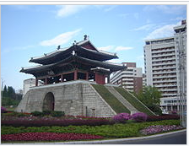
Figure 1. Potongmun (Meuser 77).
Another reason I selected the area is its closeness to the Cultural Center. The cultural center was abuzz with youth life. There I could meet with some of the most ambitious youths of North Korea. Moreover, it consisted of the traditionally-styled architecture of North Korea. It was clear that in this cultural architecture’s a theme to stick to the traditions of the nation were present. The roof, crossbeam, and pillar of the wooden houses feature a structural system that maintained their simplicity and elevation. This was a new and traditional illustration of realism (see figure 2).
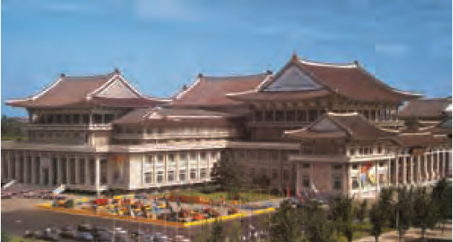
Figure 2. Palace of Culture Pyongyang (Changmo 83).
The mixture of traditional architecture with modern architecture was evident. The embracement of apartments was a key aspect in North Korea. Back in Seoul, people had not come to embrace the Western-style apartments as most found them to be inhabitable. The need for essential spaces such as a patio or small gardening area was too important and popular in Seoul. Nonetheless, the reconstruction in Pyongyang had its numerous influences. This included the acceptance and embracement of apartments as well as the western-styled apartments. The mixture of these two architectural approaches illustrated the nationalistic view of socialism where all the government’s and economic efforts were geared towards uplifting or benefiting the community under socialism. The development of these two architectural designs can be viewed in these recent apartments developed as a huge housing project in Pyongyang.
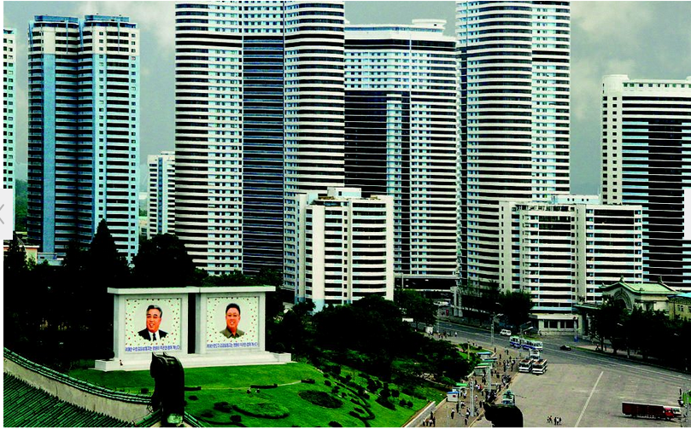
Figure 3. Mansudae Apartment in Pyongyang
Working with students, especially youth, has been one of the most amazing things to do in North Korea. One of my activities was teaching arts as well as political science at some of the numerous cultural centers. Here my work activity involved getting student to learn some of the Asia and Korean cultural games as well as dances. Based on the lack of space due to a reason or another, I would find myself turning to public space to utilize it for my lessons. One of the things I taught my students was how to play Baduk, a traditional South Korean board game. Most of the time we used the parking space to play board games by laying a mart and board and then crouching the traditional Asian style and having fun. Although this is not a mainstream activity in North Korea, the view of students as much as 15 seated on a parking lot did really change the urbanism of Pyongyang. Such use of public space to dance or play board games brought a new or modern feel to the urbanism of Pyongyang. The use of such space is popular and common in Seoul. However, it has started to take shape in North Korea. Even the existence of Pojangmacha can be traced in some parts of Pyongyang. This illustrates the changing mindset and influence the South Korean capitalists and culture have had on Pyongyang.
Another area of my work that has changed the architecture and urbanism of Pyongyang is the development of cultural study. Most of my students are innovative individuals. They are driven by curiosity, which means they love learning about new things. Part of my lessons has included lessons drawn from North and South Korea. The fusion of ideas and culture from these two states has developed a unique generation of youths. These youths focus on learning more and trying to understand themselves as well as their future. This has also developed into the Korean Wave where what is known as “Hallyu” is catching up. It is no secret most North Koreans consume media from South Korea in secrecy. This has also changed the urbanism based on the cultural consumption that is unique in its consumption as well as consequences.
Additionally, as a capitalist South Korean in North Korea, I still tend to teach capitalistic and other forms of education especially in politics. The advancement from increased censorship in education has greatly reduced in North Korea. Students can now access the internet from private internet network on campuses. Moreover, even the recent development of having the first ever privately funded university is milestones in Pyongyang’s urbanism and architecture. The development of education in a similar manner to western and South Korean approaches has also attracted students to Pyongyang. Most of Pyongyang is now populous with youths participating in different activities. This increase in student’s population has seen the development of apartments that can cater for the rising number of youth in Pyongyang. Additionally, the government has invested in more educational facilities including libraries, cultural centers, sports arenas, and universities. The sporting world has also been supported and founded on the high number of youths seeking an education. North Korea is known for its rich sporting heritage having held an international youths sporting event for the Asian countries. The architecture behind these developments has taken a unique twist with ideas of urbanism and socialism taking part in it all.
For instance, the People’s Palace of Culture was developed based on architectural inspirations stemming from socialistic ideologies. It has irregular surfaces that are complemented by traditional wooden fortifications bonded by a robust horizontal band. The roofing is also traditional based on the clustered presence attributes. To add to the twist, the May Day Stadium was constructed with modernized ideologies in mind (Changmo 84). It is developed to illustrate the idea or modernity or redefined cultural re-development in terms of architecture. The same case applies to most of the modern and renovated structures in Pyongyang. The whole idea of socialism is however present. The buildings especially sporting and cultural centers including libraries are developed to look beautiful, modern, refined and continent. In addition, the development of many public spaces including the Kim Jung City Square, Youth Libraries, Sporting Arena, and cultural palaces illustrate the whole ideology of socialism (Changmo 93). This goes to illustrate the post-modern architectural views of Pyongyang. The country is sending a message that socialism and work out and it all lies in its architecture. The focus on large and multiple public spaces illustrates that the economic benefits of businesses are reinvested in the community. This is not the same picture back in Seoul where the capitalistic nature means that businesses are privately owned and operate to make profits. However, the focus on education and ideology of socialism has enabled increased development of urbanism and architecture in Pyongyang.
In conclusion, my contribution in education as well as the arts has enabled increased acceptance and rise in the number of students in Pyongyang. From Seoul, I introduced the idea of sharing public space by playing board games on the parking lot. Moreover, through the increased education career, I was able to develop the whole focus on education in Pyongyang. Pyongyang is now one of the few cities in their world with multiple public spaces. These spaces have been developed though the an improved traditional architectural approach that includes traditional and modern designs. All in all this has changed the urbanism and architecture of Pyongyang.

Works Cited
Changmo, Ahn. Crow's Eye View: The Korean Peninsula. Eds. Hyungmin Pai Minsuk Cho, Pai Hyungmin, and Cho Minsuk. Archilife, 2014.
Meuser, Philipp, ed. Architectural and Cultural Guide Pyongyang: Backgrounds and Comments. Dom Publishers, 2012.

