Samsung Marketing Analysis

Name:

Institution:

Introduction
Samsung mobile company is a well-established manufacturer of smartphones as well as hot electronics. The primary product of the company is said to be mobile phones that create the bigger market share. Samsung majors in producing smartphones like the Samsung Note series and the Samsung Galaxy series. Currently, Smartphone international market is stiff with so many competitors trying to outdo Samsung. The market competitors include Nokia, Blackberry, Sony, Techno mobile among many others. Therefore, the company has applied marketing strategies in the form of the marketing mix to enable it to maintain its top position in the market segment.
International Marketing Mix of Samsung
The international marketing mix consists of four major sectors well defined to be the 4Ps of marketing. They are strategies put across to enhance competition any given product in the market. Samsung Company uses the 4Ps to secure a percentage of the mobile phone market.
Product Marketing Mix of Samsung
Product strategy is one of the things that have made Samsung to be at the top of the market. It produces a line of products including tablets, mobile phones, televisions, washing machines among others. When considering its position in the mobile phone market, Samsung has tablets, smartphones and standard phones as its line of product. From that, customers get a variety of products to choose. In the last few years, Samsung products have performed well making it win customer’s trust in the market. The company is seen to provide fast service from any of their products more so with their smartphones. Hence, product portfolio is a stronghold to Samsung Company.
Price Marketing Mix of Samsung
Due to the different categories of products, Samsung has to apply different pricing strategies to compete with other mobile phone companies in the world. The main challenge is that different markets in different countries have different pricing policies due to the difference in countries level of development and the fiscal policies. Samsung divides the pricing strategies according to the products they manufacture. The most common strategy is price skimming. The approach applies most in the smartphones market. The company sets high prices for these products due to the great features in them and then tends to drop the prices when other companies produce substitutes with the same characteristics. The second strategy is competitive pricing. Samsung in other products apart from the mobile phones uses competitive pricing to win customers. Despite the fact that Samsung cannot be ranked top in manufacturing home electronics like televisions, it sets lower prices of its products in the market. That helps it to win customers loyalty over strong competitors like LG who set their prices higher. Samsung merely uses penetrative pricing strategy since it does not enter the market late.
Place Marketing Mix of Samsung
Samsung has various ways of dealing with place marketing strategy. Placing of products in the market matters a lot since it determines the kind of customers who shall get access to the products. Samsung has enhanced channel marketing with all its focus lying on sales and service dealers, retailers and finally the distributors. Those are the three channels used by the company to make its products available in the market. Their modern retailers internationally include hyper city, Croma and Vijay Sales that are proud to sell Samsung products due to its branded products. Distribution strategy for this company is the most interesting since it has only one distributor in most of the cities worldwide. A good example is SSK in Mumbai, is the only Samsung distributor in Mumbai from whom other retailers get their products.
Promotion Marketing Mix of Samsung
Promotion in the world of marketing creates numerous opportunities for companies to offer their products to potential customers. Samsung as a manufacturer of mobile phones uses different promotion forms like the use of advertisements and sales promotions to promote their sales in the market. They make good use of marketing vehicles and gives offers to customers purchasing their products more so during the festive seasons. Above all, Samsung is associated with giving out discounts that motivate their clients to buy their products.
Comparison of Marketing Mix of Samsung in the US to that in Korea
The reason as to why the United States is viewed as the leading market for mobile phones in the world is because it occupies 55.1% of the total mobile phone market. The changing marketing environment in the US has affected most of the companies forcing them to design new marketing mix strategies. The changes are evident due to the huge advancement in technology. For example, below is a chart representing the market share of the mobile phone companies around the globe. It contains 2011 and 20012 results on the effect of each product in the global market.
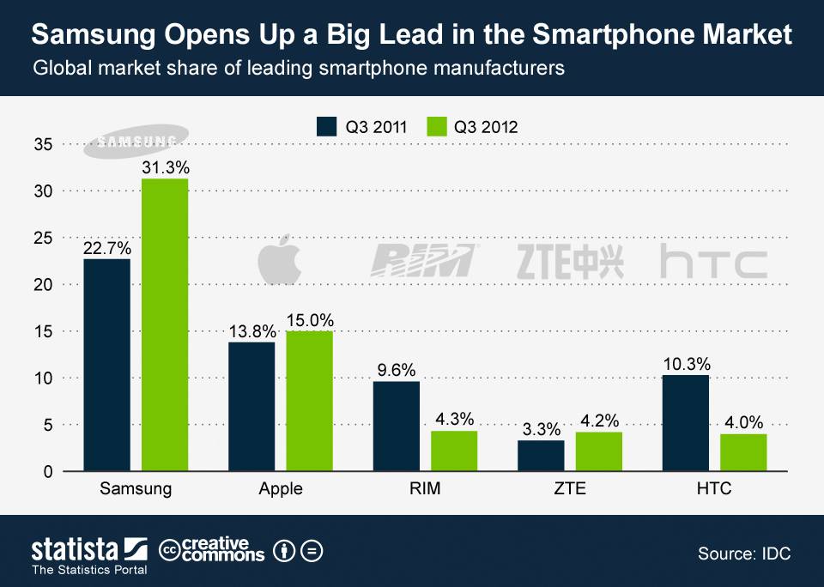
Due to the stiff completion in the US unlike in Korea where Samsung has its headquarters, the company has identified some marketing mix strategies that are different from those used in Korea to enable it to stay at the top of its competitors in the US. Unlike in Korea, the technology level of producing products is very high. Other companies like LG and iPhone are producing smartphones containing a high degree of technology. Therefore, Samsung has come up with a product strategy for manufacturing products features like cloud computing, personal health management and new operating systems. By so doing, the company is winning customer’s loyalty by providing the desired features.
On the other hand, Samsung has twisted the pricing marketing strategy in the US by setting a lower price for all its products to outdo its competitors. In Korea, the company uses the brand name popularity as a weapon towards setting higher prices since customers have already gained confident in their products. When it comes to promotion, Samsung has the strategy of forming a partnership with other companies as sponsors in return for advertisement of their products and flying their flag high. That has made it join hands with corporations in the US to try and spread its gospels to many people as possible. In Korea, promotion is not typical with Samsung since it already occupies ¾ of the smartphones market in the country. Regarding pace marketing mix strategy, Samsung has some distributors in the states unlike where in other places where it recommends only one distributor. That is to facilitate accessibility of its product throughout the states. In Korea, that is where Samsung headquarters are located hence no availability of their products is easy compared to that in the US.
Conclusion
The international marketing mix strategies of Samsung work as a lesson to other marketers in the world. That means marketers should aim at having multiple products in the market segment as it shall boost the growth of the business. They should also make proper use of the pull strategy despite it being expensive. The overall returns in future after using the approach are impressive.

