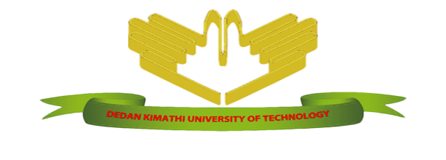
Dedan Kimathi University of Technology
Project Documentation For BIT 2221(Computer Systems Project)
Course:Bachelor of Science Information Technology
By: Laurenchia Muthoni (C025-01-0613/2014)
Farm Management System

I.Declaration
I declare that this project proposal my original work. It is my original work and has not been submitted for any degree or diploma examination in any other university.
Sign……………………………………. Date…………………………………………
LAURENCHIA MUTHONI
This project has been submitted for examination with my approval as the University supervisor.

Sign……………………………………… Date………………………………………..
Mr. Wandeto
Lecturer
Faculty of Computer Science and IT
Dedan Kimathi University of Technology

II.Dedication
I dedicate the entire work carried herein to my dear parents Mr. And Mrs Mugwiria, and the entire family at large all who have been my strength and inspiration all through my course. My sincere gratitude to my supervisor Mr. Wandeto for sacrificing his time from his busy schedule to guide me throughout the project . Finally I would like to appreciate all of you who have contributed to my success including my lecturers and classmates, remember that all your efforts are highly appreciated and you will never be forgotten for your stake in my life, God bless you all.

III.Acknowledgement
My sincere thanks go to individuals, groups and organizations that have made the development of this project a success. I am greatly indebted to the following:
- Dedan Kimathi University of Technology (DeKUT) for guiding me and giving me the highly required support throughout the project development. This support includes a serene environment to undertake the project, a 24 hour internet access, among others.
- I am also indebted to comment on the tireless work and effort of my project supervisor Mr.Wandeto. He sacrificed time from his busy schedule to guide me through the project period.I really benefitted from his pool of knowledge.
- My sincere gratitude also goes to all the lecturers who have ever taught me in any unit throughout my course work. Their knowledge has really contributed the most needed knowledge in the accomplishment of this project.
- My class mates for their fresh ideas that enabled me to develop this project in a more innovative way.
- My parents for paying my school fees.

IV.ABSTRACT
Currently Dedan kimathi farm manages their records as well as their transaction activities manually which is tedious, expensive, time consuming and erroneous. The Farm Management system is aimed at solving all these bewilderments and ease the operations of this farm .This system will keep track of all employees and customers of the farm hence smooth operations in the farm which wil increase profit by minimizing looting and also it will make retrieval of records easily. The system to manage a whole farm starting right from the the farm inputs, outputs, employees, the sales offered by the farm and the details of the customers and save the details in a database. Due to its automation, the system will reduce labor and paper work. The system will also help eliminate drawbacks and offer High security, less human error, Data redundancy can be avoided to some extent and Time wastage will be reduced

v.Table ofContent
Contents
I.Declaration 2
II.Dedication 3
III.Acknowledgement 4
IV.ABSTRACT 5
v.Table ofContent 6
Chapter 1: Introduction 9
1.1 Problem Definition 9
1.2Objectives 9
1.3 General Scope and Application of the project 10
Chapter 2 Literature review. 11
2.1 Introductions 11
2.2 Instances of similar system: 12
Chapter 3: Methodology 13
3.1 Introduction 13
3.2 Fact Finding Techniques 13
3.3 Requirements Analysis and Test Cases 13
3.3.1 Functional Requirements 13
3.3.2 Functional Requirements 14
4.2.2 Non-Functional Requirements 15
3.4Resources 16
3.4.1 Introduction 16
3.4.2Hardware resources 16
3.4.3Software Resources 16
CHAPTER 4: 17
4.1 process analysis design 17
4.1.1Data flow diagrams 17
4.1.2Compoonent diagram 18
4.1.2Use case diagram 19
4.1.3Activity diagram 20
4.1.4Package diagram 20
4.1.5Flow chart diagram 21
4.1.6Class diagram: below 22
4.1.7Sequence diagrams 23
4.2Database design 23
4.3Screen design 24
4.4PRELIMINARY DESIGN 24
4.4.1System Design 24
5.1Introduction 28
5.2System Design 28
5.2.1Database 28
5.2.2Log in page 29
5.2.3Registration of users Page 29
5.2.4Sales records Page 30
5.2.5 Statements 30
5.4.6Cereals 31
5.4.7Animals registration page 31
5.3 TEST DATA 32
5.4OBSERVATION 32
5.4 RECOMENDATION 32
CHAPTER SIX 33
6.0 CONCLUSION 33
CHAPTER SEVEN 34
7.0 REFERENCES 34
7.1Appendix 35
7.2SAMPLE QUESTIONS USED DURING INTERVIEW 35
7.3 SCHEDULE 36
7.3.1Gantt chart 36
7.4 CODING 36
Table of figures
Table 1 36

Figure 1 17
Figure 2 18
Figure 3 18
Figure 4 19
Figure 5 19
Figure 6 20
Figure 7 20
Figure 8 21
Figure 9 22
Figure 10 23
Figure 11 23
Figure 12 24
Figure 13 24
Figure 14 25
Figure 15 25
Figure 16 26
Figure 17 26
Figure 18 27
Figure 19 27
Figure 20 28
Figure 21 29
Figure 22 29
Figure 23 30
Figure 24 30
Figure 25 31
Figure 26 31
Figure 27 32

Chapter 1: Introduction

1.1 Problem Definition
This system is intended to automate the activities of the Dedan Kimathi farm including sales and service delivery. The farm currently use manual and paper work systems to deliver services to their customers. Some of this services provided in the farm are absolutely tedious and indeed involve a lot of writing and recording .Consequently this leads to wastage of resources in terms of papers, ink and time. The paper work has been associated with a lot of errors, redundancy of data and lack of accountability. Also the records are subjected to theft and catastrophes like fire, and hence the need for a system to cater for all these problems. The system will be able to store records of all the farm employees, services offered.
Upon the completion of the system, the various users of the system will benefit from the system in the following ways;
- The system will enable customers to view farm products and other services remotely.
- The system will enable the manager to manage all the employees in the farm and arrange them well so that they can be easily supervised.
- The system will help in the provision of final report on daily, weekly and monthly basis.
- The system will increase security of information so that unauthorized persons are prohibited from getting any data.
- The system will maximise profit in the farm. This will be ensured by reducing any kind of looting in the business by recording systematically all transactions.

1.2Objectives
- The system will enable customers to view farm products and other services remotely.
- The system will enable the manager to manage all the employees in the farm and arrange them well so that they can be easily supervised.
- The system will help in the provision of final report on daily, weekly and monthly basis.
- The system will increase security of information so that unauthorized persons are prohibited from getting any data.
- The system will maximise profit in the farm. This will be ensured by reducing any kind of looting in the business by recording systematically all transactions.

1.3 General Scope and Application of the project
The farm management system will be applicable to Dedan Kimathi University of Technology farms regardless of location and mode of operation. The system will also be platform independent and therefore applicable to any combination of hardware and software.
The System can be used to manage the employees, calculate input and output of the farm produce, keeping record of the grains and animals in the farm.The system also shows the different sales in daily, weekly and monthly basis.

Chapter 2 Literature review.

2.1 Introductions
Many farm management tools aimed at farmers as well as advisors are not leaving the desk where they are developed. We know what the farmers should do but not so much about what the farmers actually do. In 1977 the Swedish University of Agricultural Sciences started the project “Farmers’ need and use of management tools” and in 1978 the project “Development of computer-based tools for education, extension service and research in farm management”. In 1979 the author of this chapter visited the U.S. and Canada in order to gather information for these two projects. The visit resulted in a structuring of information about the need for, and design of, computerized farm management tools (Öhlmér and Nott, 1979)“Gelb-Ohlmer.pdf.”. Farmers’ management tasks were presented as a hypothesized outline, and citations of several published studies ranging from case studies to large sample surveys were made to provide evidence about which management tasks the respondent farmers thought were the most troublesome. Four ways of using computer systems to provide farm management help were described and compared:
- Farmer owned programmable hand calculators.
- Farmer owned microcomputers.
- Organization provided interactive farm computing.
- Mail-in system with a maxicomputer.
Each way was described in terms of (a) the hardware for communication, storing data and doing computations, (b) the software (both the type of algorithm and computer language), (c) the delivery system that links the model together from hardware through end use, and (d) the use actually made of the computer output by the farmer (i.e., the using system). The final part of the study was a case study of computerized farm management tools available to Michigan farmers at that time and how they compared to the outline of management tasks.
Nowadays, “computer literacy” has improved, which has reduced the education constraint somewhat, but it has not affected the ability to understand the information content. The data entry problem has successively been reduced through automated data collecting (Nilsson, 1987). The initially high hardware and software price has been reduced considerably. However, the problem of slow adoption persists, and it is the same in other countries as discussed at international conferences as well as in other chapters of this book. Farmers with high education use IT but other farmers lag behind (Batte, Jones and Schnitkey 1990, Brink and Josephson 1986, Putler and Zilberman 1988, Öhlmér 1989). The aim of this chapter is to explain how human information processing may influence the adoption rate and to explore how computerized management tools could be designed to meet the needs of farmers. We will look in more detail at how farmers actually process and use information, and how computerized management tools might fit in.

2.2 Instances of similar system:
- Horse Farm Management System
The Jockey Club Information Systems' Horse Farm Management System (HFMS) is a management tool designed to assist farm personnel at all levels in managing information for more efficient day-to-day operations“Horse Farm Management Software - Horse Farm Software for Your PC.html.”. The major weakness is that this system only helps to supervise and manage the employees in the farm.
- Smart Monitoring and Feedback
This is a system developed to manage the feeding, fertility and healthy of your herd. It is also called the Smaxtec system(“ smaXtec.html,” n.d.). The major weakness of this system is that it only manages the farm animals.
DeKUT FARM SYSTEM
Our system can be able to manage the employees, and also be able to take records of the farm produce, that is inputs and outputs. .The system will manage a whole farm starting right from the the farm inputs, outputs, employees, the sales offered by the farm and the details of the customers and save the details in a database. Due to its automation, the system will reduce labor and paper work. The system will also help eliminate drawbacks and offer High security, less human error, Data redundancy can be avoided to some extent and Time wastage will be reduced“Dedan Kimathi University of Technology - DeKUT Farm.html.”.

Chapter 3: Methodology

3.1 Introduction
Several fact-finding techniques that were used in the preparation of developing the system. The following are the techniques that were used to enable the analysts gather facts that concerns the development of this project. The facts we got will be used as user and functional requirements of the system because they depict what the users expected the system to do on its completion. The techniques that were used included:

3.2 Fact Finding Techniques
- Observation
This is the best method because the analyst will observe and record data of interest. The analyst observes the operations of the current system and begins to formulate questions and then finally draws a conclusion on the basis of what is observed. Through our observation we saw how the manual system affected both the farm managers, employees and customers hence this stimulated the need for a good computerized system to ease their operations.
- Interviews
This is a one-to-one conversation between the system analyst (who is the interviewer) and the users (interviewees). We interviewed the manager, employees and support levels and some customers to determine the challenges they face with the manual system. This enabled us to find some user requirements and their suggestions and recommendations concerning the design of the proposed system.

3.3 Requirements Analysis and Test Cases

3.3.1 Functional Requirements

3.3.1.1 User Login
Description of Feature
This feature is used by the User (employee/manager) to login in to the system. They are required to key in the username and the password before they are granted permission to enter the system. It is verified and the invalid username and password are not allowed to enter the system.
Stimulus: User enters the username and the password at the textbox provided.
Response: System verifies the username and the password with the data inside the database. If the username and the password do not match, the system will not allow the user to login and they are taken back to login page. If valid, the users(admin/supplier/customer) are redirected to a message telling the that login was successful.
Functional Requirements
-Username is provided when they register with the system.
-The system must only allow the user with valid username and password to enter the system.
-The system must be able to perform authorization process which decides what the user’s level can access to.
-The user must be able to logout after they are finished using the system.

3.3.1.2 Register a new users or farm products
Description of Feature
This feature will be used by the manager to register a new product or service to the system so that it can be availed to the users or the clients for the hiring process.
Stimulus/Response Sequences
Stimulus: The admin presses Add New product.
Response: System prompts add new product form.
Stimulus: User enters the product details in the form provided.
Response: System ensures that the information supplied by the user (Admin) is of the correct form through the input type of the system textboxes. After the user presses the add button a message will be provided informing the user that the information has successfully been entered in to the database.

3.3.2 Functional Requirements
-System must be able to verify the information.
-System must enter the correct information on the textboxes.
-Repeated information must be prevented from the system database.

3.3.2.1 View product/service provided
Description of Feature
This feature allows the user to view the information about the products or services available in the farm at any particular time.
Stimulus/Response Sequences
Stimulus: User selects the clicks on the list of the available product categories.
Response: System searches the record from the database and displays the entire details to the user.
Stimulus: The user can then choose to hire the product or not.
Response: If the user chooses to add, he/she clicks on the button and the item is added.

4.2.2 Non-Functional Requirements

3.3.2.2 Efficiency requirements
With the farm system, the user should be able to see the farm products.

4.2.2.2 Reliability requirements
The system must perform accurately towards the manager request. For example, when the manager saves the adds details to the system, after he reviews the details later, they must be according to the latest details that was updated. Moreover, print daily reports.

3.3.2.3 Usability requirements
This system must be designed with user-friendly and easy to use by all the users so that they can perform their tasks nicely. It must have a clear instruction to guide the user through the system. Besides that, the description of error message should be clear as well as the description of the success message.

3.3.2.4 Implementation requirements
In implementing the system, it uses java as the main programming language and tools.

3.3.2.5 Delivery requirements
The whole system is estimated to be done in 4 week’s time and the documentation will be done in 1. The full system will be delivered in a softcopy method while the documentation will be delivered in hardcopy and the softcopy as well.

3.3.2.6 Legislative requirements
The information that is supplied by the users must be acknowledged by the authorized people so that it does not violate the law. This information is copyrighted and protected by the law. Besides that, when the visitors want to become members of the system, they must agree with the rules stated in the system.

3.3.2.7 Security requirements
This system must be highly secured in the login part. This is because some of the privileges are only allowed for the manager level. The other non-specialized tasks are allowed for the other users.

3.4Resources

3.4.1 Introduction
For the comprehensive completion of the farm management system up to deployment, both hardware and software resources will play a very critical role of which the system cannot be developed with their absence. For instance, the system will ultimately need a printer to print final reports which will be needed either weekly or monthly basis by the administration. Furthermore the computers will need to be interconnected by network cables and other networking devises which will indeed make the hardware part.

3.4.2Hardware resources
- Printers
- Ethernet cables.
- Scanners.
- Keyboard.
- Mouse.

3.4.3Software Resources
- Netbeans IDE.
- MYsql database management system.
- Antivirus.
- Microsoft office
- Browser eg.Firefox maxilla.
- Network drivers.

CHAPTER 4:

4.1 process analysis design
Timing is a very important aspect of every computerized system. When the timing is right, all operations are efficient and as a result the system is said to be effective. Timing in this case is considered in areas of system response time at the peak of processing work. It involves the consideration of timely data movement into the system and of information out of the system, like updating the master file. Timeliness in terms of the operations of the system is very important as a delay in one process affects the start of another process.
The operation of the system will communicate to the user through a help of the program modules. To ensure that data security is maintained in the system, we will consider who is to be allowed access to data in the system, access to the database. Different users had varying access levels to the system. To enhance system security, the users will be assigned password, user names, a user group and access privileges. This will ensure only authorized users access the system and undertake specified operations.

4.1.1Data flow diagrams
Figure 1: DFD
Data flow diagram-level 1

Figure 2: Level1 DFD
4.1.2Compoonent diagram
Figure 3: Component diagram

4.1.2Use case diagram
Insert record
Sell products
login
Figure 4
employee

login
Register employee
Delete/update record
Figure 5: usecase
manager

View records

4.1.3Activity diagram
Figure 6: Activity Diagram

4.1.4Package diagram
Figure 7: Package Diagram

4.1.5Flow chart diagram
Figure 8: Flow chart diagram

4.1.6Class diagram: below
Figure 9: class diagram

4.1.7Sequence diagrams
Figure 10: Sequence diagram

4.2Database design
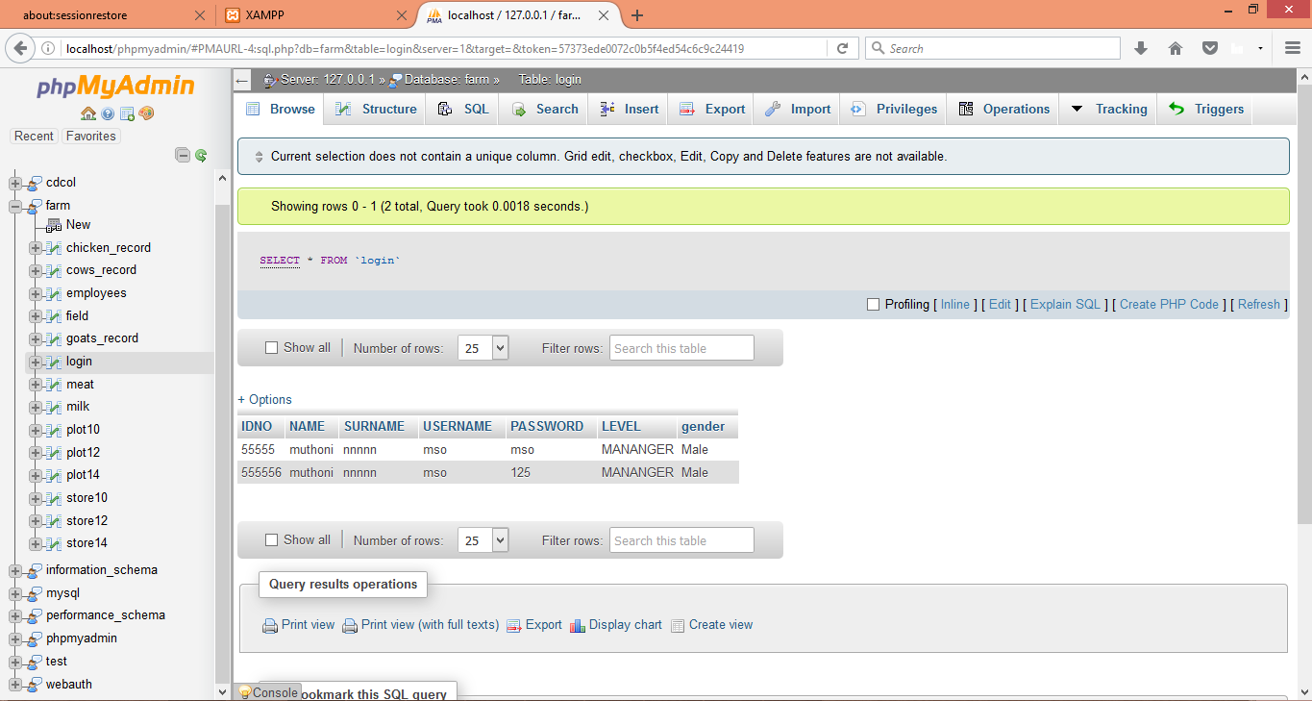
Figure 11: Database design

4.3Screen design
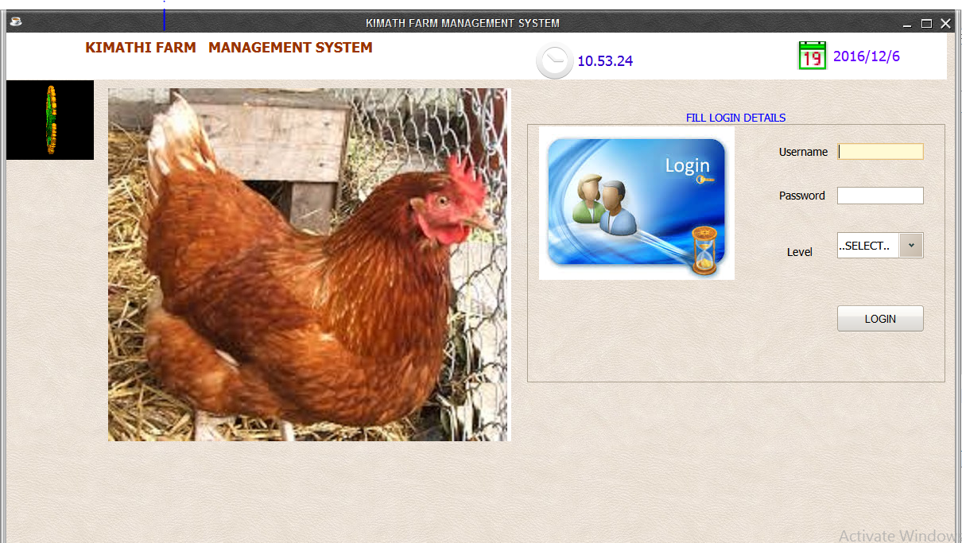
Figure 12: Screen design

4.4PRELIMINARY DESIGN

4.4.1System Design

4.4.1.1Database
Figure 13: Database
This contains tables of the records. This is where the information about the farm is stored

4.4.1.2Log in page
Figure 14: login
The log in page contains two fields for the username password and the level. Depending on the username entered, the system is able to direct you to either the employee or manager homepage.

4.4.1.3Registration of usersPage
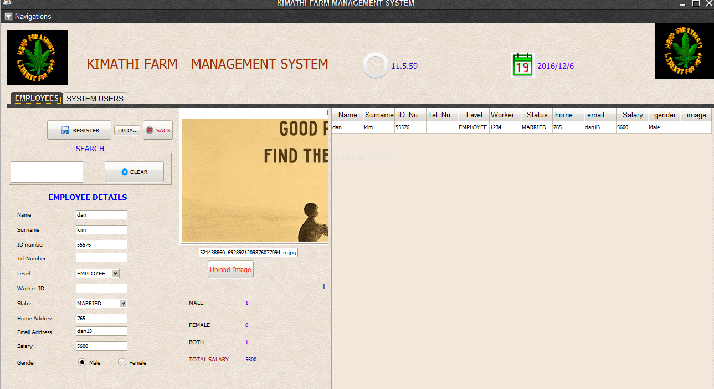
Figure 15: user registration
New users are added in the system. One can also chech who is using the system.

4.4.1.4Sales records Page
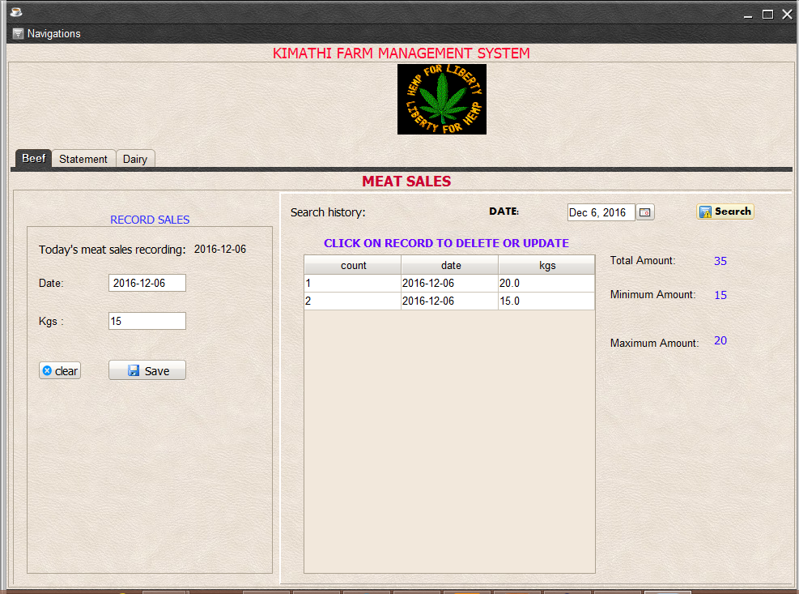
Figure 16: sales records
Sales made on meat and milk are recorded in this page. The date of sale and the amount is recorded.

4.4.1.5 Statements
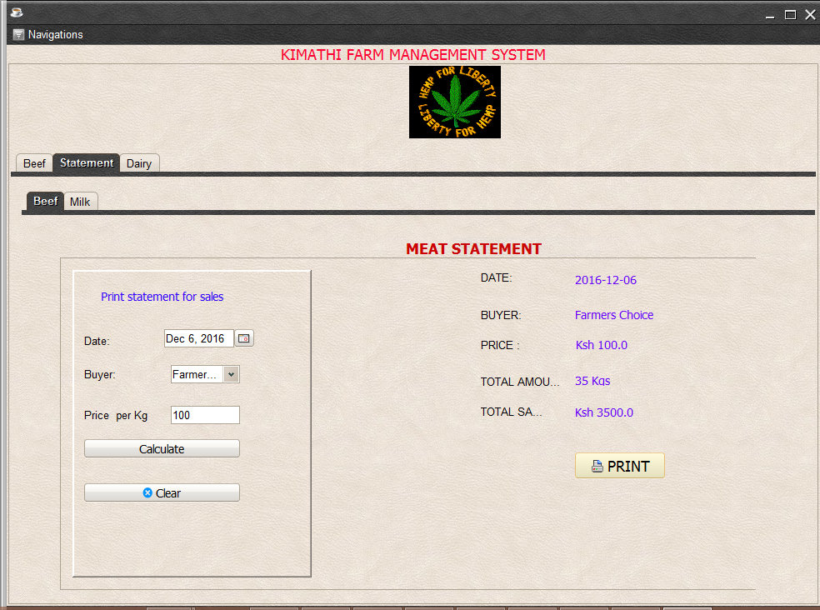
Figure 17 : statements
The total sales made per day are calculated and the record printed.

4.4.1.6Cereals
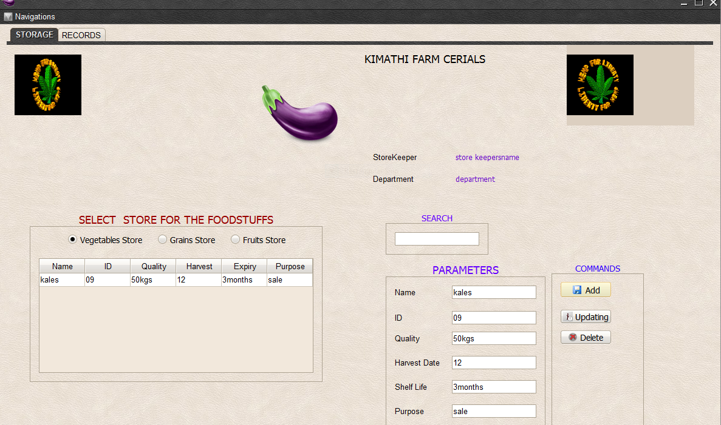
Figure 18: Cereals
Cereals from the farm are recorded here.

4.4.1.7Animals registration page
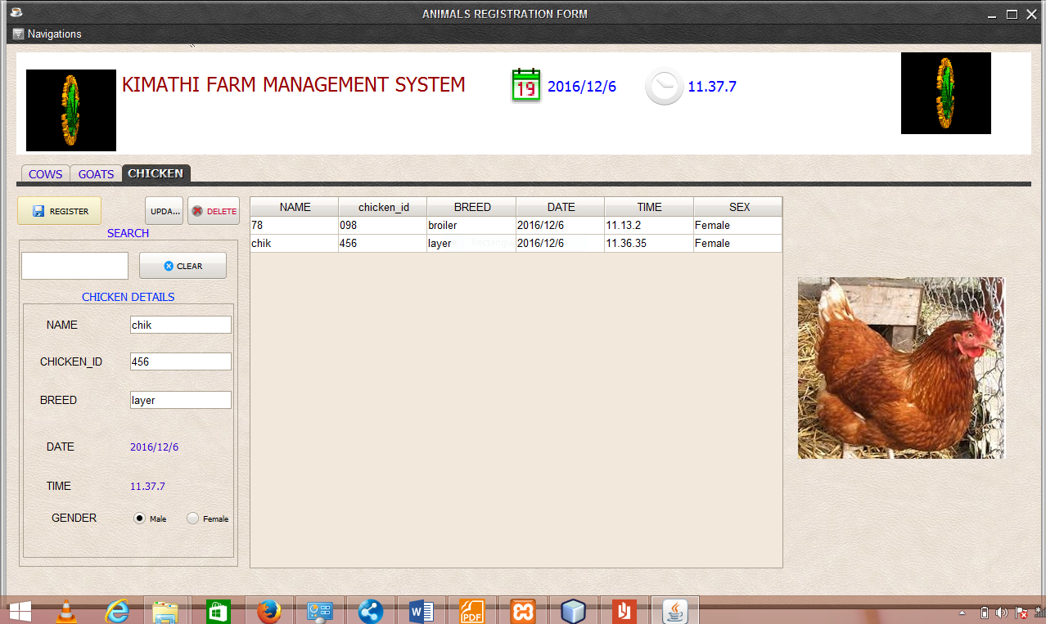
Figure 19: Animals registration
Cows, goats and chicken are recorded here.

CHAPTER FIVE:
IMPLIMENTATION AND DEPLOYMENT

5.1Introduction
After analyzing all the requirements and designing the system, the next step is to implement the system. This is done through coding and database design. I wrote the codes using Jav language. I then designed the database using XAMMP(mysql). Below are some screenshots from parts of the system.

5.2System Design

5.2.1Database
Figure 20: Database

This contains tables of the records. This is where the information about the farm is stored

5.2.2Log in page
Figure 21: login

The log in page contains two fields for the username password and the level. Depending on the username entered, the system is able to direct you to either the employee or manager homepage.

5.2.3 Registration of users Page
Figure 22: user registration
New users are added in the system. One can also chech who is using the system.

5.2.4Sales records Page
Figure 23: sales records
Sales made on meat and milk are recorded in this page. The date of sale and the amount is recorded.

5.2.5 Statements
Figure 24: Statements
The total sales made per day are calculated and the record printed.

5.4.6Cereals
Figure 25: cereals
Cereals from the farm are recorded here.

5.4.7Animals registration page
Goats
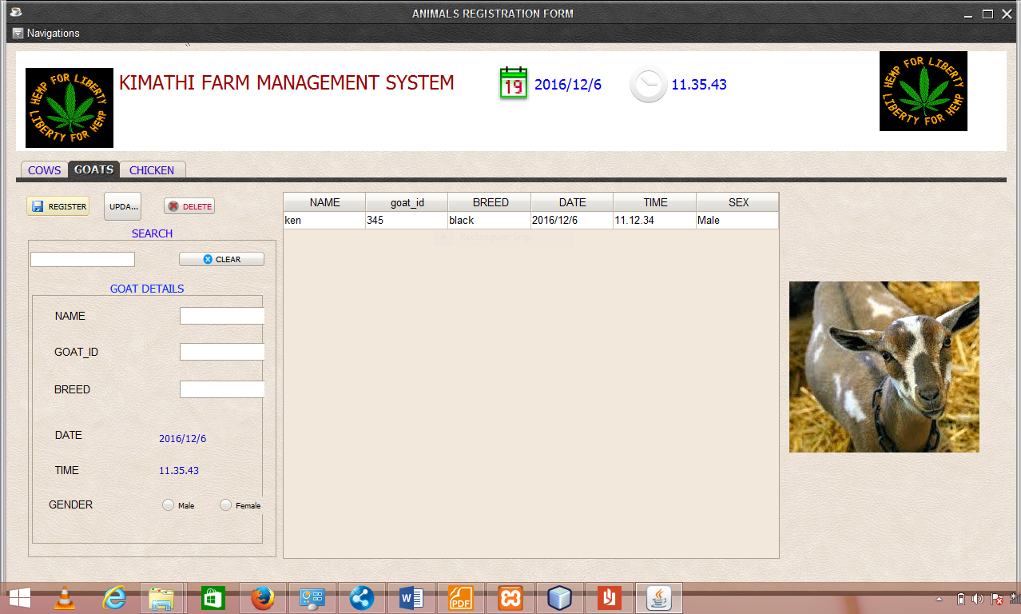
Figure 26: Animals

Figure 27: Animals

Cows, goats and chicken are recorded here.

5.3 TEST DATA
Code
The code was written in java language using Neatbeans IDE and the database using the Xampp.

5.4OBSERVATION
It was observed the the use of the automated system reduced labor and paper work. The system will also help eliminate drawbacks and offer High security, less human error, Data redundancy can be avoided to some extent and Time wastage will be reduced.

5.4 RECOMENDATION
Due to its automation, the system will reduce labor and paper work. The system will also help eliminate drawbacks and offer High security, less human error, Data redundancy can be avoided to some extent and Time wastage will be reduced.

CHAPTER SIX

6.0 CONCLUSION
Being a long a and involving process to find the requirement analyze and design the solution , I can say that the process provided an opportunity for me to learn more and increase in knowledge concerning programming.
Computers and technology provide a great opportunity to organizations, institutions and geographical entities as counties and countries which can reduce labor and paper work in the farm. The system presented in this article provides a solution to many problems related to the farm.

CHAPTER SEVEN

7.0 REFERENCES
Navathe, E.(2000). Fundamentals of Database Systems.New York:HarperCollins.
www.vb.netJunkies.com
http://www.studymode.com/essays/Project-Proposal-For-Hotel-
Reservation-System-1235938.html
“Dedan Kimathi University of Technology - DeKUT Farm.html,” n.d.
“
Farm Bill Safety Net Payments Provide Producers Small Cushion
“Dedan Kimathi University of Technology - DeKUT Farm.html,” n.d.
“Examples of Dedications _ Scribendi.com,” n.d.
“Gelb-Ohlmer.pdf,” n.d.
“Horse Farm Management Software - Horse Farm Software for Your PC.html,” n.d.
“smaXtec.html,” n.d.
“RFP_Farm_Addendum1.pdf,” n.d.
" (Castle, Becker and Nelson 1987, p.3).
(Kay and Edwards 1994, p.9).
(Heady and Jensen 1954, p.6).
(Butterfield 1910, p.3).
(Dillon 1980)
Encyclopedia of Animals Science,edited by W.G Pond and A.W Bell
(Dillon and Anderson 1990, Ch. 6).
(Hellriegel and Slocum 1986, pp. 25-9
Toffler (1980, pp. 235-8)

7.1Appendix
Code
The code was written in java language using Neatbeans IDE and the database using the Xampp.

7.2SAMPLE QUESTIONS USED DURING INTERVIEW
RESEARCH INTERVIEW QUESTIONS.
Interviewee’s position(employee/manager):
Time of interview:
Date of interview:
Questions for managers:
- Steps involved in updating farm data?
- How are you involved in data updating?
- Are there challenges in regard to the current system you use? If any may you specify some of them?
- Would you recommend that changes, i.e. computerization of the system be implemented on the system?
- What suggestions would you recommend to make those changes help improve on the systems way of use ?
Questions for employees:
- What is involved in the farm that is the tasks undertaken?
- How were you involved in farm? what list of issues and items were in updating the data
- What means or system was used in the farm,
- Are there challenges in regard to the current system that is used?
- Would you recommend that changes, i.e. computerization of the system be implemented on the system?
- What suggestions would you recommend to make those changes help improve on the systems way of use?

7.3 SCHEDULE

7.3.1Gantt chart
 | 20/10/2016  1 WEEK | 1 WEEK | 3 days | 2 days | 1 WEEK | 1 day
Project plan
Project Proposal and acceptance
Analysis and requirement specification.
Database design and client side interface
Coding
Integration of the modules, testing and final report.

Table 2: Gannt chart

7.4 CODING
The code was written in java language using Neatbeans IDE and the database using the Xampp

“Examples of Dedications _ Scribendi.com.”
Ibid.
“Dedan Kimathi University of Technology - DeKUT Farm.html.”
“RFP_Farm_Addendum1.pdf.”

