APPLICATION OF MATHEMATICAL SCIENCE TO URBAN SERVICES
Name of Student
Institution

Discussion
Some of the things to put in consideration when coming up with the best route for garbage collection in any town using mathematical Science Garbage collection is one of the most crucial tasks in any town to enhance proper maintenance of the environment. Keeping the town green and clean. Operational Research has a vast application in life problem and this is one of them i.e. creating a garbage system that works efficiently and effective. Through this discussion board, we are going to discuss the subject.
The first step that one should undertake is to do familiarize himself with the town by doing a survey to determine the number of streets in the town and the streets with garbage collection point. This can be easily done by consulting the municipal council of the town. The town is then represented in a graph e.g. fig 1.0. where edges of the graph represent the streets and vertices represent the intersections of the streets.
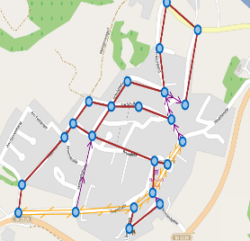 fig 1.0
The garbage collection is then reduced to a Chinese Postman problem, where every street is to be travelled in order to pick the garbage with the least possible distance covered to minimize fuel cost through deadhead travel and every street is traversed at least once. The next thing you need to put in place is to make sure the graph drafted is connected and the valence of every vertex is even. This can be done by eulerizing the graph i.e. duplicating the existing edges of a connected graph to make all vertices which are odd to be even. Then optimal route is determined to meet the optimal policy of us using the minimal fuel and time but across every road to collect the garbage, at least once without adding new edges.
Post from student 1
In addition to what you’ve enlightened us with, the purpose of eulerizing the graph is in order to make it possible for the graph to have a Euler circuit because when you have more than 2 odd vertices there can never be a Euler circuit or a Euler path and there is no possibility of one travelling along all the edges of the graphs without having to traverse them again. This prevents the garbage collector from deadhead travel and thus saving on cost. The cost incurred is directly proportional to the amount of travel. This can be obtained by the following mathematical model: COST of A ROUTE = Cost of traversing Original Edges in the graph + Cost of Deadhead Travel.
Post from Student 2
Thank you for the insight we are receiving through this discussion board. Developing a garbage collection system in any town is one of the application of mathematical science to solve the problems that come our way in our day to day life like the professor Thomas Magnanti Made an observation that "Every problem is a Euler Circuit Problem or related management science problem after which one has to develop the solution method”. If I may ask a question. What do you put in place when calculating the route cost?
Response
When calculating a cost of a route of a eulerized graph. One thing you need to have in place is that you should have all the edges weighted i.e. they should have values assigned to them based on their length. This is in order of optimising the cost as low as possible and shorten the time of collecting garbage in any street. A good Eulerization should have the smallest number of duplicated edges and the sum of the lengths of the paths pairing up vertices is as minimal as possible. The best path can also be obtained using a matching problem. Also take into consideration the length of the edges when finding the best route for the garbage collectors which plays a major role in finding the shortest route possible. 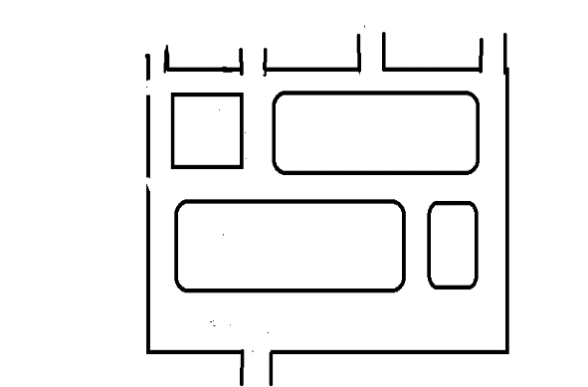fig1.1
2(a)The above is map representing few streets in our neighbourhood.
(b) A graph of our neighbourhood
This was obtained by representing the intersections of the streets as vertices and the edges represent the streets
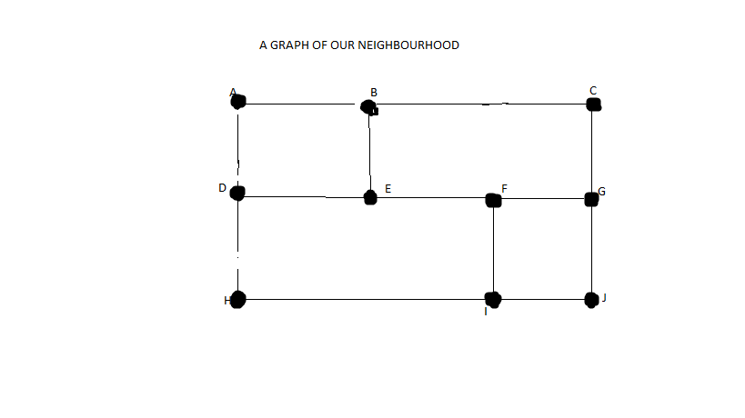
(c)The route canvas which is shown with arrows was decided upon eurelizing the graph. This because vertices B, D, E, I, F, G had odd degree i.e 3 and thus we had to duplicate the edges to make it possible for a Euler circuit to be generated. The digraph is the Eurelization of the original map which is directed to show the route which is to be travelled during the charity walk. The red edges in the digraph represent the duplicated edges which are duplicated and then they are “squeezed” so as not to introduce another edge which was not in the graph before eulerizing it. The route ABEBCGFGJIFEDHIHDA is a Euler circuit because it starts and ends at the same vertex A. This is the best charity walk route because it minimal edges and the sum of the lengths of the paths pairing up vertices is minimal.
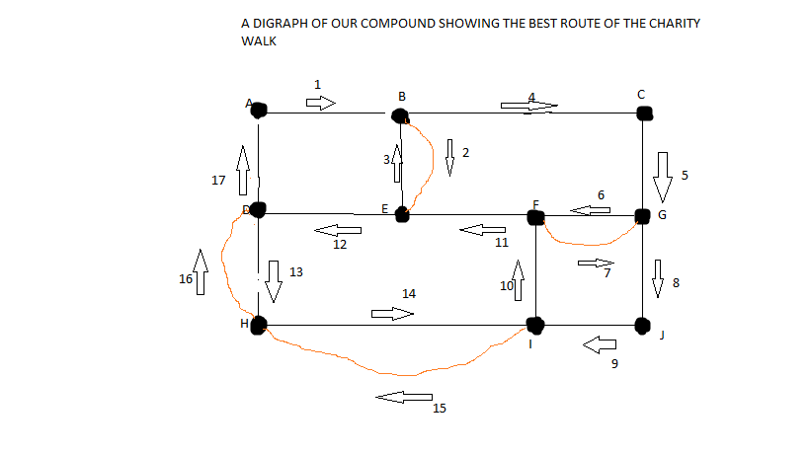

References
COMAP. (2015). Urban services. In For All Practical Purposes(High School), Mathematical Literacy in Today’s World, (10th ed., p. 912). W. H. Freeman,.

