Due 11/3
150 Points

Midterm Essay
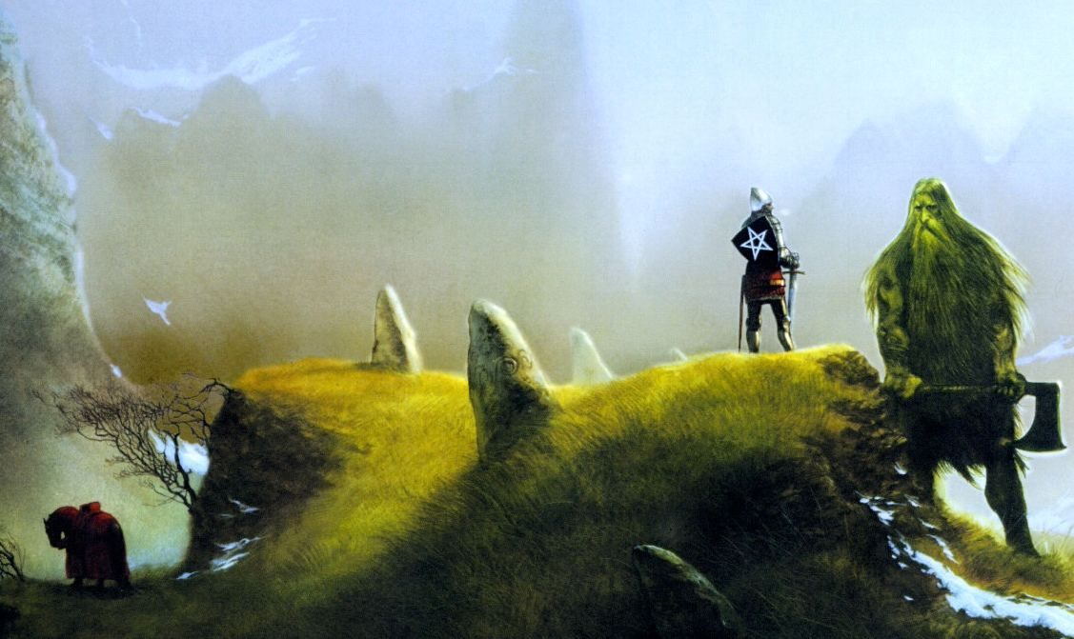
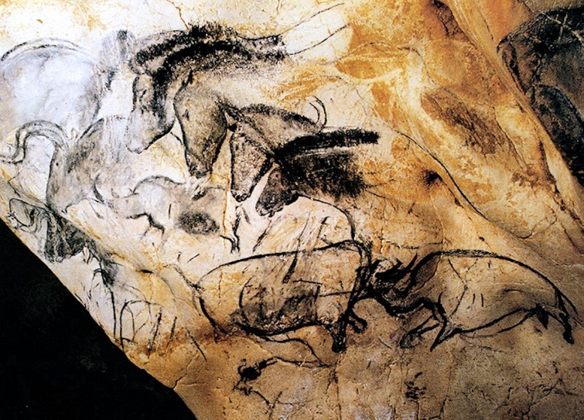
- Select any two texts that we have read or viewed so far in the course and explore how they interact with one another.
- While exploring this interaction you may do some comparing and contrasting, but this is not the limit of this assignment.
- Part of this essay is coming up with your own argument to support your claim, so try to find something that you find interesting. It is much easier to write about something you have an interest in, and I will likely find it more interesting when I am reading it.
Essay Parameters
The various works that we have looked at so far will provide the grist for this essay. I want you to use at least two of the texts we have read or viewed so far in the class. Your goal is to examine the texts and assert a claim that attempts to connect them in a meaningful manner.
Basic Requirements
- 3-4 full pages in length
- Works with at least two texts from the class.
- Have a title!
- Standard font, spacing, and margins (Times New Roman, 12 point font, double-spaced, 1” margins)
- Parenthetical citation using MLA guidelines
Tips for getting started on this project
- Go back into the texts and look at your notes. Do a re-reading if necessary. What specific passages, arguments, and ideas draw your interest? In other words, what’s still worth talking about?
- Start making connections between these lingering ideas from the essays to other details in your life. These don’t have to be personal details about friends, family, or your own life; rather, they can be details that swirl around your daily life.

