Positioning
Student’s Name
Institution Affiliation

Product/ Brand Positioning
Product positioning is the distinctive placing of a product in a market comprising other products (Kotler & Armstrong, 2015). It a place that a specific brand occupies in a consumer’s mind and how it is distinct from the competitors’ products. For effective positioning, unique features are essential in a product. Consumers are motivated to buy a product or a service on the perceived uniqueness of its price, quality, or value.
Components of Brand Positioning Statement
Brand Personality – refers to the brand’s uniqueness that distinguishes it from the other brands in the market.
Brand Value – refers to the connection between the consumer sacrifice and the benefits obtained from the brand.
Brand Promise – refers to the effectiveness of the brand in meeting the expected results. Customers expect to experience the differentiating benefits from a product or a service.
Brand Essence – refers to the reality of experiencing unique experiences of a brand
Target Audience – relates to the audience that the brand is designed to attract and influence the purchasing behavior (Kotler & Armstrong, 2015).
Sample Brand Positioning Statement – Air Asia
Positioning Statement - “Now Everyone Can Fly”
The word ‘everyone’ means every one intending to fly can fly signifying affordability of the airline tickets due to low prices. The statement targets the air travelers, obtain value from their money by flying and arrive at their destination through the airline. Brand positioning involves essential attributes in the minds of the consumers according to according to Armstrong and Kotler (2015). Air Asia stresses on the affordability of their airline tickets for travelers. The brand distinguishes itself from competitors on affordability based on low price. The brand positioning statement motivates travelers to try the airline services with disregard to their income level.
Figure 1:Brand Positioning Image
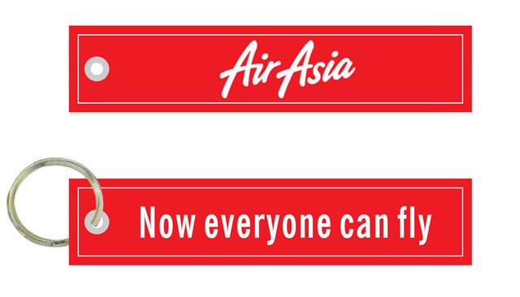
("Image: Aliexpress.com : Buy Air Asia Airasia Now Everyone Can Fly ...", 2017)

References
Image: Aliexpress.com : Buy Air Asia Airasia Now Everyone Can Fly .... (2017). Google.com. Retrieved 9 November 2017, from https://www.google.com/imgres?imgurl=https%3A%2F%2Fae01.alicdn.com%2Fkf%2 HTB1yHcBSXXXXXcjXpXXq6xXFXXXH%2FAir-Asia-Airasia-Now-Everyone-Can Fly-Aviation-Motorcycle-Keychain-Red-Edge Embroidery.jpg_640x640.jpg&imgrefurl=https%3A%2F%2Fwww.aliexpress.com%2Fs ore%2Fproduct%2FAir-Asia-Airasia-Now-Everyone-Can-Fly-Aviation-Motorcycle Keychain-Red-Edge Embroidery%2F1306705_32822871673.html&docid=aMRe6ZbE2AN56M&tbnid=aE mZORKob3K1M%3A&vet=10ahUKEwj69qevl7HXAhUIeCYKHfVJDsI4ZBAzCB4o DAc..i&w=640&h=366&bih=635&biw=777&q=air%20asia%20logo&ved=0ahUKEwj 9qevl7HXAhUIeCYKHfVJDsI4ZBAzCB4oHDAc&iact=mrc&uact=8
Kotler, P., & Armstrong, G. (2015). Principles of marketing. Harlow, Essex: Pearson Education Limited.

