Historically significant recall events 2006-2016
Product | Company | Year | Recall
Spinach | Natural Selection Foods | 2006 | Recall costs and estimated sales losses amounted to $350 million
Pet food | Menu Foods (Canada/USA) | 2007 | Melamine contamination of wheat gluten used in various pet foods due to Chinese supplier resulted in recall of 60 million containers of pet food. $42,000,000 in losses attributed to  the recall alone, not including lost sales.
Peter Pan Peanut Butter | ConAgra Foods | 2007 | Est. losses ~ $78 million in recall costs + ~ $55 million in lost sales. Est. facility refurbishment ~ $15 million
Pot Pies | ConAgra Foods | 2007 | Voluntary recall of Banquet & private label pot pies due to salmonella concerns. Direct recall cost = $27 million.
Historically significant recall events 2006-2016...2
Product | Company | Year | Recall
Tomatoes & peppers | Various | 2008 | FDA incorrectly linked Salmonella outbreak to tomatoes & cost the tomato industry ~ $350 million. Eventually, the contamination was traced to jalapeno and serrano pepper farms in Mexico.
Peanut products | Peanut Corp of America | 2008 | Salmonella-contaminated peanuts affected > 200 companies and ~ 2000 different products. Industry losses estimated at > $1B. PCA declared bankruptcy. Kellogg reported losing $70 million due to the recall.
Cookie dough | Nestlé | 2009 | National outbreak of illness from E. coli 0157 was linked to the product. Estimated recall cost = $30-$50 million.
Historically significant recall events 2006-2016...3
Product | Company | Year | Recall
Hydrolyzed vegetable proteins | Basic Food Flavors | 2010 | Salmonella contamination resulted in recall of ~ 177 products. Affected bulk, ready-to-eat & ready-to-cook products in the U.S. and Canada.
Eggs | Wright County Egg Farm | 2010 | Recall of >500 million shell eggs due to Salmonella contamination. GMA estimated loss ~ $100 Million to the shell egg industry.
Infant formula | Abbott Labs | 2010 | 5 million containers of Similac brand infant formula recalled due to possible contamination by beetles or larvae. Abbott advised that product returns reduced Q3  revenue by ~ $100 million.
Historically significant recall events 2006-2016...4
Product | Company | Year | Recall
Cantaloupe | Jensen Farms | 2011 | Deadliest foodborne illness outbreak in > 25 years. Listeria contamination results in > 30 deaths & hundreds of illnesses. Dollar volume of sales declined by 55.7% within 4 weeks & company declared bankruptcy.
Ground turkey | Cargill Meat Solutions Corp | 2011 | Largest meat recall in history | 36 million lbs. of ground turkey (=~ 6% of annual consumption for the industry) recalled for potential salmonella contamination.  The recall led to plant closure & laid off 130 employees.
Peanut butter | Sunland Inc | 2012 | > 200 different products recalled. First ever facility shutdown by FDA under FSMA authority. Sunland declared bankruptcy in 2013 with $50-$100 million in liabilities.
Historically significant recall events 2006-2016...5
Product | Company | Year | Recall
Frozen foods | Rich Products Corp | 2013 | Recalled > 10 million lbs. of food potentially contaminated with E. coli. Loss estimated > $10 million for recall expense, value of products and lost profit.
Yogurt | Chobani | 2013 | Recall due to mold on dairy products. The resulting negative publicity, destroyed product and refunds caused significant financial damage. Actual loss costs not declared
Fruit | Wauwona | 2014 | Nationwide recall of stone fruits and baked goods containing potentially tainted fruit.
Beer | Constellation Brands | 2014 | Recall of Corona Extra Beer due to glass contamination led to > $10 million in recall-related costs.
Historically significant recall events 2006-2016...6
Product | Company | Year | Recall
Ice cream | Blue Bell Creameries | 2015 | Blue Bell voluntarily recalled all of its products made at all of its facilities, including ice cream,  frozen yogurt, sherbet, and frozen snacks because of the potential to be contaminated  with Listeria monocytogenes. Estimates of the loss of income and recall related expense  were estimated in excess of $100 million
Frozen pizza and frozen lasagna | Nestlé USA | 2016 | Nestle USA recalled more than 267,000 pounds of frozen food products. Two different Nestle products--Digiorno Pizza and Stouffer’s chicken lasagna--were both pulled from shelves nationwide after multiple consumer complaints regarding small pieces of glass.
Historically significant recall events 2006-2016...7
Product | Company | Year | Recall
Cooked frozen chicken nuggets | Foster Farms | 2016 | Foster Farms, a poultry processor recalled ~220,450 lbs of fully cooked frozen chicken nuggets due to extraneous materials, specifically blue plastic and black rubber materials.
Frozen chicken and beef entrée products | Conagra | 2016 | Conagra recalled its P.F. Chang’s frozen chicken and beef entree products (total 195,597 lbs) for foreign contamination (curled, shiny, malleable metal fragments).
Fully cooked chicken nuggets | Tyson | 2016 | Tyson recalled 132,520 lbs of fully cooked chicken nugget products due to foreign contamination with plastic pieces believed to have come from a plastic rod used to connect a plastic transfer belt. Tyson claimed the products pass through a metal detector which did not detect plastic.
Historically significant recall events 2006-2016...8
Product | Company | Year | Recall
Salads | Dole Fresh Vegetables | 2016 | Dole recalled its branded and private label packaged salads for possible  Listeria contamination. Operations at the Ohio production plant were temporarily suspended.
Canned tuna | Bumble Bee Foods | 2016 | Bumble Bee recalled 31,000+ cases of canned chunk light for “accidental deviation in the sterilization process” that could result in spoilage or growth of dangerous pathogens. The process deviation reportedly occurred in a co-packing facility.
Snack cakes and donuts | Hostess Brands | 2016 | Hostess recalled 710,000 cases of snack cakes and donuts due to undeclared peanut residue in the flour supplied by a third party
Frozen waffles | The Kellogg Company | 2016 | Kellogg recalled 10,000 cases of Eggo Nutri- Grain Whole Wheat Waffles for potential Listeria contamination
Historically significant recall events 2006-2016...9
Product | Company | Year | Recall
Hummus | Sabra Dipping Company | 2016 | Sabra recalled some hummus products for potential contamination with Listeria found in a manufacturing facility, but not in any tested finished product.
Food recalls – a matter for concern
• The number of food recalls in the US is significant
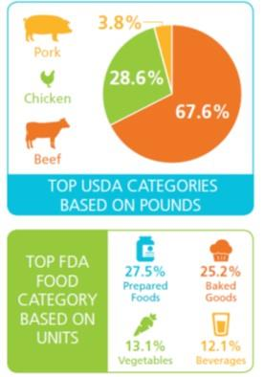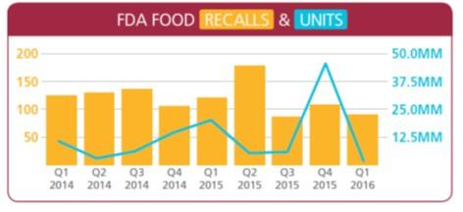
Food recalls in 2016
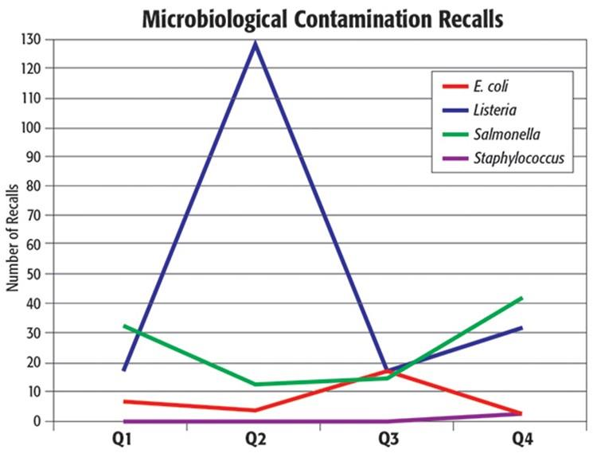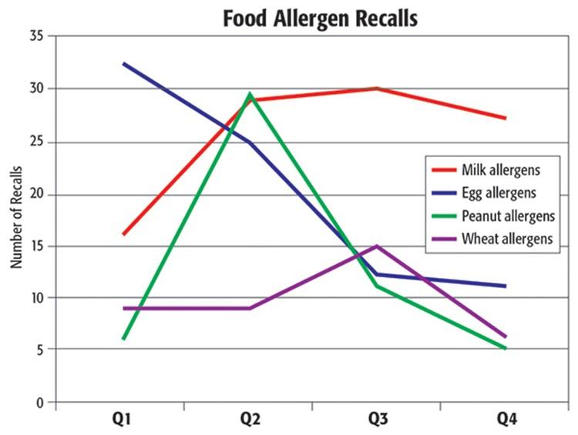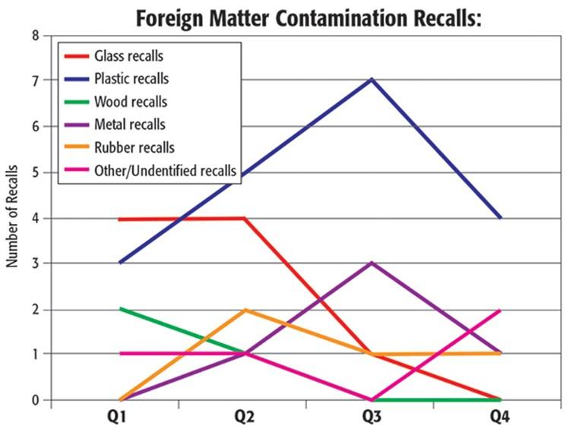
Recall plan requirements
- A Recall Plan is required for any food with a hazard requiring a preventive control.
- Must be written: A Recall Plan MUST be written and in place before an adverse effect takes place to ensure that actions taken to recall a food are conducted efficiently and as quickly as possible. A rapid response is especially important for Class I and Class II recalls with public health implications.
- Must describe steps to take and assign specific responsibility to:
 Notify direct customers and consignees: about the food being recalled, including how to
return or dispose of the product*
 Notify the public, when appropriate
 Conduct effectiveness checks to verify that the recall was carried out in terms of the number of products affected and the number recovered
 Execute appropriate disposition of the food through reprocessing, reworking, diverting to a use that does not present a safety concern, or recovery and destroying...long with how and who
Some people can be assigned to multiple tasks, but their role should be predetermined to support a quick response.
* Notification of customers is required for Class I and sometimes for Class II recalls when there is a threat to public health. Decisions on when notification is necessary may be determined through discussions with FDA. FDA has the authority to initiate a recall in Class I situations. But typically a company voluntarily issues the recall notice.
Formulating a plan: crisis management plan
- A crisis management plan is the first step in formulating a recall plan.
- While every company has its own way of dealing with crises, history shows companies that have an approach that includes preparation, execution, effective and proactive communication, and post-incident analysis are most successful and remain profitable after a crisis.
- A crisis may be contained as an incident or a “non-incident” if the right approach is taken. Having a crisis management plan in place is a very important part of successful crisis management.
- Regardless of the crisis, there are typically 5 steps that need to be taken, and each step is critical to successfully managing a crisis.
 Pre-Incident  Investigation  Initiation
 Execution
 Post-Incident
- Pre-event planning is a key step in ensuring the company is prepared for a crisis. It includes forming a team, identifying key members and a strong leader, identifying types of crises most likely to occur and contingency plans, developing a plan and ensuring the processes and protocols are in place to support the team if a crisis occurs.
Recall plan development
- The Food Safety Modernization Act (FSMA) requires all food manufacturers to have a recall plan.
- Having a plan is a good first step but not good enough to ensure that the companies can successfully manage a recall.
- The recall plans must be annually reviewed, tested and updated – and not just be a document for the next auditor to review.
- All recall members must understand the plan, their roles and responsibilities and the steps that need to be taken to successfully manage a recall. This takes PRACTICE, PRACTICE and more PRACTICE.
- While a recall is an unexpected event, the recall team should have the knowledge, commitment, training and experience to successfully manage it.
- A recall plan is a road map for the recall team. A recall plan should provide guidance for investigation and managing potential or actual recall actions. Developing a recall plan must be a cross-functional team effort to ensure all functions are properly represented. Recall plans should be short and concise, but also thorough and provide enough detail for the team members to execute the recall. Flow charts and checklists are recommended as valuable tools to assist the team as quick references through all steps of the recall process to ensure all important steps are completed and during the post recall assessment to validate the recall plan.
Recall planning
Recall plans need to be specific to the product under consideration and should be designed in a way that will work for the recalling enterprise and its customers to remove a food product from the market quickly and effectively.
- Include contacting the relevant contact at the USDA or the FDA Recall Coordinator who can assist with protocol, standards and wording that ensure an efficient and effective recall.
- Good record-keeping system is important to help identify products, codes, lots and quantities. Lot coding or date coding is important. Without it, there may not be a way to differentiate between problem product and good product. Without lot coding or date coding, much more product might have to be recalled leading to added expense.
- Choose a recall contact—a person who is the owner, manager or someone who knows the operation well. B
- Organize a list of customers, distributors, and accounts quickly. This list can be based on invoices, phone orders, retail store receipts, etc.
- Be sure to test your recall plan and practice this plan regularly. These are sometimes referred to as “mock recalls.”
Recall costs
Direct recall costs
- Value of lost product
- Notification costs, including for the regulatory body, supply chain, consumers
- Product transportation
- Product destruction
- Warehouse space to destroy product
- Labor, which sometimes requires special staff due to nature of hazard. Indirect recall costs
- Lost sales: Consumer research found that 55% of consumers temporarily switch brands following a recall, while 15% of consumers said they would never purchase recalled product again, and 21% would avoid any product made by that manufacturer. The statistics show that recalls will temporarily affect the company bottom line, and may even have a permanent impact. Therefore, lost sales should be included as an indirect cost of recall.
- Business interruption: Business interruption due to recall should be factored into the potential costs.
- Liability: Should a recall include a contaminant or mislabeling issue, one must estimate the cost of liability from customers.
Recall risk management strategies
Best practices can help avoid a recall or minimize the financial impacts of recall. Actions to consider include:
- Obtaining sufficient insurance coverage for recall expenses, such as withdrawal, recall, inspections, repair, replacement, adjustment, removal or disposal of the product, and associated loss of profit. Insurance companies suggest limits based on type of operation.
- Investing in traceability of products can limit recall losses. Studies have indicated that perfect traceability limited losses by 90–95% for products with a shelf life of 14– 28 days.
- Planning ahead. Name a crisis team, develop a crisis plan, and conduct mock recalls of potential crisis scenarios to test emergency protocols, including recall procedures with distributors, communication response, and financial recovery plans.
- Cultivating a food safety culture throughout the organization.
- Complying with Good Manufacturing Practices, and monitoring each facility with
spot checks to ensure Standard Operating Procedures are in effect.
• Enacting routine maintenance procedures for food processing facilities and equipment.
Recall risk management strategies...2
Best practices...continued
- Documenting “reasonable care” standards used to prevent contamination, which could provide a stronger defense in case of a lawsuit related to a recall.
- Reviewing Hazard Analysis & Critical Control Points (HACCP). Poor HACCP analysis is a cause for many recalls. The HACCP should be reviewed and updated regularly to incorporate new scientific and technological methods and following any modifications to the facility.
- Achieving Global Food Safety Initiative (GSFI) certification as well as the prerequisite third-party certification through Safe Quality Food (SQF) Program, BRC (British Retail Consortium) Global Standards or FSSC (The Foundation for Food Safety Certification) 22000. Though certification and compliance are costly, they can help prevent the damaging long-term effects of recalls to the business.
Recall risk management strategies...3
Best practices...continued
• Managing contracts with recall in mind. Effectively managing contracts with customers and suppliers is a key risk management strategy. Strategies and clauses for the corporate legal counsel to consider include:
 Indemnification: Requires suppliers to bear the liability for their products in case of recall
 Disclaimer of warranties: Helps to minimize losses from negligence or liability claims, though not intentional conduct
 Limit damages: Limits liabilities to purchase price, not for lost profits or other damages. Additionally, contracts can be constructed to impose a dollar limit on damages
 Additional insured: Requires suppliers to add the food business to their policies as an “additional insured.” This may be challenging in the case of international or small U.S.-based suppliers. It is important to ensure that provisions meet the needs of the manufacturer.
Closing thoughts
- There are countless circumstances that can arise in a food enterprise that can result in a product recall event.
- It is imperative to have plans in place to respond to an event both internally and externally as quickly as possible to mitigation potential losses.
- History has proven that the companies that are not adequately prepared to respond to a crisis are at a much greater risk of unrecoverable losses, or in certain cases, outright demise.
- A mock recall is the best way to get the entire team to understand their role and responsibilities during a real-world recall.
- Prevention would be ideal, but preparedness is the best approach and pragmatic. There is no excuse for not being prepared.

