Organic Foods Production Act 1990
• Required USDA to develop national standards for organically produced agricultural products
-   to assure consumers such products meet consistent standards
-   to facilitate commerce in organically produced fresh and processed
food • History:
-   Established criteria for the organic products of agricultural commodities including meat and poultry
-   Over 200,000 comments received -- irradiation/biotech/sludge were big issues
-   Re-proposed in March 13, 2000
-   Final Rule December 21, 2000 (65 FR 80548)
What is organic?
- “Feeding the soil, not the plant” | In the simplest terms, organic growing or farming is based on maintaining a living soil with a diverse population of micro and macro soil organisms.
- USDA National Organic Standards Board (NOSB) Definition: Organic agriculture is defined as "an ecological production management system that promotes and enhances biodiversity, biological cycles, and soil biological activity. It is based on minimal use of off-farm inputs and on management practices that restore, maintain, or enhance ecological harmony. The primary goal of organic agriculture is to optimize the health and productivity of interdependent communities of soil life, plants, animals and people." (NOSB, 1997).
- What does organic mean>
 Simply stated, organic produce and other ingredients are grown without the use of pesticides, synthetic fertilizers, sewage sludge, genetically modified organisms, or ionizing radiation. Animals that produce meat, poultry, eggs, and dairy products do not take antibiotics or growth hormones.
 Organic is a proactive management system based on ecologically sound practices in concert with allowed inputs.
• Organic adherence varies widely and ranges from deep to casual or shallow.
 Deep organic strives to minimize off-farm inputs & mimics nature as much as possible. Farmers
use knowledge to capitalize on ecosystem services & the myriad benefits they provide.  Casual or shallow organic substitute organic inputs for conventional inputs.
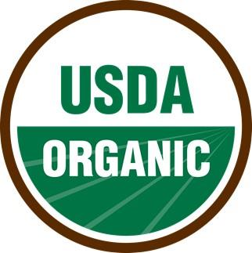
Certification
- The organic certification process makes sure that growers and handlers that claim to be organic are abiding by strict laws and regulations set by the Organic Foods Production Act. Organic certification verifies that the farm complies with the USDA organic regulations and allows the producer to sell, label, and represent products as organic.
- Producers with less than $5,000 in gross annual organic sales are exempt. Producers may also apply for a split operation if only a part of the operation is organic
• Crops eligible for certification: crops, livestock, processed, wild crops.
• Benefits of certification for farmers, ranchers, and food processors:
 Helps receive premium prices for their products
 Gives access to fast-growing local, regional, and international markets  Supports local economies
 Provides access to additional funding and technical assistance
 Market products to consumers
Certifications
Certified Organic  • https://goo.gl/vcSTIl  - USDA authority  - International trade organization | Certified Naturally Grown  • www.naturallygrown.org  - Grassroots certification for farms and communities  - USA and Canada  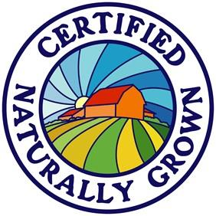 | Certified Humane Raised  • http://certifiedhumane.org  - Private non-profit  certification  - Accepted in U.S., Canada, Brazil, Peru and Chile.  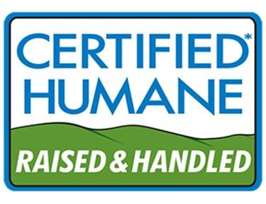
Overview of steps to organic certification
- Producer or handler adopts organic practices and develops an organic system plan. Submits application and fees to certifying agent
- Producer or handler implements system plan. Certifying agent reviews applications & organic system plan to verify that practices comply with USDA organic regulations.
- Inspector conducts on-site inspection of the producer’s/handler’s operation.
- Certifying agent reviews the application and the inspector’s report to determine if the producer/handler complies with the USDA organic regulations
- Certifying agent issues organic certificate.
Note: conventional food processing enterprises do not undergo such scrutiny in terms of the use of pesticides, synthetic fertilizers, sewage sludge, genetically modified organisms, or ionizing radiation. Conventional production of meat, poultry, eggs, and dairy products do not undergo a similar scrutiny or the abstention from antibiotics or growth hormones.
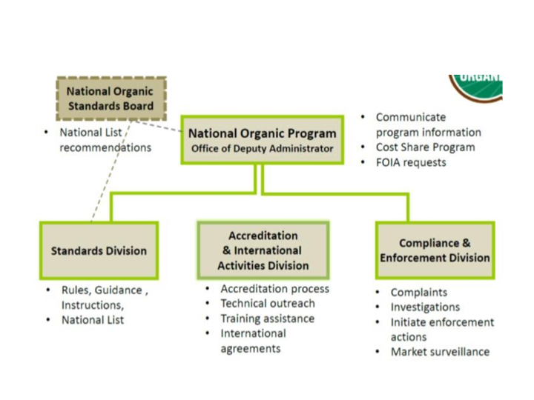
Overview of steps to organic certification
Steps to organic certification
STEP 1: Producer/handler develops an organic system plan.
- The organic system plan is the foundation of the organic certification process.
- Created by the producer or handler seeking certification, it details how an operation will comply with the regulations based on its unique characteristics.
• Plans differ based on operation type and needs and must address all practices of the farming or handling systems, such as tilling, grazing, harvesting, storing and transporting.
• Plans also specify approved substances used during the growing or handling process, monitoring practices for organic systems, recordkeeping systems, and barriers that prevent commingling with nonorganic products or contact with prohibited substances.
Steps to organic certification...2
STEP 2: Implement the organic system plan. Certifying agent reviews the organic system plan to verify practices are compliant with USDA organic regulations.
- Organic operations are certified by private, foreign or state entities called certifying agents that have been accredited by USDA.
- Certifying agents are responsible for ensuring that organic products meet all organic standards.
- Certifying agents are located throughout the United States and around the world. Currently 80 are USDA-accredited and authorized to certify operations to the USDA organic standards; 48 are based in the U.S. and 32 are based in foreign countries.
- Most certifying agents are directly accredited by the USDA National Organic Program (NOP).
- Twenty-one additional certifying agents are authorized through recognition agreements between the U.S. and foreign governments.
Steps to organic certification...3
STEP 3: Inspector conducts on-site inspection.
• Every operation applying for organic certification is first inspected on site by a certifying agent.
• These comprehensive top-to-bottom inspections differ in scope depending on the farm or facility.
-   For crops they include inspection of fields, soil conditions, crop health, approaches to management of weeds and other crop pests, water systems, storage areas and equipment.
-   For livestock, they include inspection of feed production and purchase records, feed rations, animal living conditions, preventative health management practices (e.g., vaccinations), health records, and the number and condition of animals present on the farm.
 At handling or processing facilities, an inspector evaluates the receiving, processing, and storage areas used for organic ingredients and finished products.
Steps to organic certification...4
STEP 4: Certifying agent reviews the inspection report to determine compliance of operation.
• The inspector presents findings to the certifying agent following observation of practices on the farm or facility as they compare to the organic system plan.
- In addition to the inspection points mentioned above, the inspector also presents an assessment of the risk of contamination from prohibited materials and might even take soil, tissue or product samples as needed.
- The inspector also analyzes potential hazards and critical control points and makes sure procedures to prevent contamination are adequate.
• All findings are presented to the certifying agent for review.
Steps to organic certification...5
STEP 5: Certifier issues decision and organic certificate, if compliant.
• If the operation complies with the rules, the certifying agent issues an organic certificate listing products that can be sold as organic from that operation.
• The organic farm or facility continues to update its plan as it modifies its practices, and inspections are done at least once a year to maintain certification.
What auditors should look for
- An auditor’s job is never done completely, but should be as comprehensive as possible.
- Tour the facility
  -   Start with the raw materials and finishing where the finished goods leave.
  -   Tours are not fact-finding exercises but are intended to give the auditor a general feel of the operation being audited.
  -   Tours provide an insight into the management attitude of the company with regard to quality and safety.
  -   First impressions are significant, and although it is important that the auditor does not jump to too many conclusions from the initial visit, an experienced auditor will normally be able to tell what the outcome of the audit will be from this visit.
- Review audits
  -   The auditor assesses the operation’s organic system plan (OSP), inspection report,
and other relevant certification documents.
  -   Interview the operator (and personnel) and document observations at the operation’s site(s).
  -   Auditors may use Review Audits to investigate issues identified during or before the on-site assessment audit. A certifier representative may attend as an observer.
What auditors should look for...2
- Check documentation
  -   A well-written procedure is not proof of implementation or adherence.
  -   Check elements written on paper are actually working and effective.
  -   Check as much as possible whether or not all the required procedures exist. Comprehensiveness is difficult here, so focus on a number of key elements.
  -   Are records complete, meaningful, available and up to date.
  -   In/product out audits and financial audits.
  -   Ensure quality, comprehensive, rigorous, and objective audits.
- Speak to people
 Speak to people at all levels to ensure that everyone paints the same picture.
What auditors should look for...3
• For crops to be certified organic ensure they adhere to the following guidelines:
-   Grown on land that has been free of prohibited pesticides and substances for at least three years before harvest
-   Consistent careful management of soil fertility and documentation to support it
-   Correct dispersal of manure and documentation of the procedures used
-   Use prevention as the first form of pest control
-   Buffer zones that protect from the flow of unwanted substances from nearby farms
What auditors should look for...4
• Livestock standards are implemented to maintain both organic standards for consumers and good living conditions for the animals. Auditors must look for the following in order for livestock to be certified organic:
-   Animals are fed organic food
-   There are no growth hormones, promoters or plastic pellets in the
animals’ food
-   Animals are not overcrowded
-   Animals are given allotted time outdoors in direct sunlight
-   Antibiotics are not used routinely
-   Records are kept on these practices for each animal or flock of animals
Future trends in organic certification
- Organic 3.0: Organic certification is based on foundations laid by organic pioneers of various backgrounds. Global food production is far from being sustainable. Poverty, social injustice and hunger prevail in many rural areas. Organic 3.0 will focus on political issues in the mainstream food industry with greater transparency.
- Sustainable use of natural resources rather than exploitation: Emerging strategies focused on impact rather than on perfection and will examine every aspect of building rather than exploitation. Expect full transparency of the value chain rather than green washing.
• True cost accounting: The cost of consequences will become part of accounting language across the industry and closer scrutiny of issues such as nutrition and human health, soil and water conservation, free access to seeds, land ownership, animal welfare will take into consideration true cost accounting and perverse subsidies.
• Science and evidence-based principles: Organic certification principles will incorporate elements of biodynamic agriculture principles and the clean label movement.
Future trends in organic certification...2
- Stricter Organic certification: The USDA’s National Organic Program and National Organic Standards Board will bring even more rigor to the federal regulations in terms of specificity for practices and allowed substances and practices. Government oversight will make it more difficult for “organic” to be used loosely as a marketing term, i.e. “Organic Café” or “Organic Resort.”
- Food Safety Fusion: The organic food supply will fuse with food safety and other “product integrity” programs, adding more disciplined food safety practices that are audited and certified at even the smallest of farms and plants. Organic and food safety audits will be increasingly synchronized. QAI anticipates continued growth in the offering of multiple audits so companies may bundle organic, gluten-free, kosher, and/or numerous food safety audits into one thorough audit and inspection.
Future trends in organic certification...3
• Harmonic Convergence: International standards for organic will be harmonized with USDA organic, removing former obstacles to international trade. The U.S. also will move closer to its European neighbors in non-GMO verification and labeling requirements.
• Sustainably Organic: - Increased focus on companies’ impact on biodiversity, water and soil conservation will translate to additional sustainability metrics in organic practices. As the spirit of organic is to grow in harmony with nature, each farm and company’s environmental impact will be under more scrutiny.
• Transparency Made Tangible - Consumers need to know and trust the sourcing of the products they buy will drive total transparency in the organic production chain, and make QR (quick response) codes—already introduced by QAI in July 2012—commonplace for all organic certificates and on packaging. The USDA Seal for organic will remain credible, and online tools will be used by consumers to see the credibility of each product’s organic claims.
Future trends in organic certification...4
• No More Shopping Gaps - Practical steps will be taken to be more inclusive and steps will be taken to include new or emerging industry sectors. This will make organic certification available in sectors currently excluded in the regulations—like aquaculture/seafood. It also will address underserved categories like dietary supplements, pet food, personal care, cleaning supplies, fiber and flowers. If it starts with a plant, mammal or fish, it can be certified organic. Consumers will be able to find certified organic products in all sections of the supermarket and pharmacy.
• Organic Literacy is Evident - After years of some confusion in the marketplace, efforts by the NOP, Organic Trade Association, and retailers pay off in increased consumer literacy for organic. Land grant universities also help increase knowledge in organic through their own research initiatives and increase in organic and sustainable agriculture tracks.
Future trends in organic certification...5
• Accessible Organic - Larger organic production, from farm acreage expansion to processing facilities, will translate into organic landing where it is most needed: schools, hospitals, food banks, convenience stores and in mainstream America’s home.

