Name
Supervisor
Course
Date
Accounting Discussion 1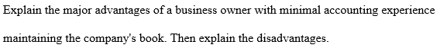
The major advantage of the business owner having minimal experience in accounting maintaining the company’s book is that the lack of accountant gives the business owner to an opportunity to expand his/her accounting knowledge. In addition, he/she gets an opportunity to learn to be self-dependent and sufficient hence maintain his/her finances. This permits the owner to directly be in charge of the financial activities in the business thus reducing the cost of hiring an accountant. The disadvantage of this case is that the business will lack the advantages brought about by accountants hence the profit may be low. For instance, an accountant offers expertise in the accounting and tax work, professional assistance, preparation of business budgets, suggesting means of reducing costs as well as completing and filling essential administrative documents within the company. Due to this reason, the lack of an accountant in the business poses a great disadvantage to the business success (Wahaba, et al).
Due to the large amount of data needed when creating the balance sheets, errors usually occur. The errors can be genuine mistakes or just attempts to conceal fraud and theft. An example of an accounting error in balance sheets in the incorrect grouping of assets and liabilities. The incorrect grouping of the assets and liabilities can have a great effect on the balance sheet hence give a misleading financial image of the given company. Another common error is the error of total omission. The errors of total omission may ignore the expenses and the inventory not being adjusted to reflect the accurate amounts. These errors may result in a balance sheet which shows a more positive financial state of a company which is not true.

Business Discussion 1
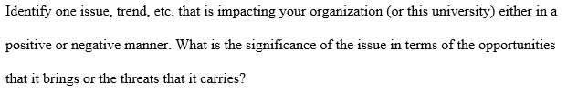
One issue affecting my organization is the use of computers in the accounting department. This factor brings about great and positive impact in the organization by reducing the occurrence of errors as well as theft in the books of accounts. In addition, it makes the accounting work more simple and fast. The advancement in technology in accounting department poses a big threat to the increase of unemployment. This is because, during the manual accounting period, the organization could hire many accountants but due to the increase in technology and introduction of the use of computers in accounting, the number of the labor force has decreased hence resulting in unemployment (Scarbrough and Martin).

Work cited
Scarbrough, Harry, and J. Martin Corbett. Technology and Organization (RLE: Organizations): Power, Meaning and Deisgn. Routledge, 2013.
Wahaba, Muhammad Syahir Abdul, et al. "Situational Inhibitors to Informal Learning in the Workplace: A Case Study of Accountants." (2016).

