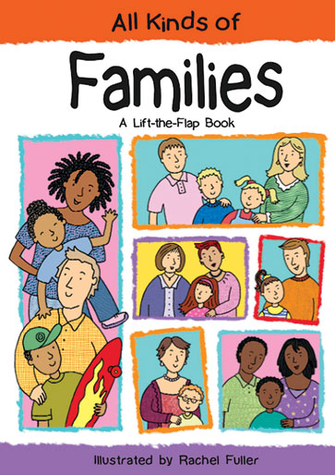
Diverse Family Structures

Diverse Family Structures
In an ideal society, all the children have the right to security and the provision of the basic needs. Education is among the basic needs that each child should be provided with. Nonetheless, the world is not an ideal place. As such, some children not only miss out on education, but they are faced with very hard situations in life; which render them in worse situations such as being homeless. Accordingly, various individuals and institutions have been founded to cater for the special needs of such children. One such institution is the Monarch School which offers education and other basic services to the homeless children in San Diego County.
Mr. Keiley who is a teacher at the Monarch School expressed his concerns regarding some of the challenges they face while handling children at the Monarch School. He indicated that children whose parents are struggling also struggle. Indeed, the teachers have the responsibility to cater for the special needs of the children from such family background. As the classroom teacher, the first thing that I would do to handle such a situation is to get the background of the problem. I would collaborate with the parents in order to identify the actual problems and brainstorm on how the problems affect their child as well as how to help the child both at school and at home (Curenton and Iruka, 2013).
Secondly, I would make the classroom environment very friendly in order to build the trust of the suffering child. This can be done by showing sensitivity; for instance when asking children to bring various resources from home. I would encourage the child by assigning them appropriate projects and commending their achievement. This would be essential in helping the child to experience mastery as a way of building his/her self- image (Wisconsin Department of Public instruction, 2011). I would also maintain the child’s privacy and discuss the special problems in private. I would also help the child with the basic amenities such as a clipboard to carry home.
One way of connecting with parents in this school would be to organize for parents’ meeting where various social and collective problems facing the children can be discussed. I would also facilitate personal parent-teacher meetings in order to discuss the progress of the child, and new strategies for assisting the child.
There are various strategies that would facilitate a consistent, effective and reliable learning environment. The first strategy would be to facilitate easy access to assistance. For instance, after identifying the psychological problems facing the homeless children, counseling services and other intervention services that would allow the children to express their fears and frustrations. The second strategy would be to connect the families with social agencies that can provide them with basic amenities such as food and housing (Curenton and Iruka, 2013).
The third strategy would be to facilitate regular communication with the children’s families in order to understand their cultural backgrounds, the history of the child, and how that history can impact on the child’s learning. Furthermore, such knowledge would be vital in establishing programs that cater to the special needs of the children. The last strategy would be providing a friendly and welcoming environment by supplying the homeless children with nutritional snacks, and other basic items such as toiletry; in order to cater for the basic items which the children may not access from their homes (Wisconsin Department of Public instruction, 2011).

References
How Teachers Can Help Students Who Are Homeless. (2011). Wisconsin Department of Public instruction. Retrieved 9 April 2018, from https://dpi.wi.gov/sites/default/files/imce/homeless/pdf/teach_help_hmls_stud.pdf
Curenton, S.M., & Iruka, I.U. (2013). Cultural competence in early childhood education [Electronic version]. Retrieved on 4th September 2018 from https://content.ashford.edu/
Monarch School; Hope through Education. (2011). Retrieved on 4th September 2018, from https://vimeo.com/20207156

