Student’s Name:
Professor’s Name:
Course:
Date:
German shepherd Dogs
Throughout history, dogs have been kept by human beings either as helpers or companions. Most people love dogs because of their usefulness, intelligence and their capability to protect them from dangerous situations (Gerritsen &Haak 34). Dogs are also the kind of animals that man can have as companions for a long time hence it is no surprise that most people are fond of keeping dogs as pets. The German shepherd dog is one of the breeds of dogs that fulfills all this needs to man. Despite being kept as pets, the German shepherd dogs are used by the police forces or the military to track criminals or drugs.
The origins of the German Shepherd Dog can be traced back to over 100 years ago in Germany after being bred by a number of breeders. The aim when breeding the dog was to produce an obedient and responsive animal hence a number of herding and local farm dogs were used in the process. The breeding process was a success as the first short-haired shepherd was presented in Berlin in 1889. However, it was until 1899 that the first dog named Horan was recognized and registered as a German shepherd (Gerritsen &Haak 35). The breed was characterized to have long hair until 1915.
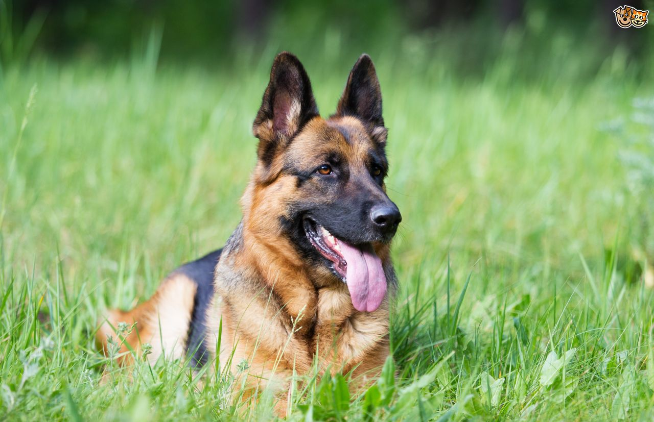
Pet4homes.co.uk
Unlike other breeds that are highly standardized, the German shepherd breeds have few variations. However, some of the breed characteristics are found in every type of the German shepherd despite where they are bred. In terms of fur coats, German shepherds have two fur coats (Mantellato 24). They include a black coat which covers the upper portion of their body and a compliment of a light brown coat which covers the belly region as well as the front and back limbs. Their fur is thick and straight hence they require frequent grooming as a thick fur tends to be smelly after some time.
When it comes to their size and height, male German Shepherds are bulkier and larger than their female counterparts. However, their height is more or less the same with measurements of about 22 to 26 inches (Gerritsen &Haak 35). As for their weight, German shepherds mostly weigh between about 20-40 kg. Particularly, adult male German shepherds weigh around 30-40 kg while the adult female weighs around 22-32kg. Their ears are erected upwards and point towards the front which makes them look attentive.
Despite their intelligence, their behavioral characteristics are what makes them ideal to be used in military units. At first sight, they may convey aggression or a fearless expression as well as the averseness to develop indiscriminate friendships. Even though they may indifferent at first, once they establish a friendship, their devotion to the human beings is life-long. Thus, they provide faithful service and loyal companionship to their owners. However, proper training and socializing are very essential at an early age to allow effective integration to a normal social routine.
The German shepherd’s lifespan is around 10-12 years and just like other dogs the vital signs for the German shepherd include the respiratory rate, the heart rate which is about 60-140 beats per minute. The body temperature is also an important vital sign for the German shepherds. However, the German shepherds are often predisposed to many health issues such as Anal Furunculosis, gastrointestinal diseases, joint disorders as well as gastric dilatation-volvulus (Mantellato 146). Therefore, they require special care in terms of regular grooming and frequent veterinary check-ups. It is also essential for them to get at least 2 hours of exercise and consistent training for them to remain active.

Work Cited
Gerritsen, Resi, and Ruud Haak. K9 Working Breeds: Characteristics and Capabilities. Calgary: Detselig Enterprises, 2007. Print.
Mantellato, Lisa. Getting to Know German shepherd: A Guide to Choosing and Owning a German Shepherd Dog. Animalinfo Publications, 2008. Print

