Indigenous Cultures
Map of Kiowa Tribe
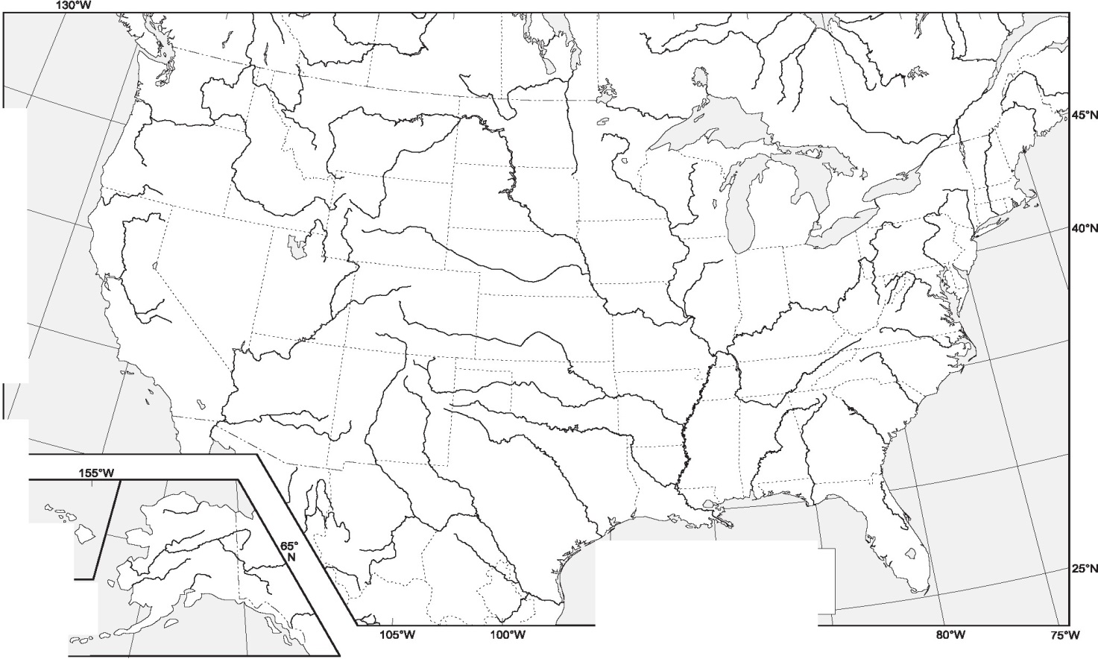

The Kiowa Tribe
The Red River

Kiowa Tribe
The Kiowa is a tribe of Native Americans or Native Indians who currently live in Southwestern Oklahoma. The name Kiowa was chosen when the tribe made their first contact with the Europeans. Kiowa means the “main people”, which was adopted as the name of the indigenous people (Kracht, 2018). Historically, the Kiowa occupied parts of New Mexico, Texas, and Oklahoma before moving southwards to Oklahoma in the 19th century. Currently, there are about 12,000 members of this indigenous community living in southwestern Oklahoma.
The Kiowa is one of the main American Native tribes with increased influence in the Southern Plains. They are famous for their fierce warriors, fighting prowess, and buffalo hunting with horses. Despite the influence of European settlers, the Kiowa have managed to maintain most of their cultures and customs. The Kiowa have maintained their traditions through dance, arts, language, religion, song, and education among others.
Historically, the Kiowa lived in the northern headwaters of the Missouri or Yellow Stone River in Montana. As hunters, they migrated southeast in search of horses and buffalos. They travelled through the Crow Native Americans and initially made contact in the Pryor Mountains (Kracht, 2018). After asking permission from the Crow people, they Kiowa migrated eastwards to the Black Hills of South Dakota in the late 17th century. Here they met up with the Apache natives and other native Indians. The Kiowa would join forces with the Apache and invade Sioux and Cheyenne natives southwards (Carl, 2006). They finally settled in the southwestern plains next to the Arkansas Rivers in Colorado, plains in western Kansas, the Texas Panhandle, the Red River drainage, and west Oklahoma (Carl, 2006). The climate of these plains was sub-tropical offering mild winter seasons and ample grazing for feral horse and bison herds. It was during this time that the Kiowa adopted a culture of hunting bison herds with horses. Later after numerous wars and treaties, the Kiowa were offered land to settle in in southwestern Oklahoma.
Today, the Kiowa is federally known as the Kiowa Tribe of Oklahoma. It has its own government with tribal jurisdictional regions. The southwestern Oklahoma region features a humid subtropical weather. The climate is characterized by humid and hot summers, as well as mild winters (Carl, 2006). This ensures a huge amount of grazing land as it allows for grass to grow. The Kiowa originally used the Kiowa language and the Plains Indian Sign Language (Carl, 2006). Currently, most Kiowa people speak English. The Kiowa language is from the Kiowa-Tanoan language family that is a shared among other Native American tribes such as the Apache and Comanche. Additionally, most Native Americans used Plains sing language to describe or communicate with different tribes.
The Kiowa have a rich and renowned traditional culture that has survived over the years until to date. The Kiowa people were nomadic people with chiefdoms. They were hunters and gathers meaning that they migrated with wild game such as bison, deer, antelope, wild fruits, and wild berries. The Kiowa traditional shelter is a temporary tent made from tipis or the hide of bison or buffalos. Kiowa people shared numerous cultures with other Native Americans. The Kiowa are renowned for their fierce warriors and invasions throughout the north. They organized warrior societies made up of individuals with the strength, courage, and skills for fighting. Their warrior societies were known as the “Dog Soldiers” since the warriors had visions and dreams of dogs. The “Main Dogs” or Koitsenko were the most fierce warrior society made up of 10 ultimate warriors of the tribe in their history (Kracht, 2018). One of the renowned members of this society was Satank who choose to die fighting for his freedom rather than in captivity.
The Kiowa people also have a rich artistic history as well as culture. The Kiowa are known for ledger art that was designed in old-fashioned pictographs. The pictographs were made from animal skin and rocks that depicted sacred visions and heroic deeds. These art forms were made for the purpose of storytelling as well as historical references. Men or males were the main artists among the Kiowa. Traditionally, the Kiowa used skins and rocks to make pictographs. However, during the Indian wars, captive Kiowa warriors used the book ledgers of whites to make pictographs, thus the name “ledge art” (Kracht, 2018). The Kiowa are also great craftsmen making traditional silverwork, jewelry, and beadworks with traditional designs. In contemporary times, the Kiowa have embraced other arts including visual and writing arts, such as the famous N. Scott Momaday (Kracht, 2018).
The Kiowa are also known for their traditional music and dance. Their traditional music is one of the most recorded among Native Americans. It features hymns that were customarily played on the flute. The songs were mostly related to the warrior society and sacred ceremonies. Music among Kiowa people goes with dancing. A famous Kiowa dance is the “Gourd dance”, which was performed by mainly men or warriors. It involved making a circular perimeter and dancing by lifting their legs to the beats of the drum (Wunder & Porter, 1989). This dance involved a “howl” at the end of the song as a tribute to the “Red Wolf” (Kracht, 2018). Another major dance is the “Sun Dance”, which marked the tribe’s most significant religious ceremony. This dance was performed only once a year mostly during summer and lasted for ten days (Wunder & Porter, 1989). During this time, they made offerings and prayed to their sacred gods. The dance took places in sacred and healing locations known as “sweatbaths” that were designed for medicinal and ritual purposes (Wunder & Porter, 1989). The Kiowa are truly a unique people who are among the famous Native Americans with significant cultural, historical, and contemporary influence in North America.
I never knew that there existed the Kiowa tribe or their indigenous culture. I have always viewed the Native Americans as the same in terms of their culture. I found the Kiowa people to be humble and true to their Native American spirit. They cherish and preserve their traditions in the most unique ways. Their men are also true definitions of warriors from their courage to strength. Again, the Kiowa are polite, accommodating, and hardworking. I believe that the Kiowa people must invest in teaching their traditional religions, culture, arts, and languages to maintain their unique identities.

References
Carl, W., (2006). Encyclopedia of Native American Tribes. New York, NY: Checkmark Books.
Kracht, B.R., (2018). Kiowa Tribe. Retrieved from http://www.okhistory.org/publications/enc/entry.php?entry=KI017
Wunder, J. R., & Porter, F. W. (1989). The Kiowa. Chelsea House Pub.

