Lab Report
Aim:
The purpose of this laboratory was to study and prove the Archimedes’ principles in measuring the density of different materials. It aimed at measuring the density of both liquids and regular solids using direct calculation of their mass and volume. It also calculated the density of liquids and irregular solids by indirect measurement with Archimedes principles.
Theory:
Density is considered as the measure of mass per each unit volume. Therefore, the density of an object is equivalent to its mass divided by its volume. This equation is represented below and illustrates the connection between mass and volume:
$$ρ= \frac{m}{v}$$
In this case, (ρ) represents the density, (m) represents the mass and (v) represents the volume of an object.
For this laboratory, we are needed to calculate the density of a regularly shaped object applying Archimedes’’ Principle. This is achieved by calculating its actual mass, which is equal to the mass of the displaced liquid. Again, it includes measuring the apparent mass, which is the object’s weight when it is influenced by the buoyancy of a liquid (such as air) in which it is dipped.
The Archimedes’ Principles maintains that the vertical buoyant force applied on a solid object when submerged in a liquid, whether completely or partly immersed, is equivalent to the vertical force at the core of the mass of the displaced liquid. The Archimedes’ Principle as an equation is represented as shown below: $$F_{B}= ρ_{f} ⨯ V_{f} ⨯ g$$
Or
$$F_{B}= W_{air}-W_{liquid}$$
In the equation, ($F_{B}$) represents buoyant force, ($ρ_{f}$) represents the density of the displaced liquid, ($V_{f}$) represents the volume of the displaced liquid and ($g$) represents the acceleration of gravity, which in our case equivalent to 9.8 $m/{s^{2}}$.
In this laboratory, the Archimedes’ Principles was applied in two methods for the experiment. The first method is to measure the volume of a solid by immersing it in a fluid of known density. The second method is measuring the density of an unknown fluid by immersing a solid with known volume and mass.
Method:
The experiment utilized wooden and aluminium blocks as the regular shaped solid objects. To determine the volume of these blocks, we began by their calculating the length, width, and height. We then determined the mass of the aluminium and wooden blocks using the top-pan balance measure. Once the volume and mass of the blocks is determined, then we can easily measure the density using (ρ) formula for density.
The second test was to apply the Archimedes’ Principe to determine the density of the Aluminium block. In this case, the test requires that we calculate the actual and apparent weight of the Aluminium and wooden blocks. To find the actual weight, we need to use the weight formula, which equals to the mass (m) multiplied by the accelerating gravity (g). Later, we measured the buoyant force ($F_{B}$) that is equivalent to the weight of the liquid (water). Now, to determine the weight of the fluid, we calculate the difference between the actual weight and the apparent weight. What follows is to find the volume of the liquid ($V_{H_{2}O}$), which is variance between the actual and seeming weight over the density multiplied by the accelerating gravity ($V_{H_{2}O}= \frac{W_{real}-W_{app}}{ρ ⨯ g}$). We then measured determined the mass of the Aluminium block through the equation given in the work sheet, which is ($M_{Al}=\frac{1}{9.8}W_{real}$). Therefore, we simply find the density of the block by substituting the mass and volume with the density formula.
The third test required us to apply the Archimedes’ Principle to find the density of the wooden block. The experiment was conducted by placing the wooden block in a bucket with water. This allows the block to float leaving a mark on the water. We then measured the height of wooden block both of the part covered and not covered by the water. The height of the part covered by water is represented by symbol (h) and the height of the part not covered by water is represented by the symbol (H) in the worksheet provided. Lastly, to find the density of the wooden block we used the ($ρ_{wood}$) equation also provided in the worksheet.
In the fourth experiment, we were required to determine the weight of the water, similar to the second experiment. Nevertheless, this experiment consisted of two stages where the weight of the water in the beaker was measure with and without immersing the Aluminium block. We measured the weight with the top-pan balance and then fixed it to Newton (N) to determine the weight. Hence, we used the same method as in experiment two to determine the weight of the water. In this case, we achieved this by finding the difference between the weight of the water in the beaker while the Aluminium block is immersed and the weight of the water in the beaker when the block is absent.
In the last part of the lab report, we aim to immerse an aluminium block of 91 grams in oil and determine the mas and density of the oil. The calculation of the mass and density of oil are illustrated in the problem solution section.
Results:
See the results completed in the worksheet below: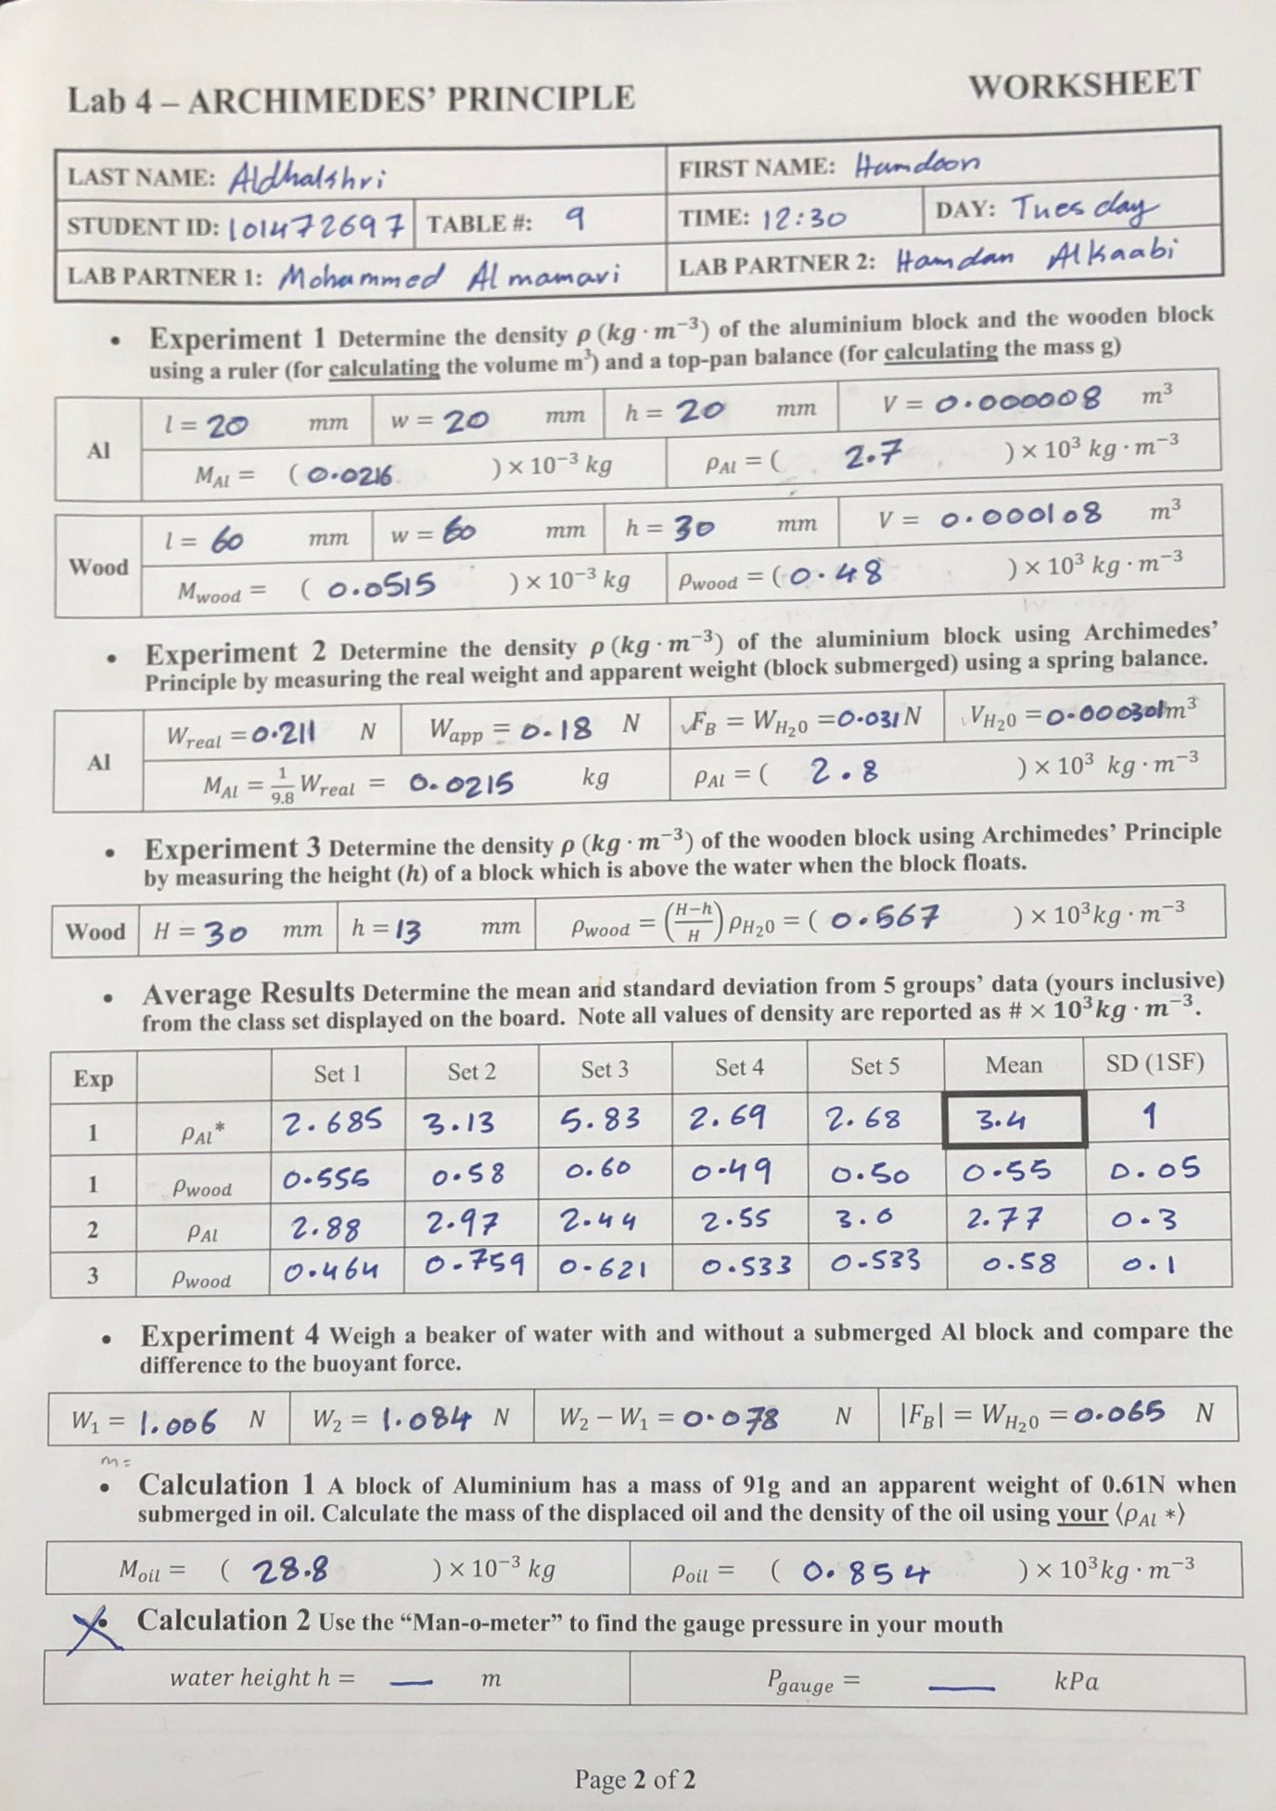
Analysis:
From the average results table illustrated in the worksheet, it is evident that in the first test there was a relevant variance in the variables of the Aluminium density. This difference could be due to the variance in the Aluminium block mass. Moreover, it could be due to reading/taking dimensions of the block using a ruler. Therefore, there was no relevant variance in the density of the wooden block. This could be due to the same measurements or the same masses for the wooden block in each group.
In experiment two, the density of the Aluminium is slightly different from that in the first experiment. This slight difference is probably caused by the use of different formulas to determine the density. The same case occurred for the wooden block in experiment three.
Problem solution:
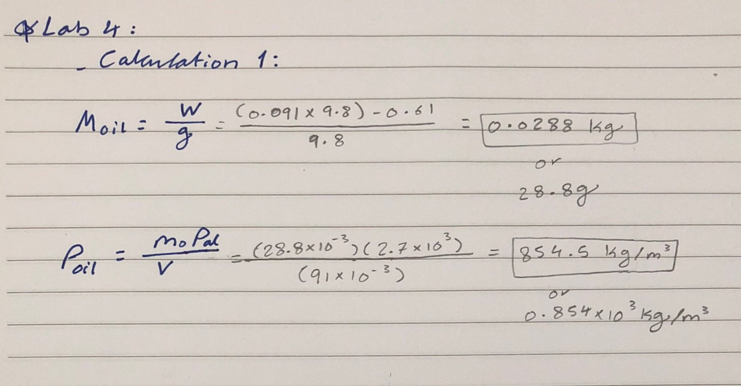
Conclusion:
The purpose of this laboratory was demonstrating Archimedes’ Principle in determining the density of liquid and solid materials. The experiments measured the different mass and volume of a regular shaped solid and irregularly shaped solid in order to determine their densities. Through the experiments, we learnt concerning the actual and apparent weights as well the buoyant force. The buoyant force ($F_{B}$) is simply the actual weight subtracted from the apparent weight. To sum up, this laboratory was successful in proving the Archimedes’ Principle on determining the density of different substances.

