Workshop title: how do you know your program is effective?

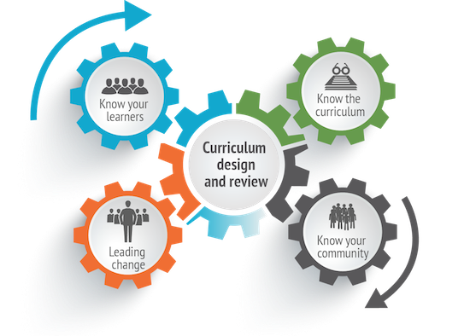Workshop topic: Assessing the effectiveness of your program

TARGET AUDIENCE: curriculum developers/ committees

PRESENTER: your name
DATE: 5th November, 2018
TIME: 10:00 AM to 2:00 PM
VENUE: Ashford multigenerational center,

ObjectiveS:
- Assessing how well students are meeting curricular-level learning expectations and experiences
- Determining the parameters that affect the effectiveness of a program
- Learning How to make curricular adjustments

Discussion Forum
My degree program is Bachelor of Art in Early Childhood Education. At the Ashford Multigenerational Centre, I was interviewed for the position of an assistant kindergarten teacher. My clients in the workshop are the curriculum developers and curriculum committee members. The title of my workshop is “How do you know that your program is effective” and the topic is “Assessing the effectiveness of your program.” I choose this topic because according to what I have leant in my undergraduate course so far, the holistic development and learning are the key focus of any curriculum. It is therefore important to know how to assess the effectiveness of a program in meeting the holistic learning and development of the students. Otherwise, using an ineffective program misses the whole point of developing a curriculum in the first place.

