Disease Process: Chronic obstructive pulmonary disease (COPD) is a long-lasting inflammatory lung illness that makes it difficult to breathe. Globally, it is one of the leading causes of the high mortality and morbidity rates that results in inflated social and economic encumbrances (Oliveira Rodrigues et al., 2021). COPD is characterized by incessant blockage of the small airways of the lungs, chronic bronchitis and the degeneration of the alveolar tissue. Notably, there are several types of COPD namely emphysema, chronic asthma and bronchitis.
Pathophysiology: COPD is precipitated when inflammatory mediators are released by the impaired bronchial epithelial cells (Agarwal, Raja & Brown, 2022). In emphysema, the alveolar walls and septae are destroyed leading to enormous perpetually bloated alveolar spaces also known as obstructive physiology. In this case, smoking triggers an inflammatory reaction, and the neutrophils lung-resident alveolar macrophages coupled with monocytes are employed. As such, they form a very inflammatory micro-environment by releasing manifold inflammatory mediators such as chemokines, proteolytic enzymes, and cytokines (Agarwal, Raja & Brown, 2022). The augmented activity of proteases and reduced production of antiproteases causes imbalance that leads to the collapse of the airway during exhalation. The genetic deficiency of alpha-1 antitrypsin hinders the production of proteases and leaves the lung parenchyma susceptible to protease-mediated impairment (Oliveira Rodrigues et al., 2021). In addition, oxidative stress can give rise to reduced production of antiproteases, stimulation of mucous creation or intensify inflammation. These structural changes lead to substantial thickening of the walls of the airway, elevated mucus production and permanent lung modifications. The changes include lung parenchyma damage, emphysema and paucity of elasticity.
Risk factors: Genetics.
Exposure to toxic fumes, dusts, chemicals and tobacco smoke.
Individuals with asthma.
Age (at least 40-years old).
Infections such as HIV and tuberculosis (VanMeter & Hubert, 2018).

Major signs and symptoms: (image if you can find one)
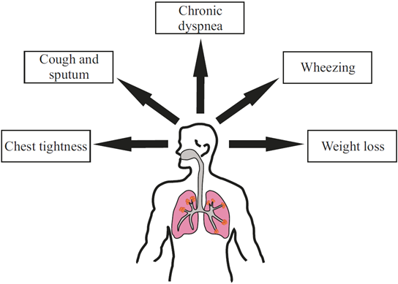

Diagnostic testing: Pulmonary function tests.
Laboratory tests.
Chest X-ray and CT scan
Arterial blood gas analysis (VanMeter & Hubert, 2018).

References:
Agarwal, A. K., Raja, A., & Brown, B. D. (2022). Chronic Obstructive Pulmonary Disease. In StatPearls. StatPearls Publishing. https://www.ncbi.nlm.nih.gov/books/NBK559281/
BSI. (n.d.). Chronic obstructive pulmonary disease. British Society for Immunology. https://www.immunology.org/sites/default/files/Symptoms%20of%20COPD.png
Oliveira Rodrigues, S. D., Coeli da Cunha, C. M., Valladão Soares, G. M., Silva, P. L., Silva, A. R., & Gonçalves-de-Albuquerque, C. F. (2021). Mechanisms, Pathophysiology and Currently Proposed Treatments of Chronic Obstructive Pulmonary Disease. Pharmaceuticals, 14(10). https://doi.org/10.3390/ph14100979
VanMeter, K. C., & Hubert, R. J. (2018). Gould's pathophysiology for the health professions. (6th ed.). Elsevier Saunders. Complete Study Guide. Chapter 13: Respiratory System Disorders

Case Presentation
N.A is a 40-year-old Caucasian female who presents to the clinic with chief complaints of shortness of breath, chest pain, cough, and wheezing episodes for the past two weeks. The patient asserts that she is a firefighter and her father who was also a firefighter was diagnosed with COPD at the age of 66 years. The patient reported that she had similar symptoms six months ago but attributed them to fatigue due to the nature of her job. N.A. was alert, and time and place oriented. The patient’s vital signs were BP: 128/75, temp 39 degrees Celsius, RR: 33 breaths/min, PR: 74 beats/min, and SpO2: 93%. The physical examination indicated audible wheezing with accessory respiratory muscle use, elevated anterior-posterior chest wall diameter, vesicular breathing with generalized expiratory rhonchi, and digital clubbing. Therefore, based on N.A.’s symptoms, a physical exam, and a family history of COPD, the diagnosis made was COPD (Choi & Rhee, 2020). The diagnostic tests ordered were pulmonary function tests to measure the amount of air she inhales and exhales, as well as chest X-ray to demonstrate emphysema. The recommended treatments were bronchodilators and inhaled corticosteroids. The patient was also edified on the importance of pulmonary rehabilitation which is a comprehensive treatment plan (Yawn, Mintz & Doherty, 2020).

Reference 1
Choi, J. Y., & Rhee, C. K. (2020). Diagnosis and Treatment of Early Chronic Obstructive Lung Disease (COPD). Journal of Clinical Medicine, 9(11). https://doi.org/10.3390/jcm9113426

Reference 2
Yawn, B. P., Mintz, M. L., & Doherty, D. E. (2020). GOLD in Practice: Chronic Obstructive Pulmonary Disease Treatment and Management in the Primary Care Setting. International Journal of Chronic Obstructive Pulmonary Disease, 16, 289-299. https://doi.org/10.2147/COPD.S222664

