Re: Week 14 Discussion 1: Individual Poster Presentation Share Discussion
by Meagan Bowcock - Thursday, 30 March 2023, 10:06 AM
Dialectical Behavior Therapy (DBT)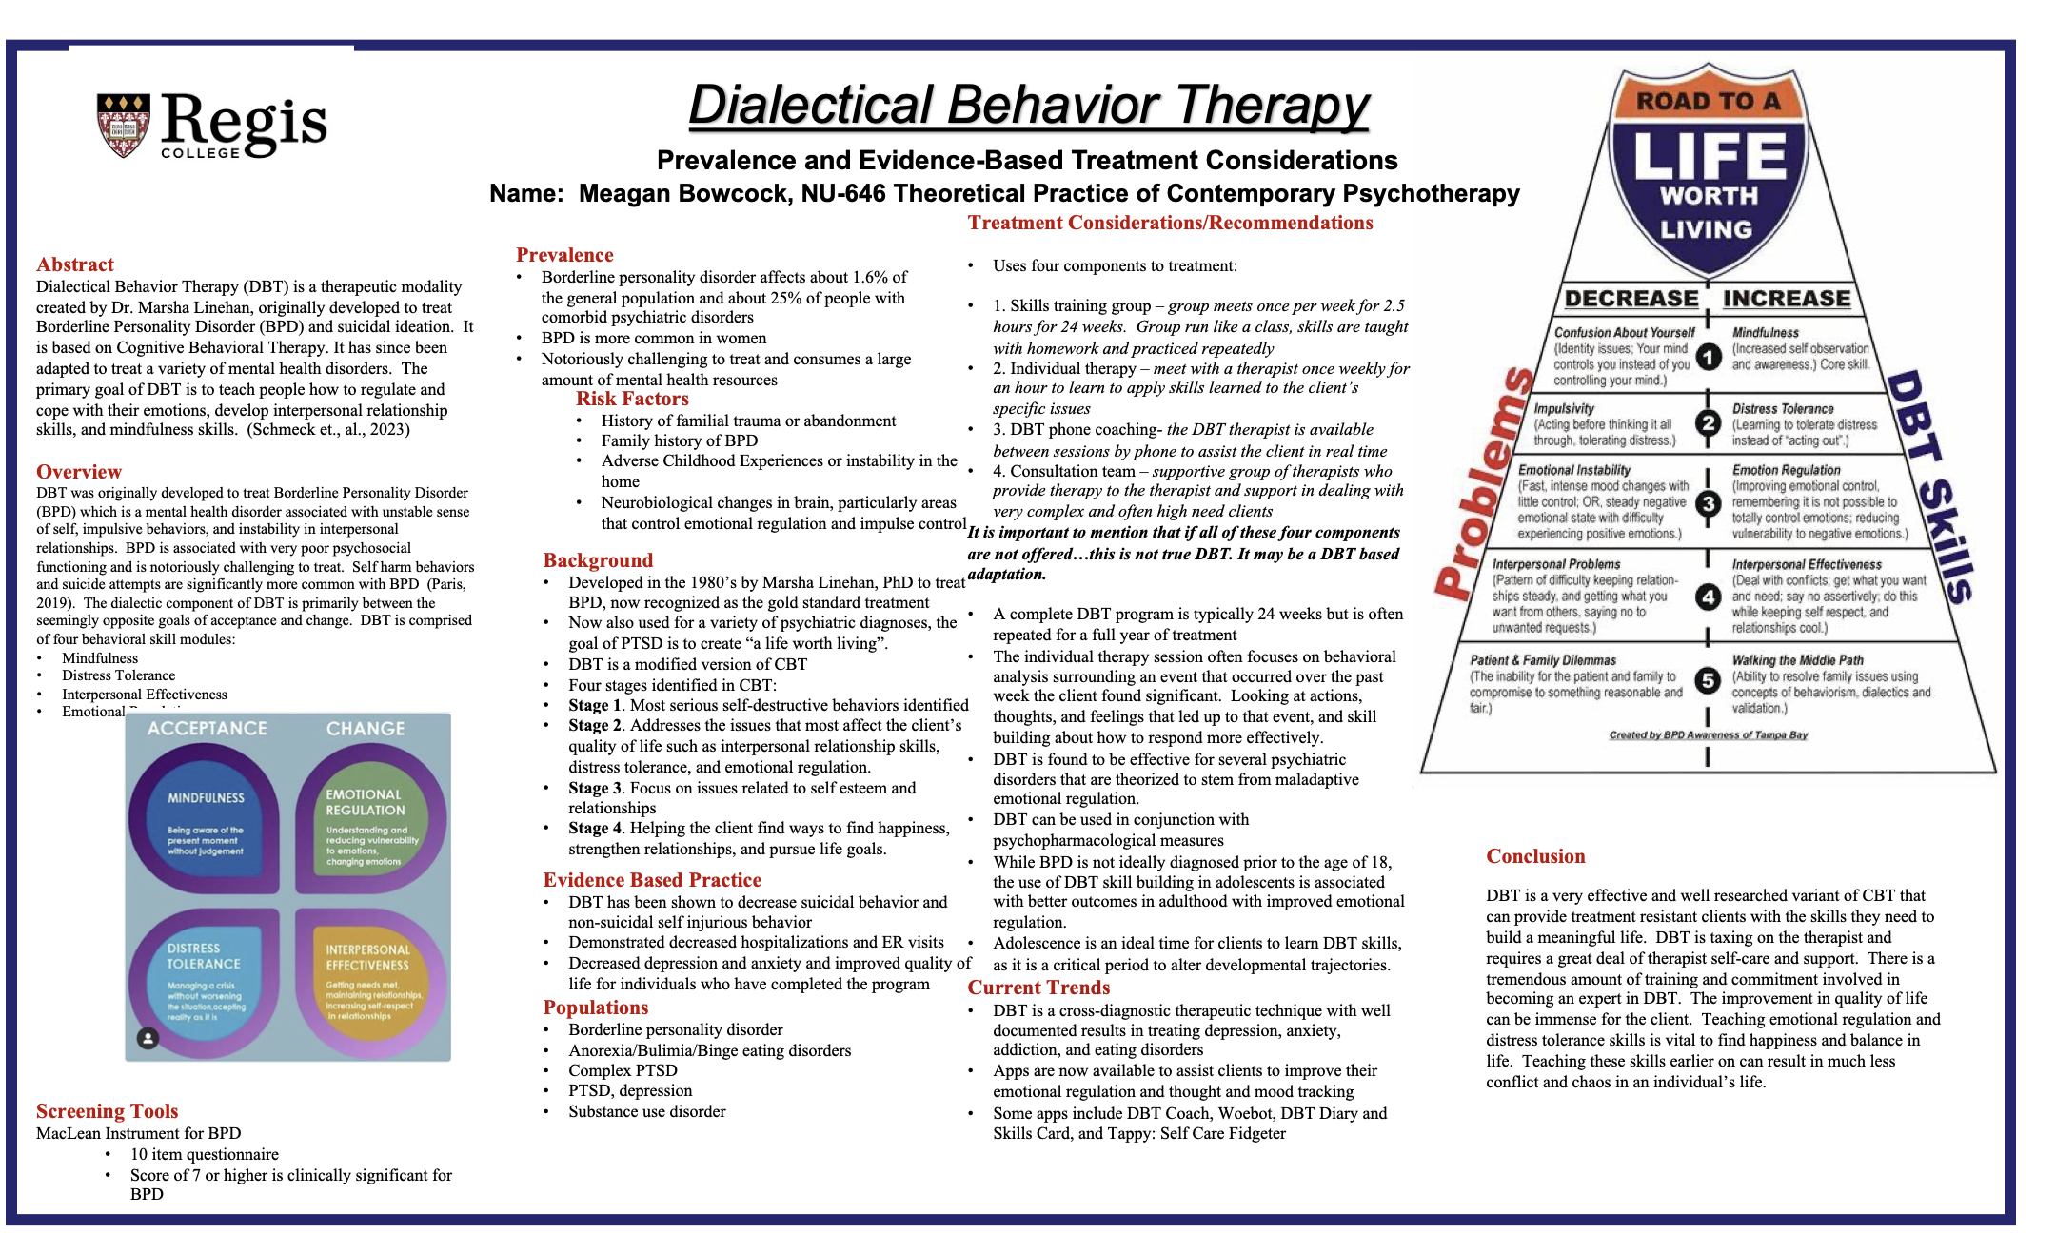

4 words
PermalinkShow parentReply

In reply to Meagan Bowcock

Re: Week 14 Discussion 1: Individual Poster Presentation Share Discussion
by Sarah McKeon - Friday, 7 April 2023, 9:35 PM
Hello Megan, thank you for your very informative poster on Dialectical Behavioral Therapy (DBT) it was clear, informative, and well laid out, honestly, I learned a lot from your poster. In many ways, the therapeutic modality which you choose is significantly different then, the therapeutic modality I choose which is Walk and Talk Therapy. DBT is an evidence base practice for the care of clients with borderline personality disorder, and suicidal ideation (Corey, 2021; Lebow, 2022). DBT also has promising evidence in the treatment of substance use disorder, anxiety, depression, eating disorders, and is known to be beneficial for clients who have mental health challenges which are treatment resistant (Lebow, 2022). Walk and talk therapy is not evidence based, there is significant research which has shown the benefits of movement and nature on mental health, however there is no significant research on the benefits of walk and talk therapy as a modality (Cooley et al., 2020; Song et al, 2018). Walk and talk also does not have indications for specific populations, though there is a possibility that it could be particularly beneficial for adolescents (Koziel et al., 2022). One thing that DBT and walk and talk therapy have in common is a mindfulness component (Corey, 2021). DBT is a very structured and well-developed therapeutic modality, while walk and talk therapy is an emergent and novel modality, which requires further research to better apply in practice.
References:
Cooley, S. J., Jones, C. R., Kurtz, A., & Robertson, N. (2020). 'Into the Wild': A meta-synthesis of talking therapy in natural outdoor spaces. Clinical psychology review, 77, 101841. https://doi.org/10.1016/j.cpr.2020.101841
Corey, G. (2021). Theory and practice of counseling psychotherapy Enhanced. (10th ed.) Belmont, CA: Cengage. ISBN: 9780357671429
Koziel, N., Vigod, S., Price, J., Leung, J., & Hensel, J. (2022). Walking Psychotherapy As a Health Promotion Strategy to Improve Mental and Physical Health for Patients and Therapists: Clinical Open-Label Feasibility Trial. Canadian journal of psychiatry. Revue canadienne de psychiatrie, 67(2), 153–155. https://doi.org/10.1177/07067437211039194
Lebow, J. (2022). Overview of psychotherapies. Uptodate. Retrieved on April 7, 2023 from: https://www-uptodate-com.regiscollege.idm.oclc.org/contents/overview-of-psychotherapies?search=dialectical%20behavior%20therapy&source=search_result&selectedTitle=2~34&usage_type=default&display_rank=2
Song, C., Ikei, H., Park, B. J., Lee, J., Kagawa, T., & Miyazaki, Y. (2018). Psychological Benefits of Walking through Forest Areas. International journal of environmental research and public health, 15(12), 2804. https://doi.org/10.3390/ijerph15122804
Hanging indent not retained
379 words
PermalinkShow parentReply

In reply to Content Services (I.B)

Re: Week 14 Discussion 1: Individual Poster Presentation Share Discussion
by Allison Marrier - Tuesday, 4 April 2023, 1:32 PM
Hi Everyone,
Here is the link to my poster presentation on CBT:
Play Video
Thanks,
Alli
15 words
PermalinkShow parentReply

In reply to Content Services (I.B)

Re: Week 14 Discussion 1: Individual Poster Presentation Share Discussion
by Ashley Amrol - Tuesday, 4 April 2023, 11:07 PM

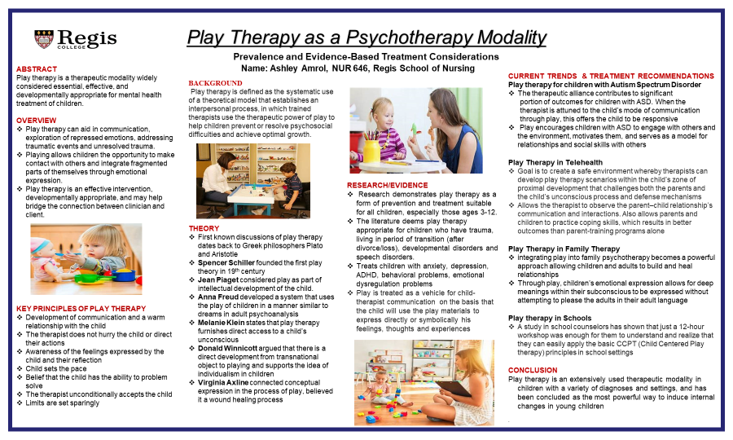

References:
Awang, S., Dioso, R., & Said, F. (2022). Knowledge and attitude of staff nurses towards the implementation of play therapy on children. Malaysian Journal of Nursing, 14(2), 51-56, doi: 10.31674/mjn.2022.v14i02.009
Hateli, B. (2022). The effect of non-directive play therapy on reduction of anxiety disorders in young children. Journal of Counselling and Psychotherapy Research, 22, 140-146, doi: 10.1002/capr.12420
Jenkins, B. (2023). LPCs and state certified school counselors’ perception of utilizing play therapy with autism spectrum disorder. International Journal of Play Therapy, 32(2), 95-106, doi: 10.1037/pla0000197
Koukourikos, K., Tsalglidou, A., Tzeha, L., Lliadis, C., Frantzana, A., Katsimbeli, A., & Kourkouta, L. (2021). An overview of play therapy. Journal of the Academy of Medical Sciences of Bosnia and Herzegovina, 33(4), 293-297, doi: 10.5455/msm.2021.33.293.297
Smith, T., Norton, A., & Marroquin, L. (2023). Virtual family play therapy: A clinician's guide to using directed family play therapy in telemental health. Contemporary Family Therapy: An International Journal, 45, 106-116, doi: 10.1007/s10591-021-09612-7

155 words
PermalinkShow parentReply

In reply to Content Services (I.B)

Re: Week 14 Discussion 1: Individual Poster Presentation Share Discussion
by Sarah McKeon - Wednesday, 5 April 2023, 9:41 PM
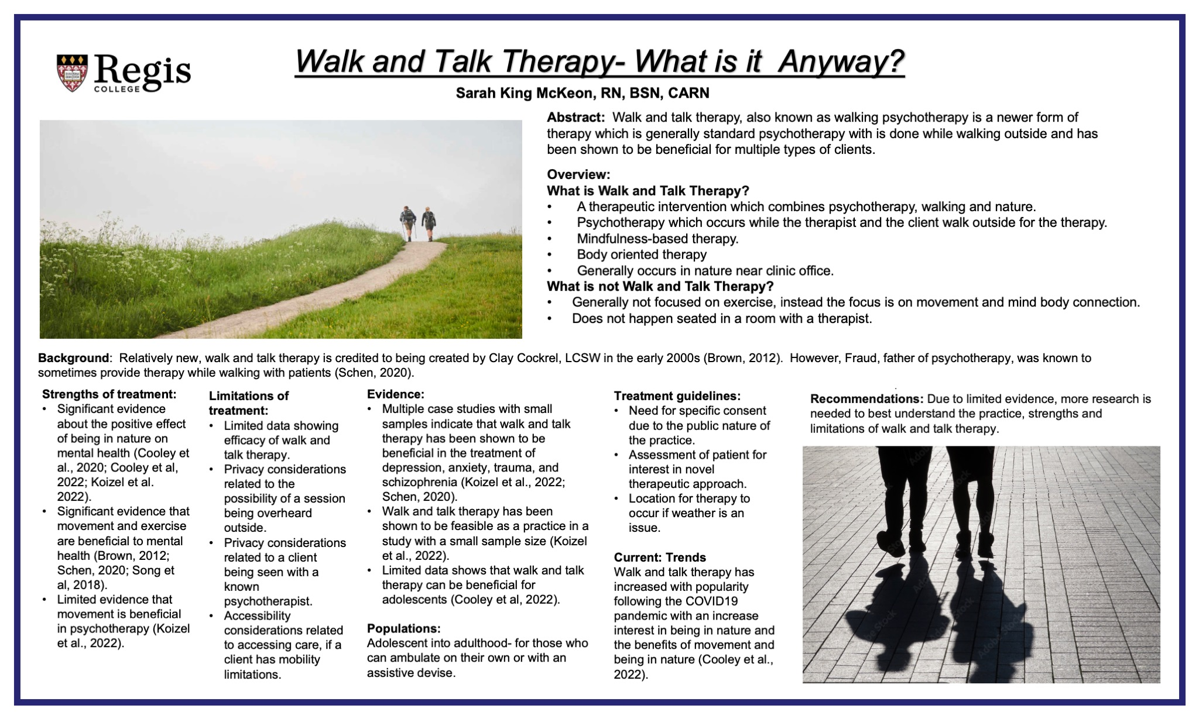

0 words
 Walk and talk therapy poster.pdf
PermalinkShow parentReply

In reply to Sarah McKeon

Re: Week 14 Discussion 1: Individual Poster Presentation Share Discussion
by Allison Marrier - Thursday, 6 April 2023, 8:43 AM
Week 14 Discussion 1: Individual Poster Presentation Share Discussion-Peer Response 1
Hi Sarah,

Thank you so much for your post. I really enjoyed learning about walk and talk therapy through your presentation. Before this week, I was not aware that this type of therapy had a formal name and was backed by research. When you look at walking alone, there are endless benefits to carrying out this activity whether it is combined with therapy or not. Walking has been shown to improve sleep, maintain blood sugar levels, improve brain function, strengthen immune system, and even lengthen your life in some cases. (Sharma & Malhotra, 2019) Additionally, it can improve your mood which is a great benefit to combine with therapy especially those dealing with anxiety and depression. Also, during COVID is proved to be a viable option for those who needed and alternative to indoor counseling. (Newman & Gabriel, 2022) Thanks again for providing me with all this new information on walk and talk therapy. I would love the possibility to integrate into my practice in the future.

Have a good day,

Alli
References
Newman, E., & Gabriel, L. (2022). Investigating clients' experiences of walk and talk counselling. Counselling and Psychotherapy Research, 23(1), 125–133. https://doi.org/10.1002/capr.12567
Sharma, S., & Malhotra, A. (2019). Reaping the rewards of exercise: It is never too late to start. European Heart Journal, 41(15), 1500–1502. https://doi.org/10.1093/eurheartj/ehz858

*Hanging indentation not retained

235 words
PermalinkShow parentReply

In reply to Sarah McKeon

Re: Week 14 Discussion 1: Individual Poster Presentation Share Discussion
by Jennifer Glynn - Saturday, 8 April 2023, 1:25 PM
​Hi Sarah,
Walk and talk therapy is not something I have heard of before in a clinical setting. Reading your poster gave me great insight into this therapy modality. One thing that I have learned while dealing with anxiety and depression on a personal level includes that act of being in nature which can be mood enhancing due to the fresh air, sunshine and other aspects. One benefit of walk and talk therapy includes being in an outdoor environment which can increase clients access to therapy, increase engagement and create a healthcare equity (Cooley et al., 2021). It is possible that clients will feel intimidated by the typical therapy room, and these clients may feel more comfortable being in nature. Another benefit of this type of therapy that has been recognized includes the client's perception that walking and talking can assist with making them not feel “stuck” while promoting psychological processing (Revell & McLeod, 2015). Therapist have also found that this type of therapy increases the collaborative way of working with clients. Researching this therapy modality was enjoyable for me, and I learned a great deal of information from your poster. I do believe that this type of treatment will be beneficial, and the effects will show once more research is obtained.
References
Cooley, S. J., Jones, C. R., Moss, D., & Robertson, N. (2021). Organizational perspectives on outdoor talking therapy: Towards a position of ‘environmental safe uncertainty’. British Journal of Clinical Psychology, 61(1), 132–156. https://doi.org/10.1111/bjc.12315
Revell, S., & McLeod, J. (2015). Experiences of therapists who integrate walk and talk into their professional practice. Counselling and Psychotherapy Research, 16(1), 35–43. https://doi.org/10.1002/capr.12042
​
277 words
PermalinkShow parentReply

In reply to Sarah McKeon

Re: Week 14 Discussion 1: Individual Poster Presentation Share Discussion
by Ashley Amrol - Saturday, 8 April 2023, 7:41 PM
Hi Sarah,
‘Walk and Talk Therapy’ is new to me as of this week and I appreciate your detailed poster and explanation. I learned this week that Walk and Talk therapy took force during the pandemic, as it became a kosher way to spend face-to-face time with minimal occupancy of others’ aerosol space, while also harnessing the therapeutic benefits of nature (Markusoff, 2021). Although the pandemic placed emphasis on this type of therapy, it has existed for many years, and it has even been referenced in Frued’s work (Newman & Gabriel, 2022). Walk and talk therapy has been shown to decrease the ‘fight or flight’ response in the amygdala associated with many mental health conditions, and is especially helpful for those patients who are claustrophobic or struggle being confined to a room (Markusoff, 2021). In a way, Walk and Talk therapy can be compared to the therapy modality I chose this week- play therapy. They both help to distract the patient, and allow them to work at their own pace. Thanks for your insightful post this week. Happy Easter 😊

References:
Markusoff, J. (2021). Therapy goes outside the box: Walk-and-talk counselling has gone from niche service to much-needed solution during the pandemic, 134(5), https://search.ebscohost.com/login.aspx?direct=true&db=edsgea&AN=edsgcl.658632012&site=eds-live
Newman, E., & Gabriel, L. (2022). Investigating clients’ experiences of walk and talk counselling. Journal of Counseling Psychotherapy Research, 23(1), 125-133, doi: 10.1002/capr.12567

227 words
PermalinkShow parentReply

In reply to Sarah McKeon

Re: Week 14 Discussion 1: Individual Poster Presentation Share Discussion
by Alyssa Malloch - Sunday, 9 April 2023, 12:05 AM
Hi Sarah,
Thank you for your wonderful poster presentation on Walk and Talk Therapy. I was unaware that this was a type of formal of therapy. I found it particularly interesting that it has gained popularity throughout the COVID-19 pandemic, although this makes a lot of sense! It seems to be much less formal than other types of psychotherapy which may be appealing to those that would not have considered indoor, seated therapy that can feel too formal or stiff. According to Newman (2022), while clients participating in Walk and Talk Therapy reported it felt somewhat informal, it did not detract from the professional relationship and clients felt that the relationship was more equal than if they were in a seated, indoor session. Similarly, practitioners have reported that Walk and Talk Therapy promotes a more collaborative relationship and aids in psychological processing (Revell & McLeod, 2016). I agree with your recommendation for more research on this mode of therapy along with specific consent due to the location of the sessions and potential for accidental disclosures of protected information.
References
Newman, E., & Gabriel, L. (2022). Investigating clients' experiences of walk and talk counselling. Counselling and Psychotherapy Research, 23(1), 125–133. https://doi.org/10.1002/capr.12567
Revell, S., & McLeod, J. (2016). Experiences of therapists who integrate walk and talk into their professional practice. Counselling and Psychotherapy Research, 16(1), 35–43. https://doi.org/10.1002/capr.12042

*Hanging indent not retained
231 words
PermalinkShow parentReply

In reply to Content Services (I.B)

Re: Week 14 Discussion 1: Individual Poster Presentation Share Discussion
by Martin Mutesasira - Thursday, 6 April 2023, 6:11 PM
Hi Class, Please see attached my individual poster presentation
Thanks.
10 words
 646_week_14_group_therapy_poster_presentation_ (3)!.pptx
PermalinkShow parentReply

In reply to Content Services (I.B)

Re: Week 14 Discussion 1: Individual Poster Presentation Share Discussion
by Jennifer Glynn - Thursday, 6 April 2023, 8:14 PM
Hi Class,
Attached is my powerpoint posted on person centered therapy.
Thanks !
13 words
person centered therapy.pptx
PermalinkShow parentReply

In reply to Content Services (I.B)

Re: Week 14 Discussion 1: Individual Poster Presentation Share Discussion
by Shoshanah Marote - Thursday, 6 April 2023, 8:31 PM

0 words
PermalinkShow parentReply

In reply to Shoshanah Marote

Re: Week 14 Discussion 1: Individual Poster Presentation Share Discussion
by Walter Adigwe - Saturday, 8 April 2023, 8:34 PM
Hi Shoshanah
Thanks for your presentation on music therapy. It has an impact for where words fail, music speaks. Unfortunately, music therapy is not covered by insurance reimbursement but is used as an adjuvant treatment in many facilities providing calmness and reducing stress. I have seen music therapy patients humming, dancing, singing, and reflecting on their situations. They use it to reflect their current emotional state and gradually advance to the desired one. The application of music as therapy undoubtedly addresses one's physical, emotional, cognitive, and social needs. It has been invaluable in managing people with depression and anxiety disorders (Eseadi & Ngwu, 2023). However, my presentation is centered on group therapy as a monotherapy or adjuvant, which has equally shown a significant outcome in treating various mental illnesses such as depression, anxiety, substance abuse, and many other diseases, including prevention of relapse (Muralidhar et al., 2018). Equally, studies have shown that music therapy interventions can positively impact recovery–based objectives and the group-based experience in substance use disorder patients (Silverman, 2019).
References
Eseadi, C., & Ngwu, M. O. (2023). Significance of music therapy in treating depression and anxiety disorders among people with cancer. World Journal of Clinical Oncology, 14(2), 69–80. https://doi.org/10.5306/wjco.v14.i2.69
Muralidhar, D., Ezhumalai, S., Dhanasekarapandian, R., & Nikketha, B. (2018). Group interventions. Indian Journal of Psychiatry, 60(8), 514. https://doi.org/10.4103/psychiatry.indianjpsychiatry_42_18
Silverman, M. J. (2019). Quantitative comparison of group-based music therapy experiences in adults with substance use disorder on a detoxification unit: A three-group cluster-randomized study. Arts & Health, 13(1), 49–62. https://doi.org/10.1080/17533015.2019.1608568
254 words
PermalinkShow parentReply

In reply to Content Services (I.B)

Re: Week 14 Discussion 1: Individual Poster Presentation Share Discussion
by Christine Perrault - Thursday, 6 April 2023, 9:05 PM
Hello Class!
Attached is my Poster Presentation on Yoga Therapy!
10 words
NU646_Yoga Therapy_poster_presentation_template.pptx
PermalinkShow parentReply

In reply to Content Services (I.B)

Re: Week 14 Discussion 1: Individual Poster Presentation Share Discussion
by Jennifer Smith - Thursday, 6 April 2023, 10:21 PM
Hello,
Please see my attached presentation on mindfulness Based Cognitive Therapy.
Best, Jennifer
13 words
Smith Mindfulness Based Cognitive Therapy Presentation.pptx
PermalinkShow parentReply

In reply to Content Services (I.B)

Re: Week 14 Discussion 1: Individual Poster Presentation Share Discussion
by Walter Adigwe - Thursday, 6 April 2023, 11:31 PM

0 words
PermalinkShow parentReply

In reply to Content Services (I.B)

Re: Week 14 Discussion 1: Individual Poster Presentation Share Discussion
by Kenechi Ogbuchiekwe - Thursday, 6 April 2023, 11:52 PM
Hello class, below is a link to my ppt. Thanks.
10 words
NU 646 Week 14 Poster Presentation.pptx
PermalinkShow parentReply

In reply to Content Services (I.B)

Re: Week 14 Discussion 1: Individual Poster Presentation Share Discussion
by Olasumbo Abegunde - Thursday, 6 April 2023, 11:58 PM

0 words
Animal Assited Therapy.pptx
PermalinkShow parentReply

In reply to Olasumbo Abegunde

Re: Week 14 Discussion 1: Individual Poster Presentation Share Discussion
by Olasumbo Abegunde - Thursday, 6 April 2023, 11:59 PM

0 words
PermalinkShow parentReply

In reply to Content Services (I.B)

Re: Week 14 Discussion 1: Individual Poster Presentation Share Discussion
by Marie Cius - Friday, 7 April 2023, 10:48 AM
Hello everyone, attached is my individual poster presentation.
8 words
NU646_individual_poster_Presentation- Yoga.pptx
PermalinkShow parentReply

In reply to Content Services (I.B)

Re: Week 14 Discussion 1: Individual Poster Presentation Share Discussion
by Alyssa Malloch - Friday, 7 April 2023, 9:50 PM
Hi everyone, I've attached my poster presentation on EMDR
9 words
EMDR poster.pdf
EMDR references.pdf
PermalinkShow parentReply

In reply to Alyssa Malloch

Re: Week 14 Discussion 1: Individual Poster Presentation Share Discussion
by Allison Marrier - Saturday, 8 April 2023, 6:19 AM
Week 14 Discussion 1: Individual Poster Presentation Share Discussion - Peer Response 2

Hi Alyssa,

Thanks so much on your great poster presentation on EMDR. This is a style of therapy that I am very interested in and thoroughly enjoyed learning more about it. In my research, I found that post traumatic stress disorder (PTSD) can mimic the symptoms of oppositional defiant disorder (ODD). In children with these disorders, EMDR was found to be an effective psychotherapy style. In as little as 5 EMDR sessions, PTSD and ODD symptoms showed improvement. (Yilmaz, 2022) Specifically, EMDR shows to be most effective in older adolescents. Also, a greater improvement was seen in trauma symptoms compared to external behavior symptoms. (Hoogsteder et al., 2021) While I am not certain where my career path will take me, I am open to providing care to adolescents who have experienced trauma. The knowledge that I have gained throughout this course has been valuable. There are many key pieces of information that will assist and influence my future practice. Thank you again for your wonderful post.

Have a good weekend,

Alli
References
Hoogsteder, L. M., ten Thije, L., Schippers, E. E., & Stams, G. M. (2021). A meta-analysis of the effectiveness of emdr and tf-cbt in reducing trauma symptoms and externalizing behavior problems in adolescents. International Journal of Offender Therapy and Comparative Criminology, 66(6-7), 735–757. https://doi.org/10.1177/0306624x211010290
Yilmaz, G. (2022). Adhd symptoms persist even when ptsd symptoms progress: An emdr case report. Dusunen Adam:The Journal of Psychiatry and Neurological Sciences. https://doi.org/10.14744/dajpns.2022.00174

*Hanging indentation not retained

258 words

