EVALUATION PLAN
Resource for this worksheet:
Agency for Healthcare Research and Quality. (2009). Health Information Technology Evaluation Toolkit. U.S. Department of Health and Human Services. https://digital.ahrq.gov/sites/default/files/docs/page/health-information-technology-evaluation-toolkit-2009-update.pdf

PROJECT: <PROJECT NAME>
PREPARED BY: <NAME>
DATE:

Brief Project Description:

Project Goals: (What are the goals of your stakeholders for this project? What needs to happen for the project to be deemed a success by your stakeholders?) Example: To improve patient safety; to improve the financial position of the hospital; to be seen by our patients as making patient safety a priority

Evaluation Goals: (To share lessons learned? To demonstrate project’s return on investment? To prepare a report for stakeholders and funders? Are the goals internal or external?)

Evaluation Measures:
What needs to be measured to demonstrate that the project has met project goals? (Check potential measure categories)
Clinical Outcomes Clinical Process Provider Adoption & Attitudes Patient Adoption, Knowledge, & Attitudes Workflow Impact Financial Impact

Evaluation Measures:

Example: (1) Goal: To improve patient safety. Measurement: The number of preventable adverse drug events in reduced post-implementation. (2) Goal: To improve the hospital’s financial position. Measurement: The number of claims rejected is reduced post-implementation.

Possible qualitative measures to consider

Evaluation of project barriers: (Organizational, financial, legal, other)

Evaluation of project facilitators: (strong leadership, training, community buy-in)

Rating Evaluation Measures: (Rate each measure in order of importance to your stakeholders, i.e., CEO, clinicians, or patients. This will help you begin to filter out measures that are interesting to you but will not provide you with information to your stakeholders)

Very Important:

Moderately Important:

Not Important:

Rate Measurement Feasibility: (Be realistic about available resources. Will the project be labor-intensive and expensive? Focus on what is achievable and what needs to be measured to determine if the implementation has met its goals.)

Feasible:

Moderate Effort:

Not Feasible:

Place measures in an Importance-Feasibility grid to determine which measures to undertake and which measures to avoid.
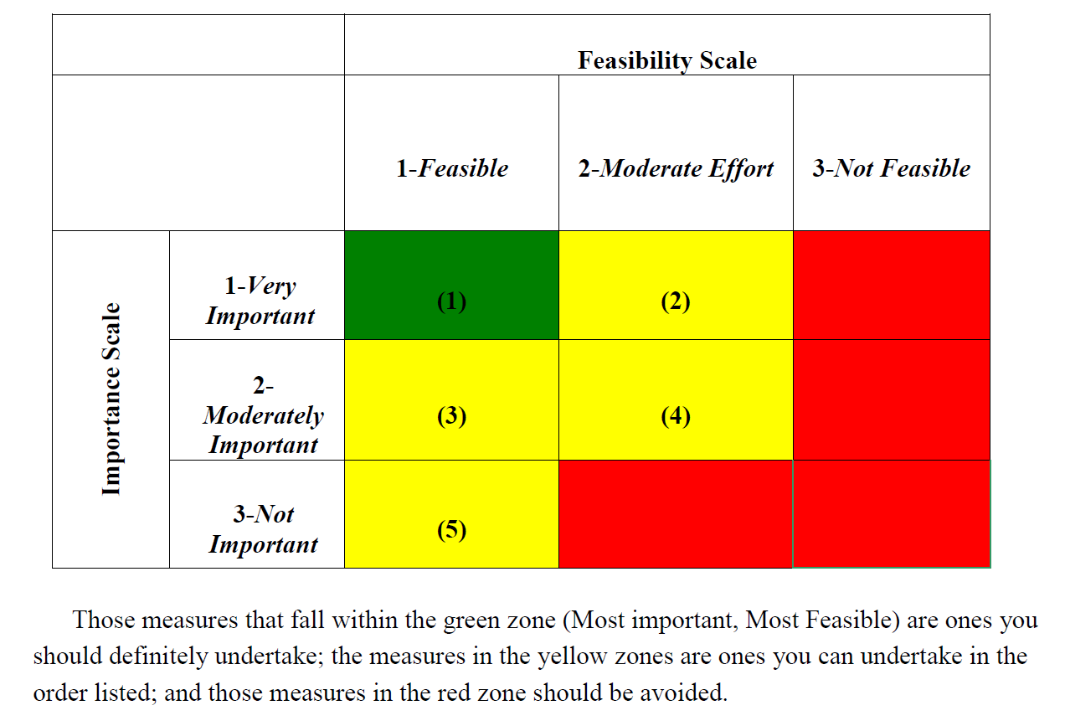

Chosen Measures to Evaluate: (Narrow your list down to four or five measures)

- ____________________________________________________________
- ____________________________________________________________
- ____________________________________________________________
- ____________________________________________________________
- ____________________________________________________________
Evaluation Study Design: (Use this table to organize your evaluation study options)
- See Health Information Technology Evaluation Toolkit, pp. 13-15
Data Collection Strategies |  | Types of Study Designs
 | Case-Control |  | RCT | Time-Motion |  | Pre-Post
Manual Chart Review

Electronic Data Mining of EMR /Registry Data

Instrument the EMR/Registry

Surveys (Paper/Electronic)

Expert Review

Phone Interview

Focus Group

Direct Observation

Consider the Impact of Study Design on Relative Cost and Feasibility
See Health Information Technology Evaluation Toolkit, pp. 15-17

Choose Your Final Measures: (This may be the same list as above or a shorter version of the list)

- ____________________________________________________________
- ____________________________________________________________
- ____________________________________________________________
- ____________________________________________________________
- ____________________________________________________________

Write Your Final Evaluation Plan:

1. Short Description of the Project
2. Goals of the Project
3. Questions to be Answered by the Evaluation Effort
4. First Measure to be Evaluated – Quantitative
A. Overview – General Considerations
B. Timeframe
C. Study Design/Comparison Group
D. Data Collection Plan
E. Analysis Plan
5. Second Measure to be Evaluated – Qualitative
A. Overview – General Considerations
B. Timeframe
C. Study Design
D. Data Collection Plan
E. Analysis Plan
6. Subsequent Measures to be Evaluated in the Same Format

