Week 6

Student Lesson Plan

Overview
- Program Competencies
- Course Outcomes
- Weekly Objectives
- Main Concepts
- Applies organizational and system leadership skills to affect systemic changes in corporate culture and to promote continuous improvement in clinical outcomes. (PO 6)
- Appraises current information systems and technologies to improve health care. (POs 6, 7)

Schedule
Section | Read/Review/Complete | Course Outcomes | Due
Prepare | Assigned Readings | COs 1, 3, 5, 6 | Wednesday
Explore | Lesson | COs 1, 3, 5, 6 | Wednesday
Translate to Practice | Discussion: Initial Post | COs 1, 5, 6 | Wednesday
Translate to Practice | Discussion: Follow-Up Posts | COs 1, 5, 6 | Sunday
Translate to Practice | Assignment | COs 1, 3, 5, 6 | Sunday
Reflect | Reflection | COs 1, 3, 5, 6 | No submission

Foundations for Learning
The following resource outlines the foundational competencies of advanced nursing practice for the DNP-prepared nurse related to informatics:
American Association of Colleges of Nursing. (2006). The essentials of doctoral educationLinks to an external site. for advanced nursing practice. https://www.aacnnursing.org/DNP/DNP-Essentials
Start your learning this week by reviewing the media:
U.S. Department of Health & Human Services. (n.d.).HIPAA: Your health information, your rights [Video]. YouTube. https://youtu.be/FKTHncn-5Vs
U.S. Department of Health & Human Services. (n.d.). HIPAA: Security rule [Video]. YouTube. https://youtu.be/QWRn2r5R7ts
U.S. Department of Health & Human Services. (n.d.). HIPAA: Explaining the notice of privacy practices [Video]. YouTube. https://youtu.be/8EXEqsN-NiU
U.S. Department of Health & Human Services. (n.d.). HIPAA: Communicating with family, friends, and others involved in your care [Video]. YouTube. https://youtu.be/om2IPAcADas

Student Learning Resources
Click on the following tabs to view the resources for this week.
- Required Textbooks
- Required Articles
- Additional Resources
McBride, S., & Tietze, M. (2023). Nursing informatics for the advanced practice nurse: Patient safety, quality, outcomes, and interprofessionalism (3rd ed.). Springer Publishing Company.
- Read Chapter 29

Learning Success Strategies
- Review the assigned readings to ensure you understand the key terms and can relate them to health information privacy, confidentiality, security, and ethics.
- Read the resources to gain an understanding of the concepts of privacy, confidentiality, security, and ethics.
- Be ready to share your thoughts through the interactive discussion board. Review the case study and recognize the concept breaches, answer questions, and discuss solutions with your peers.
- Review the discussion board guidelines for postings and the rubric.
- As you consider the assignment on the practice problem analysis and presentation, templates have been provided to guide the analysis and presentation development. Information from the Week 4 assignment may be incorporated into parts of the presentation such as the practice problem idea, PICOT, background, and significance. See rubric.
- The practice problem analysis assignment should be on your practice problem idea, plus incorporate work from the Week 4 translation science project. This assignment is excluded from Turnitin due to its incremental similarity to previously developed work in the course to support this assignment and the PICOT.
- The assignment for this week has several components. Make sure to read the instructions closely to include all those components in your submission.
- Remember the vast number of resources available to you! There is help in the library, writing resources, links to evidence for the course, your textbooks, and other places!
- Your course faculty is here to support your learning journey. Reach out for guidance with study strategies, time management, and course-related questions.
- Let’s Check In: Tips for Success are available several weeks throughout the course. Check announcements and please listen to the recording posted in the announcement if unable to attend.

Interacting with Feedback
Each week your course faculty will provide feedback in the rubric on any assignment you have submitted. Take a moment to review the following video on how to view rubric feedback in Canvas. (After clicking the link, scroll down or click on the title in the Summary area to jump directly to the video.)
- Link (video): Looking at FeedbackLinks to an external site. (2:26)
Review the following video on how to accept/reject track changes when viewing course faculty feedback on your assignment:
- Link (video): Word: Track Changes and Comments (4:19)

Lesson 1
Health Information Privacy and Security

Protected Health Information Insurance Portability and Accountability Act Compliance Risks
The Health Insurance Portability and Accountability Act (HIPAA) of 1996 was enacted into legislation enforcing federal security and privacy standards. The act included the protection and confidential handling of protected health information. Since its enactment, healthcare providers have been modifying practices to ensure compliance. With the rapid change in information technology and evolving policies, compliance with these standards can be challenging. In fact, the U.S. Department of Health and Human Services (2019) reported that the upward trend in the number of violations received by the Office of Civil Rights remains alarming. The DNP-prepared nurse and other healthcare leaders must champion best practices to ensure compliance, which requires supportive policies, processes, and tools.

Learn More!
View the following short videos to discover the 10 most common HIPAA violations and actions required for managing protected health information within federal requirements:
- Video 1: Improperly Storing Health InformationLinks to an external site. (1:01)
- Video 2: Releasing Information to an Undesignated PartyLinks to an external site. (0.55)
- Video 3: Releasing Unauthorized Health InformationLinks to an external site. (1.00)
- Video 4: Failing to Include the Right to Revoke ClauseLinks to an external site. (0:54)
- Video 5: Releasing the Wrong Patient’s Health InformationLinks to an external site. (0:51)
- Video 6: Noncompliance with Patient Signature RequirementsLinks to an external site. (1:02)
- Video 7: Failing to Release Information to PatientsLinks to an external site. (1:.07)
- Video 8: Improperly Disposing of Patient RecordsLinks to an external site. (0:52)
- Video 9: Violating the Authorization Expiration DateLinks to an external site. (0:54)
- Video 10: Granting Unauthorized Access to Medical RecordsLinks to an external site. (1:30)

10 Common HIPAA Violations Video Series Transcripts

HITECH: Ensuring Privacy in Electronic Health Information Sharing
The Health Information Technology for Economic and Clinical Health (HITECH) Act expands the scope of privacy and security rules enacted by the Health Insurance Portability and Accountability Act of 1996 (HIPAA) and increases the potential for legal liability for noncompliance. HITECH specified that, beginning in 2011, monetary incentives were to be dispersed to healthcare providers for demonstrating meaningful use of electronic health records. Disbursements were disseminated through 2015, after which time financial penalties were enforced for failure to demonstrate compliance. Of recent, such penalties have been enforced with increasing frequency (McBride & Tietze, 2023). Risk assessment processes are critical for healthcare providers to appraise personal health information practices for security risks.
View the following video to learn practices to assess personal health information as part of a risk management process.
Security 101: Security Risk Analysis (8:06)

10 Common HIPAA Violations Video Series Transcripts

Social Media Privacy and Ethical Guidelines
Although social media use in healthcare is commonplace, nurses and nurse leaders must use social media responsibly. Inappropriate social media use may result in licensure censorship and legal consequences.
Watch the following video for more information on privacy breaches:
Privacy Breach (2:02)
The National Council of State Boards of Nursing (NCSBN) developed guidelines to support nurses in using social media ethically and appropriately.
View the following video to explore the NCSBN guidelines for the responsible use of social media by nurses:
- Link (video): Social Media Guidelines for NursesLinks to an external site. (5:45)

Social Media Guidelines for Nurses Video Transcript

Privacy, Confidentiality, and Security of Health Information: The Patient Experience

Although health information technology improves the efficiency and effectiveness of healthcare through the sharing of patient information, this capacity may raise patients’ concern about the privacy and security of their health records. The healthcare team relies on technology, but adherence to policies to prevent data theft is vital. Patients trust their providers, but this trust could be jeopardized with personal health information loss. All parties must be able to trust the security of the systems used to support healthcare (McBride & Tietze, 2023).
Another aspect complicating the patient experience is the internet connectivity around us. We are connected to the world through devices, software, applications, and wearable technology. This system of interrelated devices connected to the internet is known as the Internet of Things (IoT) (Alvarez et al., 2021). In healthcare, it is known as the Medical Internet of Things comprised of the patient, physician, machines, and the care environment. This Internet of Things generates massive volumes of data known as Big Data. Even though access to this information may be improving communication, interprofessional collaboration, decision-making, and patient outcomes, security risks exist. The primary risks are confidentiality, data integrity, and availability to the authorized user (Alvarez et al., 2021). As you learned last week, the shift to value-based care is transforming our healthcare environment and the Medical Internet of Things is supporting the change. As the DNP-prepared nurse, you may be involved in decisions related to the Medical Internet of Things and patient information security risks should be considered.
View the following video to explore the Medical Internet of Things:
- Link (video): IoT Healthcare| Value-Based Care and the Medical Internet of ThingsLinks to an external site. (2:03)

IoT Healthcare Video Transcript

View the following resource to consider how concerns about cybersecuity impact the patient experience:
- Link (webpage): Cybersecurity in HealthcareLinks to an external site.

Lesson 2
Systems Development Life Cycle

Life Cycle Phases
When an organization purchases an information system, many activities occur before the system is made available to the end user. The standardized approach to the development and implementation of an information system is known as the systems development life cycle (SDLC). Nurse informaticists, system architects, and system designers work to ensure the information system functionality supports the workflow of the end-users and protects the patients by ensuring processes decrease errors and minimize harm. Significant work hours are devoted to designing the system to support users’ current workflows, meet regulatory requirements, and protect patients’ personal health information. The process can be extensive, taking months or years, and involves the following steps (McBride & Tietze, 2023):
- Planning
- Analysis
- Design and Implementation
- Functionality and Testing
- System Implementation, Evaluation, and Maintenance
As with managing any project, the planning phase is the most important, having an impact on all the subsequent phases of the systems development life cycle. The goals are simple to have a system that does the following:
- Provides ease of use for the end user
- Functions as expected
- Meets the user’s needs
- Protects the patients’ information
- Promotes efficiency
- Heightens communication
The DNP-prepared nurse, as the expert for the nursing profession within the healthcare setting, may advocate for both staff and patient needs within the information system design working collaboratively with the informatics team. Once an information system has been purchased, the planning begins from screen design recommendations to testing and staff education. The DNP-prepared nurse should be willing to share nursing knowledge and expertise on behalf of the staff and patients throughout any phases of the life cycle.
View the following graphic that illustrates the phases of the systems development life cycle.
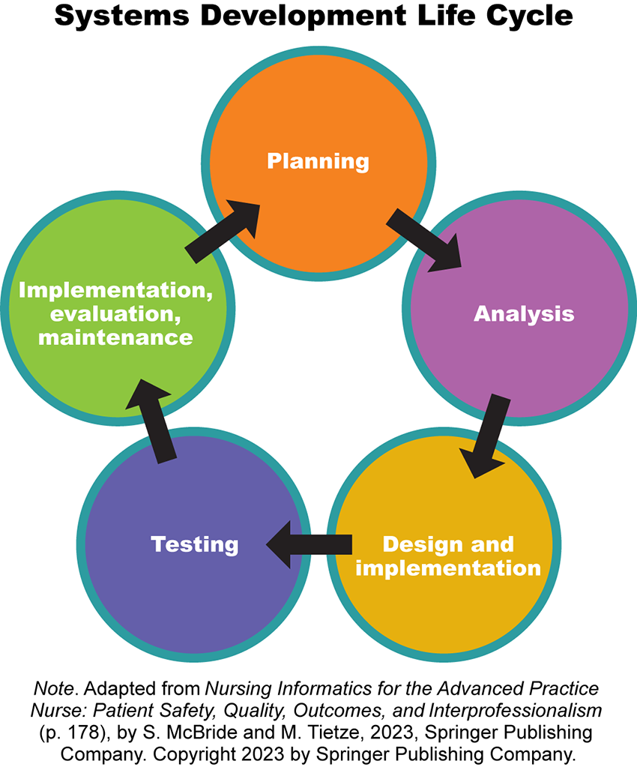

Systems Development Life Cycle

In some respects, the systems development life cycle is analogous to the steps in the nursing process. Information systems aid the nursing process, communication, and coordination related to nursing activities and patient care.
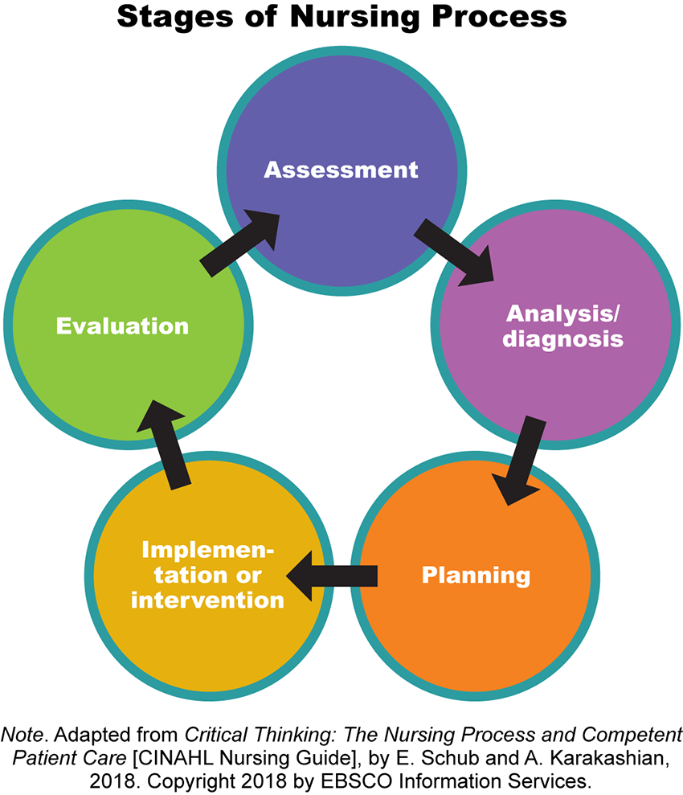

Stages of Nursing Process

To accomplish planning, analysis, design, and testing, the informatics team and DNP-prepared nurse may work in a variety of information system environments. In addition to the real or live environment available and used daily by healthcare employees, there may be additional information system environments. Those environments may include build, test, or training environments to support activities associated with system design.
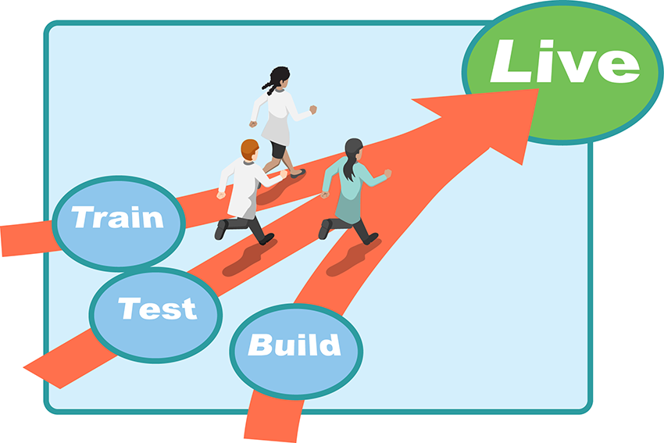

Process Evaluation
A process at first glance may seem complex because of extensive planning, analysis, and testing. However, the benefits to the healthcare providers and patients are innumerable. Remember, the nurse informaticist and informatics team are there to guide and to support the DNP-prepared nurse as different aspects of the information system design are broken down into manageable projects. Analyzing process steps is one of the first goals for a nurse informaticist assigned to a specific project related to system design.
Click on the following link for an illustration of an analysis created by a nurse informaticist tasked with understanding the workflow in the emergency department for heart failure patients. The DNP-prepared nurse may become a source of critical information to assist in the process evaluation phase.
- Link (Word doc): Emergency Department Workflow for Heart Failure PatientLinks to an external site.

Emergency Department Workflow for Heart Failure Patient Transcript

Identifying, analyzing, and understanding steps in processes may be rather broad in scope as the illustration above or more simplistic in relation to a specific practice problem. The DNP-prepared nurse, through evidence translation and process improvement, plays a significant role in practice problem analysis. The goals are to improve processes to prevent errors leading to harm for staff or patients, and to ensure patient privacy and confidentiality are maintained.

References
Alvarez, Y., Leguizamon-Paez, M., & Londono, T. (2021). Risks and security solutions existing in the internet of things (IoT) in relation to big data. Telematics Engineering, 23(1), 1-13. https://doi.org/10.25100/iyc.23:1.9484
Department of Health and Human Services. (2019). Health information privacy: Numbers at a glance. https://www.hhs.gov/hipaa/for-professionals/compliance-enforcement/data/numbers-glance/index.html
McBride, S., & Tietze, M. (2023). Nursing informatics for the advanced practice nurse: Patient safety, quality, outcomes, and interprofessionalism (3rd ed.). Springer Publishing Company.

Health Privacy Breach

Discussion

Purpose
The purpose of this discussion is for you to investigate healthcare privacy breaches and the associated risks and the ethical and legal issues confronted as a DNP-prepared nurse. Privacy breaches are serious offenses that negatively affect the trust between nurses and patients. To maintain this trust, nurses must maintain the privacy and security of patient information.

Instructions
Reflect on the following scenarios related to the protection of health information. Select two of the scenarios to discuss.
- Scenario 1: A staff nurse posted the following comment on her social media page: “Can this shift be any longer? It started out with a waiting room full of nagging people who don’t seem to know what ‘emergency’ means. Then, I had to deal with the drama of trying to transfer a 400 lbs. (no joke) intubated chronic obstructive pulmonary disease patient down the hall to the intensive care unit. Those intensive care unit nurses are such divas, and I wasn’t in the mood for their whining. Someone help!”
  - Analyze the privacy and security issues related to this social media posting.
- Scenario 2: A nurse practitioner is preparing a presentation poster for an infectious disease conference. She includes pictures of varying stages of a client’s lesions in the poster.
  - Analyze the privacy and security issues related to the inclusion of patient information on the poster.
- Scenario 3: A clinical instructor is working with nursing students on a medical unit for the day. While rounding to check on students, the instructor discovers a patient’s daughter wants to take a picture of the nursing student and the patient together to post on social media.
  - Analyze the privacy and security issues and explain the best response for the clinical instructor.
Please click on the following link to review the DNP Discussion Guidelines on the Student Resource Center program page:
- Link (webpage): Graduate Discussion Grading Guidelines and RubricLinks to an external site.

Program Competencies
This discussion enables the student to meet the following program competencies:
- Applies organizational and system leadership skills to affect systemic changes in corporate culture and to promote continuous improvement in clinical outcomes. (PO 6)
- Appraises current information systems and technologies to improve health care. (POs 6, 7)

Course Outcomes
This discussion enables the student to meet the following course outcomes:
- Assess the impact of informatics and information technology on organizational systems, change, and improvement. (PCs 2, 4; PO 6)
- Appraise consumer health information sources for accuracy, timeliness, and appropriateness. (PC 4; PO 7)
- Resolve ethical and legal issues related to the use of information, communication networks, and information and patient care technology. (PCs 2, 4; PO 6)

Due Dates
- Initial Post: By 11:59 p.m. MT on Wednesday
- Follow-Up Posts: By 11:59 p.m. MT on Sunday
Search entries or author
Filter replies by unreadUnread Collapse replies Expand replies
Subscribe
ReplyReply to Week 6: Discussion | Health Privacy Breach

Collapse SubdiscussionKatie Hooven

Katie Hooven
Oct 21, 2023Local: Oct 21 at 8:22am<br>Course: Oct 21 at 6:22am
Manage Discussion Entry
Welcome to our Week 6 Discussion!

Remember: you may begin posting for credit on Sunday of Week 6. Please do not post before then.

When you make your initial response, click on the “Reply” arrow above this post. In Canvas this will set your post apart from all others. When you reply to another’s post, you will click the “Reply” arrow under that particular post.

Please read the question carefully to understand all the components. Then respond in a scholarly manner following the Graduate Discussion Grading Guidelines and Rubric. Our interactive discussion addresses the following course outcomes:
CO 1: Assess the impact of informatics and information technology on organizational systems, change, and improvement. (PCs 2,4; PO 6)

CO 5: Appraise consumer health information sources for accuracy, timeliness, and appropriateness. (PC 4; PO7)

CO 6: Resolve ethical and legal issues related to the use of information, communication networks, and information and patient care technology. (PCs 2,4; PO6)

Consider your own experiences as well as the literature.

I am looking forward to your discussions.
Dr. Hooven
ReplyReply to Comment

Week 6Practice Problem Analysis and Presentation

Assignment

Purpose
The purpose of this assignment is to critically evaluate a practice problem idea you identified. This assignment builds on the Week 4 assignment. Information used in the Week 4 assignment may be used as a basis for this assignment. The goal is to develop a deeper understanding of the identified practice problem idea, using two continuous quality improvement tools, specifically, a Failure Mode and Effects Analysis (FMEA) and an Ishikawa (fishbone) cause and effect diagram to analyze, improve, and mitigate related risks. This assignment will allow you to apply competencies through sequential development of workflow steps in relation to an identified practice problem idea and promotion of presentation skills. Assignment content supports professional formation, communication, and dissemination skills relevant to the DNP-prepared nurse.

Instructions
This assignment has four components:
- Identified practice problem idea in PICOT format
- Failure Mode and Effects Analysis
- Ishikawa (Fishbone) cause and effect diagram
- Professional PowerPoint with speaker notes at the bottom of each slide to disseminate information
Follow these guidelines when completing each component of the assignment. Contact your course faculty if you have questions.
- Consider the identified practice problem idea used in the Week 4 translation science project including PICOT, background, and significance. Incorporate course faculty feedback from the Week 4 assignment.
- Review the examples of the failure mode and effects analysis and fishbone diagram in the Week 4 Explore section of the course called Evidence-Based Practice: Improving Outcomes.
- Download the required documents inserted in the guidelines:
  - Link (PPT): PowerPoint TemplateLinks to an external site.
  - Link (Word doc): Failure Mode and Effects Analysis TemplateLinks to an external site.
  - Link (Word doc): Ishikawa Fishbone Template ALinks to an external site. (Word 2016 or higher)
  - Link (Word doc): Ishikawa Fishbone Template BLinks to an external site. (older version of Word)
- Complete the failure mode and effects analysis and then the Ishikawa fishbone diagram. The Ishikawa fishbone diagram requires Word 2016 to download. If you do not have the Word 2016 version, you may update your current version of Word (click on the following link for instructions: Office 365Links to an external site.) or use the alternative version provided or create your own fishbone diagram as long as you are addressing the five areas:
  - People
  - Environment
  - Materials
  - Methods
  - Equipment
- Create the PowerPoint Presentation.
The assignment should include the following components. Use the templates provided for the assignment.
- Introduction (1 slide)
  - Title of Practice Problem Analysis Presentation
  - Student Name
  - Assignment Title
  - Course Faculty Name
- Practice Problem Identification (1-3 slides)
  - State identified practice problem as a PICOT question in question format.
  - Identify all PICOT components.
  - Describe the background and significance of the identified practice problem idea (cited).
  - Develop inclusion criteria for the population of interest.
  - Develop exclusion criteria for the population of interest.
- Failure Mode and Effects Analysis (1-2 slides)
  - Identify three steps in the identified practice problem idea process with potential breakdown or process gaps.
  - Identify at least one potential error (failure mode) for each of the three process steps.
  - Identify at least one possible cause of failure (failure cause) for each of the three process steps.
  - Identify at least one adverse consequence (failure effect) for each of the three process steps.
  - Using a scale 1-10, rate likelihood of occurrence of failure for each process step.
  - Using a scale 1-10, rate likelihood of detection of failure for each process step.
  - Using a scale 1-10, rate likelihood of severity of harm if failure occurs for each process step.
  - Calculate the Risk Profile Number (Multiply likelihood of occurrence X likelihood of detection X likelihood of severity or harm).
  - Summarize FMEA analysis.
Note: The following article has scoring guidelines for FMEA ratings which may be helpful.
Warnick, R. E., Lusk, A. R., Thaman, J. J., Levick, E. H., & Seitz, A. D. (2020). Failure mode and effects analysis (FMEA) to enhance safety and efficiency of Gamma Knife Radiosurgery.Links to an external site. Journal of Radiosurgery and SBRT, 7, 115-125.
- Ishikawa (Fishbone) Cause and Effect Diagram (1-2 slides)
  - Identify people involved in the identified practice problem idea.
  - Identify the environment in which the identified practice problem idea occurs.
  - Identify the materials used.
  - Identify the methods used.
  - Identify the equipment used.
  - Summarize cause and effect analysis.
- Evidence-Based Intervention (1 -2 slides)
  - Identify the evidence-based intervention for your identified practice problem idea (listed in PICOT).
  - Identify barriers to overcome based upon what you learned from the FMEA and Fishbone Analyses.
  - Discuss feasibility of the evidence-based intervention.
- Conclusion (1 slide)
  - Summarize the purpose and findings of the analysis.
  - Provide and justify the main conclusions.
  - Draw inferences from the quality improvement analysis.
- References (1 slide)
  - Include in-text citations used in the presentation.
  - Provide complete matching references in correct APA format.
  - Include minimum of four scholarly sources.

Writing Requirements
- Length: Maximum of 14 slides
- Standard English usage and mechanics
- APA format guidelines for in-text citation and references
- Clear, succinct, and readable slides
- Elaboration on the slide questions
- Speaker notes section with legible comprehensive notes for each slide

Graduate Re-Purpose Policy
The late assignment policy and the reuse repurpose policy (located in the student handbook) apply to this assignment.

Program Competencies
This assignment enables the student to meet the following program competencies:
- Applies organizational and system leadership skills to affect systemic changes in corporate culture and to promote continuous improvement in clinical outcomes. (PO 6)
- Appraises current information systems and technologies to improve health care. (POs 6, 7)

Course Outcomes
This discussion enables the student to meet the following course outcomes:
- Assess the impact of informatics and information technology on organizational systems, change, and improvement. (PCs 2, 4; PO 6)
- Design programs that monitor and evaluate outcomes of care, care systems, and quality improvement. (PC 4; PO 7)
- Appraise consumer health information sources for accuracy, timeliness, and appropriateness. (PC 4; PO 7)
- Resolve ethical and legal issues related to the use of information, communication networks, and information and patient care technology. (PCs 2, 4; PO 6)

Due Date
- By 11:59 p.m. MT on Sunday
- Late Assignment Policy applies

Rubric
W6 Assignment Grading Rubric
W6 Assignment Grading Rubric
Criteria | Ratings | Pts
This criterion is linked to a Learning OutcomeIntroduction (1 slide)  Requirements:  a. Title of Practice Problem Analysis Presentation  b. Student Name  c. Assignment Title  d. Course Faculty Name |  | 10 pts
  10 pts  Includes all requirements and provides an excellent introduction. | 9 pts  Includes fewer than all requirements and/or provides a very good introduction. | 8 pts  Includes fewer than all requirements and/or provides a basic introduction. | 0 pts  Includes fewer than all requirements and/or provides a poor introduction.
This criterion is linked to a Learning OutcomePractice Problem Identification (1-3 slides)  Requirements:  a. State identified practice problem as a PICOT question in question format.  b. Identify all PICOT components.  c. Describe the background and significance of the identified practice problem (cited).  d. Develop inclusion criteria for the population of interest.  e. Develop exclusion criteria for the population of interest. |  | 50 pts
  50 pts  Includes all requirements and provides an excellent description of the practice problem and question. | 45 pts  Includes fewer than all requirements and/or provides a very good description of the practice problem and question. | 40 pts  Includes fewer than all requirements and/or provides a basic description of the practice problem and question. | 0 pts  Includes fewer than all requirements and/or provides a poor description of the practice problem and question.
This criterion is linked to a Learning OutcomeFailure Mode and Effects Analysis (1-2 slides)  Requirements:  a. Identify three steps in the identified practice problem idea process with potential breakdown or process gaps. (1-2 slides)  b. Identify at least one potential error (failure mode) for each of the three process steps.  c. Identify at least one possible cause of failure (failure cause) for each of the three process steps.  d. Identify at least one adverse consequence (failure effect) for each of the three process steps.  e. Using a scale 1-10, rate likelihood of occurrence of failure for each process step.  f. Using a scale 1-10, rate likelihood of detection of failure for each process step.  g. Using a scale 1-10, rate likelihood of severity of harm if failure occurs for each process step.  h. Calculate the Risk Profile Number (Multiply likelihood of occurrence X likelihood of detection X likelihood of severity or harm).  i. Summarize FMEA analysis. |  | 70 pts
  70 pts  Includes all requirements and provides an excellent failure mode and effects analysis. | 63 pts  Includes fewer than all requirements and/or provides a very good failure mode and effects analysis. | 56 pts  Includes fewer than all requirements and/or provides a basic failure mode and effects analysis. | 0 pts  Includes fewer than all requirements and/or provides a poor failure mode and effects analysis.
This criterion is linked to a Learning OutcomeIshikawa (Fishbone) Cause and Effect Diagram (1-2 slides)  Requirements:  a. Identify people involved in the identified practice problem.  b. Identify the environment in which the identified practice problem occurs.  c. Identify the materials used.  d. Identify the methods used.  e. Identify the equipment used.  f. Summarize cause and effect analysis. |  | 70 pts
  70 pts  Includes all requirements and provides an excellent fishbone cause and effect diagram. | 63 pts  Includes fewer than all requirements and/or provides a very good fishbone cause and effect diagram. | 56 pts  Includes fewer than all requirements and/or provides a basic fishbone cause and effect diagram. | 0 pts  Includes fewer than all requirements and/or provides a poor fishbone cause and effect diagram.
This criterion is linked to a Learning OutcomeEvidence-Based Intervention (1 -2 slides)  Requirements:  a. Identify the evidence-based intervention for your identified practice problem idea (listed in PICOT).  b. Identify barriers to overcome based upon what you learned from the FMEA and Fishbone Analyses.  c. Discuss feasibility of the intervention. |  | 50 pts
  50 pts  Includes all requirements and provides an excellent evidence-based intervention discussion. | 45 pts  Includes fewer than all requirements and/or provides a very good evidence-based intervention discussion. | 40 pts  Includes fewer than all requirements and/or provides a basic evidence-based intervention discussion. | 0 pts  Includes fewer than all requirements and/or provides a poor evidence-based intervention discussion.
This criterion is linked to a Learning OutcomeConclusion (1 slide)  Requirements:  a. Summarize the purpose and findings of the analysis.  b. Provide and justify the main conclusions.  c. Draw inferences from the quality improvement analysis. |  | 20 pts
  20 pts  Includes all the requirements and provides an excellent conclusion. | 18 pts  Includes fewer than all requirements and provides a very good conclusion. | 16 pts  Includes fewer than all requirements and/or provides a basic conclusion. | 0 pts  Includes fewer than all requirements and/or provides a poor conclusion.
This criterion is linked to a Learning OutcomeReferences (1 slide)  Requirements:  a. Include in-text citations used in the presentation.  b. Provide complete matching references in correct APA format.  c. Include minimum of four scholarly sources. |  | 10 pts
  10 pts  Includes all requirements and provides excellent references. | 9 pts  Includes fewer than all requirements and/or provides very good references. | 8 pts  Includes fewer than all requirements and/or provides basic references. | 0 pts  Includes fewer than all requirements and/or provides poor references.
This criterion is linked to a Learning OutcomePresentation and Writing  Requirements:  a. Length: Maximum of 14 slides  b. Standard English usage and mechanics  c. Clear, succinct, and readable slides  d. Elaboration on the slide questions  e. Speaker notes section with legible comprehensive notes for each slide |  | 20 pts
  20 pts  Includes all requirements and provides an excellent presentation and writing. | 18 pts  Includes fewer than all requirements and/or provides a very good presentation and writing. | 16 pts  Includes fewer than all requirements and/or provides basic presentation and writing. | 0 pts  Includes fewer than all requirements and/or provides poor presentation and writing.
Total Points: 300

