NU-643-01-23PCSP Adv.Psychopharmacology
- Dashboard
- My courses
- NU-643-01-23PCSP
- Week 2: Foundations of Neuroscience and the Principles of Pharmacodynamics
- Week 2 Assignment 1: Neurotransmitters Mind Map

Week 2 Assignment 1: Neurotransmitters Mind Map
Due: Sunday, 15 January 2023, 11:55 PM
To do: Make a submission
Value: 100 points
Due: Day 7
Gradebook Category: Assignments

Instructions
For this assignment, you will create a “Mind-Map” or “Stream of Thought” of the following six neurotransmitters with the brain as the center of controls.
- Dopamine
- GABA
- Glutamate
- Serotonin
- Norepinephrine/Epinephrine
- Histamine
You will link the neurotransmitters to the main properties/characteristics, link to the anatomical location where the neurotransmitter is found, and any associated receptors, as well as psychiatric diagnoses that could occur with a deficit or surplus of the neurotransmitter. Additionally, list symptoms under the deficits and surplus. Lastly, link what medications/drug classes can increase and decrease the effects of the neurotransmitters.
Sign up for a free account and use Bubbl.us or use a Word template from Template Lab to create your Mind Map.
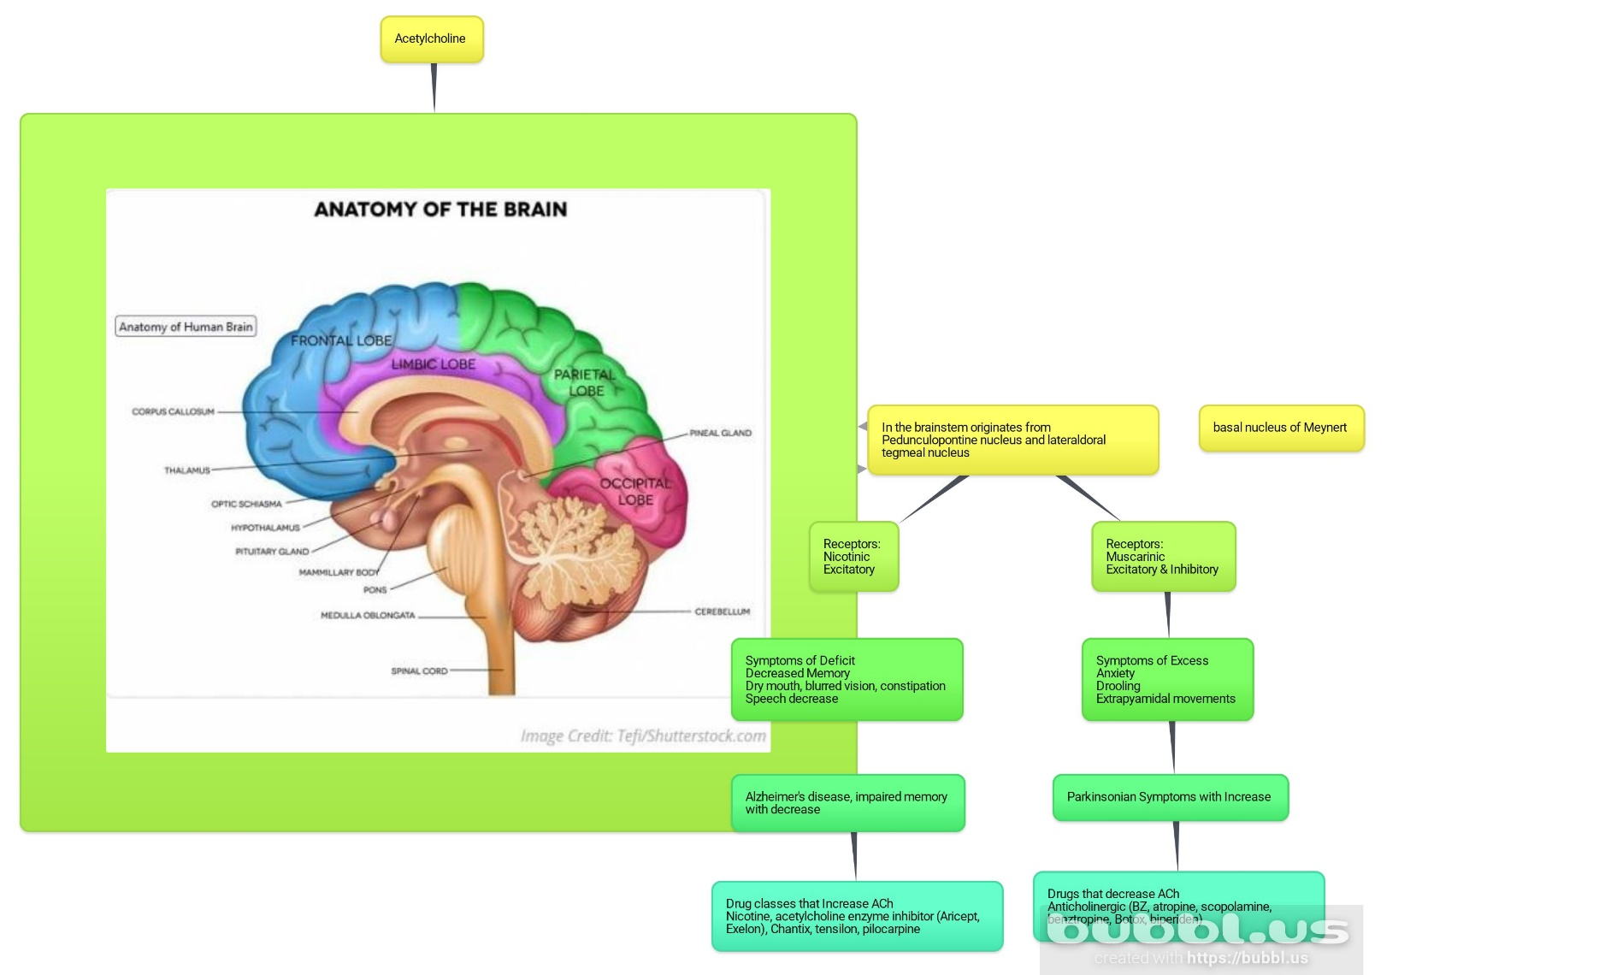
As an additional note, all components must be included for full points in the content area of the rubric for each neurotransmitter: (see Checklist):
- Name of neurotransmitter
- Main properties and characteristics of neurotransmitter
- Anatomical location (s)
- Associated receptors
- Psychiatric diagnosis with deficit
- Psychiatric diagnosis with surplus
- Medications/drug class that increase neurotransmitter
- Medications/drug class that decrease neurotransmitter
You can complete this as one large mind map or a separate mind map, one for each neurotransmitter. Be creative, as there are several ways to create them. You will also review the Mind Map Checklist (PDF) and include your references. A minimum of one reference for each neurotransmitter is required.
Upload all files you created as Mind Map(s) and the Checklist that includes your references.
Please refer to the Grading Rubric for details on how this activity will be graded. The described expectations meet the passing level of 80 percent. Students are directed to review the Grading Rubric for criteria that exceed expectations.
To Submit Your Assignment:

