Disease Process: Edema is the accrual of excess fluid in the body’s tissue. It results from intensified fluid movement from the intravascular to the interstitial segments or, it can build up within the cells. Furthermore, edema leads to the swelling of certain body parts such as ankles, legs, and ankles since the fluid ends up localized in the tissues (Lent-Schochet & Jialal, 2022). It can manifest in several guises including generalized, one-sided, bilateral, or restricted edema.

Pathophysiology: The materialization of edema encompasses modifications and imbalance in the capillary hemodynamics that bolsters fluid movements into and out of the body’s tissues. Additionally, diminished water movement from the interstitium into either the lymphatic or capillaries repositories induce edema. It is noteworthy to acknowledge that edema can result from several mechanisms such as intensified capillary hydrostatic pressure, dwindled plasma oncotic pressure, Obstruction of the lymphatic system, and amplified capillary absorbency (VanMeter & Hubert, 2022). Intensified capillary hydrostatic pressure denotes the pressure exerted by blood on the walls of the arteries. As such, if the pressure is elevated, the fluid can leak out of the repository and into the adjacent tissues. Conversely, diminished plasma oncotic pressure entails the pressure wielded by proteins in the blood and it is vital as it aids in keeping the fluid in the arteries. Hence, if it is low, the fluid is able to leak out and flow into the tissues leading to edema. Notably, the lymphatic system eliminates unnecessary fluid from the body. Thus, when it is obstructed it cannot function adequately resulting in edema (Lent-Schochet & Jialal, 2022). Remarkably, the capillary walls are relatively impervious, facilitating miniscule molecules passage. However, the impairment or inflammation of the capillary walls leads to proliferated permeability which induces leakage and eventually edema.
Risk factors: Pregnancy.
Surgery procedure that entails lymph nodes
Chronic conditions like kidney disease or congestive heart failure (Lent-Schochet & Jialal, 2022).

Major signs and symptoms: (image if you can find one)
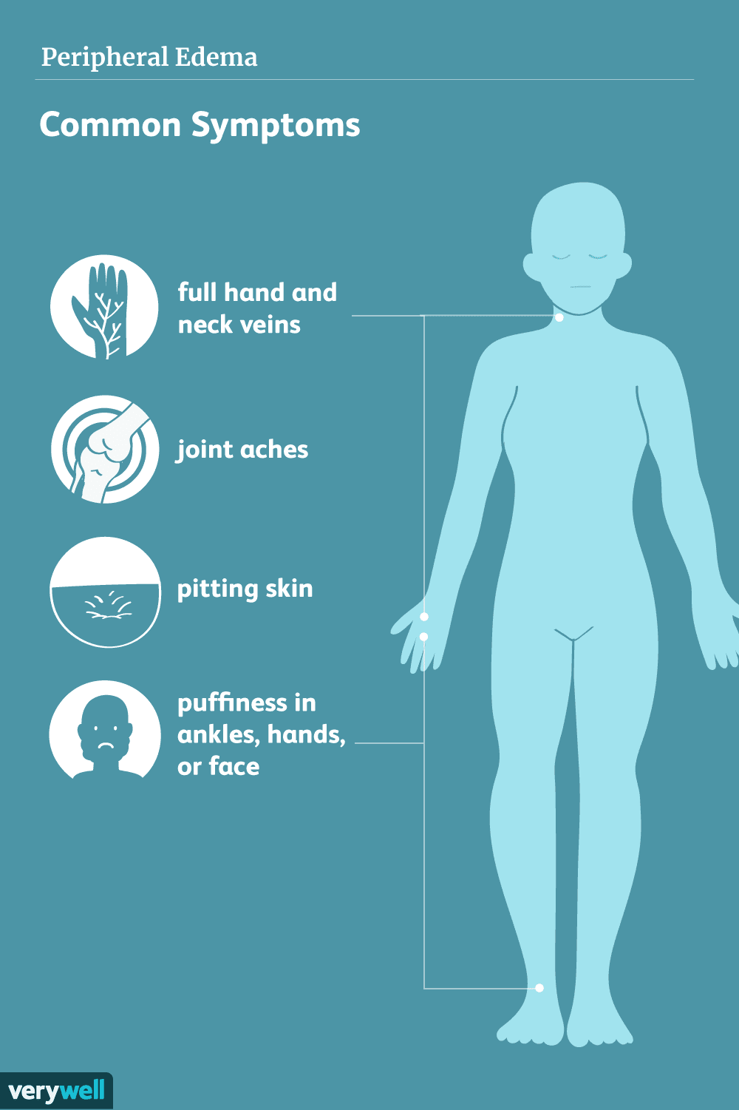 (Barhum, 2022).
Diagnostic testing: Physical examination to detect the location and predict the magnitude of edema.
Blood tests and Vein studies aid in determing the conditions inducing edema.
Urine tests are essential in assessning kidney function and recognizing causal factors precipitating edema (Goyal, Cusick & Bhutta, 2022).

References:
Goyal, A., Cusick, A. S., & Bhutta, B. S. (2022). Peripheral Edema. In StatPearls. StatPearls Publishing. https://www.ncbi.nlm.nih.gov/books/NBK554452/
Lent-Schochet, D., & Jialal, I. (2022). Physiology, Edema. In StatPearls. StatPearls Publishing. https://pubmed.ncbi.nlm.nih.gov/30725750/
VanMeter, K. C., & Hubert, R. J. (2022). Gould\'s pathophysiology for the health professions. (7th Ed.). Elsevier Saunders. Chapter 2: Fluid, Electrolyte, and Acid-Base Imbalances

Case Presentation
A.K. is a 40-year-old Caucasian male who presented to the facility complaining of swelling on the right leg and constant fatigue. The patient reported that he started feeling tired three months ago and assumed that was akin to his work since he is a surveyor. He asserted that he has diabetes diagnosed five years ago and hypertension three years prior to the visit, however, he adheres to his medication. He smokes cigarettes and drinks occasionally. According to the patient, his weight increased six weeks ago, and presumed that related to his consumption of junk food. His mother is diabetic and has dementia. He was oriented to people, place, and time and has no known allergies.
The vital signs included a temperature of 36.4°C, blood pressure of 100/65 mm Hg, heart rate of 72 beats per minute, oxygen saturation of 98%, and a body mass of 28. The physical exam indicated that the patient did not have jaundice, no evidence of rales, distended abdomen, jugular venous distention was evident, and 2+ unilateral pitting edema. The diagnosis was peripheral edema (Patel, Skok & DeMarco, 2022). The recommended tests were duplex ultrasound and a CT scan which confirmed the diagnosis. The apt treatment for A.K. is a diuretic. He was also advised to reduce his salt intake, wear compression socks and sleep with a pillow under his legs (Gasparis et al., 2020).

Reference 1
Patel, H., Skok, C., & DeMarco, A. (2022). Peripheral edema: evaluation and management in primary care. American Family Physician, 106(5), 557–564. https://pubmed.ncbi.nlm.nih.gov/36379502/

Reference 2
Gasparis, A. P., Kim, P. S., Dean, S. M., Khilnani, N. M., & Labropoulos, N. (2020). Diagnostic approach to lower limb edema. Phlebology, 35(9), 650–655. https://doi.org/10.1177/0268355520938283

