- Week 14: Endocrine

July 31 – August 6
  - Week 14: Introduction and ObjectivesPage
Done: View
  - Week 14: What's Due WhenPage
Done: View
  - Week 14: Learning MaterialsPage
Done: View
  - Learning Activities
  - Week 14 Assignment 1: Interactive Diabetes Mellitus Case Study
To do: Make a submission
11111111111111111111111111111111111111111111111111111111111111111111111111111111111111111111111111111111111111111

Week 14: Introduction and Objectives
Done: View

Introduction
Along with cardiovascular, one of the most prevalent diseases that we will encounter involves endocrinology. We will learn to safely and appropriately select endocrine system related pharmacologic agents in the management of client health issues based on client variations, the problems being managed, and cost effectiveness. We also will discuss comprehensive and appropriate client education in relation to prescribed pharmacologic agents. There will be a review of the endocrine system, hormone regulation and antidiabetic agents, as well as thyroid hormones.

Learning Materials Introduction
This week, our focus will be healthcare.
All of the weekly learning materials (WO 1, 2, 3) will assist you as you complete the weekly assignments. They will also prepare you with content needed to complete the exams and other tasks within the course.
The content within the learning materials should provide support to substantiate the value of the knowledge and skills gained throughout this course for the advanced education of nursing.

Learning Objectives
By the end of this week, you will be able to:
- Select the optimal pharmacologic agents in the management of endocrine disorders.
- Discuss comprehensive client education in relation to prescribed pharmacologic agents.
- Analyze factors influencing adherence behavior to prescription medications and the use of medications as a means to promote, maintain, and restore health to clients.
2222222222222222222222222222222222222222222222222222222222222222222222222222222222222222

Week 14: What's Due When
Done: View
What's Due Week 14
Learning Activity | Due Date | Points
Week 14 Assignment 1: Interactive Diabetes Mellitus Case Study | Day 7 | 100 points
Complete Learning Activities Table
3333333333333333333333333333333333333333333333333333333333333333333333333333333333333333333333333333333333333

Week 14: Learning Materials
Done: View

Readings

Required
- Woo, T. M., & Robinson, M. V. (2020). Pharmacotherapeutics for Advanced practice Nurse prescribers for Advanced practice Nurse prescribers (5th ed.). F.A. Davis Company.
  - Chapter 18: Drugs Affecting the Endocrine System: Pancreatic Hormones and Antidiabetic Drugs
  - Chapter 19: Drugs Affecting the Endocrine System: Pituitary, Thyroid, and Adrenal Drugs
  - Chapter 35: Diabetes Management
  - Chapter 40: Hormone Replacement Therapy
  - Chapter 43: Hyperthyroidism and Hypothyroidism
The Writing for Publication e-book is available from the Regis College Library.

Recommended Texts
- Recommended for drug dosing desk reference of adult populations-based practitioners: Lexicomp. (2017). Drug Information Handbook for Advanced Practice Nursing (17th ed.). Wolters Kluwer Clinical Drug Information.
- Recommended for drug dosing desk reference of pediatric and family medicine populations-based practitioners: Taketamo, C. K. (2017). Pediatric and Neonatal Dosage Handbook (24th ed.). Lexicomp Incorporated

Recommended Resources
- American Diabetes Association Standards of Care (PDF)
- American Thyroid Association Professional Guidelines
- Pharmaceutical Online
- Type 2 Diabetes: Management and Primary Care

Lecture Presentations
View the following presentations for more information regarding this week’s learning content.
- Drugs Affecting the Endocrine System: Pancreatic Hormones and Antidiabetic Drugs (PPT)
- Drugs Affecting the Endocrine System: Pituitary, Thyroid, and Adrenal Drugs Lecture (PPT)
- Diabetes Management Lecture (PPT)
- Hormone Replacement Therapy Lecture (PPT)
- Hyperthyroidism and Hypothyroidism Lecture (PPT)

Videos

Diabetic Drugs (3:18 minutes)
Diabetic Drugs Video Transcript

Anti-Diabetic drugs/ Blood glucose lowering agents classification in details described with mnemonics (15:38 minutes)
Anti-Diabetic drugs/ Blood glucose lowering agents classification in details described with mnemonics Video Transcript

Hypothyroid Medication Choices (8:36 minutes)
Hypothyroid Medication Choices Video Transcript
444444444444444444444444444444444444444444444444444444444444444444444444444444444444444444444444444444444444444444444444444444444444444444444444444444444

Week 14 Assignment 1: Interactive Diabetes Mellitus Case Study
Due: Sunday, 6 August 2023, 11:55 PM
To do: Make a submission
Value: 100 points
Due: Day 7
Grading Category: Case Studies (Assignments)

Instructions
In this assignment, you will review the interactive Endocrine Diabetes Mellitus Case Study patient scenario and analyze the data to determine the health status of the patient. You will need a minimum of two evidence-based practice articles to include clinical practice guidelines, as well as the course textbook.
- Use the NU641 Endocrine Diabetes Mellitus Case Study Questions (Word) document to complete the case study assignment.
- Follow the requirements posted in the rubric.
- This case study should be three to five pages, excluding title and references pages.
All papers must conform to the most recent APA standards.
Please refer to the Grading Rubric for details on how this activity will be graded.
To Submit Your Assignment:
- Select the Add Submissions button.
- Drag or upload your file to the File Picker.
- Select Save Changes.
C999999999999999999999999999999999999999999999999999999999999999999999999999999999999999999999999999999999999999
CASE STUDY/ CASE STUDY/CASE STUDY / CASE STUDY

Overview of Patient
Rosa is a 55-year-old moderately obese Hispanic woman (body mass index is 29). She was referred to you when her gynecologist noted glucose on a routine urinalysis. She subsequently has an FPG of 190 and 200 mg/dL on two separate occasions. She is thirstier than usual and has more frequent urination. She also complains of decreased energy over the last several months and numbness and tingling in her left lower extremity.
Bbbbbbbbbbbbbbbbbbbbbbbbbbbbbbbbbb

Detailed Patient Information
Select each item to learn more.
Family historySocial historyReview of systemsPhysical examAllergiesDiagnosis

Group of senior women playing cards and having fun together
Sister, mother, and maternal grandmother have diab
Cccccccccccccccccccccccccccccccccccccccccccccc

Detailed Patient Information
Select each item to learn more.
Family historySocial historyReview of systemsPhysical examAllergiesDiagnosis

Homemade whiskey sour cocktail drink with cherry lemon
- nonsmoker
- drinks alcohol socially (one drink about three times a month)
- does not exercise.
Ddddddddddddddddddddddddddddddddddddddddddddddddddddddddddddddddd

Detailed Patient Information
Select each item to learn more.
Family historySocial historyReview of systemsPhysical examAllergiesDiagnosis

Medical history with stethoscope
- 20 lb weight gain over the past two years, has some blurred vision, has had two urinary tract infections in the past year, and has frequent vaginal yeast infections.
- Gestational diabetes in last two pregnancies.
Eeeeeeeeeeeeeeeeeeeeeeeeeeeeeeeeeeeeeeeeeeeeeeeeeeeeeeeeeeeeeeeeeeeeeeeeeeeeeeeeeeeeeeeeeeeeeeeeeeeeeeeeeeeeeeeeeeeeeeeeeeeeeee

Detailed Patient Information
Select each item to learn more.
Family historySocial historyReview of systemsPhysical examAllergiesDiagnosis

Medical manometer, stethoscope and cardiogram
- Unremarkable except blood pressure of 150/90
- Height: 5 feet 2 inches
- Weight: 200 lb
- Laboratory results: FPG 200 mg/dL, HbA1C 10%, LDL 160 mg/dL, HDL 35 mg/dL, total cholesterol 248 mg/dl and triglyceri
Fffffffffffffffffffffffffffffffffffffffffffffffffffffffffffffffffffffffffffffffffffffffffffffffffffffffffffffffffffffffffffffffffffffffffffffffffffffffffffffffff

Detailed Patient Information
Select each item to learn more.
Family historySocial historyReview of systemsPhysical examAllergiesDiagnosis
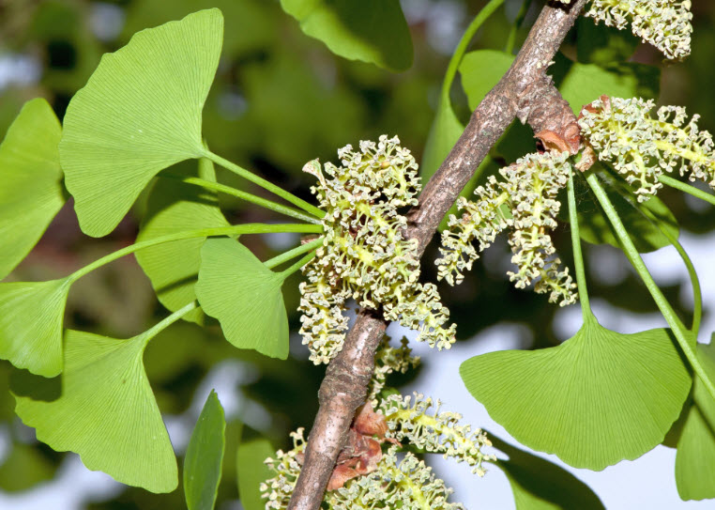
Foliage and pollen-bearing cones of male ginkgo
NKDA
Ggggggggggggggggggggggggggggggggggggggggggggggggggggggggggggggggggggggggggggggggggggggggggggggggggggggggggggg

Detailed Patient Information
Select each item to learn more.
Family historySocial historyReview of systemsPhysical examAllergiesDiagnosis
Type 2 Diabetes Mellitus
666666666666666666666666666666666666666666666666666666666666666666666666666666666

Summary

You should now have all of the patient information necessary to complete your case study assignment.
Return to the assignment page within Moodle to download the Case Study Questions document. Complete the questions and then submit it within the Moodle assignment page.

Objectives

Topic 1: Patient
- Develop your understanding of the patient in this case study.

Topic 2: Patient Information
- Describe the patient information to answer the case study questions correctly.

