Student Lesson Plan

Overview
- Program Competencies
- Course Outcomes
- Weekly Objectives
- Main Concepts
- Applies organizational and system leadership skills to affect systemic changes in corporate culture and to promote continuous improvement in clinical outcomes. (PO 6)
- Appraises current information systems and technologies to improve health care. (POs 6, 7)

Schedule
Section | Read/Review/Complete | Course Outcomes | Due
Prepare | Assigned Readings | COs 2, 4, 6 | Wednesday
Explore | Lesson | COs 2, 4, 6 | Wednesday
Translate to Practice | Discussion: Initial Post | COs 2, 4, 6 | Wednesday
Translate to Practice | Discussion: Follow-Up Posts | COs 2, 4, 6 | Sunday
Reflect | Reflection | COs 2, 4, 6 | No submission

Foundations for Learning
The following resource outlines the foundational competencies of advanced nursing practice for the DNP-prepared nurse related to informatics:
American Association of Colleges of Nursing. (2006). The essentials of doctoral education for advanced nursing practice.Links to an external site. https://www.aacnnursing.org/DNP/DNP-Essentials
Review the following media:
CRICO Video. (2019). Future of electronic health records: Supporting the clinicians and patients [Video]. YouTube. https://www.youtube.com/watch?v=_0HEQv5YUN4

Student Learning Resources
Click on the following tabs to view the resources for this week.
- Required Textbooks
- Required Articles
- Additional Resources
McBride, S., & Tietze, M. (2023). Nursing informatics for the advanced practice nurse: Patient safety, quality, outcomes, and interprofessionalism (3rd ed.). Springer Publishing Company.
- Read Chapters 7, 15
- Read Chapter 11
  - Section: Standards and Interoperability Framework

Learning Success Strategies
- Review the assigned readings to ensure you understand the key terms and can relate them to health information technology, patient care, and point-of-care technologies.
- Read the resources to gain an understanding of the electronic health record and point-of-care technologies. This week focuses on certified technology under the Technology for Economic and Clinical Health Act (HITECH) adoption, implementation, and maintenance of the electronic health record.
- Be ready to share your thoughts through the interactive discussion board regarding clinical information systems features such as costs, functionality, usability, popularity, and environments.
- Review the discussion board guidelines and review the rubric.
- Remember the vast number of resources available to you! There is help in the library, writing resources, links to evidence for the course, your textbooks, and other places!
- Supplemental resources are not mandatory but can provide additional knowledge and understanding.
- Your course faculty is here to support your learning journey. Reach out for guidance with study strategies, time management, and course-related questions.
- Let's Check In: Tips for Success are available several weeks throughout the course. Check announcements and please listen to the recording posted in the announcements if unable to attend.

Interacting with Feedback
Each week your course faculty will provide feedback in the rubric on any assignment you have submitted. Take a moment to review the following video on how to view rubric feedback in Canvas. (After clicking the link, scroll down or click on the title in the Summary area to jump directly to the video.)
- Link (video): Looking at FeedbackLinks to an external site. (2:26)
Review the following video on how to accept/reject track changes when viewing course faculty feedback on your assignment:
- Link (video): Word: Track Changes and Comments (4

Lesson 1
Health Information Technology: A Catalyst for Reform

Transforming Healthcare through Health Information Technology
Today's technologically rich healthcare delivery system is transforming the nature of patient care. Much has been written about the important role of healthcare information technology (HIT) in reforming many of the deficiencies within the nation's healthcare systems (Joshi & Lee, 2019; Zaroukian & Basch, 2018). Information technology is critical to evidence-based practice, and future advancements in generating new knowledge are dependent on it. HIT is acknowledged for promoting healthcare quality through data analysis, reducing errors and costs, and allowing for real-time interactions between and among consumers, providers, and healthcare systems. The development and use of Personal Health Records (PHR) and patient portals have transformed communication. The electronic PHR centralizes a patient's information onto a portable device shifting control from the provider to the patient through an easily transportable format. The PHR enhances health literacy, patient-centric care, and communication by promoting patient engagement and information exchange. The patient portal is a secure web-based, online application providing patients access to their personal health information 24-hours a day. Enhancing health literacy, patient-centric care, and communication, the PHR and patient portals stimulate ongoing monitoring and facilitate continuity of care. The functionality integrates patient data in a retrievable and printable format creating a sustainable health information exchange model promoting patient engagement, empowerment, health tracking, and individual patient responsibility.
View the video below to discover more about HIT and its role in transforming healthcare.
Health Information Technology (HIT) (2:58)

Electronic Health Records
The use of electronic health records (EHR) technology has increased substantially. According to the Office of the National Coordinator for Health Information Technology (2020), certified EHRs were used by 80 percent of healthcare providers and 96 percent of hospitals as of 2017. EHRs provide detailed patient information to guide patient health management, as well as clinically rich data to inform quality improvement and research. Using EHRs is key to curbing the increasing costs associated with the U.S. healthcare system and improving the safety and quality of patient care (Pearson & Frakt, 2018).
View the following video to investigate the crucial role of EHRs in reforming healthcare.
Electronic Health Record (3:15)

Week 2Lesson 2
Reducing Medication Errors—Computerized Provider Order Entry

Computerized Provider Order Entry (CPOE)
Unintended harm from prescribing errors has led to significant morbidity and mortality in the U.S. and around the world. To reduce the incidence of medication errors, computer provider order entry (CPOE) was implemented to permit providers to enter and send treatment orders electronically, with the orders transmitted directly to the recipient. The latest CPOE systems allow for digital ordering of medications, tests, procedures, consultations, and other treatment modalities through the use of standardized, computerized order sets often based upon a patient diagnosis. Widespread implementation of CPOE promises to provide a safer and more efficient method of prescribing for providers and patients alike (Baysari et al., 2018). Computerized order sets serve as an electronic checklist for best practice standards and coupled with CPOE enhance patient care during the entire hospitalization and post-discharge phases.
View the following diagram to discover more about the benefits of CPOE on reducing medication errors and improving safety and quality.
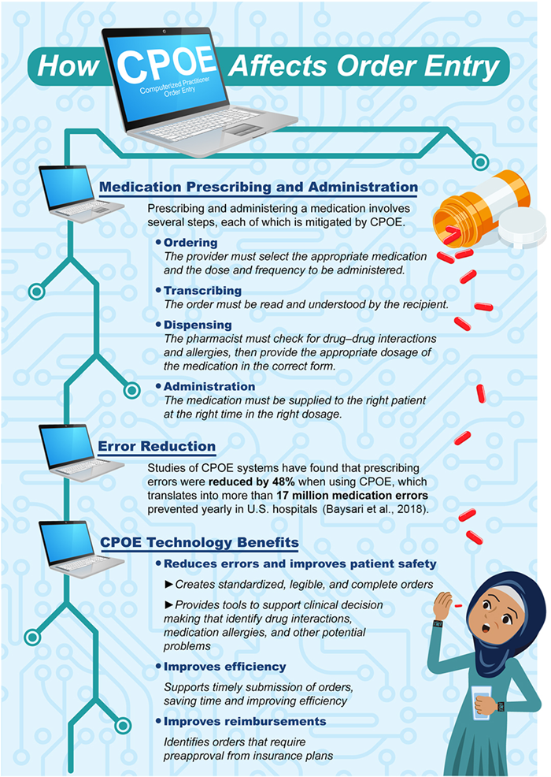

How CPOE Affects Order Entry Image Description

References
Baysari, M. T., Hardie, R. A., Lake, R., Richardson, L., McCullagh, C., Gardo, A., & Westbrook, J. (2018). Longitudinal study of user experiences of a CPOE system in a pediatric hospital. International Journal of Medical Informatics, 109, 5-14. https://doi.org/10.1016/j.ijmedinf.2017.10.018
Joshi, K., & Lee, K. (2019). Making impact in the healthcare sector with outsourced information technology services: An interview with Day Veerlapati, president and CEO, Seven Seas Technologies Inc, Chesterfield, USA. Journal of Global Information Technology Management, 22(1), 71-74. https://www.tandfonline.com/doi/abs/10.1080/1097198X.2019.1567666
Pearson, E., & Frakt, A. (2018). Administrative costs and health information technology. JAMA, 320(6), 537-538. https://doi.org/10.1001/jama.2018.10819
The Office of the National Coordinator for Health Information Technology. (2020). Health IT dashboard: Electronic health record adoption. https://dashboard.healthit.gov/apps/health-information-technology-data-summaries.php?state=National&cat9=all+data&cat1=ehr+adoption
Zaroukian, M. H., & Basch, P. (2018). Quality time in healthcare: Meaningful use of health information technology and the journey to paying for value. In S.D. Kudyba (Ed.), Healthcare informatics: Improving efficiency through technology, analytics, and management (1st ed., pp. 43-78). Auerbach Publications. https://www.taylorfrancis.com/chapters/quality-time-healthcare-michael-zaroukian-peter-basch/e/10.1201/b21424-3

Clinical Information Systems

Discussion

Purpose
The purpose of this discussion is for you to analyze different clinical information systems' features and functionality and determine the most beneficial system for your healthcare setting.

Instructions
Conduct an online search for two different electronic health record (EHR) software solutions you view as beneficial to your healthcare setting. Examples may include, but are not limited to, the following: eClinicalWorks, McKesson, Cerner, Allscripts, Athena Health, GE Healthcare, Epic, Care360, Practice Fusion, OptumInsight, and NEXTGEN.
Then, address the following:
- Identify two selected EHR software solutions and describe three features of each software solution.
- Compare and contrast the benefits of the two selected EHR software solutions.
- Select an EHR software solution that is best suited for your workplace environment and provide the rationale for your selection.
Please click on the following link to review the DNP Discussion Guidelines on the Student Resource Center program page:
- Link (webpage): Graduate Discussion Grading Guidelines and RubricLinks to an external site.

Program Competencies
This discussion enables the student to meet the following program competencies:
- Applies organizational and system leadership skills to affect systemic changes in corporate culture and to promote continuous improvement in clinical outcomes. (PO 6)
- Appraises current information systems and technologies to improve health care. (POs 6, 7)

Course Outcomes
This discussion enables the student to meet the following course outcomes:
- Use information technology to collect and analyze data to generate evidence-based nursing practice across healthcare settings. (PC 4; PO 7)
- Evaluate the types of healthcare information systems, knowledge-based systems, and patient care technology and the impact on patient safety, quality of care, and outcome measurement. (PC 4; PO 7)
- Resolve ethical and legal issues related to the use of information, communication networks, and information and patient care technology. (PCs 2, 4; PO 6)

Due Dates
- Initial Post: By 11:59 p.m. MT on Wednesday
- Follow-Up Posts: By 11:59 p.m. MT on Sunday
Search entries or author
Filter replies by unreadUnread Collapse replies Expand replies
Subscribe
ReplyReply to Week 2: Discussion | Clinical Information Systems

Collapse SubdiscussionKatie Hooven

Katie Hooven
SaturdayLocal: Oct 21 at 8:20am<br>Course: Oct 21 at 6:20am
Manage Discussion Entry
Welcome to week 2!

Remember: you may begin posting for credit on Sunday of Week 2. Please do not post before then.

When you make your initial response, click on the “Reply” arrow above this post. In Canvas this will set your post apart from all others. When you reply to another’s post, you will click the “Reply” arrow under that particular post.
.
Please read the question carefully to understand all the components. Then respond in a scholarly manner following the Graduate Discussion Grading Guidelines and Rubric. Our interactive discussion addresses the following course outcomes:

CO 2: Use information technology to collect and analyze data to generate evidence-based nursing practice across healthcare settings (PC 4; PO 7)
CO 4: Evaluate the types of healthcare information systems, knowledge-based systems, and patient care technology and the impact on patient safety, quality of care and outcome measurement. (PCs 2,4; PO 7)

CO 6: Resolve ethical and legal issues related to the use of information, communication networks, and information and patient care technology. (PCs 2,4; PO 6)

As you think about the topic, consider your own experience with the clinical information system implementation process. What worked? What was the system lacking? What was the impact on the daily work environment and patient care? What would help you best today?

I am looking forward to your discussions.
Dr. Hooven
ReplyReply to Comment

