PAGE
PAGE

Week 2: Introduction and Objectives
- Dashboard
- My courses
- NU-643-01-23PCFA
- Week 2: Foundations of Neuroscience and the Principles of Pharmacodynamics
- Week 2: Introduction and Objectives
Completion requirements
Done: View

Introduction

Week 2: Introduction (0:34 Minutes)
- 
Week 2: Introduction Video Transcript

Learning Objectives
By the end of this week, you will be able to:
- Identify major neurotransmitters involved in mental illness.
- Describe signs and symptoms associated with the major neurotransmitters.
- Examine the mechanisms of neuronal transmission as they relate to pharmacological drug action.
- Analyze how medications are designed to target signs and symptoms.
◄ Information Literacy Assessment Questionnaire
AGE

Week 2: What's Due When
- Dashboard
- My courses
- NU-643-01-23PCFA
- Week 2: Foundations of Neuroscience and the Principles of Pharmacodynamics
- Week 2: What's Due When
Completion requirements
Done: View
What's Due When
Learning Activity | Due Date | Points
Week 2 Discussion 1: Neurotransmission Story | Initial Post: Day 4;  Replies: Day 7 | 100 Points
Week 2 Assignment 1: Neurotransmitters Mind Map | Day 7 | 100 Points
Complete Learning Activities Table

Week 2: Learning Materials
- Dashboard
- My courses
- NU-643-01-23PCFA
- Week 2: Foundations of Neuroscience and the Principles of Pharmacodynamics
- Week 2: Learning Materials
Completion requirements
Done: View

Readings
- Stahl, S. (2021). Essential psychopharmacology: Neuroscientific Basis and Practical Applications (5th ed.). Cambridge University Press.
  - Chapter 1, “Chemical Neurotransmission”
  - Chapter 2, “Transporters, Receptors, and Enzymes as Targets of Psychopharmacological Drug Action”
  - Chapter 3, “Ion Channels as Targets of Psychopharmacological Drug Action”
- Stahl, S. (2020). Essential psychopharmacology: The prescriber's guide (7th ed.). Cambridge University Press. (Reference as needed.)

Week 2: Note-taking Tool
The Note-taking Tool Week 2 is a web-based study tool that provides helpful thoughts and questions to help you focus and master the course materials throughout this module. It is important to reference the Note-taking Tools (which are printable and downloadable) as you do your readings each week so that you are prepared for quizzes in this course.

Videos and Faculty Chapter Lectures

Chapter 2: (26:52 minutes)
- 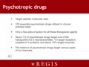
Chapter 2: Transcript

The Cell (0:59 minutes)
The Cell Video Transcript

cAMP Signaling Pathway (8:28 minutes)
cAMP Signaling Pathway Video Transcript

Receptors: Signal Transduction and Phosphorylation Cascade (6:25 minutes)
Receptors: Signal Transduction and Phosphorylation Cascade Video Transcript

2-Minute Neuroscience: Membrane Potential (2:01 minutes)
2-Minute Neuroscience: Membrane Potential Video Transcript

2-Minute Neuroscience: Action Potential (2:01 minutes)
2-Minute Neuroscience: Action Potential Video Transcript

2-Minute Neuroscience: Synaptic Transmission (1:51 minutes)
2-Minute Neuroscience: Synaptic Transmission Video Transcript

2-Minute Neuroscience: Receptors and Ligands (2:01 minutes)
2-Minute Neuroscience: Receptors and Ligands Video Transcript

Flashcards
Use these flashcards to review key terms for neuroscience and pharmacodynamics.
◄ Week 2: What's Due When
Top of Form
Bottom of Form
Week 2 Discussion 1: Neurotransmission Story ►

Week 2 Discussion 1: Neurotransmission Story
- Dashboard
- My courses
- NU-643-01-23PCFA
- Week 2: Foundations of Neuroscience and the Principles of Pharmacodynamics
- Week 2 Discussion 1: Neurotransmission Story
Completion requirements
To do: Make forum posts: 1
Value: 100 points
Due: Create your initial post by Day 4, and reply to at least two of your classmates’ posts by Day 7.
Gradebook Category: Discussion Forums

Initial Post
Tell a “story” by describing how a neuronal impulse creates a cascade of events to occur within the neuron and between neurons. Imagine that you are explaining how neuronal activation occurs, and what the step-by-step processes are, as you would to a fellow nurse practitioner who has not specialized in psychiatric nursing but is familiar with medical/biology terminology.
Concepts/words that must be incorporated and explained throughout your story include:
- Neurotransmitter
- Synaptic cleft
- Receiving neuron
- Signal Transduction Cascade
- Voltage-gated and Ligand-ion channels
- G-protein-linked receptor
- Agonist, partial agonist, antagonist, and inverse agonist and their role in signal transduction

Instructions
- Carefully read the questions presented.
- Reflect on the assigned materials from this week and consider experiences from your own practice to support your ideas.
- Include at least three outside scholarly references to support your statements. Your sources must use APA format.

Reply Posts
Reply to at least two of your classmates’ posts. Compare your answers to that of your classmates to produce some interesting dialog. Your responses should include evidence of review of the course material through the inclusion of proper citations using APA format.
Discuss why it is critical to understand this process as part of the prescribing role for the PMHNP.
Please refer to the Discussion Grading Rubric for details on how this activity will be graded.
The described expectations meet the passing level of 80 percent. Students are directed to review the Discussion Grading Rubric for criteria that exceed expectations.

Posting to the Discussion Forum
- Select the appropriate Thread.
- Select Reply.
- Create your post.
- Select Post to Forum.
ASSIGNMENT

Week 2 Discussion 1: Neurotransmission Story (For Grading Purposes Only)
- Dashboard
- My courses
- NU-643-01-23PCFA
- Week 2: Foundations of Neuroscience and the Principles of Pharmacodynamics
- Week 2 Discussion 1: Neurotransmission Story (For Grading Purposes Only)
Week 2 Discussion 1: Neurotransmission Story (For Grading Purposes Only)

Submission status
ASSIGNMENT

Week 2 Assignment 1: Neurotransmitters Mind Map
- Dashboard
- My courses
- NU-643-01-23PCFA
- Week 2: Foundations of Neuroscience and the Principles of Pharmacodynamics
- Week 2 Assignment 1: Neurotransmitters Mind Map
Completion requirements
To do: Make a submission
Due: Sunday, 10 September 2023, 11:55 PM
Value: 100 points
Due: Day 7
Gradebook Category: Assignments

Instructions
For this assignment, you will create a “Mind-Map” or “Stream of Thought” of the following six neurotransmitters with the brain as the center of controls.
- Dopamine
- GABA
- Glutamate
- Serotonin
- Norepinephrine/Epinephrine
- Histamine
You will link the neurotransmitters to the main properties/characteristics, link to the anatomical location where the neurotransmitter is found, and any associated receptors, as well as psychiatric diagnoses that could occur with a deficit or surplus of the neurotransmitter. Additionally, list symptoms under the deficits and surplus. Lastly, link what medications/drug classes can increase and decrease the effects of the neurotransmitters.
Sign up for a free account and use Bubbl.us or use a Word template from Template Lab to create your Mind Map.
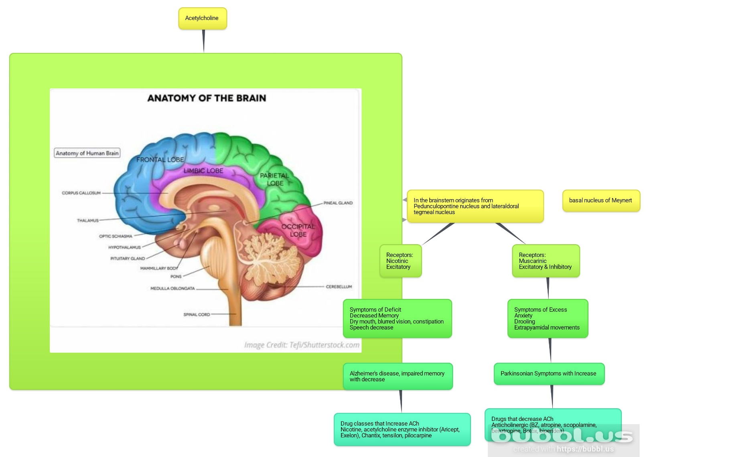
As an additional note, all components must be included for full points in the content area of the rubric for each neurotransmitter: (see Checklist):
- Name of neurotransmitter
- Main properties and characteristics of neurotransmitter
- Anatomical location (s)
- Associated receptors
- Psychiatric diagnosis with deficit
- Psychiatric diagnosis with surplus
- Medications/drug class that increase neurotransmitter
- Medications/drug class that decrease neurotransmitter
You can complete this as one large mind map or a separate mind map, one for each neurotransmitter. Be creative, as there are several ways to create them. You will also review the Mind Map Checklist (PDF) and include your references. A minimum of one reference for each neurotransmitter is required.
Upload all files you created as Mind Map(s) and the Checklist that includes your references.
Please refer to the Grading Rubric for details on how this activity will be graded. The described expectations meet the passing level of 80 percent. Students are directed to review the Grading Rubric for criteria that exceed expectations.
To Submit Your Assignment:
- Select the Add Submissions button.
- Drag or upload your file to the File Picker.
- Select Save Changes.

