Week 8

Student Lesson Plan

Overview
- Program Competencies
- Course Outcomes
- Weekly Objectives
- Main Concepts
- Analyzes health care policies to advocate for equitable health care and social justice to all populations and those at risk due to social determinants of health. (POs 2, 9)
- Translates a synthesis of research and population data to support preventative care and improve the nation’s health. (PO 1)
- Leads others in professional identity, advanced clinical judgment, systems thinking, resilience, and accountability in selecting, implementing, and evaluating clinical care. (PO 1)

Schedule
Section | Read/Review/Complete | Course Outcomes | Due
Prepare | Assigned Readings | COs 1, 2, 3, 5, 6 | Wednesday
Explore | Lesson | COs 1, 2, 3, 5, 6 | Wednesday
Translate to Practice | Discussion: Initial Post | COs 1, 2, 3, 4, 5, 6 | Wednesday
Translate to Practice | Discussion: Follow-Up Posts | COs 1, 2, 3, 4, 5, 6 | Saturday
Reflect | Reflection | COs 1, 2, 3, 4, 5, 6 | No submission

Foundations for Learning
Review the following resources in preparation for the week:
Centers for Disease Control and Prevention. National Center for Health Statistics.Links to an external site. (2021). http://www.cdc.gov/nchs/
Clarke, P., Swider, S., & Bley, M. B (2013). Nursing leadership and health policy; A dialogue with nurse leaders.Links to an external site. Nursing Science Quarterly, 26(2), 136-142.
Cox, K. S., & Naegle, M. A. (2019). The opioid crisis.Links to an external site. Nursing Outlook, 67(1), 3. https://doi.org/10.1016/j.outlook.2018.12.016
U.S. Department of Health and Human Services. (n.d.). U.S. Department of Health and Human Services home page.Links to an external site. http://www.dhhs.gov/

Student Learning Resources
Click on the following tabs to view the resources for this week.
- Required Textbooks
- Required Articles
- Additional Resources
Patton, B., Zalon, M., & Ludwick, R. (2019). Nurses making policy: From bedside to boardroom (2nd ed.). Springer Publishing Company.
- Read Chapter 11
- Read Chapter 15
  - Section: Nurses’ Critical Role in Advancing Health Policy

Learning Success Strategies
- Review the assigned readings to ensure you understand the role of the DNP-prepared nurse in practice readiness.
- As you review weekly content, consider how each concept and discussion can be translated into practice at your unique setting.
- Be ready to share your thoughts through the interactive discussion. Review the discussion guidelines and rubric to optimize your performance.
- You have access to a variety of resources to support your success. Click on the DNP Resources tab on the home page to access program and project resources.
- Your course faculty is here to support your learning journey. Reach out for guidance with study strategies, time management, and course-related questions. Review rubric feedback and individual comments to optimize performance.
- Remember the course and discussion ends on Saturday this week.

Interacting with Feedback
Each week your course faculty will provide feedback in the rubric and on any assignment you have submitted. Take a moment to review the following video on how to view rubric feedback in Canvas:
- Link (video): Looking at FeedbackLinks to an external site. (2:26)
Review the following video on how to accept/reject track changes when viewing course faculty feedback on your assignment:
- Link (video): Word: Track Changes and Comments (4:19)

Lesson
Practice Readiness in Population Health and Health Policy

Impacting Population Health
Nurses have a critical role in advancing health policy that impacts the profession of nursing. Practice readiness speaks to the level of confidence the DNP-prepared nurse possesses as a result of experiences or education that fosters the development of essential political skills. In this course, the focus has been on developing an awareness of how you can influence change through understanding the relationship between population health and health policy. Throughout your learning, you have applied evidence-based concepts to provide effective analysis of healthcare policy, developed a platform for advocacy, and came to understand how important a professional network of support can be as you advocate for a cause that is important to your community. You have come to understand the voice of nurses and that values important to nursing as a discipline must be included in the development of healthcare policy and present within the national healthcare conversation. You learned that the strong collective voice of the profession of nursing can have a significant impact. It is time for nurses to take part in shaping and reframing healthcare into the next decade. In this course you developed your own professional understanding of what you need to do to foster political competence within your practice.
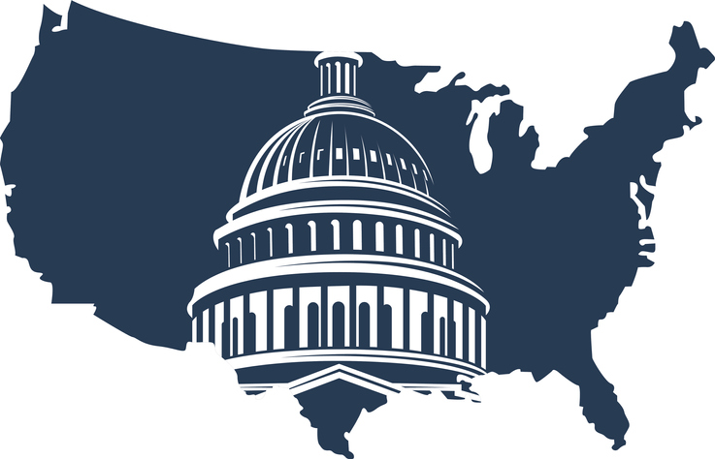
You learned that impacting population health requires coordination across all healthcare settings as well as across the lifespan of diverse individuals and populations. Healthcare systems are revising strategic goals and reorganizing services to move more care from the most expensive venues—inpatient facilities and emergency departments—to primary care and community settings. Consequently, nurse employment settings also are shifting, thus creating a change in workforce distribution and the requisite knowledge and skills necessary to provide care in those settings. The DNP-prepared nurse must assess for equity and equality in healthcare systems, and they are needed to lead initiatives to address structural racism, systemic inequity, and discrimination as equitable healthcare better serves the needs of all individuals, populations, and communities.
The skill sets needed for practice readiness to improve health in individuals and populations are an integral part of the DNP educational experience. The American Association of Colleges of Nursing (AACN) has published the Essentials series since 2006. These Essentials have provided guidance for the development and revision of nursing curricula. Nursing education has historically emphasized clinical education in acute care settings. As future needs to deliver healthcare to populations are considered it is becoming clear that focusing on acute care alone is not sufficient. The AACN has created core competencies for nursing where the future of delivering healthcare should be provided within four spheres of care (AACN, 2021).
Click through the following slides to learn about each.

Spheres of Care Interactive Transcript

Impacting Health Policy
Nurses are truly healthcare experts, and within the context of this knowledge, nurses understand the human experience and live this experience with patients every day. Nurses possess the understanding of healthcare like no other profession and can address issues like disparate care and the need for increased access to care for populations often marginalized by society and the current healthcare system. Nurses understand the shifting demographic within the population and possess cultural competency to work with and understand the highly complex needs of these patients and all patients across the lifespan.
Health policy is a driving force in advancing population health outcomes. At this point in your DNP journey, it is important to be aware of the capacity of the DNP-prepared nurse to impact policy interventions that aim for safe, effective, patient-centered care. Through advocacy for health policy change, DNP-prepared nurses are making a significant impact on the quality, efficiency, and effectiveness of healthcare systems everywhere.
Now, explore the case study below to consider the need for coalition building as an important healthcare resource.

Impacting Health Policy to Affect the Global Burden of Disease Interactive Transcript

Practice Readiness as a DNP-Prepared Nurse: Your Call to Action

The key to improving health outcomes in a population or in the individual patient is through action. As a DNP-prepared nurse, you will be charged with shaping the future of healthcare. The complexity of today's healthcare system, along with the increasing volume of new practices, policies, and information systems, have generated the need for you to bring your unique perspective to improving the health of the nation and enhancing health outcomes across settings. As such, you are a valuable contributor and health advocate for all populations.
As the largest segment of the healthcare team, nurses play a significant role delivering care in schools, hospitals, community health centers, long-term care facilities, and other places. The voice of the nurse must be felt more at decision-making tables. The groundwork for increasing nursing’s influence was laid by The Future of Nursing: Leading Change, Advancing Health report (Institute of Medicine, 2010). The context of this report spoke to the idea that nurses can and should play a larger part in the delivery of healthcare in the United States. Central to this theme, the report called for several significant actions that would promote the advancement of nursing in healthcare and increase the role of nurses across the entire spectrum. One of the recommendations called for nurses to serve on community boards, healthcare panels, and corporate boards as a means of providing a unique and qualified perspective. As a result of this recommendation, the organization, Nurses on Boards, was formed with the goal of reaching 10,000 nurses on boards by 2020, which was achieved.
The fundamental reason for developing political competency and engagement is to help you to realize the number of skills you already possess as a means of forward movement in the advocacy role from the bedside to the community. The premise of social change fosters the notion that a nurse can make a difference across the world to impact population health and the Global Burden of Disease. This premise holds true within the content of this course and as you begin to realize your full potential as one individual that has the power to make a huge change within your community. Only then can we, collectively, as a learned and scientific community, truly understand the impact we can make on the nation and ultimately on the world. As you consider your new advocacy role, consider joining a professional nursing organization or taking part in a grass roots effort within your community. These questions are before you today:
- What will you do with this knowledge and new awareness?
- Will you heed the call to action and take your rightful place in shaping healthcare, or will you sit back and be a spectator?
The choice is truly yours to make.
View the following diagram to explore how you can get involved in policy-making as a DNP-prepared nurse.

References
The American Association of Colleges of Nursing. (2021). The essentials: Core competencies for professional nursing education. http://www.aacn.nche.edu/index.htm
Institute of Medicine. (2010). The future of nursing: Leading change, advancing health. https://books.nap.edu/openbook.php?record_id=12956&page=R1
National Academies of Sciences, Engineering, and Medicine. (2010). Assessing progress on the Institute of Medicine report The Future of Nursing. National Academies Press.
Nurses on Boards Coalition (2021). About. https://www.nursesonboardscoalition.org/about/

Week 8Reflection on Learning and Practice Readiness

Discussion

Purpose
The purpose of this discussion is to reflect on your own readiness to practice as a DNP-prepared nurse and consider what you learned in this course and how this knowledge will impact your practice.

Instructions
Each week, you have been reminded that reflective inquiry allows for expansion of self-awareness, identification of knowledge gaps, and assessment of learning goals. As you reflect on your own readiness to practice as a DNP-prepared nurse, it is important to consider what you learned in this course.
As you review the course outcomes and your experience in this course, address the following:
- Analyze and evaluate how your thinking was challenged in this course related to (1) advocacy for population health, (2) disaster preparedness, and (3) health policy.
- Considering this new knowledge, examine how this learning prepares you to practice as a DNP-prepared nurse.
Please click on the following link to review the DNP Discussion Guidelines on the Student Resource Center program page:
- Link (webpage): DNP Discussion GuidelinesLinks to an external site.

Program Competencies
This discussion enables the student to meet the following program competencies:
- Analyzes health care policies to advocate for equitable health care and social justice to all populations and those at risk due to social determinants of health. (POs 2, 9)
- Translates a synthesis of research and population data to support preventative care and improve the nation’s health. (PO 1)
- Leads others in professional identity, advanced clinical judgment, systems thinking, resilience, and accountability in selecting, implementing, and evaluating clinical care. (PO 1)

Course Outcomes
This discussion enables the student to meet the following course outcomes:
- Critically analyze the history, formation, and implementation of local, state, and national health policies from the perspectives of stakeholders and the profession of nursing. (PC 5; PO 2)
- Synthesize ethical and legal principles to advocate for value-based, equitable, and ethical health policies at the micro, meso, and macrosystem levels. (PC 5; PO 9)
- Assimilate epidemiology principles and interventions to impact the social determinants of health, Global Burden of Disease, and population health outcomes. (PCs 7, 8; PO 1)
- Analyze the role of the advanced practice nurse in disaster and emergency management. (PCs 7, 8; PO 1)
- Formulate strategies for providing culturally relevant and high-quality healthcare to vulnerable and high-risk populations to address social injustice and health inequities. (PCs 7, 8; PO 1)
- Demonstrate collaborative interprofessional leadership and political competency to develop and implement healthcare policy to improve healthcare delivery and population health outcomes. (PC 5; PO 2)

Due Dates
- Initial Post: By 11:59 p.m. MT on Wednesday
- Follow-Up Posts: By 11:59 p.m. MT on Saturday
Search entries or author Filter replies by unreadUnread Collapse replies Expand replies
Subscribe
ReplyReply to Week 8: Discussion | Reflection on Learning and Practice Readiness

Collapse SubdiscussionSalena Tully

Salena Tully
Aug 22, 2023Local: Aug 22 at 9:10am<br>Course: Aug 22 at 7:10am
Manage Discussion Entry
Class, you may begin posting in this discussion for credit on Sunday. As a friendly reminder, the course closes on Saturday (11:59 MT) this week.
Hello Class,
Welcome to the last leg of your journey in NR717! As a DNP-prepared nurse, you will have a clear role in advocating for positive change within the discipline of nursing and advocating for effective change with policies that affect population health. Nurses must shape the future of nursing and influence health policy to impact the Global Burden of Disease. To accomplish this lofty goal, nurses must recognize the value of their individual and collective voices and get involved! With your new degree, you will lead the way for the profession and take political action to make positive changes in healthcare outcomes!

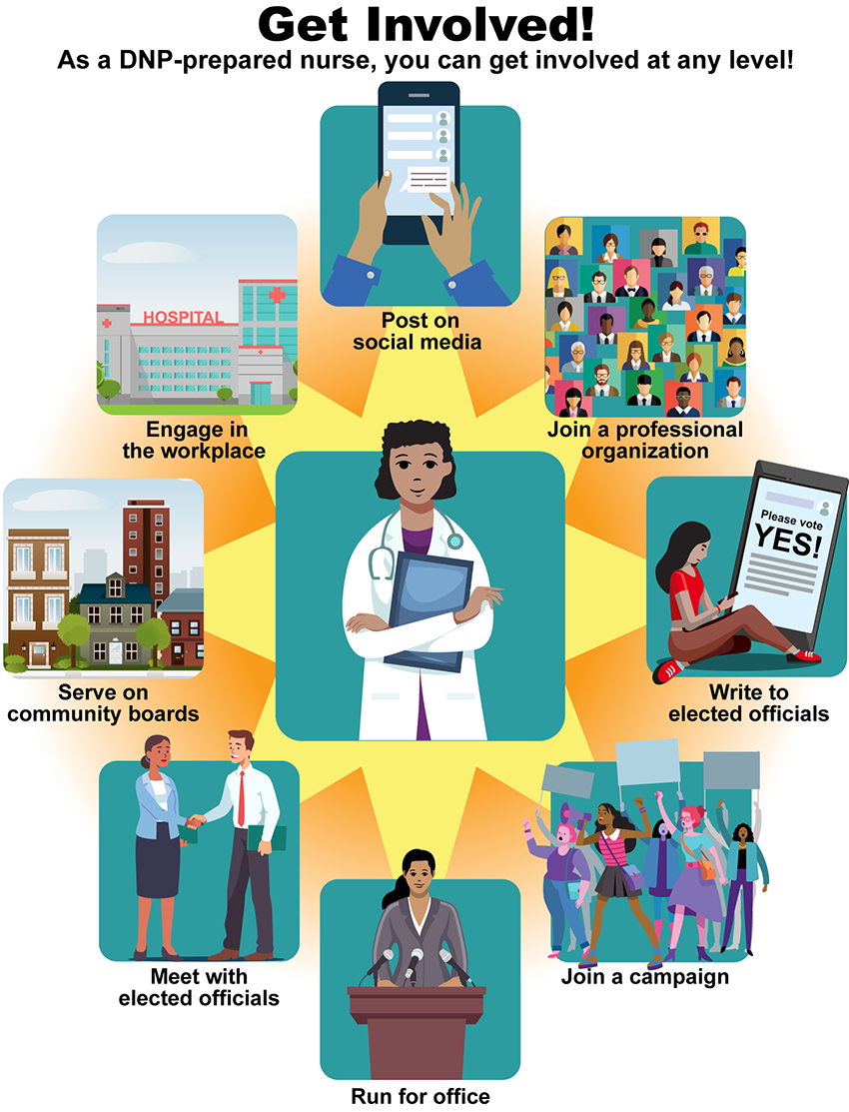

Get Involved! Image Description
PreviousNext

