Week 6- 730

Student Lesson Plan

Overview
- Program Competencies
- Course Outcomes
- Weekly Objectives
- Main Concepts
- Integrates scientific underpinnings into everyday clinical practice. (POs 3, 5)
- Uses analytic methods to translate critically appraised research and other evidence into clinical scholarship for innovative practice improvements. (POs 3, 5)
- Analyzes health care policies to advocate for equitable health care and social justice to all populations and those at risk due to social determinants of health. (POs 2, 9)
- Leads others in professional identity, advanced clinical judgment, systems thinking, resilience, and accountability in selecting, implementing, and evaluating clinical care. (POs 1, 4)

Schedule
Section | Read/Review/Complete | Course Outcomes | Due
Prepare | Assigned Readings | COs 1, 2 | Wednesday
Explore | Lesson | COs 1, 2 | Wednesday
Translate to Practice | Discussion: Initial Post | COs 1, 2 | Wednesday
Translate to Practice | Discussion: Follow-Up Posts | COs 1, 2 | Sunday
Translate to Practice | Assignment | COs 1 | Sunday
Reflect | Reflection | COs 1, 2 | No submission

Foundations for Learning
American Association of Colleges of Nursing. (2006). The essentials of doctoral education for advanced nursing practice.Links to an external site. https://www.aacnnursing.org/DNP/DNP-Essentials (Note: These Essentials outline the foundational competencies of advanced nursing practice for the DNP.)

Student Learning Resources
Click on the following tabs to view the resources for this week.
- Required Textbooks
- Required Articles
- Additional Resources
Roush, K. (2019). A nurse’s step-by-step guide to writing a dissertation or scholarly project (2nd ed.). Sigma Theta Tau International.
- Read Chapter 3

Learning Success Strategies
- Review the assigned readings to ensure you understand the key terms and can relate them to the role of the DNP-prepared nurse.
- As you review weekly content, consider how each concept and discussion can be translated into practice in your unique setting.
- Be ready to share your thoughts through the interactive discussion. It is important to share your own thoughts so that we hear your voice. Also, support your positions with evidence from the literature. Growing in your ability to share your ideas is encouraged, and the use of first-person is accepted for the discussion board.
- Review the discussion guidelines and rubric to optimize your performance.
- You have access to a variety of resources to support your success. Click on the DNP Resources tab on the home page to access program and project resources.
- Your course faculty is here to support your learning journey. Reach out for guidance with study strategies, time management, and course-related questions. Review rubric feedback and individual comments to optimize performance.
- Let's Check-In: Tips for Success are available several weeks throughout the course. Check announcements and please listen to the recording posted in the announcements if unable to attend.
- The Human Subjects Research Course CITI training is due by 11:59 p.m. MT on Sunday of this week. If you have not already begun to work on this assignment, you will want to get started as soon as possible as the training takes 6 or more hours to complete.

Interacting with Feedback
Each week your course faculty will provide feedback in the rubric on any assignment you have submitted. Take a moment to review the following video on how to view rubric feedback in Canvas. (After clicking the link, scroll down or click on the title in the Summary area to jump directly to the video.)
- Link (video): Looking at FeedbackLinks to an external site. (2:26)
Review the following video on how to accept/reject track changes when viewing course faculty feedback on your assignment:
- Link (video): Word: Track Changes and Comments (4:19)

Lesson
Documentation of the Practicum Experience

Documenting, Evaluating, and Disseminating Project Outcomes
As you have learned in previous courses, the Doctor of Nursing Practice (DNP) degree is a practice-focused doctorate, in comparison to the PhD, which is a research-focused doctorate degree. The DNP degree prepares you with the knowledge, skills, and abilities to advance nursing practice. This is demonstrated through the implementation of evidence-based practice interventions, quality improvement processes and programs, and advanced leadership projects in the clinical practice setting (Bemker, Ralyea, & Schreiner, 2022).
Your DNP degree program will culminate with the completion and dissemination of your final DNP practice change project. The DNP practice change project will demonstrate the achievement of the following competencies:
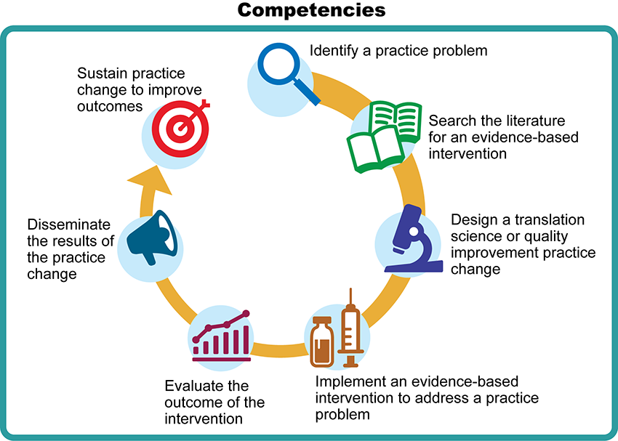

Competencies Image Description
So far in your DNP degree journey, you have identified a practice problem, searched the literature for an evidence-based intervention, and started the design process for your DNP practice change project. It is crucial that you design, implement, and evaluate your project through a lens of ethical accountability, protecting your participants and the practicum site from harm or risk. As you learned last week, informed consent may be required prior to the implementation of your project. This is one way of demonstrating ethical accountability for your participants and the practicum site.
Ethical practices are vital during the data collection and evaluation phase of your DNP practice change project as well. All data collected related to your project must be protected and recorded precisely to ensure the accuracy of your project outcome. Your disseminated outcomes must be reflective of what transpired as a result of your evidence-based intervention.
As DNP projects are disseminated in print, at conferences, and through databases, large audiences of nursing professionals view the outcomes. The opportunity to significantly impact populations, far beyond the brick and mortar of a practicum site, exists within the potential of every DNP project. It is for these reasons that judicious procedures must be used when gathering data and disseminating the outcomes of your DNP practice change project. The highest ethical standards must be maintained throughout the four Project & Practicum courses and during the implementation, evaluation, and dissemination of your DNP practice change project.

Documenting Practicum Hours

When you enter NR702 Project & Practicum I, you will begin documenting your DNP project practicum hours. You will document your practicum activities in each of the four Project & Practicum courses. You are required to complete a minimum of 1,024 practicum hours to complete your DNP degree. It is critical that you document your practicum activities consistently as they occur so that you do not forget the activities but rather have an accurate portrayal of your practicum experience. A best practice is to document your practicum hours daily or at a minimum each week. This will help you stay on track and meet the required hours for each session.
There are many activities that you may complete outside your practicum site while preparing for your project that will support the achievement of the program outcomes and the American Association of Colleges of Nursing DNP Essentials (AACN, 2006). For some students, your Master of Science in Nursing degree may have included a practicum experience, which may partially satisfy a portion of the practicum hour requirement.

Documentation Guidelines
For each documented practicum activity, address the following:
- Align with an appropriate AACN DNP Essential.
- Provide enough detail to substantiate not only the selected essential but also the amount of time documented.
- Reflect and support the actual time you were involved in the activity in your submissions.
- Use the following increments:
  - No more than 4-hour increments per entry
  - May enter in minutes, such as 15 minutes, 30 minutes, 45 minutes, etc.

The following interactive provides an example of appropriate documentation and inappropriate documentation. Check your knowledge by identifying the inappropriate documentation on the second example.

Document Examples Interactive Transcript

The submission of your documented DNP practicum hours is a course assignment in each DNP Project & Practicum course. As such, the academic integrity policies of Chamberlain University College of Nursing apply to your submissions. Entries will not be accepted if sufficient information is not provided to substantiate the time entered. If you have questions regarding whether an activity can be submitted for practicum hour consideration, you will need to consult with your course faculty. Students who do not earn at least 1,024 approved practicum hours by the end of NR709 Project & Practicum IV will not be eligible for graduation until such time as all 1,024 practicum hours are completed.
Bemker, M. A., Ralyea, C. M., & Schreiner, B. (Eds.). (2022). The successful completion of your DNP project: A practice guide with exemplars. DEStech Publications, Inc.

Documenting the Practicum Experience

Discussion

Purpose
As already mentioned, you are required to complete 1,024 practicum hours for the DNP program. This may seem daunting at first; however, reviewing the different types of activities that align with each DNP Essential and how to document the hours correctly and consistently will help you prepare for the experience. The purpose of this assignment is to examine practices and processes used to accurately document the DNP practicum experience.

Instructions
Reflect on your readings this week and review the Project & Practicum Activities Form. Then, describe activities that you might complete during your Project & Practicum courses and identify the associated DNP Essential.
Please click on the following link to review the DNP Discussion Guidelines on the Student Resource Center program page:
- Link (webpage): DNP Discussion GuidelinesLinks to an external site.

Program Competencies
This discussion enables the student to meet the following program outcomes:
- Integrates scientific underpinnings into everyday clinical practice. (POs 3, 5)
- Uses analytic methods to translate critically appraised research and other evidence into clinical scholarship for innovative practice improvements. (POs 3, 5)
- Analyzes health care policies to advocate for equitable health care and social justice to all populations and those at risk due to social determinants of health. (POs 2, 9)
- Leads others in professional identity, advanced clinical judgment, systems thinking, resilience, and accountability in selecting, implementing, and evaluating clinical care. (POs 1, 4)

Course Outcomes
This discussion enables the student to meet the following course outcomes:
- Prioritize and apply ethical considerations and theories relevant to translation science. (PCs 1, 3, 8; POs 3, 4, 5)
- Apply clinical scholarship methodologies for designing, developing, implementing, and evaluating quality improvements and the translation of evidence-based practice, to improve healthcare outcomes at the micro, meso, or macrosystem level. (PCs 1, 3, 5; POs 3, 5, 9)

Due Dates
- Initial Post: By 11:59 p.m. MT on Wednesday
- Follow-Up Posts: By 11:59 p.m. MT on Sunday
Search entries or author
Filter replies by unreadUnread Collapse replies Expand replies
Subscribe
ReplyReply to Week 6: Discussion | Documenting the Practicum Experience

Feb 27, 2024Local: Feb 27 at 5:37pm
Course: Feb 27 at 3:37pm
Manage Discussion Entry
Hello class and welcome to Week 6 discussion. This discussion enables the student to meet the following course outcomes:
  - Prioritize and apply ethical considerations and theories relevant to translation science. (POs 3, 4, 5)
  - Apply clinical scholarship methodologies for designing, developing, implementing, and evaluating quality improvements and the translation of evidence-based practice, to improve healthcare outcomes at the micro, meso, or macrosystem level. (POs 3, 5, 9)

Reflect on your readings this week and review the Project & Practicum Activities Form. Then, describe activities that you might complete during your Project & Practicum courses and identify the associated DNP Essential.

