721- Lesson Plan

Overview
- Program Competencies
- Course Outcomes
- Weekly Objectives
- Main Concepts
- Analyzes health care policies to advocate for equitable health care and social justice to all populations and those at risk due to social determinants of health. (POs 2, 9)
- Creates a supportive organizational culture for flourishing collaborative teams to facilitate clinical disease prevention and promote population health at all system levels. (PO 8)
- Translates a synthesis of research and population data to support preventative care and improve the nation’s health. (PO 1)
- Leads others in professional identity, advanced clinical judgment, systems thinking, resilience, and accountability in selecting, implementing, and evaluating clinical care. (POs 1, 4)

Schedule
Section | Read/Review/Complete | Course Outcomes | Due
Prepare | Assigned Readings | COs 1, 4 | Wednesday
Explore | Lesson | COs 1, 4 | Wednesday
Translate to Practice | Discussion: Initial Post | COs 1, 4 | Wednesday
Translate to Practice | Discussion: Follow-Up Posts | COs 1, 4 | Sunday
Reflect | Reflection | COs 1, 4 | No submission

Foundations for Learning
American Association of Colleges of Nursing. (2006). The essentials of doctoral education for advanced nursing practice.Links to an external site. https://www.aacnnursing.org/DNP/DNP-Essentials (Note: These Essentials outline the foundational competencies of advanced nursing practice for the DNP.)
American Organization for Nursing Leadership. (2015). AONL nurse leader competencies.Links to an external site. https://www.aonl.org/resources/nurse-leader-competencies

Student Learning Resources
Click on the following tabs to view the resources for this week.
- Required Textbooks
- Required Articles
- Additional Resources
Daft, R. L. (2018). The leadership experience (7th ed.). Cengage Learning.
- Read Chapter 6
  - Section: Servant Leadership

Learning Success Strategies
- Review the assigned readings to ensure you understand the key terms and can relate them to the role of the DNP-prepared nurse leader.
- As you review weekly content, consider how each concept and discussion can be translated into practice at your unique setting.
- Be ready to share your own thoughts through the interactive discussion. It is important to share your own thoughts so that we hear your voice. Also, support your positions with evidence from the literature. Growing in your ability to share your ideas is encouraged, and the use of first-person is accepted for the discussion board.
- Review the discussion guidelines and rubric to optimize your performance.
- You have access to a variety of resources to support your success. Click on the DNP Resources tab on the home page to access program and project resources.
- Your course faculty is here to support your learning journey. Reach out for guidance with study strategies, time management, and course-related questions. Review rubric feedback and individual comments to optimize performance.
- Let’s Check-In: Tips for Success: PowerPoints and recordings are posted each Sunday for the following week. Live Let’s Check-Ins are conducted in selected weeks throughout the course, so check your announcements for details. .

Interacting with Feedback
Each week your course faculty will provide feedback in the rubric on any assignment you have submitted. Take a moment to review the following video on how to view rubric feedback in Canvas. (After clicking the link, scroll down or click on the title in the Summary area to jump directly to the video.)
- Link (video): Looking at FeedbackLinks to an external site. (2:26)
Review the following video on how to accept/reject track changes when viewing course faculty feedback on your assignment:
- Link (video): Word: Track Changes and Comments (4:19)
- he Servant Leader
- Introduction
- The concept of a servant leader is not new and certainly not unique to the nursing profession. The phrase “servant leadership” was first created by Robert K. Greenleaf in an essay published in 1970. Greenleaf explained that a servant leader has an intrinsic desire to serve others, and it is through that selfless desire that leadership evolves. Servant leadership has a central focus on the needs of others and is guided by helping others and communities to reach their optimal well-being (Greenleaf Center for Servant Leadership, n.d.).
- 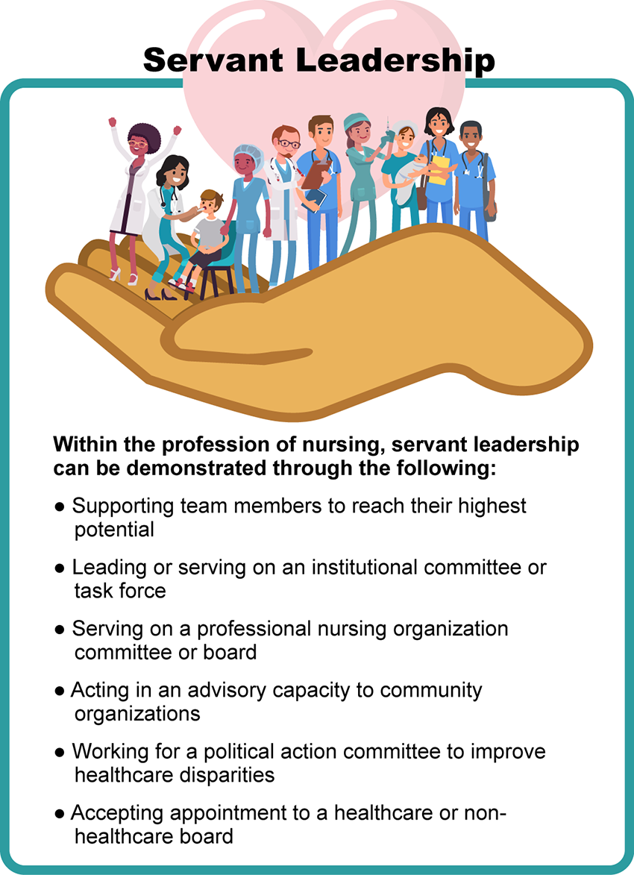
- Servant Leadership Image Description
- History provides us with many examples of servant leaders, such as Martin Luther King, Jr., Mother Teresa, Albert Schweitzer, and Nelson Mandela. These individuals, first and foremost, had an innate desire to serve humanity, and, out of that desire, they became leaders of compassion and purpose. The nursing profession can also boast a bountiful history of servant leaders.
- Click on the following images to look at a few of nursing’s servant leaders and their contribution to healthcare and humanity:

- Servant Leaders Interactive Transcript
- Each of these nursing icons had a desire and mission greater than their own needs. Their acts of altruism and self-sacrifice were instrumental in improving the healthcare outcomes of generations to come. They approached their work with the heart of a servant.
- Leading With the Heart of a Servant
- A servant leader focuses on building relationships to fully understand the perspectives of other individuals and promote the development of their leadership skills and characteristics. As a DNP-prepared nurse, your efforts and motivation to serve others can significantly influence those you lead. Servant leaders yield the needs of the organization to the individual needs of each team member, building trust and investing in the welfare of those they serve. A culture shift occurs by leading through a serve-first mindset, providing a safe and healthy environment rich in creativity, and leading to enhanced productivity. One way to visualize a servant leader is to consider the structure of a pyramid. A traditional leader is at the top of the pyramid, with employees/customers at the base of the pyramid. In servant leadership, the structure is reversed so that employees/customers are at the top of an inverted pyramid, and the leader is at the bottom.
- Servant leadership is not formally considered a leadership “style” but rather is a manner of conducting oneself in which self-interests fade and the interests of others are brought to the foreground. For example, a servant leader may seek to understand how their energy and strengths can encourage and support underrepresented populations facing health disparities before they pursue activities that increase their authority or power. Their transition to a position of leadership is, therefore, secondary to their devotion to service.

- Test your knowledge of leadership characteristics by dragging and dropping the word to the associated type of leader.
- Servant Leader Characteristics Interactive Transcript
- Leading Through Service and Board Stewardship
- Although service to an organization and team is critical to the fostering of a healthy workplace, service opportunities extend far beyond the boundaries of an institution. With extensive clinical expertise and an understanding of evidence-based practice, DNP-prepared nurse leaders have the knowledge and competencies to serve professional nursing organizations, boards of nursing, and on community, state, and national boards. Board service can provide an opportunity for the nurse leader to expand upon their existing capabilities and demonstrate their leadership skills to influence the health outcomes of their community and the nation.
- A wide range of boards seek the contribution of nursing leaders to support the organizational mission. These include private and public boards, non-profit and non-nursing boards, advisory boards, and commissions and appointments. In 2014, the Nurses on Boards Coalition (NOBC) was first established to ensure at least 10,000 board seats were occupied by nurses by 2020. By 2021, over 10,200 nurses were impacting the health of communities through board service (NOBC, 2021). The NOBC reflects the local, state, and national focus by nursing leaders to support an improvement in health outcomes at the micro, meso, and macrosystem level through nursing’s presence and contribution on boards. Representing the largest population of healthcare workers, nurses’ voices must be heard to influence the decision-making process of boards and other policymakers and reduce disparities in healthcare services.
- Greenleaf Center for Servant Leadership (n.d.). What is servant leadership? Retrieved December 6, 2021 from https://www.greenleaf.org/what-is-servant-leadership/
- Nurses on Boards Coalition. (2021). Our story. https://www.nursesonboardscoalition.org/about/

The Servant Leader

Discussion

Purpose
The purpose of this discussion is to explore the role of the nurse leader in contributing to professional organizations, the community, state, and nation through board service.

Instructions
Reflect on your readings this week and respond to the following:
- Consider your area of nursing practice and specialty. Identify opportunities where you might use your knowledge and expertise to serve on a specific board (professional board, community board, state or national board, or task force). If you have difficulty identifying a board of interest, you may go to the following link and review a list of potential board positions:
  - Link (webpage): Board Posting & Matching Programs by RegionLinks to an external site.
- Explain why you selected this board and how you might contribute from your nursing expertise to advance the mission of the organization.
Please click on the following link to review the DNP Discussion Guidelines on the Student Resource Center program page:
- Link (webpage): DNP Discussion GuidelinesLinks to an external site.

Program Competencies
This discussion enables the student to meet the following program competencies:
- Analyzes health care policies to advocate for equitable health care and social justice to all populations and those at risk due to social determinants of health. (POs 2, 9)
- Creates a supportive organizational culture for flourishing collaborative teams to facilitate clinical disease prevention and promote population health at all system levels. (PO 8)
- Translates a synthesis of research and population data to support preventative care and improve the nation’s health. (PO 1)
- Leads others in professional identity, advanced clinical judgment, systems thinking, resilience, and accountability in selecting, implementing, and evaluating clinical care. (POs 1, 4)

Course Outcomes
This discussion enables the student to meet the following course outcomes:
- Evaluate the attributes of effective communication practices that build collaborative relationships and balance the concerns of individuals with organizational goals. (PCs 5, 6; POs 2, 8)
- Critique the value of nurse leaders to serve and advocate on both healthcare and non-healthcare community-based boards, advisory groups, and task forces. (PCs 5, 6, 7, 8; POs 1, 2, 8)

Due Dates
- Initial Post: By 11:59 p.m. MT on Wednesday
- Follow-Up Posts: By 11:59 p.m. MT on Sunday
Search entries or author
Filter replies by unreadUnread Collapse replies Expand replies
Subscribe
ReplyReply to Week 7: Discussion | The Servant Leader

Collapse SubdiscussionPhillis Dewitt

Phillis Dewitt
Feb 13, 2024Local: Feb 13 at 9:33am
Course: Feb 13 at 7:33am
Manage Discussion Entry
Hi everyone,
Welcome to Week 7! The purpose of this discussion is to explore the role of the nurse leader in contributing to professional organizations, the community, the state, and the nation through board service.
This discussion enables you to meet the following course and program outcomes:
1. Evaluate the attributes of effective communication practices that build collaborative relationships and balance the concerns of individuals with organizational goals. (POs 2, 8)
4. Critique the value of nurse leaders to serve and advocate on both healthcare and non-healthcare community-based boards, advisory groups, and task forces. (POs 1, 2, 8)
Please review the discussion grading guidelines and support your post with scholarly references.

I am looking forward to our discussion!

