Student Lesson

Plan

Overview
- Program Competencies
- Course Outcomes
- Weekly Objectives
- Main Concepts
- Integrates scientific underpinnings into everyday clinical practice. (POs 3, 5)
- Uses analytic methods to translate critically appraised research and other evidence into clinical scholarship for innovative practice improvements. (POs 3, 5)
- Appraises current information systems and technologies to improve healthcare. (POs 6, 7)
- Analyzes healthcare policies to advocate for equitable healthcare and social justice to all populations and those at risk due to social determinants of health. (POs 2, 9)
- Leads others in professional identity, advanced clinical judgment, systems thinking, resilience, and accountability in selecting, implementing, and evaluating clinical care. (POs 1, 4)

Schedule
Section | Read/Review/Complete | Course Outcomes | Due
Prepare | Assigned Readings | COs 1, 2, 3 | Wednesday
Explore | Lesson | COs 1, 2, 3 | Wednesday
Translate to Practice | Discussion: Introduction Posts | n/a | Wednesday
Translate to Practice | Discussion: Initial Post | COs 1, 2, 3 | Wednesday
Translate to Practice | Discussion: Follow-Up Posts | COs 1, 2, 3 | Sunday
Reflect | Reflection | COs 1, 2, 3 | No submission

Foundations for Learning
Institute for Healthcare Improvement. (2021). Home page.Links to an external site. http://www.ihi.org/Pages/default.aspx
Institute for Healthcare Improvement. (2021). Initiatives: Transforming care at the bedside.Links to an external site. http://www.ihi.org/Engage/Initiatives/Completed/TCAB/Pages/default.aspx
Institute for Healthcare Improvement. (2021). Tools: Quality improvement essentials toolkit.Links to an external site. http://www.ihi.org/resources/Pages/Tools/Quality-Improvement-Essentials-Toolkit.aspx
Titler, M. G. (2018). Translation research in practice: An introduction.Links to an external site. Journal of Issues in Nursing, 23(2). https://doi.org/10.3912/OJIN.Vol23No02Man01

Student Learning Resources
Click on the following tabs to view the resources for this week.
- Required Textbooks
- Required Articles
- Additional Resources
Harris, J. L., Roussel, L. A., Thomas, T., & Dearman, C. (2020). Project planning & management: A guide for nurses and interprofessional teams (3rd ed.). Jones & Bartlett Learning.
- Read Chapter 9
Waxman, K. T., & Knighten, M. L. (2023). Financial and business management for the Doctor of Nursing Practice (3rd ed.). Springer Publishing Company.
- Read Chapter 13

Learning Success Strategies
- Reflection on Learning: As you familiarize yourself with the course layout, you will see the system of information prepared for your learning. Please look at each section as moving systematically will assist you as you learn throughout the course.
  - The Prepare section will have the objectives, key terms, and direct you to the readings to broaden your knowledge.
  - Moving next to the Explore section there will be information about the topics and additional readings, links, and references to continue to build your knowledge.
  - Next, the Translate section is where you will apply your new knowledge, answering the discussion questions for the week and completing the assignments.
  - Finally, we will close off the week with a Reflect section to recap what we have learned and give you pause to consider the value of the new knowledge you are gaining.
- Review the assigned readings to ensure you understand the key terms and can relate them to the changing and evolving roles of the DNP-prepared nurse.
- As you review weekly content, consider how each concept and discussion can be translated into practice at your unique setting.
- Importantly, consider the Global Burden of Disease and National Practice Problems facing us every day in our healthcare settings. You will begin to consider your ability to bring forward practice changes as you search for research solutions.
- Be ready to share your thoughts through the interactive discussion. It is important to share your own thoughts so that we hear your voice. Also, support your positions with evidence from the literature. Growing in your ability to share your ideas is encouraged, and the use of first person is accepted for the discussion board.
- Review the discussion guidelines and rubric to optimize your performance.
- You have access to a variety of resources to support your success. Click on the DNP Resources tab on the home page to access program and project resources.
- Your course faculty is here to support your learning journey. Reach out for guidance with study strategies, time management, and course-related questions.

Interacting with Feedback
Each week your course faculty will provide feedback in the rubric on any assignment you have submitted. Take a moment to review the following video on how to view rubric feedback in Canvas. (After clicking the link, scroll down or click on the title in the Summary area to jump directly to the video.)
- Link (video): Looking at FeedbackLinks to an external site. (2:26)
Review the following video on how to accept/reject track changes when viewing course faculty feedback on your assignment:
- Link (video): Word: Track Changes and Comments (4:19)
Organizational Assessment Strategies

Continuous Organizational Improvement and High Reliability
In the United States, healthcare costs are increasing with little improvement to the quality and efficiency of care. Dynamic healthcare organizations recognize the need for continuous organizational improvement and high reliability of services delivered to achieve quality outcomes, efficiency, and patient satisfaction. Organizations that are not able to adapt to external changes with internal mobilization will not be sustainable over time.
The main driver of continuous organizational improvement is the customer: patients. Successful organizations are very similar to their competitors, but what sets them apart is that they are better at adapting quickly to meet or exceed patient needs and frequently evaluate themselves to sustain the change or initiate a new improvement. Consequently, healthcare organizations that have mechanisms that support continuous organizational improvement excel in their outcomes and are also resilient regarding changes in healthcare.
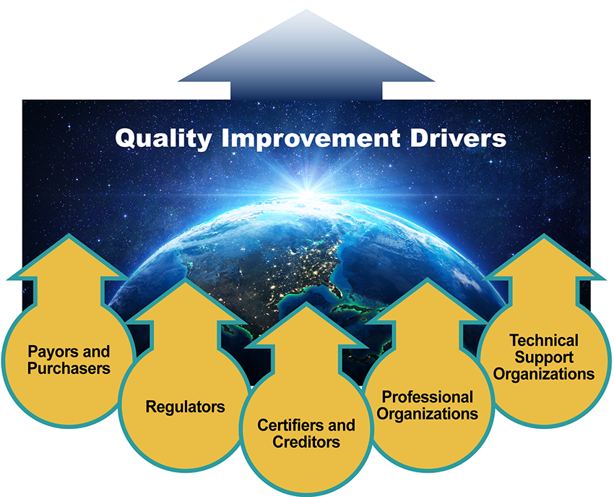

Quality Improvement Drivers Image Description
Healthcare organizations are complex and must provide high quality care to succeed regardless of associated risk factors. These healthcare organizations have few to zero adverse events despite operating daily under hazardous conditions. In high reliability environments, the focus on safety is paramount, and methods to prevent accidents or errors are well defined and followed by all levels of the organization. The result is an organization that a patient can trust.

Reflection Interactive Transcript

Steps to Planning a Needs Assessment Survey
Review the following two needs assessment process frameworks.

Center for Community Health and Development Assessment Steps
The Center for Community Health and Development, 1994-2021., as cited in Harris, Roussel, Dearman, and Thomas (2020), identified seven steps to planning a needs assessment.

Center for Community Health and Development Assessment Steps Interactive Transcript

Stakeholder Identification, Analysis, and Management
Identification of stakeholders is one of the first steps in project planning management. A stakeholder can be loosely defined as anyone who can be affected by a given project or who influences and affects the project's success or failure. Stakeholders can be internal to the project’s organization or external such as patients, insurance companies, or community members.
A methodical and logical process should be used to identify the stakeholders. One strategy to identify stakeholders is to brainstorm and list all stakeholders. The stakeholders can then be organized into groups using relevant characteristics (e.g., patients, providers, organizational leadership, community members). Some groups may be affected more by the change project. The stakeholders can also be broken down into direct and indirect stakeholder groups.
Conducting a stakeholder analysis before launching a project is an important step in the planning process. Stakeholder analysis requires assessing each stakeholder to understand their interest and power relative to the success or failure of the project. As the project manager, you will want to determine how best to earn their support and address conflicts or issues early on. The results of the stakeholder analysis form the basis of the project communication plan.

Video
Watch the following video for more information:
- Link (video): What Is Power/Interest Stakeholder AnalysisLinks to an external site. (4:57)
The stakeholder management plan is a formal document that outlines the strategies the team will use to engage stakeholders and manage expectations. The project manager needs to understand who needs what information and when or how often they need it. The project manager creates a communication strategy to garner the greatest support of key stakeholders and minimize resistance. The primary components of a stakeholder management plan include the following:
- Prioritization of stakeholders
- Identification of stakeholder expectations
- Development of communication rules
- Development of the action plans to be executed

Six Sigma
The demands or standards that currently exist in the organization, contextual factors, external and internal trends, and identification of resources needed to address the problem (processes, people, finance, and means) should be considered. Some organizations use the traditional Six Sigma 6M’s method to prioritize the organizational problems, delete wasteful processes, reduce costs and improve quality of care (Improta et al., 2019; Singh, & Rathi, 2019).

Culture of Safety
DNP-prepared leaders create high-reliability organizations and are committed to safety. In these organizations, everyone is aware of the interconnected and dynamic nature of daily operations and that a change in one area or process can ripple to other areas within the organization. DNP-prepared leaders speak directly with frontline nurses and caregivers through executive rounds and open forums and focus on resources the employees need to provide safe care to patients and families.
One challenge to healthcare safety and quality practices is the complex regulatory reporting requirements. Healthcare organizations are required to systematically collect and analyze outcome data for broad dissemination across healthcare settings and public domains. The aim of the reporting requirements is for healthcare organizations to benchmark against other similar organizations and to continuously improve outcomes. This is especially important when the organization’s quality data and outcomes are in the public domain because special interest groups, partner organizations, patients, families, and the public can compare the organization’s quality outcomes. Importantly, healthcare organizations are not only compared to their peers, but their revenues are also based on the quality of the patient and organizational outcomes.
Review the following interactive to discover various organizations impacting a culture of safety:

Quality and Safety Interactive Transcript

Value-Based Purchasing
Important drivers of quality improvement include payors and purchasers, regulators, certifiers and creditors, professional organizations, and technical support organizations. Purchasers and payors have considerable influence on quality and make decisions about the selection of health plans offered to their constituents, especially with the implementation of the Affordable Care Act and the increased obligation of employers to offer health insurance to employees. As the cost of health insurance increases, those charged with paying for coverage are looking more closely at the value of their health insurance for the cost of the insurance.
The U.S. healthcare system is the most expensive in the world, yet outcomes are continually substandard when compared to the outcomes in other developed countries, which proportionally spend less on healthcare. The United States spends more per capita on healthcare with substandard outcomes as compared to other countries. Especially since 2010, there have been attempts to improve outcomes in many ways. The greatest impetus to quality improvement efforts has been through the implementation of value-based purchasing, particularly by the federal government through the Centers for Medicare and Medicaid Services and the Affordable Care Act.
Value-based purchasing focuses on outcomes accomplished rather than the number of procedures performed or volume (Centers for Medicare & Medicaid Services [CMS], 2021). All healthcare organizations receiving payments from CMS are required to send specific organizational and patient-related outcome data. CMS rewards higher quality outcomes with higher reimbursements, so it is in the healthcare organization’s interest to establish the culture and processes for continuous quality improvement.
Healthcare outcome data collected on performance and patient-related quality outcomes and satisfaction scores is assessed from available national benchmark quality metrics.
One way to implement improvement in the delivery of healthcare is through the development of Accountable Care Organizations (ACO). This healthcare delivery mechanism requires the organization to manage care delivery because the organization received a fixed reimbursement. If the organization can deliver quality healthcare for less than the contracted rate, it will be more profitable; if it fails to achieve designated goals, the cost overruns will be paid by the organization. A key factor in successful Accountable Care Organizations is that the organizations need to have robust quality measurement and improvement capacity across settings.

Quality Measures and HCAHPS
Benchmarking is a method that assists in comparing the outcomes of two or more entities. Benchmarking is an excellent tool to share improvements in an organization for a timeframe and how patient and nurse outcomes in one healthcare organization compare to other similar organizations.
Over the past few years, the stakes have been raised as more knowledgeable consumers actively select where they will receive care, and their evaluation of their care experience begins to have an effect on payment patterns. The federal government uses its Hospital Consumer Assessment of Healthcare Providers and Systems (HCAHPS) (Centers for Medicare & Medicaid Services, n.d.) survey to measure patients' perceptions of their hospital experience.
This is the first tool to help consumers compare hospitals nationally on key variables that include communication, responsiveness, cleanliness, noise, and data specifically related to nursing performance. This data allows for comparisons across organizations. New accreditation standards and federal regulations for hospitals provide a powerful stimulus toward a culture of patient and family-centered care.

Reflection
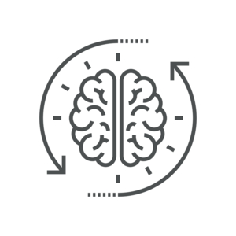Publicly available posts may be found on the following webpage:
- Link (webpage): Medicare: HCAHPSLinks to an external site.
Review and compare hospital scores related to nursing performance (e.g., nurses are respectful, nurses listen, nurses do everything to control pain). Reflect on your thoughts about the scores and the strengths and weaknesses of the hospitals that you compared.

Lesson 2
Policy and Framework

Strategies and Frameworks for Change
The DNP-prepared leader will play a critical role in change at this macrosystem level, as well as at the mesosystem and microsystem levels. A sound assessment of organizational culture is a method the DNP-prepared leader can use to identify and mitigate risk stemming from the organization's culture and subcultures. Organizational culture is an abstract conception of an organization's values, beliefs, and assumptions.
Although these basic values, beliefs, and assumptions are difficult to identify, they can strongly affect how a project is perceived and whether staff members are willing to collaborate on the project. Culture can be overtly apparent, such as in the case of an organization that displays a value statement in the entry of the hospital, stating that the organization values employee input. However, culture is more subtly manifested, such as the observation that an employee hesitates to offer a viewpoint that differs from that of upper management. The DNP-prepared leader has an essential role in understanding how culture influences projects and must be prepared to intervene to guide projects to completion within various organizational subcultures.
Organizational culture is a strong underlying force that can be harnessed to support successful translation science projects. DNP-prepared nurse leaders can influence the culture positively by modeling and mentoring behaviors supportive of explicitly challenging “the way it has always been done,” explicitly using the research as the foundation for decision-making and practice change recommendations, holding leadership and staff accountable for evidence-based practice, and offering targeted education to support evidence-based practice and translation science projects. A good mission and vision will also guide staff to the target culture.

Reflection
Examine your organizational culture.
- Does it have the hallmarks of a culture of excellence?
- If not, what is lacking?
- What changes could you, as a DNP-prepared leader, institute to improve the culture?
This next portion of this lesson gives recommendations on how a DNP-prepared leader can influence the culture of an organization.
Leadership is the first component in the transformational model and the fundamental currency of cultures of excellence. The DNP-prepared leader is the driver for instigating change. Leadership begins with a respectful environment and the creation of trust that supports the potential for relationships. The second major component of creating a culture of excellence, beyond leadership and people, is embedding a process for continuous improvement into the culture. The component for building excellence is using models and guiding principles. The Magnet Recognition Program (ANCC, n.d.) is an excellent performance model that considers the dynamic flow of organizations. Criteria-based programs provide a map for the journey. These programs with their integrated models can be templates to compare and improve the organization’s performance.
Change requires strong DNP leadership and commitment to engage followers. Changing a culture, moving it from mediocrity to excellence or from chaos to stability, can require an extended period of time because it involves adjustments in every aspect of the organizational structure and function. For successful change, several key roles must be identified, and the DNP leader must adequately consider who is in what role, whether they are clear in their role, and how their participation can be optimized in support of the change.
Readiness for change is perhaps the most difficult to achieve but is essential for successful quality and safety transformation. For change to happen, the workforce's motivation must align with the goals and the process of the organization. Readiness depends on a culture of learning. Change is a continuous process, and DNP-prepared leaders have many forces to consider.
There are multiple proven strategies that can be applied to assist with performance improvement activities. Donabedian's quality framework is a validated approach for evaluating the quality of care delivered. Donabedian (1988) stated that structural factors of the organization influence the process of care, which then impacts the effect of changes in care on the outcomes. Each element in this chain produces an effect on the element that follows and is affected by the element that precedes it. Donabedian defined structure as the relatively stable characteristics of the system, including providers of care, tools and resources they have at their disposal, and the physical and organizational setting in which they work. Processes of care refer to the activities in which professionals engage to provide services to patients. The processes indicate the mechanisms responsible for producing the intended outcomes and include continuity of care and technical and interpersonal management of patient care. As such, these factors explain the processes responsible for producing the desired outcomes and subsequently the effectiveness of the organization. Donabedian noted that good structure increases the likelihood of good process, which increases the likelihood of good outcomes.
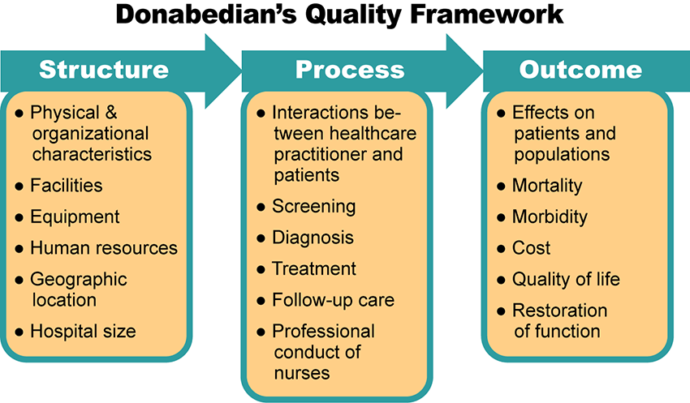

Donabedian Structure Interactive Transcript
The Deming Plan-Do-Study-Act (PDSA) cycle (Institute for Healthcare Improvement, 2021) uses a quick iterative cycle to make small changes in the system or process. Each change is measured for the intended improvement and this process gradually leads to larger, aggregate and targeted change. In applying PDSA, ask yourself three questions:
- What are we trying to accomplish?
- Are smaller incremental changes needed to improve the process or system?
- What iterative changes can we make that will result in system or process improvements and how will we measure the success of each change?
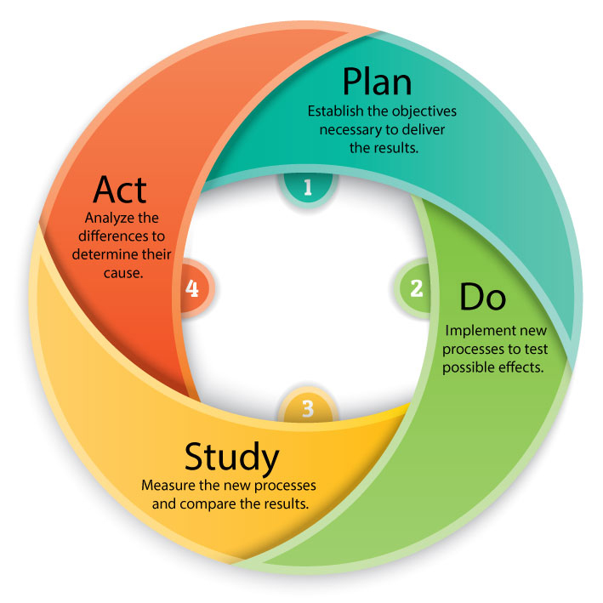

Plan-Do-Study-Act Image Description

Translation Science Theories and Models and Quality Improvement Models Review
The translation science theories and models are different from the Deming Plan-Do-Study-Act (PDSA) model. Whereas the PDSA model focuses on rapid iterative change to a system or process, the translation science theories focus on implementing the intervention exactly as described in the research supporting the intervention. The purpose of the translation science theories is to provide the steps and framework for translating the evidence-based intervention from the published research into clinical practice.
Translation of evidence is integral to the role of the DNP-prepared nurse and essential to the implementation of evidence-based interventions for practice change. Using the systematic approach of a conceptual model or framework increases the chances of successful evidence implementation into practice. In previous courses, you learned about four translation science theories and models.
- Everett Rogers's theory of Diffusion of Innovations, a five-step innovation-decision process and the five types of responses to change
- Knowledge to Action model
- Normalization Process Theory
- i-PARIHS model
Click through the following interactive to review the four common translation processes.

Translation Models Interactive Transcript

National and International Practices and Health System Framework
DNP-prepared nurses should thoroughly understand that the delivery of patient care within their system will be directly linked to the macro, meso, and microsystems that create the care. They will be challenged with the task of transforming and creating the culture within the organization that enables the intertwined linkages of the macro, meso, and microsystems to function successfully and recognize that improvement necessitates change.
Following are national frameworks and health system practices developed and popularized to optimize the three levels of the healthcare system.

National and International Practice Interactive Transcript

Hospital Compare Database
https://www.medicare.gov/hospitalcompare/search.html Links to an external site.
- Reports data on patient quality and satisfaction
- Reports submitted by hospitals
- Consumer-oriented website
- Provides comparison information related to care provided to patients
- The Hospital Consumer Assessment of Health Care Providers and Systems (HCAHPS) survey located here
- HCAHPS is a standardized instrument to collect data on patient perceptions of care received

Malcolm Baldrige National Quality Award
https://asq.org/Links to an external site.
- Empowers DNP-prepared leaders to improve work on the macro, meso and microsystem levels
- Utilizes assessment framework based on 7 criteria for design, development, deployment, and continuous improvements within and throughout organizations

National Quality Forum (NQF)
https://www.qualityforum.org/Home.aspxLinks to an external site.
- Endorsed 400 measures of quality indicators in healthcare
- Rigorous endorsement process
- Examines evidence to support validity and reliability of measures
- Final arbiter of recognized measures
- Publishes quality standards for nursing

Robert K Greenleaf, Center for Servant Leadership
https://www.greenleaf.org/Links to an external site.
- International nonprofit organization
- Mission is to advance the awareness, understanding and practice of servant leadership by individuals and organizations
- Identifies that a leader consists of an individual who encourages the whole person—head, hand, and heart

Institute of Health Care Improvement (IHI)
http://www.ihi.org/Links to an external site.
- Enhances safe patient care
- Provides tools and techniques to prevent patient harm
- References
- American Nurses Credentialing Center. (n.d.). Magnet model—creating a magnet culture. Retrieved December 4, 2022, from https://www.nursingworld.org/organizational-programs/magnet/magnet-model/
- The Center for Community Health and Development University of Kansas. (1994-2021). Community tool box: Chapter 3 section 7: Conducting needs assessment surveys. https://ctb.ku.edu/en/table-of-contents/assessment/assessing-community-needs-and-resources/conducting-needs-assessment-surveys/main
- Centers for Medicare & Medicaid Services. (n.d.). Find & compare nursing homes, hospitals & other providers near you. Retrieved December 4, 2022, from https://www.medicare.gov/care-compare/?providerType=Hospital&redirect=true
- Donabedian, A. (1988). The quality of care: How can it be assessed? JAMA, 260(12), 1743–1748. https://doi.org/10.1001/jama.1988.03410120089033 https://jamanetwork-com.chamberlainuniversity.idm.oclc.org/journals/jama/article-abstract/374139
- Harris, J. L., Roussel, L. A., Thomas, T., & Dearman, C. (2020). Project planning & management: A guide for nurses and interprofessional teams (3rd ed.). Jones & Bartlett Learning.
- Hussain, S. T., Lei, S., Akram, T., Haider, M. J., Hussain, S. H., & Ali, M. (2018). Kurt Lewin's change model: A critical review of the role of leadership and employee involvement in organizational change. Journal of Innovation & Knowledge, 3(3) 123-127. https://doi.org/10.1016/j.jik.2016.07.002
- Improta, G., Balato, G., Ricciardi, C., Russo, M. A., Santalucia, I., Triassi, M., & Cesarelli, M. (2019). Lean Six Sigma in healthcare: Fast track surgery for patients undergoing prosthetic hip replacement surgery. TQM Journal, 31(4), 526–540. https://doi.org/10.1108/TQM-10-2018-0142
- Institute for Healthcare Improvement. (2021). How to improve. http://www.ihi.org/resources/Pages/HowtoImprove/default.aspx
- Singh, M., & Rathi, R. (2019). A structured review of Lean Six Sigma in various industrial sectors. International Journal of Lean Six Sigma, 10(2), 622–664. https://doi.org/10.1108/IJLSS-03-2018-0018
- Waxman, K. T., & Knighten, M. L. (2023). Financial and business management for the Doctor of Nursing Practice (3rd ed.). Springer Publishing Company.
- Zaccagnini, M. E., & Pechacek, J. (2021). The Doctor of Nursing Practice essentials: A new model for advanced practice (4th ed.). Jones & Bartlett Publishers.

Organizational Assessment

Discussion

Purpose
The purpose of this discussion is to assess for organizational gaps or problems, allowing you to explore the process you would follow to assess your selected organization.

Instructions
Reflect upon your readings and consider the practice problem you have identified for your DNP project and respond to the following:
- Examine and describe the process you would follow to assess the organization where you plan to conduct your project for opportunities for improvement, including the identification of stakeholders.
- Determine the ultimate goals for your DNP project.
- Describe how your project goals relate to the organization’s mission and vision.
Please click on the following link to review the DNP Discussion Guidelines on the Student Resource Center program page:
- Link (webpage): DNP Discussion GuidelinesLinks to an external site.

Program Competencies
This discussion enables the student to meet the following program competencies:
- Integrates scientific underpinnings into everyday clinical practice. (POs 3, 5)
- Uses analytic methods to translate critically appraised research and other evidence into clinical scholarship for innovative practice improvements. (POs 3, 5)
- Appraises current information systems and technologies to improve healthcare. (POs 6, 7)
- Analyzes healthcare policies to advocate for equitable healthcare and social justice to all populations and those at risk due to social determinants of health. (POs 2, 9)
- Leads others in professional identity, advanced clinical judgment, systems thinking, resilience, and accountability in selecting, implementing, and evaluating clinical care. (POs 1, 4)

Course Outcomes
This discussion enables the student to meet the following course outcomes:
- Examine the role of the DNP-prepared nurse in leading financial planning and management across healthcare settings. (PCs 5, 8; POs 2, 4, 9)
- Formulate a needs-based organizational assessment to inform strategic leadership decision-making. (PCs 1, 3, 4; POs 3, 5, 7)
- Develop strategies to lead project planning, implementation, management, and evaluation to promote high-value healthcare. (PCs 1, 3, 4; POs 3, 5, 7)

Due Dates
- Initial Post: By 11:59 p.m. MT on Wednesday
- Follow-Up Posts: By 11:59 p.m. MT on Sunday
Search entries or author
Filter replies by unreadUnread Collapse replies Expand replies
Subscribe
ReplyReply to Week 1: Discussion | Organizational Assessment

Welcome to our Week 1 Discussion!
After taking time to read Chapter 9 in Harris et al. (2020) and spending time in our lessons, you are ready for the discussions.
The purpose of this discussion is to assess your project alignment with the practicum site’s needs, mission, and vision. In this discussion, students explore the process you would follow to assess the organization. State your project goals and discuss if your project goals align with the organizational mission and vision.
Be sure to read the discussion questions carefully to answer all components.
Our interactive discussion addresses the following course outcomes:
  - CO 1 Examine the role of the DNP-prepared nurse in leading financial planning and management across healthcare settings. (POs 2, 4, 9)
  - CO 2 Formulate a needs-based organizational assessment to inform strategic leadership decision-making. (POs 3, 5, 7)
  - CO 3 Develop strategies to lead project planning, implementation, management, and evaluation to promote high-value healthcare. (POs 3, 5, 7) Please post your initial response by Wednesday 11:59 pm MT and your reply post by Sunday 11:59 pm MT.

