Week 3 Discussion NR730 EE
The PICOT Question: A Building Block of the DNP Project
Discussion
Purpose
The purpose of this assignment is to examine a PICOT question, which will serve as the mechanism for the development of the DNP practice change project. ( e.g. The aim of the DNP Project is to Enhancing Staff Education to address postpartum depression in Mental Health Clinic)

Instructions
Reflect on your readings this week and respond to the following:

State your proposed DNP practice change project PICOT question.
Examine how your PICOT question addresses the identified practice problem.
Evaluate how the outcome identified in your PICOT question aligns with the evidence-based intervention.

YOU may also include

References
Zaccagnini, M., & Pechacek, J. M. (2021). The Doctor of Nursing Practice essentials: A new model for advanced practice nursing (4th ed.). Jones & Bartlett Learning.

As you consider the evidence you have gathered related to your proposed practice problem, you will craft a practice question that drives the development and scope of your entire DNP project. The practice question is referred to as a PICOT (population, intervention, comparison, outcome, timeline). The PICOT format is used to organize the practice question.

PICOT Image Description

A template for a PICOT looks something like this:
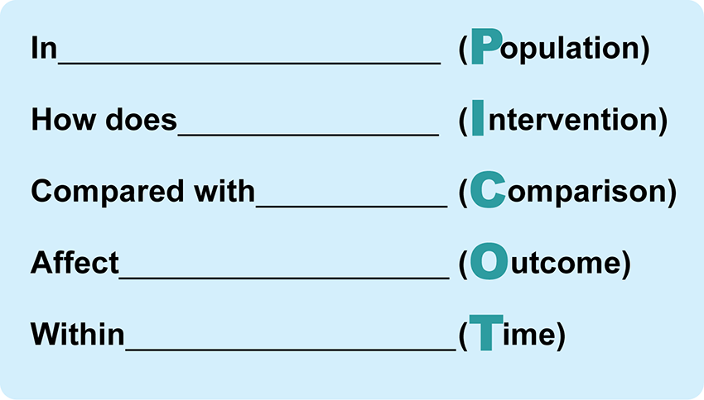

PICOT Template
Identifying Measurable Outcomes
The purpose of the DNP project is to influence practice problems at the micro, meso, or macro systems level through the introduction and integration of evidence into practice. As you develop your PICOT question, the outcome you plan to measure must be consistent with the evidence-based intervention and the identified practice problem.

Here are some questions to consider:

Why is the project being done?
Is the project directed towards the identified practice problem?
Will the outcome you measure indicate if the practice problem was impacted?
Click on the following hourglass and take a moment to reflect on the statement.

