Student Lesson Plan

Overview
- Program Competencies
- Course Outcomes
- Weekly Objectives
- Main Concepts
- Applies organizational and system leadership skills to affect systemic changes in corporate culture and to promote continuous improvement in clinical outcomes. (PO 6)
- Appraises current information systems and technologies to improve health care. (POs 6, 7)
- Analyzes health care policies to advocate for equitable health care and social justice to all populations and those at risk due to social determinants of health. (POs 2, 9)
- Creates a supportive organizational culture for flourishing collaborative teams to facilitate clinical disease prevention and promote population health at all system levels. (PO 8)
- Translates a synthesis of research and population data to support preventative care and improve the nation’s health. (PO 1)
- Leads others in professional identity, advanced clinical judgment, systems thinking, resilience, and accountability in selecting, implementing, and evaluating clinical care. (POs 1, 4)

Schedule
Section | Read/Review/Complete | Course Outcomes | Due
Prepare | Assigned Readings | COs 1, 3 | Wednesday
Explore | Lesson | COs 1, 3 | Wednesday
Translate to Practice | Discussion: Initial Post | COs 1, 3 | Wednesday
Translate to Practice | Discussion: Follow-Up Posts | COs 1, 3 | Sunday
Translate to Practice | Assignment | COs 1, 2, 3, 4, 5 | Sunday
Reflect | Reflection | COs 1, 3 | No submission

Foundations for Learning
Review the following resources in preparation for the week:
American Association of Colleges of Nursing. (2006). The essentials of doctoral education for advanced nursing practice.Links to an external site. https://www.aacnnursing.org/DNP/DNP-Essentials (Note: These Essentials outline the foundational competencies of advanced nursing practice for the DNP.)
American Organization for Nursing Leadership. (2015). AONL nurse leader competencies.Links to an external site. https://www.aonl.org/resources/nurse-leader-competencies

Student Learning Resources
Click on the following tabs to view the resources for this week.
- Required Textbooks
- Required Articles
- Additional Resources
Huber, D. L. (2018). Leadership & nursing care management (6th ed.). Elsevier.
- Read Chapters 4, 15

Learning Success Strategies
- Review the assigned readings to ensure you understand the key terms and can relate them to the role of the nurse leader in supporting a culture of inquiry, evidence-based practice, and innovation.
- As you review weekly content, consider how each concept and discussion can be translated into practice in your unique setting in the role of nurse leader.
- Be ready to share your thoughts and leadership experiences through the interactive discussion. It is important to share your thoughts so that we hear your voice. Also, support your positions with evidence from the literature. Growing in your ability to share your ideas is encouraged, and the use of first-person is accepted for the discussion board.
- Review the discussion guidelines and rubric to optimize your performance in this course.
- You have access to a variety of resources to support your success. Click on the DNP Resources tab on the home page to access program and project resources.
- Supplemental resources are not mandatory but can provide additional knowledge and understanding of the course content.
- Your course faculty is here to support your learning journey. Reach out for guidance with study strategies, time management, and course-related questions.
- Let’s Check-In: Tips for Success: PowerPoints and recordings are posted each Sunday for the following week. Live Let’s Check-Ins are conducted in selected weeks throughout the course, so check your announcements for details.

Interacting with Feedback
Each week your course faculty will provide feedback in the rubric on any assignment you have submitted. Take a moment to review the following video on how to view rubric feedback in Canvas. (After clicking the link, scroll down or click on the title in the Summary area to jump directly to the video.)
- Link (video): Looking at FeedbackLinks to an external site. (2:26)
Review the following video on how to accept/reject track changes when viewing course faculty feedback on your assignment:
- Link (video): Word: Track Changes and Comments (4:19)
- Lesson 1
- The Decisions of a Nurse Leader
- Introduction
- As a DNP-prepared nurse leader, your role will be essential in developing a vision and leading your organization towards improved patient outcomes, a reduction in the burden of disease, and resource sustainability in an ever-changing healthcare environment. Decision-making is a crucial skill of the nurse leader, especially in light of the complexity of today’s healthcare market. Decisions should be made after the completion of an analysis, synthesis, review of the evidence, and appraisal of data to support the identified goal of the decision. Let’s begin this week by discussing the decision-making process of a nurse leader.
- Making Decisions Like A Leader
- As a DNP-prepared nurse leader, your decisions will ultimately impact the safety and quality of patient care provided within and by your organization. Decisions will be made based on the daily needs that arise, as well as the overall goal and vision of the organization. Analytical decision-making has been identified as a critical competency not only by the American Organization for Nursing Leadership (AONL) but also in the Institute of Medicine (IOM) Future of Nursing 2011 report (Huber, 2018).
- While various models can be used in the decision-making process, it is the responsibility of the nurse leader to seek a clear understanding of the problem before moving forward with a decision. There are many tools, such as clinical protocols or smart alerts, that can be used when making decisions. However, one of the most important steps to consider in today’s complex healthcare setting is making informed decisions based on evidence. Evidence-informed decisions, like evidence-based practice (EBP), can assist in driving the quality of care upward while reducing the risk of stagnant practices and processes or compromising the safety of staff or patients.
- Leading With a Spirit of Inquiry and Innovation
- Decisions made with the best available evidence can assist the DNP-prepared nurse leader in nurturing a culture in which translation of evidence to the bedside is anticipated and expected throughout the organization. As the nurse leader incorporates evidence into their daily work and decision-making, the spirit of inquiry and innovation will increase among staff. A spirit of inquiry is a continuous curiosity that cultivates questions and creates strategies to address practice problems. Staff will begin to seek answers to questions or solutions to problems from the existing body of evidence and a culture of continuous examination, innovation, and analysis will grow within the organization.
- The current state of healthcare in the United States has many complex problems that require a spirit of inquiry and innovative thinking to affect change. DNP-prepared nurse leaders are in the perfect position to be innovative leaders of change. Nurse leaders can use innovative practice models to provide care for diverse populations and to collaborate with other disciplines.
- Nurse leaders can also serve as expert consultants to solve unique practice problems through evidence-based interventions. Innovation does not happen overnight but takes time and work. The nurse leader must continually monitor market disturbances and be able to respond promptly to ensure the sustainability of the organization (Boston-Fleischhauer, 2020).
- Healthcare innovation may require influences from other disciplines, including business. Innovators spend time watching, listening, and reading diverse topics. Innovative leaders not only develop and implement the innovation, but they also spread the word and share their creative ideas with others. Innovation, therefore, fosters innovation. Innovative leaders encourage others to think big and take risks. Innovators also need to be able to secure the appropriate resources and partnerships to make the innovation successful.
- In the book Evidence-Based Leadership, Innovation, and Entrepreneurship in Nursing and Healthcare, Melnyk and Raderstorf (2021) identify the Seven Steps of EBP as the building blocks for developing a spirit of inquiry within an organization.
- 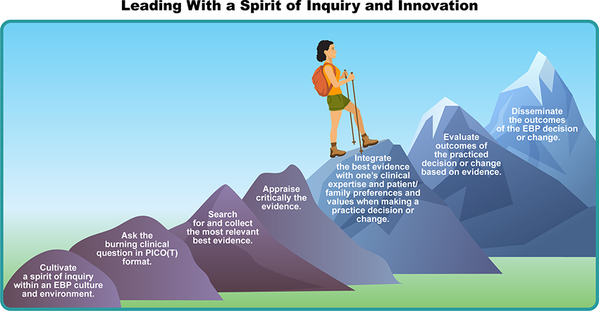
- Leading With a Spirit of Inquiry and Innovation Image Description
- As we examine the Seven Steps of EBP, let’s consider how the DNP-prepared nurse leader can be a champion for the integration of evidence into each area of practice, both as a nurse leader and as an expert clinician.

Lesson 2
Championing Evidence-Based Practice as a DNP-Prepared Nurse Leader

Introduction
With today’s increasingly complex healthcare environments, the DNP-prepared nurse leader has a vital role in transforming healthcare through the translation of evidence to the practice setting. As the consummate consumer of published research, the DNP-prepared nurse emerges with the knowledge, skills, and abilities to identify gaps in practice and render evidence to address the eight National Practice Problems and the Global Burden of Disease facing all communities. The DNP-prepared nurse leader is well-positioned to champion the introduction and advancement of evidence-based practice in diverse healthcare settings.
As a change agent, the DNP-prepared nurse can assist in expediting the stream of innovation while being careful not to strain the healthcare system with disproportionate information. The nurse leader must be astute in recognizing information overload, which can result in a barrier to the translation of evidence and innovation. The more open an organization is to change, the easier it is to accelerate innovation (Crowell & Boynton, 2020). Through innovation, we consistently improve the quality of care provided locally, nationally, and globally.
Examine the following graphic, The Conceptual Framework for Healthcare, and how this model supports a culture of evidence-based practice and leads to improved patient outcomes.
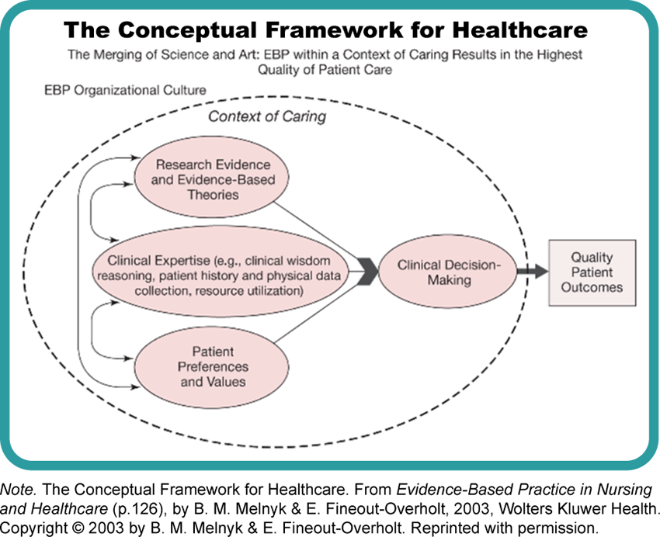

The Conceptual Framework for Healthcare Image Description

Leading Rapid Change Across Complex Healthcare Environments

As a DNP-prepared nurse leader, you will be expected to not only lead change but at times respond to the necessity for rapid change. This was the situation for many nurse leaders when the COVID-19 pandemic first emerged in 2020. Changes were needed swiftly to respond to the influx of critically ill patients and staff. Do you remember what we discussed during Week 1? When rapid change occurs, the nurse leader must use both head and heart to guide staff and provide a sense of direction, alleviate fears of the unknown, maintain high ethical standards, and maintain morale and motivation to meet the needs of patients and the organization (Daft, 2017). The nurse leader's skills of leading with both head and heart were essential as COVID-19 began to take a toll on the human and material resources of healthcare organizations.
When rapid change is needed, the nurse leader must have a seat at the table for decisions impacting patients, staff, and operations. The standard procedures and policies can become antiquated during rapid change as the needs of complex healthcare environments are not always compatible with strategies that focus on authoritarian power and control (Boston-Fleischhauer, 2020). As the need for rapid change developed during the early months of COVID-19, nurse leaders across the country, as well as globally, brainstormed to quickly identify potential solutions and processes to adapt to the pandemic environment. Innovative ideas were brought forth and tested for their efficacy in addressing the problems at hand. Reliance on existing policies and procedures did not always support the quickly evolving demand on healthcare systems.
As a need for rapid change is identified, the nurse leader should collaborate with staff and other disciplines to identify and engage in a viable solution. Even small rapid changes that have a positive outcome can instill confidence in staff and cultivate an environment where change is readily accepted and adopted. Change is not easy for many individuals and at times the initial response to change may be one of emotion and resistance.

Emotional Support Strategies

The DNP-prepared nurse leader needs to provide emotional support through strategies such as:
- Communicating with transparency
- Listening objectively to concerns
- Asking for feedback
- Inspiring participation
Monitoring reactions from stakeholders is important with any change, especially when rapid change is needed. By using the strategies discussed, the nurse leader can reduce fear and resistance to change and establish a healthy work environment where change is viewed as a positive disruption.

References
American Organization for Nursing Leadership. (2015). AONL nurse leader competencies. https://www.aonl.org/resources/nurse-leader-competencies
Boston-Fleischhauer, C. (2020). Chief nurse executive readiness for the here and now. Journal of Nursing Administration, 50(6), 307-309. https://doi.org/10.1097/NNA.0000000000000889
Crowell, D., & Boynton, B. (2020). Complexity leadership: Nursing’s role in health care delivery. F.A. Davis.
Daft, R. L. (2017). The leadership experience (7th ed.). Cengage Learning.
Melynk, B., & Raderstorf, T. (2021). Evidence-based leadership, innovation, and entrepreneurship in nursing and healthcare: A practice guide to success. Springer Publishing.

Leading Through a Lens of Evidence-Based Practice

Discussion

Purpose
The purpose of this discussion is to identify the importance of leading evidence-based practice change as a nurse leader.

Instructions
Reflect on the readings and lesson this week and respond to the following:
- Identify at least one gap in practice within your organization.
- What evidence supports the need for this practice change?
- What strategies will you use as a nurse leader to champion the project and garner buy-in for the change?
Please click on the following link to review the DNP Discussion Guidelines on the Student Resource Center program page:
- Link (webpage): DNP Discussion GuidelinesLinks to an external site.

Program Competencies
This discussion enables the student to meet the following program competencies:
- Applies organizational and system leadership skills to affect systemic changes in corporate culture and to promote continuous improvement in clinical outcomes. (PO 6)
- Appraises current information systems and technologies to improve health care. (POs 6, 7)
- Analyzes health care policies to advocate for equitable health care and social justice to all populations and those at risk due to social determinants of health. (POs 2, 9)
- Creates a supportive organizational culture for flourishing collaborative teams to facilitate clinical disease prevention and promote population health at all system levels. (PO 8)
- Translates a synthesis of research and population data to support preventative care and improve the nation’s health. (PO 1)
- Leads others in professional identity, advanced clinical judgment, systems thinking, resilience, and accountability in selecting, implementing, and evaluating clinical care. (POs 1, 4)

Course Outcomes
This discussion enables the student to meet the following course outcomes:
- Express the role of the nurse leader in the advancement of the profession through personal and professional accountability. (PCs 2, 4, 5, 6, 8; POs 2, 4, 6, 8)
- Formulate strategies to adapt leadership style to situational needs and rapid change in the healthcare environment. (PCs 2, 4, 5, 6; POs 6, 8, 9)

Due Dates
- Initial Post: By 11:59 p.m. MT on Wednesday
- Follow-Up Posts: By 11:59 p.m. MT on Sunday
Search entries or author
Filter replies by unreadUnread Collapse replies Expand replies
Subscribe
ReplyReply to Week 3: Discussion | Leading Through a Lens of Evidence-Based Practice

Collapse SubdiscussionAislynn Moyer

Aislynn Moyer
Dec 26, 2023Local: Dec 26, 2023 at 8:54am<br>Course: Dec 26, 2023 at 6:54am
Manage Discussion Entry
Hi everyone,
Welcome to Week 3! The purpose of this week’s discussion is to identify the importance of leading evidence-based practice change as a nurse leader.

This discussion enables you to meet the following course and program outcomes:

1. Express the role of the nurse leader in the advancement of the profession through personal and professional accountability. (POs 2, 4, 6, 8)

2. Formulate strategies to adapt individual leadership style to situational needs and rapid change in the healthcare environment. (POs 6, 8, 9)

1. Identify at least one gap in practice within your organization.
2. What evidence supports the need for this practice change?
3. What strategies will you use as a nurse leader to champion the project and garner buy-in for the change?

Please review the discussion grading guidelines and support your post with scholarly references.

The Nurse Leader and Ethical Accountability

Assignment

Purpose
The purpose of this assignment is to examine the role of the nurse leader in identifying and leading teams through ethical dilemmas that present in today’s complex healthcare systems.

Instructions
For this assignment, select an ethical dilemma and examine the accountability of the nurse leader in resolving ethical dilemmas.
Include the following in your paper:
- Introduction
  - Introduce the paper’s topic and establish its importance.
  - Present a clear purpose statement.
  - Provide the reader with a brief organizing statement of what will be discussed in the paper that reflects the level 1 headings (except the conclusion).
- Ethical Dilemmas in Healthcare: Select an ethical dilemma in healthcare.
  - Describe the ethical dilemma and its impact on healthcare outcomes.
  - Is the dilemma an ethical issue, a legal issue, or both?
  - Identify the key issues surrounding the dilemma.
  - What are the consequences if the dilemma is not resolved appropriately and timely?
- Differing Views: Identify and examine differing views that create the dilemma.
  - Determine the stakeholders most impacted by the dilemma.
  - Describe the impact on staff, patients, and the community.
  - Explain how the views are influenced by culture, socio-economic status, religion, generational differences, ethnic diversity, or other factors.
- The Role of the Nurse Leader in Resolving Ethical Dilemmas: Based on a review of the literature.
  - Explain the position you would choose as a nurse leader.
  - Cite at least three (3) scholarly sources to defend your position.
  - How would you demonstrate leadership accountability to reach a positive outcome?
  - How would you mitigate risk to the organization?
- Conclusion
  - Recap the paper’s purpose statement and organizing criteria.
  - Draw major conclusions from the body of the paper.
  - Summarize the nurse leader’s accountability for resolving ethical dilemmas in the healthcare setting.
- References (minimum of 3 scholarly, peer-reviewed sources)
  - Create a reference page.
  - Ensure each reference has a matching citation. References and citations are in the current APA style.
  - Support your position and the impact of the dilemma on healthcare by using evidence from at least three (3) scholarly peer-reviewed journal sources (preferably research or systematic reviews) that are retrieved from the Chamberlain library databases. Do not use textbooks, government sources, or organizational websites for the three sources in this assignment.
Review the rubric for the grading criteria.

APA Guidelines
Use the current edition of the Publication Manual of the American Psychological Association (APA Manual) and the Chamberlain Guidelines for Writing a Professional Paper (located in the Canvas Resources under the APA Basics section of the Writing Center) to inform your construction of this assignment. Follow these guidelines when completing each component. Contact your course faculty if you have questions.
- Use the APA Paper Template (located in the Canvas Resources under the APA Basics section of the Writing Center) to format this assignment.
- Turn on Grammarly to check the correctness of the grammar and punctuation as you write. (Note: if you have not already done so, please download the free version at Grammarly.com before construction of the assignment.)
- Construct a title page using the DNP APA paper template.
- Use the following prescribed Level I headings for the paper:
  - Ethical Dilemmas in Healthcare
  - Differing Views
  - Role of the Nurse Leader in Resolving Ethical Dilemmas
  - Conclusion

Writing Requirements (APA format)
- Length: 5-7 pages (not including title page or references page)
- 1-inch margins
- Double-spaced pages
- 12-point Times New Roman or 11-point Arial font
- Level headings & subheadings
- In-text citations in APA format match references
- Title page (formatted according to the DNP template)
- References page & references are in APA format
- Standard English usage and mechanics (grammar, punctuation, & spelling) as prescribed in the current APA style guide.
- Organized presentation of ideas in sentences and paragraphs

Program Competencies
This assignment enables the student to meet the following program competencies:
- Applies organizational and system leadership skills to affect systemic changes in corporate culture and to promote continuous improvement in clinical outcomes. (PO 6)
- Appraises current information systems and technologies to improve health care. (POs 6, 7)
- Analyzes health care policies to advocate for equitable health care and social justice to all populations and those at risk due to social determinants of health. (POs 2, 9)
- Creates a supportive organizational culture for flourishing collaborative teams to facilitate clinical disease prevention and promote population health at all system levels. (PO 8)
- Translates a synthesis of research and population data to support preventative care and improve the nation’s health. (PO 1)
- Leads others in professional identity, advanced clinical judgment, systems thinking, resilience, and accountability in selecting, implementing, and evaluating clinical care. (POs 1, 4)

Course Outcomes
This assignment enables the student to meet the following course outcomes:
- Express the role of the nurse leader in the advancement of the profession through personal and professional accountability. (PCs 2, 4, 5, 6, 8; POs 2, 4, 6, 8)
- Analyze the role of the nurse leader in interpreting and responding to legislation at the state and federal level, which impacts nursing and healthcare at the micro, meso, and macrosystem level. (PCs 5, 7, 8; POs 1, 4, 9)
- Formulate strategies to adapt individual leadership style to situational needs and rapid change in the healthcare environment. (PCs 2, 4, 5, 6; POs 6, 8, 9)
- Promote advocacy for cultural diversity, social justice, and health equity. (PCs 2, 4, 5, 7, 8; POs 1, 2, 4, 6)
- Demonstrate nursing leadership knowledge of the complexity of the healthcare environment and ethical dilemmas facing healthcare systems. (PCs 5, 7, 8; POs 1, 2, 4, 9)

Due Date
- By 11:59 p.m. MT on Sunday
- Late Assignment Policy applies

Rubric
Week 3 Assignment Grading Rubric
Week 3 Assignment Grading Rubric
Criteria | Ratings | Pts
This criterion is linked to a Learning OutcomeIntroduction  Requirements:  a. Introduce the paper’s topic and establish its importance.  b. Present a clear purpose statement.  c. Provide the reader with a brief organizing statement of what will be discussed in the paper that reflect the level 1 headings (except the conclusion). |  | 40 pts
  40 pts  Includes all requirements and provides an in-depth introduction. | 36 pts  Includes all requirements and provides a sufficient introduction. | 32 pts  Includes 2 requirements and/or provides a partial introduction. | 0 pts  Provides an undeveloped introduction.
This criterion is linked to a Learning OutcomeEthical Dilemmas in Healthcare: Select an ethical dilemma in healthcare  Requirements:  a. Describe the ethical dilemma and its impact on healthcare outcomes.  b. Identify the key issues surrounding the dilemma.  c. What are the consequences if the dilemma is not resolved appropriately and timely? |  | 60 pts
  60 pts  Includes all requirements and provides an in-depth discussion. | 54 pts  Includes at least 2 requirements and/or provides a sufficient analysis of the ethical dilemma. | 48 pts  Includes at least 1 requirement 1 and/or provides a partial analysis of the ethical dilemma. | 0 pts  Includes none of the prescribed requirements and/or provides an undeveloped analysis of the ethical dilemma.
This criterion is linked to a Learning OutcomeDiffering Views: Identify and examine differing views that create the dilemma.  Requirements:  a. Determine the stakeholders most impacted by the dilemma.  b. Describe the impact on staff, patients, and the community.  c. Explain how the views are influenced by culture, socio-economic status, religion, generational differences, ethnic diversity, or other factors? |  | 60 pts
  60 pts  Includes all requirements and provides an in-depth evaluation of differing views. | 54 pts  Includes at least 3 requirements and/or provides a sufficient evaluation of differing views. | 48 pts  Includes at least 2 requirements and/or provides a partial evaluation of differing views. | 0 pts  Includes fewer than 2 requirements and/or provides an undeveloped evaluation of differing views.
This criterion is linked to a Learning OutcomeThe Role of the Nurse Leader in Resolving Ethical Dilemmas: Based on a review of the literature.  Requirements:  a. Explain the position you would choose as a nurse leader.  b. Cite at least three (3) scholarly sources to defend your position.  c. How would you demonstrate leadership accountability to reach a positive outcome?  d. How would you mitigate risk to the organization? |  | 60 pts
  60 pts  Includes all requirements and provides an in-depth discussion of the role of the nurse leader. | 54 pts  Includes at least 3 requirements and/or provides a sufficient explanation of the role of the nurse leader. | 48 pts  Includes at least 2 requirements and/or provides a partial explanation of the role of the nurse leader. | 0 pts  Includes fewer than 2 requirements and/or presents an undeveloped explanation of the role of the nurse leader.
This criterion is linked to a Learning OutcomeConclusion  Requirements  a. Recap the paper’s purpose statement and organizing criteria.  b. Draw major conclusions from the body of the paper.  c. Summarize the nurse leader’s accountability for resolving ethical dilemmas in the healthcare setting. |  | 40 pts
  40 pts  Includes all requirements and provides an in-depth summary in the conclusion. | 36 pts  Includes at least 2 requirements and/or provides a sufficient summary in the conclusion. | 32 pts  Includes at least 1 requirement and/or provides a partial summary in the conclusion. | 0 pts  Provides an undeveloped summary in the conclusion.
This criterion is linked to a Learning OutcomeReferences  Requirements  a. Create a reference page.  b. Ensure each reference has a matching citation and reference and citations are in the current APA style.  c. Support your position and the impact of the dilemma on healthcare by using evidence from at least three (3) scholarly peer-reviewed journal sources (preferably research or systematic reviews) that are retrieved from the Chamberlain library databases. Do not use textbooks, government sources, or organizational websites for the three sources in this assignment. |  | 20 pts
  20 pts  Includes all requirements of the reference section, at least three scholarly references with matching citations, and the reference page is formatted without errors. | 18 pts  Includes a new page for references, 3 matching references and citations, and/or the reference page is formatted with minor errors. | 16 pts  Includes at least 2 matching references and citations, and/or the reference page is formatted with multiple errors. | 0 pts  Includes fewer than 1 requirement for the references, and/or the reference page is formatted with multiple errors
This criterion is linked to a Learning OutcomeAPA Style and Standards  Requirements:  a. Uses appropriate level 1 headings as described in the assignment guidelines.  b. The paper is formatted in the current APA edition style.  c. Paper length is 5-7 pages, excluding title and reference pages. |  | 10 pts
  10 pts  Includes all requirements of APA style and standards. | 9 pts  Includes 2 requirements of APA style and standards. | 8 pts  Includes 1 requirement of APA style and standards | 0 pts  Includes no requirement of APA style and standards that conform to APA style.
This criterion is linked to a Learning OutcomeClarity of Writing  Requirements:  a. Use of standard English usage and mechanics (current APA style guide).  b. No grammar, spelling, punctuation, or typographical errors  c. Organized presentation of ideas in sentences and paragraphs |  | 10 pts
  10 pts  Includes all requirements of clarity of writing. | 9 pts  Includes 2 requirements of clarity of writing. | 8 pts  Includes 1 requirement of clarity of writing. | 0 pts  Includes no clarity of writing requirements that conform to standard English (APA) style.
Total Points: 300

