Week 2: Introduction and Objectives
- Dashboard
- My courses
- NU-710-03-24PBS2
- Week 2: Health Informatics Systems and Applications
- Week 2: Introduction and Objectives
Open course index
Completion requirements
Done: View

Introduction
This week we will be focusing on informatics used in community health and public health and the impact of clinical data on diverse populations. The goal is to create standardized terminology when working with data sets in community health. One example is the OMAHA System Model, which incorporates practice, documentation, and information management in an orderly manner. This model evolved from the Visiting Nurses in Omaha, Nebraska in 1970 (See the Figure below). The goal was to collect and share pertinent qualitative and quantitative data from the community. This federally funded project involving four studies included Donabedian (1966), the developer of what is now known as Quality Improvement (QI), as a consultant. This resulted in an examination of the quality of patient care and the value within.

OMAHA System Model
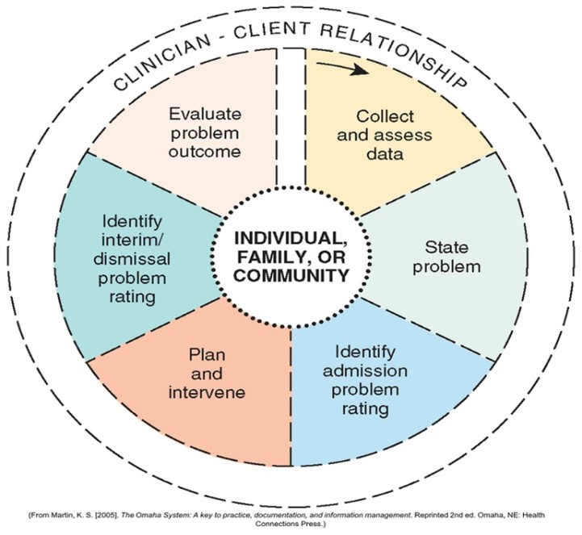

Learning Materials Introduction
This week, our focus is on components and attributes of an EHR. We will explore the importance of quality and safety for patients in using health information, including the ethical issues involved. Other issues include threats to the security of data storage, public health safety, and precision medicine. Theories or conceptual frameworks have been used to increase the understanding of applying health information technology (HIT) to healthcare safety, efficacy, and quality. A work system considers the many interacting technical (hardware, software, networking infrastructure) and non-technical (clinical workflow, internal organization policies, people, physical environment, and external policies) variables that affect health-IT related patient safety.
The required readings provide overall support to achieve WO 1, 2, 3, 4, 5, 6, 7, & 8 as you complete the discussions for this week.

Learning Objectives
By the end of this week, you will be able to:
- Describe how information technology (IT) improves quality and safety for patients (CO: 2, 3).
- Explain the potential threats to the security of the healthcare IT infrastructure (1, 4, 5).
- Delineate the differences between electronic medical records (EMR) and the electronic health record (EHR) (CO: 1, 2, 7).
- Explore the usefulness of precision medicine in healthcare (5, 6, 8).
- Define the methods used in IT applications to improve healthcare for diverse populations (CO: 2, 3, 6).
- Explain the use of information technology to store clinical data in the community health setting (CO: 7, 8).
- Discuss how public health informatics impacts overall public health (CO 1, 2, 3).
- Discuss the various theories and frameworks used in Informatics (CO 1, 2, 3).

NU-710-03-24PBS2 Informatics in Health Care
FORUM

Week 2 Discussion 1: Identify a Gap or an Issue About Health Informatics
- Dashboard
- My courses
- NU-710-03-24PBS2
- Week 2: Health Informatics Systems and Applications
- Week 2 Discussion 1: Identify a Gap or an Issue About Health Informatics
Open course index
Completion requirements
To do: Make forum posts: 1
Value: 100 points
Due: To facilitate scholarly discourse, create your initial post by Day 3 and reply to at least two of your classmates, on two separate days, by Day 7.
Gradebook Category: Discussions

Overview
Select one of the Recommended Readings listed as part of this week’s learning materials. Provide an overview of the key points found in the article. Find two other articles in the literature related to this topic. It is important to look at how other authors share their studies to identify how your topic or issue for your Informatics Scholarly Paper will unfold. If your topic of interest is not found using the Recommended Readings, you may share your idea with your faculty. Remember it is ok to use a fictitious patient or provider scenario related to health informatics to shape your paper. It is best to look at your textbook too to formulate an idea best for you to present in your paper! Once you have this nailed down, you can then choose the informatics theory to fit it. This will help you to begin your first two drafts of your paper and lead to a few new references for your paper.
Later, you will create a social media intervention based on the evidence to solve the problem. In the following weeks, you will be given suggested instruments or tools to measure the pretest and posttest changes and analyze what is found using basic statistics as a beginner. This will help you to be prepared to do so with your DNP project.

Initial Post
Consider potential topics related to health informatics and advanced practice nursing. Discuss the reason for your choice, how relevant it is in your practice or area of expertise, how it might improve quality, safety, and security for patients to improve care for diverse populations.
Hint: Use what you have written in your post as an introduction for your paper.
Please refer to the Grading Rubric for details on how this activity will be graded.

Posting to the Discussion Forum

Week 2 Discussion 2: Theory or Conceptual Framework Selection
- Dashboard
- My courses
- NU-710-03-24PBS2
- Week 2: Health Informatics Systems and Applications
- Week 2 Discussion 2: Theory or Conceptual Framework Selection
Open course index
Completion requirements
To do: Make forum posts: 1
Value: 100 points
Due: To facilitate scholarly discourse, create your initial post by Day 3, and reply to at least two of your classmates, on two separate days, by Day 7.
Gradebook Category: Discussions

Instructions
In preparation for your scholarly paper submission for Week 3, please select one of the following health informatics theories below to use in your paper. Be sure to devote a page or two to the explanation of the theory and how it was developed. Then expand on how the theory’s basic premises fit with your chosen topic or gap.
- Diffusion of Innovation Theory (Rogers, 2003)
- User Acceptance Theory (Venkateshe et al., 2003)
- Theory of Distributed Cognition (Hutchins, 1995; Furniss et al., 2019)
- Sociotechnical Model (Singh and Sitting, 2016)
- The Theory of Reasoned Action (Ajzen & Fishbein, 1975)
- The Swiss Cheese Model (Reason, 1997)
- Technology Acceptance Model (TAM) (Davis, 1985)
- Unified Theory of Acceptance and Use of Technology (UTAUT) (Venkateshe & Davis, 2003)
- Distributed Cognition (Hutchins, 1995)
Informatics Theories-reference
If you have found a theory you would like to use that is not included in this list, kindly get approval from your faculty.

Initial Post

NU-710-03-24PBS2 Informatics in Health Care
ASSIGNMENT

Week 2 Assignment 1: Health Informatics Scholarly Paper – Draft I
- Dashboard
- My courses
- NU-710-03-24PBS2
- Week 2: Health Informatics Systems and Applications
- Week 2 Assignment 1: Health Informatics Scholarly Paper – Draft I
Open course index
Completion requirements
To do: Make a submission
Due: Sunday, 7 July 2024, 11:55 PM
Value: 100 points
Due: Day 7
Gradebook Category: Informatics Scholarly Paper Draft I

Introduction
Review the guidelines for the Informatics Scholarly Paper for complete instructions on your paper's contents. It is now time to look at the literature for articles. Next steps include creation of a topic and title page for your paper, which may change as the paper develops. Next, you will review the literature for the references on this topic. It is helpful to meet with the Regis College librarian for assistance in your search of the literature. Create an introduction to set the stage for the rest of the paper and prepare the reader for what the chosen topic is and how it evolved using very current citations.
Begin to research your selected population in the literature. When needed, please contact Regis College Library Services for help finding resources.
Submit your draft in a Microsoft Word document that includes your chosen topic, title page, and references. Be sure to include references published within the last five years that are relevant to your chosen topic. By this point, you should have gathered at least eight of 13-15 references for this paper. Make sure you have cited each of these references in your draft for next week.

Informatics Scholarly Paper Timeline
- Weeks 1-2 Choose Topic: Selection of a gap or issue in health informatics for patients and/or providers. Other creative ideas are welcome and are at the discretion of the faculty.
- Week 2 Assignment 1: Draft I of the Health Informatics Scholarly Paper. Title page, introduction, eight references and the theory or conceptual model based in informatics from a list.
- Week 3 Creation of the social media intervention for the chosen topic.
- Week 4 Assignment 1: Health Informatics Scholarly Paper Draft II Due- Informatics Theoretical Model, Picture Graphic, and Potential Media Intervention (based on evidence). Add more references here to total 8-10.
- Week 5 Assignment 1: Informatics Scholarly Paper Draft III- Instruments to Measure and Analysis. Add more references to total 13-15.
- Week 6 Assignment 1: Final Informatics Scholarly Paper-Recommendations and Conclusion.
- Week 7 Discussion 1: Informatics Scholarly PowerPoint Presentation Peer Review.
- Week 7 Assignment 1: Informatics Scholarly PowerPoint Presentation for Faculty review.
Visit the Resources tab of this course to access Brainfuse and submit your paper to the Writing Lab team for proofreading and feedback. The turn-around time for the writing lab team is at least 24 hours, so account for review time prior to your assignment deadline.
Please refer to the Grading Rubric for details on how this activity will be graded.
To Submit Your Assignment:
- Select the Add Submissions button.
- Drag or upload your file to the File Picker.
- Select Save Changes.

Reminder! Week 4 Assignment 1: Health Informatics Scholarly Paper Draft II: Theoretical Model and Intervention
- Dashboard
- My courses
- NU-710-03-24PBS2
- Week 2: Health Informatics Systems and Applications
- Reminder! Week 4 Assignment 1: Health Informatics Scholarly Paper Draft II: Theoretical Model and Intervention
Open course index
Completion requirements
Done: View
Value: 100 points
Due: Day 7
Grading Category: Informatics Paper Draft II

Instructions
Review the guidelines for the Informatics Scholarly Paper for complete instructions on your paper's contents. Submit your draft in a Microsoft Word document that includes your chosen topic, title page, and references. Be sure to consider using newer references relevant to your chosen topic. By now, you should have gathered all your 13-15 references for this paper.

Submission Timeline
- Weeks 1-2 Choice: Selection of a gap or issue in healthcare informatics for patients or providers.
- Week 2 Assignment 1: Informatics Scholarly Paper-Draft I Title Page, Introduction, and References.
- Week 4 Assignment 1: Informatics Scholarly Paper Draft II- Informatics Theoretical Model, Picture Graphic, and Social Media Intervention (based on evidence)
- Week 5 Assignment 1: Informatics Scholarly Paper Draft III- Instruments to Measure and Analysis
- Week 6 Assignment 1: Final Informatics Scholarly Paper-Recommendations and Conclusion.
- Week 7 Discussion 1: Informatics Scholarly PowerPoint Presentation Peer Review.
- Week 7 Assignment 1: Informatics Scholarly PowerPoint Presentation for Faculty review.

