Week 3: Introduction and Objectives
- Dashboard
- My courses
- NU-710-03-24PBS2
- Week 3: Decision-Making and the Digitally Engaged Patient
- Week 3: Introduction and Objectives
Open course index
Completion requirements
Done: View

Introduction
This week focuses on evidence-based Informatics, clinical decision support, and the ever-evolving e-patient. In addition, we will explore the management of health and wellness in digital health, the use of personal health records (PHR), and social media tools for health informatics. The six chapters presented in this section called “Decision-making and the digitally engaged patient” is one of the key areas for the DNP to understand and apply. According to Patel and Johnson (2019), recent research suggests that clinicians offer help to access electronic medical records for patients only 50% of the time. Patel and Johnson (2019) further explain that only 30% of all patients in this study actually access their electronic medical records. This is an alarming rate that as nurses, we need to rectify. This week we will investigate the use of Evidence Based Practice Models (EBP) and Practice Based Evidence (PBE) and shed light on the role of health informatics in merging the two, perhaps with the help of Artificial Intelligence (AI).

Learning Materials Introduction
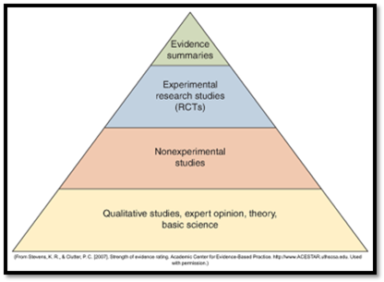
Once the literature has been reviewed, perhaps with the assistance of a professional librarian, the evidence can be synthesized, and the levels identified. The next step is to identify the data on the topic and analyze the findings. This is part of what you will do in the Informatics Scholarly Paper. Below is an example of data to speak to. For your paper, consider what data charts you can find that exemplify the issues for your topic idea.

The Balance of Wellness, Disease, and Treatment Management
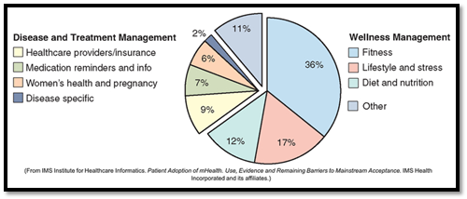
Once the data has been uncovered on the topic, one way to disseminate the findings is through electronic methods such as social media, email, conferences, journal publication, national organization sites, and in workplace interfaces. If we do a project for the DNP and never share what we found through a conference poster or paper, or through publication, then we are missing one of the main objectives found in the guidelines for the Scholarly Practice Project (SPP) or the SQUIRE 2.0 template used as a shortened, condensed version of the SPP.

The Use of Social Media and SMS for Sharing Health Information
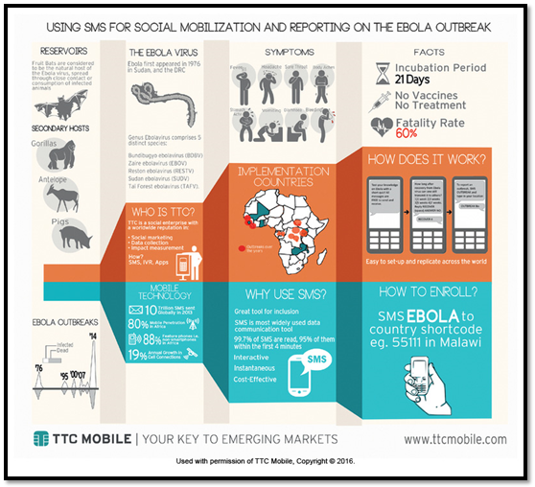
Lastly, it is crucial that we as nurses working with patients show and explain the importance of looking at their electronic health records, ask questions about them, and move away from hiding the electronic medical records from our patients. It is their right to see these and critical for them to take ownership of their health. Of course, there are appropriate pieces of the electronic medical record that should be reserved for the provider to share, but shielding the computer from the patient makes no sense. Shielding the computer from those that are not authorized to read it is yet another matter of privacy.
Reading the assigned readings, watching the suggested videos, and reviewing the PowerPoints will help to achieve Weekly Objectives 1, 2, 3, 4, 5, 6, & 7 for this week.

Learning Objectives
By the end of this week, you will be able to:
- Explain the importance of using evidence-based research in supporting scholarly writing about health informatics (CO: 1, 8).
- Describe the levels of evidence and the application to reviewing the literature about health informatics (CO: 6, 7).
- Explore the use of social media platforms and telehealth to expand communication for patients, families, and the community (CO: 3, 5, 7).
- Examine the role of the provider in promoting patient motivation to learn about their electronic health records and become stakeholders (CO: 2, 4, 5).
- Investigate the concerns in healthcare regarding the lack of patient engagement with electronic health records (CO: 1, 2, 7).
- Discuss the potential barriers for patients accessing their electronic health records and security of heath information (CO: 6, 8).
- Define possible strategies to increase the dissemination of health information electronically to promote health and the role of AI (CO: 2, 3, 5).

Week 3 Discussion 1: The Convergence of Patient, Nursing Care, and Provider Input in Digital Health
- Dashboard
- My courses
- NU-710-03-24PBS2
- Week 3: Decision-Making and the Digitally Engaged Patient
- Week 3 Discussion 1: The Convergence of Patient, Nursing Care, and Provider Input in Digital Health
Open course index
Completion requirements
To do: Make forum posts: 1
Value: 100 points
Due: To facilitate scholarly discourse, create your initial post by Day 3 and reply to at least two of your classmates, on two separate days, by Day 7.
Gradebook Category: Discussions
Note: In this type of discussion, you will not see the responses of your classmates until after you have posted your own response to the question below.

Initial Post
- In your initial post, pick one of the articles from either the Recommended Readings or the accompanying Resources and summarize the key points in three paragraphs.
- Answer the following questions:
  - What are the benefits for providers and patients using social media?
  - What are some of the risks or concerns for providers and patients using social media?
  - How would AI fit into this equation?
- Provide three new literature references published within the last five years that support your claims.
- Use APA formatting for your post.

Replies
Reply to at least two of your classmates. Your reply to posts should:
- Ask a clarifying question about your peer’s initial post.
- Incorporate one of each of your peer’s references in your reply. Agree or disagree using critical thinking to one of your peer’s initial posts picking their response from one of the three required questions (i.e. benefits, risks, or AI).
Please refer to the Grading Rubric for details on how this activity will be graded.

Posting to the Discussion Forum
- Select the appropriate Thread.
- Select Reply.
- Create your post.
- Select Post to Forum.

Week 3 Assignment 1: Social Media Tools for Health Informatics Intervention
- Dashboard
- My courses
- NU-710-03-24PBS2
- Week 3: Decision-Making and the Digitally Engaged Patient
- Week 3 Assignment 1: Social Media Tools for Health Informatics Intervention
Open course index
Completion requirements
To do: Make a submission
Due: Sunday, 14 July 2024, 11:55 PM
Value: 100 points
Due: Day 7
Gradebook Category: Assignment Week 3 Workflow Diagram

Introduction
For this assignment, the focus will be on creating a visual learning presentation using the media of your choice, which will become your intervention for your Informatics Scholarly Paper. This is a creative assignment in which you will select an appealing presentation that will capture the target audience and get their attention. Chapters 13 and 16 of your Hardy (2024) textbook are excellent resources for your intervention. Consider your chosen topic, then think of what you want to do to improve the situation. Then get creative and do a social media blast to address the problem. What you create will be used as the intervention in your scholarly paper.
It will be only five minutes in length or less. This assignment should be well referenced at the end of the presentation and include at least five references in APA format published within the last two years. We will share these in our next week’s Discussion Board.
TIP: Use your chosen topic and create a social media intervention to improve the issue at hand. Then copy and paste the intervention and references to your Informatics Scholarly Paper
Please refer to the Grading Rubric for details on how this activity will be graded.
To Submit Your Assignment:
- Select the Add Submissions button.
- Drag or upload your file to the File Picker.
- Select Save Changes.

Reminder: Week 4 Assignment 1: Health Informatics Paper Draft II: Theoretical Model
- Dashboard
- My courses
- NU-710-03-24PBS2
- Week 3: Decision-Making and the Digitally Engaged Patient
- Reminder: Week 4 Assignment 1: Health Informatics Paper Draft II: Theoretical Model
Open course index
Completion requirements
Done: View
Value: 100 points
Due: Day 7
Grading Category: Informatics Paper Draft II

Instructions
Review the guidelines for the Informatics Scholarly Paper for complete instructions on your paper's contents. It is now time to look at the literature for articles on your theoretical model and intervention. Submit your draft in a Microsoft Word document that includes your chosen topic, title page, and references. Be sure to consider using newer references relevant to your chosen topic. By this point, you should have gathered at least ten of your 13-15 references for this paper. Make sure you have cited each of these references in your draft for next week.

Submission Timeline
- Weeks 1-2 Choice: Selection of a gap or issue in healthcare informatics for patients or providers.
- Week 2 Assignment 1: Informatics Scholarly Paper-Draft I Title Page, Introduction, and References.
- Week 4 Assignment 1: Informatics Scholarly Paper Draft II- Informatics Theoretical Model, Picture Graphic, and Social Media Intervention (based on evidence)
- Week 5 Assignment 1: Informatics Scholarly Paper Draft III- Instruments to Measure and Analysis
- Week 6 Assignment 1: Final Informatics Scholarly Paper-Recommendations and Conclusion.
- Week 7 Discussion 1: Informatics Scholarly PowerPoint Presentation Peer Review.
- Week 7 Assignment 1: Informatics Scholarly PowerPoint Presentation for Faculty review.
By this point, you should have gathered at least ten of your references for this paper. Make sure you have cited each of these references in your draft.
Visit the Resources tab of this course to access Brainfuse and submit your paper to the Writing Lab team for proofreading and feedback. The turn-around time for the writing lab team is at least 24 hours, so account for review time prior to your assignment deadline.

PAGE

Reminder: Week 4 Discussion 3: Social Media Strategy Presentation
- Dashboard
- My courses
- NU-710-03-24PBS2
- Week 3: Decision-Making and the Digitally Engaged Patient
- Reminder: Week 4 Discussion 3: Social Media Strategy Presentation
Open course index
Completion requirements
Done: View
Value: 100 points
Due: To facilitate scholarly discourse, create your initial post by Day 3, and reply to at least two of your classmates, on two separate days, by Day 7.
Gradebook Category: Discussions

Initial Post
For your initial post, please upload your Week 3 Assignment 1: Social Media Tools for Health Informatics Intervention presentation.
In presenting your strategy be sure to address these key points in your initial post:
- What is the purpose of their presentation?
- What is the audience for their presentation?
- What behavior or issue are they trying to change?
- Could this social media strategy be considered an intervention?

