Student Lesson Plan
Overview
- Program Competencies
- Course Outcomes
- Weekly Objectives
- Main Topics and Concepts
- Integrates scientific underpinnings into everyday clinical practice. (POs 3, 5)
- Applies organizational and system leadership skills to affect systemic changes in corporate culture and to promote continuous improvement in clinical outcomes. (PO 6)
- Uses analytic methods to translate critically appraised research and other evidence into clinical scholarship for innovative practice improvements. (POs 3, 5)
- Appraises current information systems and technologies to improve health care. (POs 6, 7)
- Analyzes health care policies to advocate for equitable health care and social justice to all populations and those at risk due to social determinants of health. (POs 2, 9)
- Creates a supportive organizational culture for flourishing collaborative teams to facilitate clinical disease prevention and promote population health at all system levels. (PO 8)
- Translates a synthesis of research and population data to support preventative care and improve the nation’s health. (PO 1)
- Leads others in professional identity, advanced clinical judgment, systems thinking, resilience, and accountability in selecting, implementing, and evaluating clinical care. (POs 1, 4)
Schedule
Section | Read/Review/Complete | Course Outcomes | Due
Prepare | Assigned Readings | COs 1, 2, 3 | Wednesday
Explore | Lesson | COs 1, 2, 3 | Wednesday
Translate to Practice | Discussion: Initial Post | COs 1, 2, 3 | Wednesday
Translate to Practice | Discussion: Follow-Up Posts | COs 1, 2, 3 | Sunday
Reflect | Reflection | COs 1, 2, 3 | No submission
Foundations for Learning
A Dang, D., & Dearholt, S., Bissett, K., Ascenzi, J., & Whalen, M. (2022). Johns Hopkins evidence-based practice for nursing and healthcare professionals (4th ed.). Sigma Theta Tau International.
- Read Chapters 2, 3
Roush, K. (2023). Writing a dissertation or scholarly project (3rd ed.). Sigma Theta Tau International.
- Read Chapters 1, 2
Literature Synthesis Videos
- Summary and Synthesis Method of Scholarly Writing
- Writing Resources and Tips for Success Recording
Link (video): Summary and Synthesis Method for Scholarly WritingLinks to an external site.
Student Learning Resources
Click on the following tabs to view the resources for this week.
- Required Textbooks
- Required Articles
- Additional Resources
Bemker, M. A., Ralyea, C. M., & Schreiner, B. (2021). The successful completion of your DNP project: A practical guide with exemplars. DEStech Publications, Inc.
- Read Chapter 2
  - Section: Role of the Literature Review
- Read Chapter 9
Learning Success Strategies
- Resources
  - Complete all the weekly readings.
  - Review the Foundations for Learning and the additional resources for the Johns Hopkins Individual Evidence Summary Tool and writing a literature synthesis. Review assignments in the Explore section.
  - Make an appointment with the librarian if you are in need of additional research to support your evidence-based intervention.
  - Use writing resources, track changes video, and current APA guidelines in the course to assist you in your scholarly writing of the DNP Project Manuscript.
  - Your course faculty is here to support your learning journey. Reach out for guidance with writing assistance, time management strategies, and course-related questions.
  - Remember to use the Q & A forum to post questions whose answers may benefit other students.
- Appointments & Forums
  - Attend the Let's Check-In session for this week to gain valuable insight on the analysis of your research articles supporting your evidence-based intervention and beginning the writing of your literature synthesis. If you cannot attend, be sure to listen to the recording for the tips to success.
  - Meet with your preceptor (and mentor if applicable) weekly to share your DNP Project Manuscript writing and discuss the design of your project.
- Discussions
  - Take time to collaborate in the threads with your student colleagues, reading their insight regarding analysis and synthesis of research evidence, offering them guidance and references (when applicable) to assist their work.
  - Remember to follow the guidelines for the discussion criteria to capture all the points for this assignment.
- Practicum Hours
  - Log your practicum hours weekly. Remember to use the resources in the Project & Practicum section of the DNP Program
  - Resources tab for guidance on these entries.
- Self-Care
  - In the spirit of Chamberlain Care®, it is very important to take care of yourself as, at the Week 3 point, some students feel challenged. Remember to adhere to your weekly schedule for writing, editing, the discussions, and practicum hour logging. Also remember to eat well, sleep well, exercise, and provide yourself with frequent breaks and transcending activities to help revive and renew your spirit as you juggle many things in your academic, professional, and personal life.
Interacting with Feedback
Each week your course faculty will provide feedback in the rubric on any assignment you have submitted. Take a moment to review the following video on how to view rubric feedback in Canvas. (After clicking the link, scroll down or click on the title in the Summary area to jump directly to the video.)
- Link (video): Looking at FeedbackLinks to an external site. (2:26)
Review the following video on how to accept/reject track changes when viewing course faculty feedback on your assignment:
- Link (video): Word: Track Changes and Comments (4:19)

Lesson 1
Review: Johns Hopkins Table of Evidence—Using the Tool
The Johns Hopkins Individual Evidence Summary Tool
Recall appraising quantitative research studies is an ongoing process throughout the design phase of your future practice change project.
Here is one additional resource that guides your transfer of appraisal findings to the Johns Hopkins Individual Evidence Summary Tool. This resource compliments the resources available in Figure 11 – details to the JH Textbook
The Johns Hopkins Individual Evidence Summary Tool is a fluid document where you systematically add additional research study evidence throughout the design phase of the practice change project. This is what is meant by immersion in published research study evidence as an iterative, cyclical process. The Johns Hopkins Individual Evidence Summary Tool is a summary of your personal library of research evidence. During the design phase of a practice change project, immersion in published research studies that connect with a selected practice problem or evidence-based intervention is required.
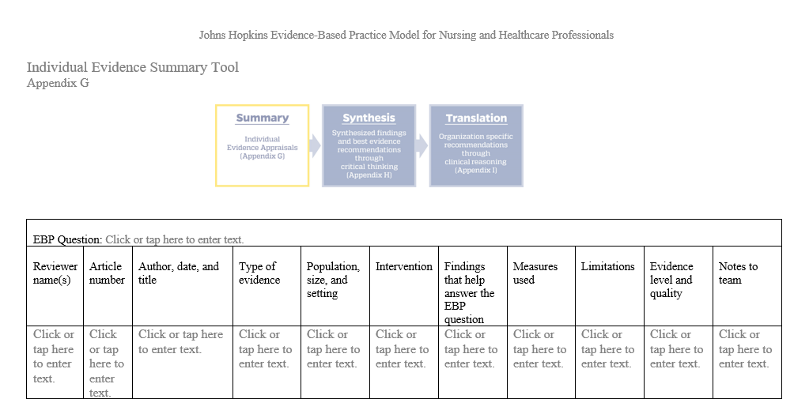
Johns Hopkins Individual Evidence Summary Tool Image Description
Click below for tips to complete each column of the Johns Hopkins Individual Evidence Summary Tool.
Column 1: Reviewer name(s)
Column 2: Article number
Column 3: Author, date, and title
Column 4: Type of Evidence
Column 5: Population, Size, and Setting
Column 6: Intervention
Column 7: Findings that help answer the EBP question
Column 8: Measures used
Column 9: Limitations
Column 10: Evidence level and quality
Column 11: Notes to team
Lesson 2
Review: Literature Synthesis
Literature Synthesis
Weeks 3 and 4 focus on the synthesis of the literature, which includes the primary research and national experts who support the evidence-based intervention of the project. Please take time to view the following video on composing and writing the literature synthesis.
Literature Synthesis Video (5:29)
Key Features of a Synthesis
A synthesis is a written discussion that draws on one or more sources. It follows that your ability to write syntheses depends on your ability to infer relationships among sources—quantitative research, qualitative research, and mixed methods research. This process is nothing new for you because you infer relationships all the time—say, between something you have read in a scholarly article and your practice experience.
View the following activity to explore some key features you should keep in mind as you continue to write a synthesis that captures your emerging practice problem.
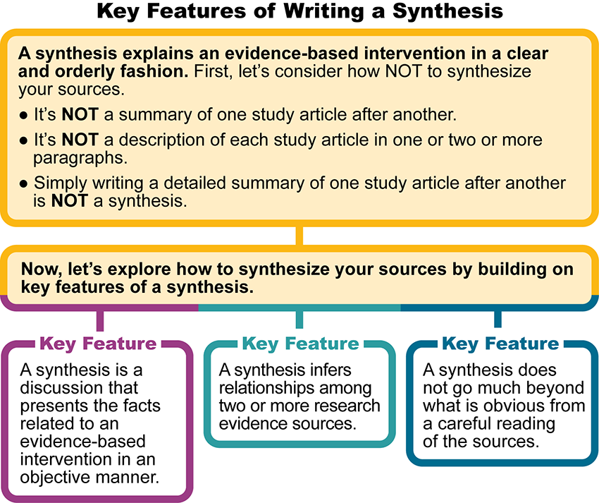
Key Features of Writing a Synthesis Image Description
Simply writing a detailed summary of one article after another is not a synthesis. If you find yourself citing a single source, you should pause and confirm that this single source is a ground-breaking research study. Also, the use of direct quotations is a warning that you have strayed from the intention of a synthesis. As a DNP student, you write in your own words. Your strong, paraphrased sentences are supported with a synthesis of research.
References
Dang, D., & Dearholt, S., Bissett, K., Ascenzi, J., & Whalen, M. (2022). Johns Hopkins evidence-based practice for nursing and healthcare professionals (4th ed.). Sigma Theta Tau International.

The Literature Synthesis: Analyzing the Evidence
Discussion
Purpose
The purpose of this discussion is to begin the analysis of evidence collected for your evidence-based intervention literature synthesis. Through comparing and contrasting an excerpt of your research synthesis and discussing it with student colleagues, you will examine the analysis process.
A suggestion for identifying themes in the research articles is to read the research results and discussion sections for each article. The authors will discuss elements (or themes) that influenced the outcome or results. For example, the research articles focused on diet and exercise in reducing obesity in elementary or middle-school age children. In the results section of the articles, the researchers talked about school and family support being integral to the success of the intervention. Some other research articles focused on culturally accepted foods that contributed to a successful outcome for the same intervention.
Instructions
Review this week’s readings and provide your response in 150 words or less:
- State your practice question in PICOT format.
- Examine the main themes in at least five (5) research articles demonstrating your intervention is effective in changing the practice problem and/or your outcome. (This research provides the strong support for an effective intervention)
- Explain why the intervention was selected. Cite at least five (5) research articles in your discussion.
- Attach your completed Johns Hopkins Individual Evidence Summary Tool to this discussion with at least five (5) articles supporting your intervention.
Refer to your completed Johns Hopkins Individual Evidence Summary Tool and the Johns Hopkins Research Evidence Appraisal Tool to answer this discussion question this week. If you need blank copies of the tools, they are located in the Student Resource Center under Project & Practicum Resources.
Use Grammarly and current APA format for the posts. Do not repeat the prompts in the post. Provide respectful and thought-provoking feedback to your student colleagues. Ask for clarification and elaboration if needed.
Please click on the following link to review the DNP Discussion Guidelines on the Student Resource Center program page:
- Link (webpage): DNP Discussion GuidelinesLinks to an external site.
Program Competencies
This discussion enables the student to meet the following program competencies:
- Integrates scientific underpinnings into everyday clinical practice. (POs 3, 5)
- Applies organizational and system leadership skills to affect systemic changes in corporate culture and to promote continuous improvement in clinical outcomes. (PO 6)
- Uses analytic methods to translate critically appraised research and other evidence into clinical scholarship for innovative practice improvements. (POs 3, 5)
- Appraises current information systems and technologies to improve health care. (POs 6, 7)
- Analyzes health care policies to advocate for equitable health care and social justice to all populations and those at risk due to social determinants of health. (POs 2, 9)
- Creates a supportive organizational culture for flourishing collaborative teams to facilitate clinical disease prevention and promote population health at all system levels. (PO 8)
- Translates a synthesis of research and population data to support preventative care and improve the nation’s health. (PO 1)
- Leads others in professional identity, advanced clinical judgment, systems thinking, resilience, and accountability in selecting, implementing, and evaluating clinical care. (POs 1, 4)
Course Outcomes
This discussion enables the student to meet the following course outcomes:
- Synthesize scientific knowledge, theory, and practice expertise to inform evidence-based practice and impact outcomes. (PCs 1, 2, 3, 4, 5, 7, 8; POs 1, 3, 4, 5, 6, 9)
- Design an evidence-based translational science project to address a practice problem. (PCs 1, 2, 3, 4, 5, 6, 7, 8; POs 1, 2, 3, 4, 5, 6, 7, 8, 9)
- Apply effective strategies in project design for managing practice problems in healthcare delivery at the micro, meso, and macro-system levels. (PCs 1, 2, 3, 4, 5, 6, 7, 8; POs 1, 2, 3, 4, 5, 6, 7, 8, 9)
Due Dates
  - Initial Post: By 11:59 p.m. MT on Wednesday
  - Follow-Up Posts: By 11:59 p.m. MT on Sunday
Reply
Mark post as read
Karen Perez
Edited Jun 24 11:18pm
Manage Discussion by Karen Perez
Reply from Karen Perez
Hello Amazing Students,
Welcome to Week 3!
The course outcomes guiding your learning this week include:
CO 1. Synthesize scientific knowledge, theory, and practice expertise to inform evidence-based practice and impact outcomes. (PCs 1, 2, 3, 4, 5, 7, 8; POs 1, 3, 4, 5, 6, 9)
CO 2. Design an evidence-based translational science project to address a practice problem. (PCs 1, 2, 3, 4, 5, 7, 8; POs 1, 2, 3, 4, 5, 6, 7, 8, 9)
CO 3. Apply effective strategies in project design for managing practice problems in healthcare delivery at the micro, meso, and macro-system levels. ( PCs 1, 2, 3, 4, 5, 6, 7, 8; POs 1, 2, 3, 4, 5, 6, 7, 8, 9)

Before completing the discussion this week, take a few minutes to watch the video on How to Create a Literature Synthesis in our explore section- Lesson #2. This discussion aims to begin the analysis of evidence collected for your evidence-based intervention literature synthesis. In this discussion, please state the PICOT practice question documented on your DNP Practicum Readiness Form. Next, review the results in the research articles supporting your evidence-based intervention. Discuss the themes in the research results and how the themes relate to the intervention and your project. Please cite the articles which support each theme as you discuss the themes. Lastly, add a brief statement of why the intervention was selected. This statement should be based on the research supporting the intervention.

Please take some time this week to watch the Let’s Check-In to understand the expectations for this week and tips for success! Provide respectful and thought-provoking feedback to your student colleagues and ask for clarification and elaboration if needed.

To Do Week Three
Discussion Board
Review feedback from faculty and update the Part 1 paper and revise your paper
Review how to create a synthesis
Enter Practicum Hours
Practicum Hours:
As a part of the practicum experience, students will enter practicum hours for the work they are doing in the practicum courses to meet the AACN Essentials. The Practicum Log Assignment in Week 8 requires you to enter the number of practicum hours indicated by your course letter.
Practicum Hour Guidelines:
- Each entry is limited to 4 hours and a maximum of 12 hours per day
- Practicum Hours must be entered within 7 days of the activity
- The Number of practicum hours for quality improvement meetings is 10 hours per course
- Entries cannot contain multiple activities because the DNP Essential and Activity must match what is in the notes
- The “Notes” section you enter must be detailed and substantiate the number of hours logged for the entry.
- Please enter all of the practicum hours for your didactic courses during NR702. This is the course designated to enter those hours.

Please Note for the Week 8 Practicum Log Assignment:
- All students are required to enter the number of practicum hours according to your course letter.
- Partial Points will Not be given.
- An Excel (not a PDF) Practicum Hour Report for "Case Duration Total" (Total Approved Hours) is required to be submitted by the due date of Wednesday of Week 8 for the Practicum Log Assignment.
- Link to Medtrics Instructions: Medtrics for Chamberlain University DNP Students
- The Late Assignment Policy will be applied if the assignment is not completed by the due date.
To find a list of Activities that can be entered for Practicum Hours in NR702 please review our Course Announcement: “Important Notice for the Week 8 Practicum Log Assignment” and review the activities listed in the DNP Practicum Activities Document.
I am looking forward to our discussions!

