

Informatics in Health Care

Week 5 Learning Materials

Readings

Required
- Hardy, L. (2024). Health informatics: An interprofessional approach. Elsevier.
  - Chapter 22: Improving the User Experience for Health Information Technology (WO 1, 2)
  - Chapter 23: Data Science and Analytics in Healthcare (WO 2, 3, 4)
  - Chapter 24: Safety and Quality Initiatives in Health Informatics
  - Chapter 25: Informatics in the Curriculum (WO 6)
  - Chapter 26: Distance Education—A New Frontier (WO 7)

Recommended
- Berni, A., Borgianni, Y., Basso, D., & Carbon, C-C. (2023). Fundamentals and issues of user experience in the process of designing consumer products. Design Science, 9, e10. (WO 1, 3, 4)
- Golay, D., Karlsson, M., & Cajander, A. (2022). Effortlessness and security: Nurses' positive experiences with work-related information technology use. Computers, Informatics, Nursing, 40(9), 589-597. (WO 1, 2)
- Silvia, M., & Teehar, M. (2024). Clinical Analytics and Data Management for the DNP (3rd ed.). Springer Publishing. (WO 6, 7)

Week 5 Discussion 1: Trends in Healthcare Using AI, Robots, and Implantable Devices
- Dashboard
- My courses
- NU-710-03-24PBS2
- Week 5: Usability, Analytics, and Education
- Week 5 Discussion 1: Trends in Healthcare Using AI, Robots, and Implantable Devices
Open course index
Completion requirements
To do: Make forum posts: 1
Value: 100 points
Due: To facilitate scholarly discourse, create your initial post by Day 3 and reply to at least two of your classmates, on two separate days, by Day 7.
Gradebook Category: Discussions

Introduction
Recent literature and media accounts are enthusiastic about the idea that using AI and robots may lead to the possibility of decreasing medical errors. As the nursing shortage becomes more significant, perhaps assistance from the world of informatics could benefit from a bit of help. We will explore this further in this discussion board. More specifically, we will focus on those patients wearing implanted devices, as they rely upon ethical manufacturing of the device, which often they must use daily. Use this discussion board to stretch and reach for information on AI, robots, and implantable devices.

Initial Post
This week we are exploring the uses of AI, robotics, and implantable devices in healthcare. Please refer to the videos posted and pick one of them to present in your initial post. Answer the following questions:
- What relevant information did you find out in the video you chose?
- How do you feel that AI, robots, and implantable devices may improve nursing care in multiple settings? (Provide one reference)
- What do you think about the patient's perspective in response to these recent changes?

- Bastarache, L., Brown, J. S., Cimino, J. J., Dorr, D. A., Embi, P. J., Payne, P. R., Wilcox, A. B., & Weiner, M. G. (2022). Developing real‐world evidence from real‐world data: Transforming raw data into analytical datasets. Learning Health Systems, 6(1), 1–9. (WO 3, 4, 5)
- Booth, R., Strudwick, G., McBride, S., O’Connor, S., Solano López, A.L. (2021) How the nursing profession should adapt for a digital future. BMJ, 14, 373. (WO 6, 7)
- Former CEO Of Medical Device Company Indicted For Creating And Selling A Fake Medical Component That Was Implanted Into Patients (2023). U.S. Attorney's Office, Southern District of New York

Videos

Healthcare Technology Trends in 2023 | ISI Technology (10:44 Minutes) (2023) (WO 1, 2, 3)
Healthcare Technology Trends in 2023 Video Transcript

Why Am I Optimistic About AI In Healthcare? - The Medical Futurist (6:58 Minutes) (2023) (WO 8)
Why Am I Optimistic About AI In Healthcare? Video Transcript

Disrupting Nursing Education With XR, AI and ML (2:42 Minutes)
Disrupting Nursing Education with XR, AI, and ML Video Transcript

AI Hospitals: A Step Towards the Future - Science View (28:05 Minutes)
AI Hospitals: A Step Towards the Future - Science View Video Transcript

Delivery of Medicine with Implantable Devices: Diabetes Type I (32:25 Minutes) (2023) (WO 1, 5)
Delivery of Medicine with Implantable Devices: Diabetes Type I Video Transcript

Power Points
- Chapter 22: Improving the User Experience for Health Information Technology
- Chapter 23: Data Science and Analytics in Healthcare
- Chapter 24: Safety and Quality Initiatives in Health Informatics
- Chapter 25: Informatics in the Curriculum
- Chapter 26: Distance Education—A New Frontier

Week 5: Introduction and Objectives
- Dashboard
- My courses
- NU-710-03-24PBS2
- Week 5: Usability, Analytics, and Education
- Week 5: Introduction and Objectives
Open course index
Completion requirements
Done: View

Introduction
Usability refers to how practical and easy a product can be and in health information technology (HIT), there is a strong relationship between safe and quality care and a decrease in errors. When the use of technology to prevent human error is applied, there is less frustration for clinicians and higher quality. If the user is content with the methods in place to protect the patient, confidentiality, and reduce error, there is higher overall satisfaction. In analyzing healthcare data, one must understand project design, measurement using instruments, and statistics and probability. In Chapter 4, we reviewed these concepts and analyzed instruments and articles regarding reliability and "p-values." For clinicians and providers, the key to analysis lies in knowledge of percentages, ratios, and probabilities for interpreting the data. When using data analytics in research and thus decision-making, a thorough review of the evidence or data is necessary. There are many steps in the research process that lead to statistical significance, which eventually become part of the decision-making process. The whole idea behind research is to predict and control variance in the results. This same premise is true for health informatics as descriptive analytics are used to explore a theory or premise, predictive analytics is useful for suggesting an outcome and utilizes AI. Lastly, the data science life cycle includes a collaborative effort between data scientists and those that are stakeholders making decisions. It is a circular process somewhat similar to the nursing process, which has the goal of the care and safety of the patient and the organization (See the two Figures below).

Cross-Industry Standard Process for Data Mining (CRISP-DM Life Cycle Phases)
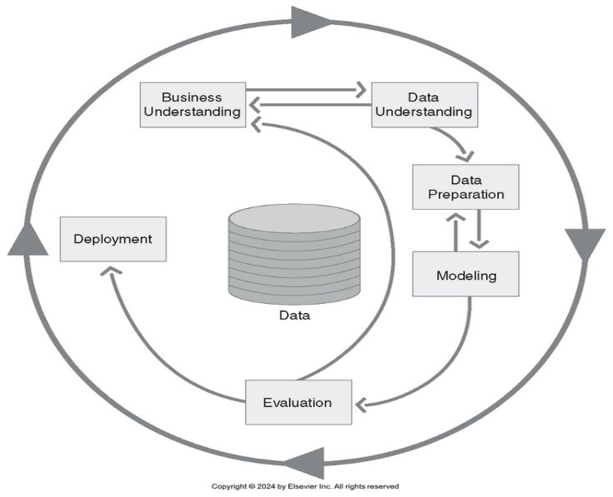
There are three approaches to applying analytics in the interpretation of data for a healthcare organization. These include descriptive analytics, predictive analytics, and prescriptive analytics where data is described, classified, and analyzed to confidently predict future outcomes through AI, information technology, and infrastructure. Such models of predictive analytics were used in the COVID-19 pandemic to predict the spread of the disease (See Figure below).

Predictive Analytics to Predict Spread of COVID-19
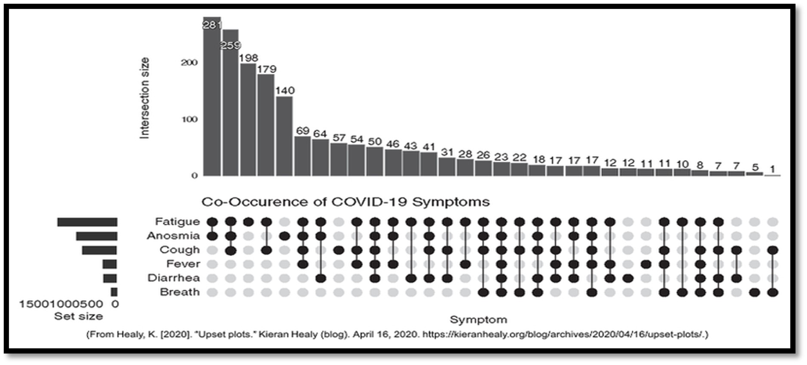

Learning Materials Introduction
This week, our focus is on the complexities involved in protecting the privacy of the patient in the data collection, analysis, and appraisal of findings. Accuracy of measures is critical to assuring high confidence in the results. As a doctorally-prepared student, you will be required to learn, define, describe, and apply these concepts in practice and research.
The required readings provide overall support to achieve WO 1, 2, 3, 4, 5, 6, 7, & 8 as you complete the discussions for this week.

Learning Objectives
By the end of this week, you will be able to:
- Define the term usability as it relates to health information technology (CO 1, 5).
- Explain the three types of data analytics used in healthcare (CO 1, 2).
- Describe possible statistical approaches used in analyzing the independent and dependent variables (CO 6, 7).
- Identify the process of selecting a sample and setting to measure information technology health data (CO 4, 5).
- Recognize the importance of the accuracy of measures and specificity in conducting quality and safety data collection (CO 3, 5).
- Describe the importance of providing health information in the nursing curriculum (CO 3, 4, 5).
- Explain the role of academia in providing excellence in asynchronous online learning in nursing (CO 2, 3, 5).
- Identify the positive impact artificial intelligence has had on healthcare (CO 2).

Week 5 Discussion 1: Trends in Healthcare Using AI, Robots, and Implantable Devices
- Dashboard
- My courses
- NU-710-03-24PBS2
- Week 5: Usability, Analytics, and Education
- Week 5 Discussion 1: Trends in Healthcare Using AI, Robots, and Implantable Devices
Open course index
Completion requirements
To do: Make forum posts: 1
Value: 100 points
Due: To facilitate scholarly discourse, create your initial post by Day 3 and reply to at least two of your classmates, on two separate days, by Day 7.
Gradebook Category: Discussions

Introduction
Recent literature and media accounts are enthusiastic about the idea that using AI and robots may lead to the possibility of decreasing medical errors. As the nursing shortage becomes more significant, perhaps assistance from the world of informatics could benefit from a bit of help. We will explore this further in this discussion board. More specifically, we will focus on those patients wearing implanted devices, as they rely upon ethical manufacturing of the device, which often they must use daily. Use this discussion board to stretch and reach for information on AI, robots, and implantable devices.

Initial Post
This week we are exploring the uses of AI, robotics, and implantable devices in healthcare. Please refer to the videos posted and pick one of them to present in your initial post. Answer the following questions:
- What relevant information did you find out in the video you chose?
- How do you feel that AI, robots, and implantable devices may improve nursing care in multiple settings? (Provide one reference)
- What do you think about the patient's perspective in response to these recent changes?

Replies
Reply to at least two of your classmates. Your reply to posts should:
- Ask a clarifying question about the video discussed.
- Share another video relevant to the discussion that was created within the last two years.
- Doctoral education requires you to address and approach your classmates and professors in a professional and respectful manner. It is necessary to refer to them by the names they use and be consistent throughout the course.

