NU-726-04-24PCS3 Adv.Research:Evid.BasedPrac I
FORUM

Week 7 Discussion 1: Synthesizing the Literature
- Dashboard
- My courses
- NU-726-04-24PCS3
- Week 7: Literature Review Synthesis and Project Completion Plan (Timeline/Gantt Chart)
- Week 7 Discussion 1: Synthesizing the Literature
Open course index
Completion requirements
To do: Make forum posts: 1
Value: 100 points
Due: In an effort to facilitate scholarly discourse, create your initial post by Day 3, and reply to at least two of your classmates, on two separate days, by Day 7.
Grading Category: Discussion Boards

Initial Post
The following points provide guidance in synthesizing the literature and help confirm that you are on the right track in reviewing and synthesizing the literature specific to your chosen problem. In this discussion board, address how you have met the following:
- Discuss the importance of synthesis of the literature review findings specifically related to your SPP. Note the implications for when synthesis is not achieved.
- The use of headers can provide visual signals or themes for the reader to know what content is going to be discussed in the literature review. What headers do you anticipate needing to insert into your Chapter II? List two headers and provide a rationale as to why you selected these headers.
- Select two articles and synthesize the contents within one of your headers. You will use this paragraph to then assess your peers’ synthesis and compare whether you or your peers are synthesizing properly.
- You will need three paragraphs and two scholarly citations requirement to meet expectations.

Replies
Reply to at least two of your classmates and compare the synthesis from the two articles used in the initial post synthesis paragraph to yours. Constructively add what your peer did well and not do well? Provide at least one scholarly citation to support your statements to meet expectations.
Please refer to the Grading Rubric for details on how this activity will be graded.
The described expectations meet the passing level of 80%. Students are directed to review the Discussion Grading Rubric for criteria which exceed expectations.

Week 7 Assignment 1: Project Completion Plan—Timeline/Gantt Chart
- Dashboard
- My courses
- NU-726-04-24PCS3
- Week 7: Literature Review Synthesis and Project Completion Plan (Timeline/Gantt Chart)
- Week 7 Assignment 1: Project Completion Plan—Timeline/Gantt Chart
Open course index
Completion requirements
To do: Make a submission
Due: Sunday, 16 June 2024, 11:55 PM
Value: 100 points
Due: Day 7
Grading Category: Practice Scholarly Project Timeline

Instructions
Planning efforts should include the development of a project completion plan that provides estimates of when important tasks will be completed. A Gantt chart is a useful tool to develop your plan.
Remember to save this Gantt chart for your Chapter III and in future courses.

Instructions
- Review the presentation regarding Gantt charts.
- Review the Gantt Chart Exemplar (Excel).
- Use Microsoft Excel to develop a proposed Gantt chart for your Scholarly Practice Project (SPP).
Think about which upcoming terms during which you will be enrolling in NU741–NU743 to more realistically reflect the specifics tasks of the SPP.

Project Management in Under 5: What is a Gantt Chart? Video (5:21 minutes)
Project Management in Under 5: What is a Gantt Chart? Video Transcript
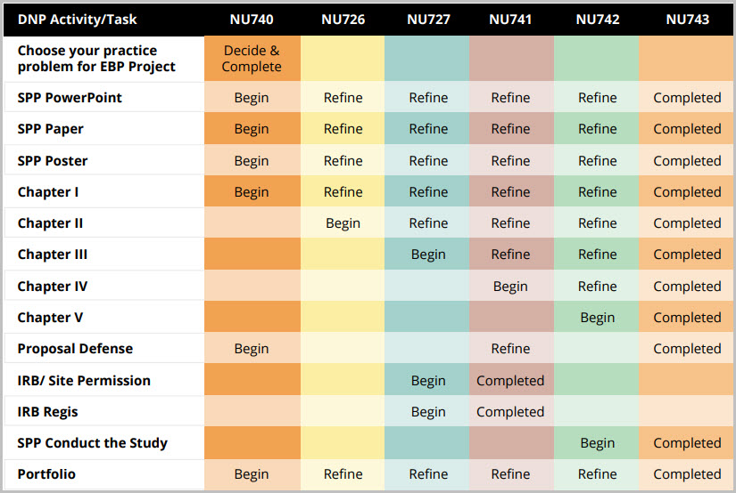
DNP Activity/Task Table (PDF)
Please refer to the Grading Rubric for details on how this activity will be graded.
To Submit Your Assignment:
- Select the Add Submissions button.
- Drag or upload your file to the File Picker.
- Select Save Changes.



Advanced Research Methods for EBP I

Week 7: Learning Materials

Readings
- Moran, K., Burson, R., & Conrad, D. (2020). The Doctor of nursing scholarly practice project: A framework for success (3rd ed.). Jones & Bartlett Learning.
  - Section II (WO 1)
- American Psychological Association. (2020). Publication manual of the American Psychological Association (7th ed.). American Psychological Association.

Videos

Create a Basic Gantt Chart Video (8:11 minutes)
Create a Basic Gantt Chart Video Transcript

Synthesis for Literature Review Video (8:11 minutes)
Synthesis for Literature Review Video Transcript

