Student Lesson Plan

Overview
- Program Competencies
- Course Outcomes
- Weekly Objectives
- Main Concepts
- Analyzes health care policies to advocate for equitable health care and social justice to all populations and those at risk due to social determinants of health. (POs 2, 9)
- Creates a supportive organizational culture for flourishing collaborative teams to facilitate clinical disease prevention and promote population health at all system levels. (PO 8)

Schedule
Section | Read/Review/Complete | Course Outcomes | Due
Prepare | Assigned Readings | CO 1 | Wednesday
Explore | Lesson | CO1 | Wednesday
Translate to Practice | Discussion: Introduction Posts | n/a | Wednesday
Translate to Practice | Discussion: Initial Post | CO 1 | Wednesday
Translate to Practice | Discussion: Follow-Up Posts | CO 1 | Sunday
Reflect | Reflection | CO 1 | No submission

Foundations for Learning
American Association of Colleges of Nursing. (2006). The essentials of doctoral education for advanced nursing practice.Links to an external site. https://www.aacnnursing.org/DNP/DNP-Essentials (Note: These Essentials outline the foundational competencies of advanced nursing practice for the DNP.)
American Organization for Nursing Leadership. (2015). AONL nurse leader competencies.Links to an external site. https://www.aonl.org/resources/nurse-leader-competencies

Student Learning Resources
Click on the following tabs to view the resources for this week.
- Required Textbooks
- Required Articles
- Additional Resources
Daft, R. L. (2017). The leadership experience (7th ed.). Cengage Learning.
- Read Chapter 9
Huber, D. L. (2018). Leadership & nursing care management (6th ed.). Elsevier.
- Read Chapter 7

Learning Success Strategies
- Reflection on Learning: As you familiarize yourself with the course layout, you will see the system of information prepared for your learning. Please look at each section; moving systematically will assist you as you learn throughout the course.
  - The Prepare section will have the objectives, key terms, and readings to broaden your knowledge.
  - Moving next to the Explore section, there will be information about the topics and additional readings, links, and references to continue to build your knowledge.
  - Next, the Translate section is where you apply your new knowledge, answering the discussion questions for the week and completing the assignments.
  - Finally, we close the week with a Reflect section to recap what you learned and give you pause to consider the value of the new insights you are gaining.
- Review the assigned readings to ensure you understand the key terms and can relate them to the role of the DNP-prepared nurse leader.
- As you review weekly content, consider how each concept and discussion can be translated into practice in your unique setting.
- Be ready to share your own thoughts through the interactive discussion. It is important to share your own thoughts so that we hear your voice. Also, support your positions with evidence from the literature. Growing in your ability to share your ideas is encouraged, and the use of first-person is accepted for the discussion board.
- Review the discussion guidelines and rubric to optimize your performance.
- You have access to a variety of resources to support your success. Click on the DNP Resources tab on the home page to access program and project resources.
- Your course faculty is here to support your learning journey. Reach out for guidance with study strategies, time management, and course-related questions. Review rubric feedback and individual comments to optimize performance.
- Be certain to complete your student attestation, due by Sunday 11:59 p.m. MT. You can locate this by going to Modules and selecting Student Attestation.
- Be sure to attend the Week 1 student forum or listen to the recording.
- Let’s Check-In: Tips for Success: PowerPoints and recordings are posted each Sunday for the following week. Live Let’s Check-Ins are conducted in selected weeks throughout the course, so check your announcements for details.

Interacting with Feedback
Each week your course faculty will provide feedback in the rubric on any assignment you have submitted. Take a moment to review the following video on how to view rubric feedback in Canvas. (After clicking the link, scroll down or click on the title in the Summary area to jump directly to the video.)
- Link (video): Looking at FeedbackLinks to an external site. (2:26)
Review the following video on how to accept/reject track changes when viewing course faculty feedback on your assignment:
- Link (video): Word: Track Changes and Comments (4:19)

Lesson
The Power of Words

Introduction
When you think about the word communication, what is the first thing that comes to your mind? Daft (2018) describes communication as a method of transferring information between two or more people. This is also known as interpersonal communication. Barriers to interpersonal communication can impact the efficacy of the nurse leader in developing and sustaining a culture in which communication is fluid and reciprocal. Acknowledging potential barriers is an essential first step in improving communication style.
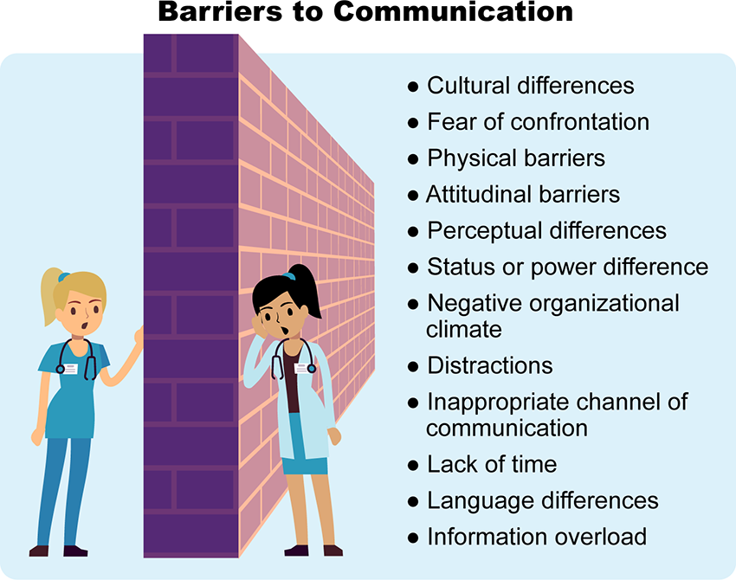

Barriers to Communication Image Description
To overcome these barriers, the DNP-prepared nurse leader should do the following:
- Identify the appropriate communication channel.
- Ascertain the environment most conducive to successful communication.
- Maintain eye contact and be mindful of facial expressions during face-to-face meetings
- Prepare a clear, concrete, and concise message. All communication should be goal-oriented and delivered respectfully to minimize any negative impact.
Intrapersonal communication is the process one uses to communicate with the inner self. It is through intrapersonal communication that critical thinking takes place to help decipher complex problems, visualize solutions, and practice self-reflection. Intrapersonal communication can be accomplished within one’s mind. Nurse leaders utilize both interpersonal and intrapersonal communication as they lead organizations.

Active Listening
As a DNP-prepared nurse leader, the information you receive from others on your team can be as important, and at times more important, than the information you distribute. Listening is one of the most important communication skills a nurse leader can possess. It is through the art of active listening that effective communication can flourish. Active listening involves the following:
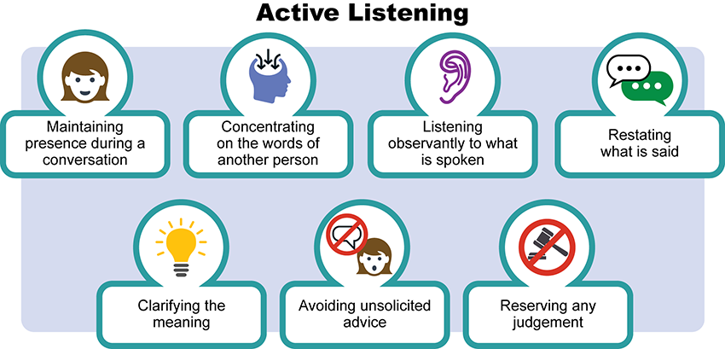

Active Listening Image Description
In active listening, it is essential to understand the other person before seeking to be understood. When the focus of one’s attention is on preparing a response to what is being said rather than listening, the transfer of information can be fragmented or even lost. Motivation, engagement, and satisfaction will deteriorate when individuals do not feel like they are being heard. By practicing silence and intently listening when someone speaks, the DNP-prepared nurse leader demonstrates respect for the views and ideas of others, which is critical to effective communication and building a trusting relationship.
Words have tremendous power, and how they are delivered shapes responses, behaviors, and the environment where you live and work. As a DNP-prepared nurse leader, the words you use to communicate with your team can give rise to both positive and negative emotional reactions, depending on what is said and how the message is conveyed.

Communicating with Clarity and Transparency
As a nurse leader, your communication should reflect openness and honesty while demonstrating a commitment to the organization's values and mission. This ensures the team understands your expectations and, therefore, gives them the liberty to share their perspectives and ask questions. Effective communication is especially important during times of change or instability within the unit or organization for any reason. Any change implemented depends on communication, and the sustainability of the change can be linked to the communication skills of the change agent.
Consider for a moment the many changes that evolved in the early days of the COVID-19 pandemic. As healthcare leaders struggled to maintain inventories of personal protective equipment, nurses around the globe became front-line warriors in the fight against the virus. Leadership communication and transparency related to changing processes, procedures, and staffing strategies were essential in providing staff with relevant and just-in-time information. Through clear communication and acknowledging the potential anxiety and burnout being felt, nursing leaders were able to mitigate some of the stressors experienced by nursing staff (Kerfoot, 2019).
As a DNP-prepared nurse leader, the path to collaborative, candid, and constructive communication can flourish as you learn more about your team members and they come to know you and your expectations better. When a transfer of information is needed, it is important to identify the purpose of the conversation and what you hope to accomplish with the message. As examined in this week’s reading, there is a distinct difference between leading a discussion and leading dialogue.
Discussion vs. Dialogue
 | Discussion | Dialogue
Purpose | To present one’s point of view and then convince others to align with that view | To facilitate focused listening, consideration of a mixture of perspectives where personal views are not initially promoted, and to then emerge with a more collaborative and common ground result (Daft, 2018)
Outcomes | To reach a decision | To reach a greater understanding of the contrasting views
Based on what you have learned in the readings, determine if the following actions fits best with discussion or dialogue. Drag the action to the correct area.

Discussion vs. Dialogue Interactive Transcript

Communicating in an Age of Technology Overload
Watch the following video.
Communicating in an Age of Technology Overload (1:52)

Facilitating Strategic Conversations
Communication encompasses more than just delivering information. There will be opportunities for the DNP-prepared nurse leader to facilitate a strategic conversation in which a group of individuals from various levels convene to determine how to apply the organizational mission and values to achieve specific healthcare outcomes. Strategic conversations can be most effective when the nurse leader opens the dialogue in the following ways:
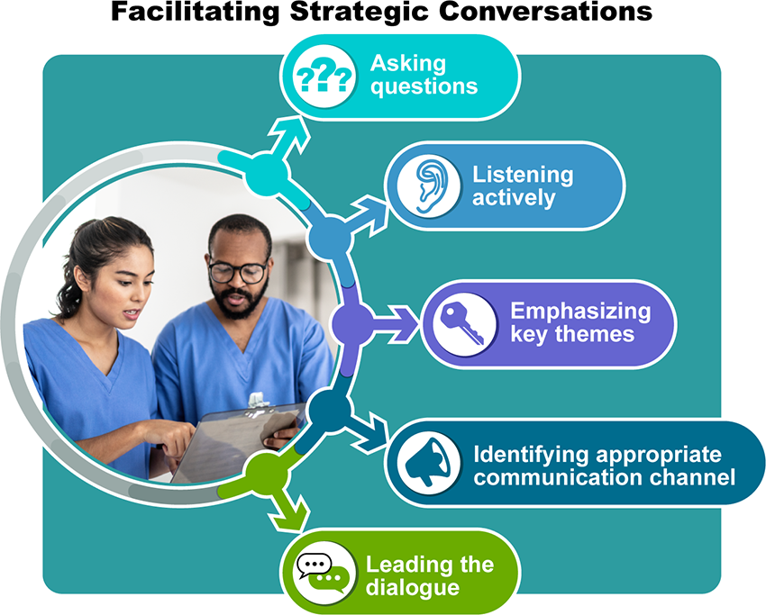

Facilitating Strategic Conversations Image Description
As a communication champion, the DNP-prepared nurse leader uses communication skills to embed the organization's values as they purposefully guide the direction of nursing staff and organizational strategies. Through this approach, trust is gained, and staff approach their work with a deeper understanding of how their actions support the mission and vision of the institution. Trust in the nurse leader fosters engagement and satisfaction as nursing team members have a deeper sense of their place within the organization. When team members find meaning and a deeper understanding of how their contributions impact others, their intrinsic motivation to excel in their work increases.

Daft, R. L. (2017). The leadership experience (7th ed.). Cengage Learning.
Huber, D. L. (2018). Leadership & nursing care management (6th ed.). Elsevier.
Keerfoot, K. (2019). Chao, teamwork, compassion, and leadership: Disasters and nursing’s finest hours. Nursing Economic$, 37(5), 265-267.

~Week 1: Discussion | Introductions (required, not graded)
All Sections
11 unread reply.11 reply.

Week 1Introductions

Discussion
Welcome! For this discussion, write a few sentences introducing yourself to your colleagues and the course faculty. Tell us a little about your nursing background, why you chose to become a DNP-prepared nurse, your aspirations in seeking this degree, and anything else you would like to share! Then, video record your introduction. Click on the following link for a step-by-step guide on recording your video introduction. Please note that there may be a short delay before the video appears in your post.
- Link (website): Kaltura TutorialsLinks to an external site.
Search entries or author
Filter replies by unreadUnread Collapse replies Expand replies
Subscribe
ReplyReply to ~Week 1: Discussion | Introductions (required, not graded)

Collapse SubdiscussionPhillis Dewitt

Phillis Dewitt
Feb 13, 2024Local: Feb 13 at 9:19am<br>Course: Feb 13 at 7:19am
Manage Discussion Entry

(I also provided a transcript for those who would rather read it).
Hello!
I am very happy to be here as your instructor during this session. My name is Dr. Phillis Dewitt.
I have been a nurse since 1993. I started off with an associate degree in nursing, went on to get my BSN, my MSN, my DNP, and a post-doctorate certificate. I have worked in many areas throughout my nursing career including as a: medical-surgical nurse, emergency room nurse, utilization review, management, as a SANE nurse, and in nursing education. I can honestly say I have never worked in a nursing role that I have not thoroughly enjoyed.
My first APN license and training was as an Adult Clinical Nurse Specialist, I then went on to get my DNP, and then my post-doctorate certificate as a Family Nurse Practitioner. I have used my APN licenses in several roles. I have worked as an adult inpatient hospitalist, in the Prompt Cares, and in our Clinical Decision Unit. My APN role is currently PRN which allows me to control my schedule quite nicely. I have also taught in many different capacities since 2002.
I have a great passion for medical mission trips. I have gone on over 20 medical mission trips in the past 10 years including to Haiti, Guatemala, Brazil, India, and Israel (many of these areas multiple times). In July 2017 and 2018, I was able to staff a floating hospital on the Amazon River for 10 days and learned a great deal from those experiences. If you have a chance to do medical mission trips I would highly recommend it.
I am married and together with my husband and we have 16 children. My first husband passed away in 2006 and he and I had 13 children (10 are adopted). I remarried in 2010. We are empty nesters now and love to travel. We have recently been to China, Tibet, Hong Kong, Jamaica, Israel, India, and Guatemala. We live in Central Illinois 6 months out of the year and are in Central Standard Time when there and live in Florida 6 months and are in EST when there.
I have also recently written and published a book (which was quite the journey for me) about my life and have had the opportunity to recently be on several podcasts all over the country (and a couple outside the United States) due to the book.
I am very excited to be working with each of you during this course. I love seeing committed nurses who value the furthering of their education.
Please feel free to ask questions at any time. I am available by email, phone, or text. I do ask if you need to call me that you text me first (please identify yourself and the course you are in) so we can set up a time that will work for both of us.
Dr. Phillis Dewitt DNP, CNS-BC, FNPc
Cell 309-241-0273
ReplyReply to Comment

Week 1Communication Channels

Discussion

Purpose
The purpose of this discussion is to explore the impact of communication channel selection on the transfer of information.

Instructions
As a DNP-prepared nurse leader, imagine you have an important message to deliver to your team. Examples of message topics you might use include the following:
- Poor teamwork
- Medical mistakes/errors
- Pattern of call-ins
- Patient complaints
- Leadership change
- Failure to prepare patients for discharge
- Organizational merger
- Potential layoffs
You know that some of the information may not be received well by all team members, and you are concerned about their potential reaction. Reflect on your readings this week and respond to the following:
- Describe the critical message you need to convey based on your hypothetical topic.
- Analyze strategies that you will use to prepare for the communication.
- Determine which communication channel would be most effective and explain why.
Please click on the following link to review the DNP Discussion Guidelines on the Student Resource Center program page:
- Link (webpage): DNP Discussion GuidelinesLinks to an external site.

Program Competencies
This discussion enables the student to meet the following program competencies:
- Analyzes health care policies to advocate for equitable health care and social justice to all populations and those at risk due to social determinants of health. (POs 2, 9)
- Creates a supportive organizational culture for flourishing collaborative teams to facilitate clinical disease prevention and promote population health at all system levels. (PO 8)

Course Outcomes
- Evaluate the attributes of effective communication practices that build collaborative relationships and balance the concerns of individuals with organizational goals. (PCs 5, 6; POs 2, 8)

Due Dates
- Initial Post: By 11:59 p.m. MT on Wednesday
- Follow-Up Posts: By 11:59 p.m. MT on Sunday
Search entries or author
Filter replies by unreadUnread Collapse replies Expand replies
Subscribe
ReplyReply to Week 1: Discussion | Communication Channels

Collapse SubdiscussionPhillis Dewitt

Phillis Dewitt
Feb 13, 2024Local: Feb 13 at 9:22am<br>Course: Feb 13 at 7:22am
Manage Discussion Entry
Hi everyone,
Welcome to Week 1! The purpose of this discussion is to explore the impact of communication channel selection on the transfer of information.

This discussion enables you to meet the following course and program outcomes:
1. Evaluate the attributes of effective communication practices that build collaborative relationships and balance the concerns of individuals with organizational goals. (POs 2, 8)
5. Analyzes health care policies to advocate for equitable health care and social justice to all populations and those at risk due to social determinants of health. (POs 2, 9)
  - Creates a supportive organizational culture for flourishing collaborative teams to facilitate clinical disease prevention and promote population health at all system levels. (PO 8)

Please review the discussion grading guidelines and support your post with scholarly references.

I am looking forward to our discussion!

