WK2 NR721

Student Lesson Plan

Overview
- Program Competencies
- Course Outcomes
- Weekly Objectives
- Main Concepts
- Applies organizational and system leadership skills to affect systemic changes in corporate culture and to promote continuous improvement in clinical outcomes. (PO 6)
- Appraises current information systems and technologies to improve health care. (POs 6, 7)
- Analyzes health care policies to advocate for equitable health care and social justice to all populations and those at risk due to social determinants of health. (POs 2, 9)
- Creates a supportive organizational culture for flourishing collaborative teams to facilitate clinical disease prevention and promote population health at all system levels. (PO 8)
- Leads others in professional identity, advanced clinical judgment, systems thinking, resilience, and accountability in selecting, implementing, and evaluating clinical care. (POs 1, 4)

Schedule
Section | Read/Review/Complete | Course Outcomes | Due
Prepare | Assigned Readings | COs 1, 2, 3 | Wednesday
Explore | Lesson | COs 1, 2, 3 | Wednesday
Translate to Practice | Discussion: Initial Post | COs 1, 2, 3 | Wednesday
Translate to Practice | Discussion: Follow-Up Posts | COs 1, 2, 3 | Sunday
Reflect | Reflection | COs 1, 2, 3 | No submission

Foundations for Learning
American Association of Colleges of Nursing. (2006). The essentials of doctoral education for advanced nursing practice.Links to an external site. https://www.aacnnursing.org/DNP/DNP-Essentials (Note: These Essentials outline the foundational competencies of advanced nursing practice for the DNP.)
American Organization for Nursing Leadership. (2015). AONL nurse leader competencies.Links to an external site. https://www.aonl.org/resources/nurse-leader-competencies

Student Learning Resources
Click on the following tabs to view the resources for this week.
- Required Textbooks
- Required Articles
- Additional Resources
Daft, R. L. (2017). The leadership experience (7th ed.). Cengage Learning.
- Read Chapter 10
Huber, D. L. (2018). Leadership & nursing care management (6th ed.). Elsevier.
- Read Chapter 8
- Read Chapter 10
  - Section: Conflict

Learning Success Strategies
- Review the assigned readings to ensure you understand the key terms and can relate them to the role of the DNP-prepared nurse leader.
- As you review weekly content, consider how each concept and discussion can be translated into practice at your unique setting.
- Be ready to share your own thoughts through the interactive discussion. It is important to share your own thoughts so that we hear your voice. Also, support your positions with evidence from the literature. Growing in your ability to share your ideas is encouraged, and the use of first-person is accepted for the discussion board.
- Review the discussion guidelines and rubric to optimize your performance.
- You have access to a variety of resources to support your success. Click on the DNP Resources tab on the home page to access program and project resources.
- Your course faculty is here to support your learning journey. Reach out for guidance with study strategies, time management, and course-related questions. Review rubric feedback and individual comments to optimize performance.
- Be sure to listen to the Week 1 student forum recording if you have not done so already.
- Let’s Check-In: Tips for Success: PowerPoints and recordings are posted each Sunday for the following week. Live Let’s Check-Ins are conducted in selected weeks throughout the course, so check your announcements for details.

Interacting with Feedback
Each week your course faculty will provide feedback in the rubric on any assignment you have submitted. Take a moment to review the following video on how to view rubric feedback in Canvas. (After clicking the link, scroll down or click on the title in the Summary area to jump directly to the video.)
- Link (video): Looking at FeedbackLinks to an external site. (2:26)
Review the following video on how to accept/reject track changes when viewing course faculty feedback on your assignment:
- Link (video): Word: Track Changes and Comments (4:19)

Lesson
Developing and Leading Teams

Building Relationships as a Nurse Leader
As a DNP-prepared nurse leader, one of your most important responsibilities will be to develop a unified and high-functioning team. To guide others, a nursing leader must have a clear vision of the goal they are trying to accomplish. The vision must be one that can be clearly articulated so that the team can conceptualize the vision and understand the direction of their work. Therefore, effective communication is at the center of a team-based approach to improving patient care.
A high-functioning team delivers quality healthcare services focused on the needs of diverse populations. By building a cohesive healthcare team, as a DNP-prepared nurse leader, you will be able to advance healthcare outcomes grounded on the latest available evidence.

Team Characteristics

- A team develops over time through the following:
- Engagement in the vision
- Identification of tasks to be accomplished
- Competencies and traits of team members
- Performance goals
- Communication practices
- Leadership empowerment
For the nursing team to engage in the vision, a relationship must exist between the nursing leader and the team members. Relationship building is key to the cohesiveness and compatibility of the team. The DNP-prepared nurse must be viewed as a part of the team to lead it and solicit the most significant contributions from each member. This strategy helps to gain the confidence of each individual and thereby gain an appreciation for their strengths and limitations as an individual and a team member. Additionally, the DNP-prepared nurse leader must understand what motivates each individual directly or indirectly. When team members are cohesive and motivated, successful performance and accomplishment of goals will follow.

Team Building and Group Dynamics
As a DNP-prepared nurse leader, you may be asked to lead an existing team or to compile an original team to staff a new department or unit. In either case, you will be responsible for ensuring the team aligns with the mission and vision of the organization and provides the highest quality of safe patient care. The team’s functionality will change over time as team members become more comfortable communicating openly and aligning integrally as a group. Trust is crucial to the effectiveness of any team, and members must work collaboratively to accomplish identified goals. It is equally important that the members of the team embrace each other’s diversity of thoughts, experiences, and skills. Through these differences, the team can become stronger and more unified in meeting the needs of the populations they serve.

The differences between individuals can adversely impact group dynamics if not effectively managed. When barriers to performance arise, the nurse leader must use strategies to overcome obstacles and address both team and individual performance. Team-building activities and professional development opportunities can be beneficial to mitigate barriers to high performance and facilitate transparent communication. The dynamics of the group should be such that all points of view are embraced, and judgments are withheld when differences in opinions arise.

Team Cohesiveness and Competencies
Several different factors drive team cohesiveness, and one of the most critical components is the leadership style of the nurse leader. The DNP-prepared nurse leader establishes the tone for communication and the expectation of team unity.
Click on the following tabs to learn about the different areas in which the DNP-prepared nurse leader’s leadership style can impact.

Leadership Style Interactive Transcript

Resolving Inter-Team Conflict
Team conflict can have both constructive and destructive effects on the productivity of a team (Huber, 2018). Conflict can be constructive when it promotes creativity, identifies opportunities for quality improvement, and stimulates engagement. Conflict can also be disruptive when it negatively impacts performance and communication or results in decreased cohesiveness within the team.
Review the following graphic for the different effects.
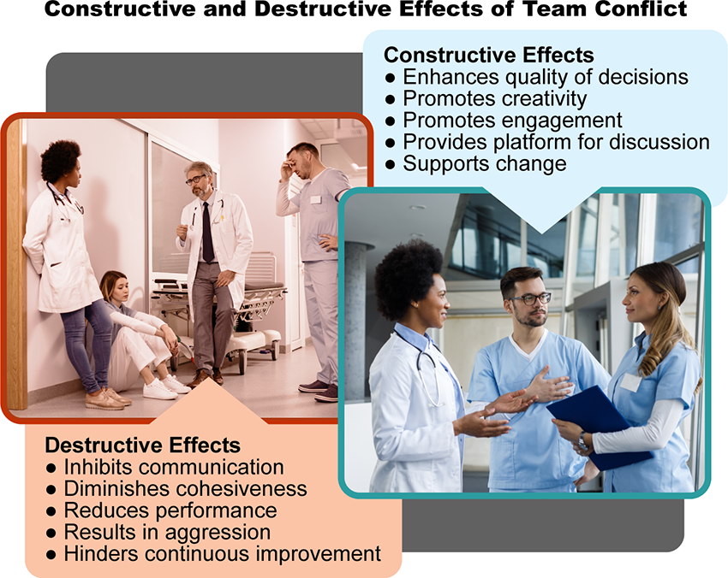

Team Conflict Image Description
Inter-team conflict is one of the most significant barriers to a high-functioning and effective team. When conflict arises within a team, the DNP-prepared nurse leader must quickly deploy strategies to resolve the conflict. Although the nurse leader is ultimately responsible for bringing the conflict to resolution, in a highly effective team, each team member has a responsibility for the team outcomes and should hold each other to a high standard of behavior. Disruptive or distracting behaviors can interfere with the vision of the team and negatively impact team dynamics and can ultimately become a risk to patient safety.
Click the on the plus signs in the following interactive to view some of the different ways disruptive behavior may present:

Disruptive Behaviors Interactive Transcript
As a DNP-prepared nurse leader, you will hold the keys to the performance of your team through the members you select, the training and professional development you provide, the culture you endorse, and the communication you model. While no individual alone can make a team highly effective in reaching established objectives, the DNP-prepared nurse leader has the skills to facilitate a healthy work environment that is open to change and embraces the concept of team cohesiveness and collaboration.

Leadership Thoughts to Ponder
When he hired the Sherman brothers, Walt Disney discovered that conflict could be a good thing, but it needed to be managed. Aspiring novelist Robert Sherman and his brother, Richard, who wanted to become a great composer, were in constant conflict when working together to create songs. Their managed conflict produced the music of Mary Poppins, The Jungle Book, and even the song, “It’s a Small World (After All)” (DeGraff, 2017).
Describe a professional relationship you may have had in which conflict was expected and produced good outcomes, not bad.

References
DeGraff, J. (2017). 3 legendary creative conflicts that sparked revolutionary innovation. https://www.huffpost.com/entry/3-legendary-creative-conflicts-that-sparked-revolutionary_b_59c85a9de4b08d66155043d6
Huber, D. L. (2018). Leadership & nursing care management (6th ed.). Elsevier.

Resolving Inter-team Conflict

Discussion

Purpose
The purpose of this discussion is to explore the role of the DNP-prepared nurse in managing and resolving inter-team conflict.

Instructions
Reflect on your readings this week and respond to the following:
- Identify a situation that you experienced in which inter-team conflict impacted team cohesiveness and evaluate the cause of the conflict.
- What style of conflict management was used to resolve the problem?
- Examine and explain the barriers to resolving the conflict.
Please click on the following link to review the DNP Discussion Guidelines on the Student Resource Center program page:
- Link (webpage): DNP Discussion GuidelinesLinks to an external site.

Program Competencies
This discussion enables the student to meet the following program competencies:
- Applies organizational and system leadership skills to affect systemic changes in corporate culture and to promote continuous improvement in clinical outcomes. (PO 6)
- Appraises current information systems and technologies to improve health care. (POs 6, 7)
- Analyzes health care policies to advocate for equitable health care and social justice to all populations and those at risk due to social determinants of health. (POs 2, 9)
- Creates a supportive organizational culture for flourishing collaborative teams to facilitate clinical disease prevention and promote population health at all system levels. (PO 8)
- Leads others in professional identity, advanced clinical judgment, systems thinking, resilience, and accountability in selecting, implementing, and evaluating clinical care. (POs 1, 4)

Course Outcomes
This discussion enables the student to meet the following course outcomes:
- Evaluate the attributes of effective communication practices that build collaborative relationships and balance the concerns of individuals with organizational goals. (PCs 5, 6; POs 2, 8)
- Create collaborative relationships with interprofessional and intraprofessional groups to champion organizational strategies and goals. (PCs 2, 4, 5, 6; POs 2, 6, 8)
- Analyze the role of the nurse leader in financial management, human resource management, strategic management, and information management at the micro, meso, and macrosystem levels. (PCs 2, 4, 5, 6, 8; POs 2, 4, 6, 8, 9)

Filter replies by unreadUnread Collapse replies Expand replies
Subscribe
ReplyReply to Week 2: Discussion | Resolving Inter-team Conflict

Collapse Subdiscussion

Phillis Dewitt
Feb 13, 2024Local: Feb 13 at 9:23am<br>Course: Feb 13 at 7:23am
Manage Discussion Entry
Hi everyone,
Welcome to Week 2! The purpose of this discussion is to explore the role of the DNP-prepared nurse in managing and resolving inter-team conflict.
This discussion enables you to meet the following course and program outcomes:

1. Evaluate the attributes of effective communication practices that build collaborative relationships and balance the concerns of individuals with organizational goals. (POs 2, 8)
2. Create collaborative relationships with interprofessional and intraprofessional groups to champion organizational strategies and goals. (POs 2, 6, 8)
3. Analyze the role of the nurse leader in financial management, human resource management, strategic management, and information management at the micro, meso, and macrosystem levels. (POs 2, 4, 6, 8, 9)
Please review the discussion grading guidelines and support your post with scholarly references.

I am looking forward to our discussion!

