Week 5: Discussion | Analyzing Descriptive Statistics
Week 5
Analyzing Descriptive Statistics
Discussion
Purpose
The purpose of this discussion is for you to demonstrate an understanding of the well-prepared nurse's role in the work of both appraising statistical tests in quantitative research studies and application of descriptive statistical tests to a practice change project.

Instructions
Consider the following scenario:

As a well -prepared nurse working in a rural clinic, you have a large population of patients with type 2 diabetes whose HbA1c levels are greater than 7% and body mass index (BMI) is over 30. You design a 9-month practice change project to impact these values.

Based on an exhaustive search and appraisal of research studies, you select an evidence-based intervention—diabetic self-management education (DSME)—to translate to your local rural clinic.

The evidence-based intervention includes exercise, healthy eating, and understanding the importance of regular blood glucose monitoring.

Before implementing the intervention, you retrieve aggregate data from 3, 6, and 9 months from medical records prior to the intervention being implemented. Data included HbA1c levels, BMIs, and numbers of patients with uncontrolled HbA1c. You also collected demographic data.

You collect the same data at 3, 6, and 9 months after implementation of the evidence-based intervention (DSME) to your patients.

Pre-implementation and post-implementation data include the following.

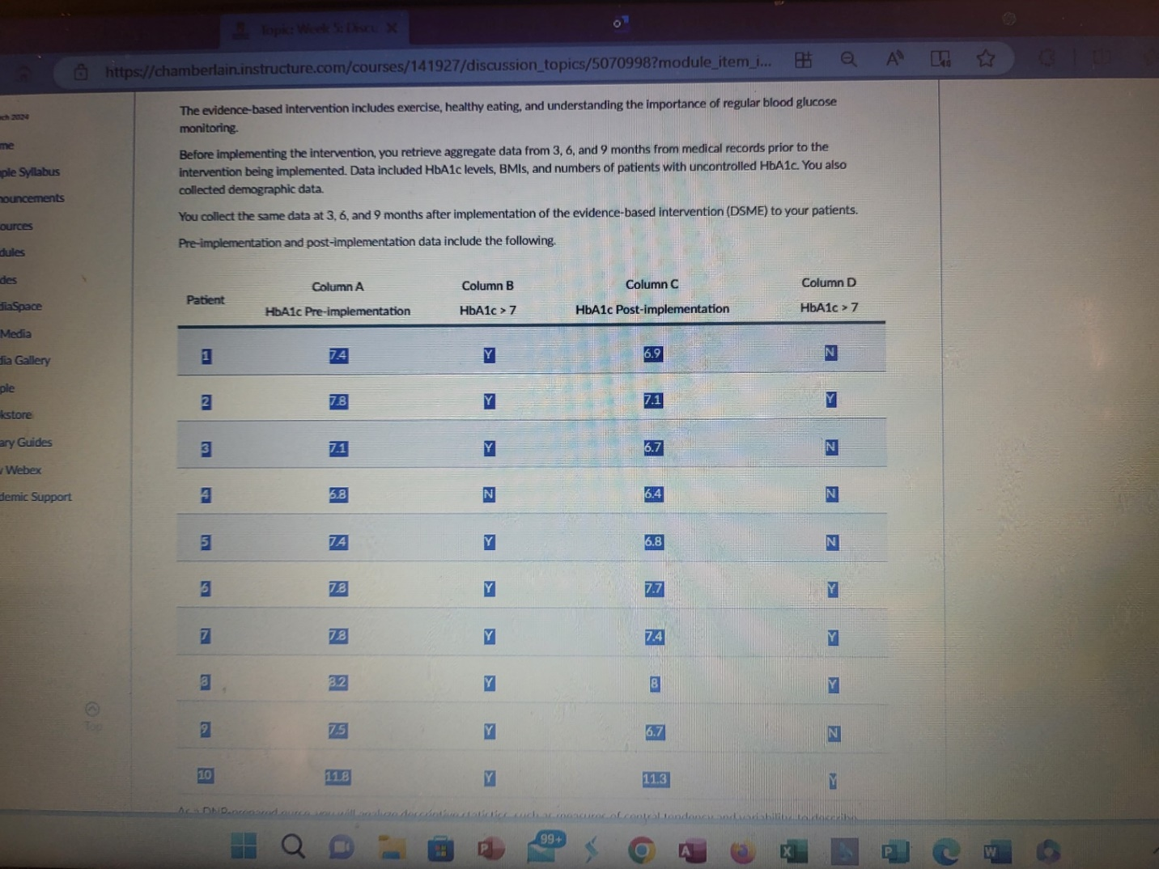

As a well prepared nurse, you will analyze descriptive statistics, such as measures of central tendency and variability, to describe outcomes of a practice change project. Reflect upon this scenario and the data presented.1, What conclusions would you make at the end of this practice change project? 2, What recommendations would you make to stakeholders for continuing the diabetes self-management education (DSME) program based on these results?

In order to respond to this discussion question, you will first need to complete the following calculations and consider responses to your analysis of the descriptive statistics.

1,Perform the following calculations:
A, Based on the data set provided, calculate the average percentage of patients with uncontrolled diabetes (HbA1c>7) both pre-implementation and post-implementation.
B, Next, calculate the mean pre-implementation and post-implementation HbA1c values for patients involved in this practice change project.
C, Now calculate the pre-implementation and post-implementation median score of HbA1c levels.
D, Next, calculate the pre-implementation and post-implementation standard deviation of HbA1c levels of patients involved in the practice change project. The standard deviation will determine the spread of increase or decrease in HbA1c levels.
E, Finally, calculate the pre-implementation and post-implementation range of HbA1c levels. If no outliers exist, the range will determine how close together HbA1c levels are in the patients involved.
2, Based on your analysis of the descriptive statistics, what determinations related to the mean HbA1c levels following implementation of the evidence-based intervention can be made?

3, As you reflect upon HbA1c levels, you observe that patient #10 HbA1c levels are an outlier. What does this do to your understanding of the data?

Instructions for Discussion Criteria

1. Application of Knowledge

a. Address all bullet points in the weekly discussion accurately and thoroughly with a substantive, in-depth discussion.
2. Engagement in Meaningfully
3. Integration of Evidence

a. Incorporate three (3) different sources each week: two (2) of the three (3) should be scholarly.

b. A scholarly source is (a) evidence-based, (b) peer-reviewed, and (c) published in the last five (5) years.

e. ** Please be sure to follow your discussion post’s explicit instructions, as additional sources may be required.

4. Professionalism in Communication

a. References are consistent with APA style/formatting with no error patterns; the hanging indent is not required.

b. Presents information in an organized manner.

c. Uses clear and concise language.

d. Communicates with no error patterns in English grammar, spelling, syntax, and punctuation.

e. Please continue to use your writing resources as you construct your posts, such as Grammarly, Chamberlain Guidelines for Professional Writing, and Turnitin Draft Box.

Program Competencies
This discussion enables the student to meet the following program competencies:

Integrates scientific underpinnings into everyday clinical practice. And
Uses analytic methods to translate critically appraised research and other evidence into clinical scholarship for innovative practice improvements.
Appraises current information systems and technologies to improve health care.
Analyzes health care policies to advocate for equitable health care and social justice to all populations and those at risk due to social determinants of health.
Translates a synthesis of research and population data to support preventative care and improve the nation’s health.
Leads others in professional identity, advanced clinical judgment, systems thinking, resilience, and accountability in selecting, implementing, and evaluating clinical care.

